Lastminute.com Code Interview

# Parking Widget

You are going to develop a parking widget:

* "Parking" because the goal is to show a collection of parking slots and let the user buy one
* "Widget" because it should be an independent module that can be embedded in any Web application

You are free to use any JS/CSS library, framework or build system.

You are asked to implement an UI like this one:

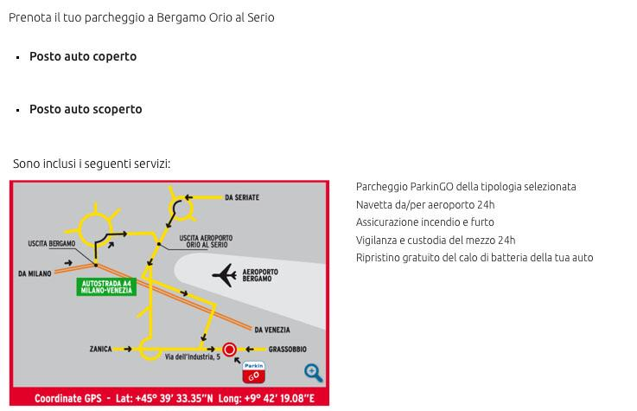

* Clicking on "Posto auto coperto" or "Posto auto scoperto" will add the parking slot to the shopping cart
* In the source code you have a *model.json* with the data from the server. Use them to fill the UI, as mock data received from your server-side service
* Implement a notifications system to tell to the host Web app that a parking slot has been selected
* Add a button show/hide details (the map and the features list)

## Before start implementing

Think about widget interface requirements.

The Web app that wants to use the widget must respect/implement an agreement between the Web app and the widget in order to retrieve the parking slot that the user has selected inside the widget.

How can you initialize and render the widget in that Web page? How can communicate Web app and widget?

How can you guarantee that another developer can modify your code without breaking the features? How can you guarantee to modify your code during a refactoring without breaking any functionality?

Write your thoughts.