| logo.png | ***Flaggermus Lydopptaker*** |
| --- | --- |

The main display consists of a waveform view and a spectrogram view. The frequency scale is in kHz and the time scale is in seconds.

The UI is designed to be used in landscape mode, and should automatically orient to landscape (if it does not, just tilt the device to get it to do so).

The display can be zoomed or scrolled using a pinch-and-stretch or fling gestures, respectively. The relative sizes of the spectrogram and waveform views can also be adjusted by touching the display with three fingers and dragging down or up.

The app has the following controls:

**Listen**  


This control toggles whether the app is listening to the microphone. Note that this control does NOT control whether the app is recording the signal. Rather, you can record segments of the incoming signal manually by using the record control or automatically by using the trigger control (see below).

**Record**  
This control at the top left corner of the screen can be used to manually turn recording on and off.

By making a long press on the record control, Bat Recorder will save up to 10 seconds of the current listening buffer as part of a recording. This provides a way to capture sounds that may have been heard by the app before the recording control has been pressed.

**Gain**  
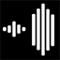

This control displays a slider that allows you to specify the amount of gain applied to the visual display of a signal during playback. Note that this only affects the displays, playback and trigger sensitivity but does not alter the amplitude of the audio signal being recorded.

You can also change the volume of the playback by using the volume controls on your Android device.

**Recording Trigger**

This control toggles whether the app should automatically record incoming signals, based on parameters specified in the Settings panel. Note that the app must be listening to the microphone in order for recordings to be automatically triggered.

A long press on this control will turn on an optional listening timer that will periodically listen and record signals based on the trigger settings. For example, by setting the appropriate settings and using a long press on this control, the app can be set to listen for incoming audio for 5 minutes (recording any signal that meets the trigger criteria) and then pauses for 55 minutes, then listens again for another 5 minutes, and so on.



| **Real Time Audio** headset_cutoff.png headset_div.png headset_tune.png |
| --- |

If the app is in listening mode, this control sets whether the incoming ultrasonic signal can be audibly monitored in real time using either frequency division, heterodyne tuning, or a frequency lowpass filter (these are explained in the next section). A short press on this control turns the output on and off. A long press toggles between the modes.

Note that in order to prevent interference, this control should be turned on only if a headset is connected to your Android device. Use the volume controls on your device to set the playback volume to a comfortable level.

| **Playback Mode** frequency.png tuning.png cutoff.png time.png |
| --- |

If the app is currently displaying a previously saved recording, this control enables you to specify how the recording is played back. There are four playback modes: frequency division, heterodyne tuning, frequency low pass filter, or time expansion.

| **Frequency Division** | This mode analyzes the frequencies in the recording and shifts them into the audible range by dividing those frequencies by a factor of 10 (or 20 depending on settings) and then resample. |
| --- | --- |
| **Heterodyne Tuning** | This mode uses heterodyne tuning to make an ultrasonic signal audible. When this mode is selected, a tuning line indicator will appear on the frequency axis.  A red line indicates manual tuning - to manually adjust the tuning frequency, just drag the indicator.  A green line indicates automatic tuning. In this case, Bat Recorder will attempt to automatically set the tuner to the optimal frequency for the incoming signal.  To toggle between automatic and manual tuning, just double tap on the frequency axis - the tuner will change from green to red (or vice versa) to indicate that the tuning mode has changed. |
| **Frequency Low Pass Filter** | This mode effectively filters out any frequency above half the the highest sampling rate of your Android device. For example, if your Android device can play audio at a maximum sampling rate of 48 KHz, then all frequencies above 24 kHz will be filtered out. This mode is useful when recording and playing back recordings in the audible frequency range. |
| **Time Expansion** | This mode plays back the recording at a rate (10x or 20x) slower than the original recording, allowing ultrasonic signals to be audible. Note that unlike the other two modes, the recording is not resampled. |

Note that a long press on this control will allow you to export an audible version of the current recording. For example, if the Time Expansion mode is currently selected, using a long press on this control will make a ‘time expanded’ copy of the current recording so that it can be played back in other non-ultrasonic software programs. Currently, only the Time Expansion is supported for export.

To get back to recording, simply tap on the Listen (microphone) icon in the lower left corner of the display.

**Loop Playback**

Use this control to toggle whether playback is looped or not.

**Palette**palette.png

This control allows you to change the color palette used in the spectrogram.

Double tapping on the palette cycles through the available palettes - currently, the app supports four palettes: *rainbow*, *iron*, *arctic*, and *white hot*.

Holding a finger down on the palette and dragging right or left modifies the relative contribution of the colors in the color ramp. A long press on the palette resets any changes.

**Power Spectrum**

This control toggles the visibility of a resizeable overlay which displays the power spectrum for the currently selected point in time. The frequency at peak energy and the peak energy value are displayed in the upper right corner of the overlay. Change the size and shape of the overlay by dragging the lower right corner.

**Archive**

This control allows you to view samples previously recorded with the app. To load a sample, simply use a long press on its name.

Note that swiping left on a sample name will expose controls for renaming the sample, sharing the sample, exporting the metadata to a separate file, and deleting the sample, respectively.

All files are stored in subdirectories within the *BatRecorder* directory. Each subdirectory contains recordings made on a given day.

This control allows you to view samples previously recorded with the app. All files are stored in subdirectories within the BatRecorder directory. Each subdirectory contains recordings made on a given day. To load a sample, simply use a long press on its name.

Swiping left on a sample name will expose controls for renaming the sample, sharing the sample, exporting the metadata to a separate file, and deleting the sample, respectively.

Across the top of the screen are various controls:



**SD Card.** If your Android device supports a writable SD card, a card is mounted, and you are running Android OS 4.4 or later, you will see a SD card icon in the top left hand corner. Tapping on this icon will allow you to toggle between saving recordings to internal or SD card storage. IMPORTANT: Because of Android’s security policy, all app-related files on the SD card will be automatically deleted when and if the app is uninstalled. Thus, if you do use the SD card, please make sure you backup any recordings you wish to keep before you uninstall the Bat Recorderapp. Note that this is not an issue for recordings saved to internal storage.

On SD cards, recordings can be found in this directory:

Android/data/com.digitalbiology.audio/files/BatRecorder

**Sort Order.** This control controls the direction of sorting of the files.

The next series of controls determine the sorting criteria for the files. From left to right, they are sort by file name, recording creation date, recording length, file size, location, device used, and species.

**Export CSV.** The CSV icon in the upper right hand corner will create a comma delineated text file containing the metadata for each recording in the current directory. This file is saved to the topmost directory of your Android device.

**Export GPX.** The GPX icon in the upper right hand corner will create a GPS Exchange File that will contain the GPS track for a given directory and includes recordings as route waypoints. Bat Recorder will begin saving location information after the first recording is made, based on the GPSD update frequencies and distances settings. This file is saved to the topmost directory of your Android device.

**Map View.** The map icon in the upper right hand corner of the panel will allow you to view any geotagged recordings on a Google Map display from within the app. Tap on a ‘bat’ marker to get information on the recording at that location. A long press on a ‘bat’ marker will open the associated file.  
 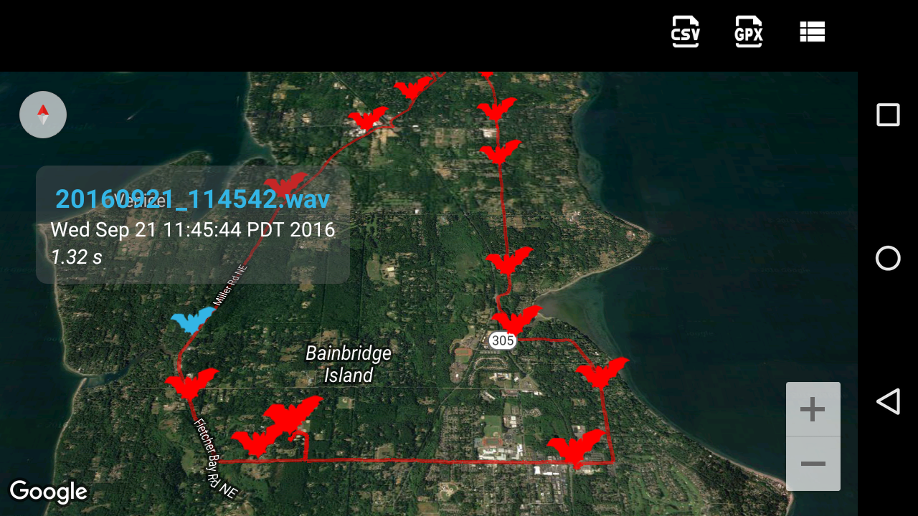

**Recording Playback**

Once a sample is loaded, you can use the play control (arrow) at the top left corner of the screen to toggle playback on and off. Tap anywhere on the waveform display to place the current play head - it will be shown as a vertical white line. Alternatively, simply tap on the play head and drag it to a new location.

To playback only a portion of a recording, use a long press on the waveform display and then drag your finger to select the region of interest - you should see a gray selection rectangle on the waveform display. To clear this selection, simply double tap on the display other than the gray selection rectangle. To export the clip to a separate WAV file, double click anywhere on the gray selection rectangle.

When a previously saved recording is loaded, there will be an ‘i’ icon in the bottom right corner of the display. Tapping on this icon will display an informational overlay describing basic information about the recording, such as length, sample rate, capture device, and optionally location.

In addition, a small ‘bat’ icon can be found at the bottom of the information pane. Tapping on this icon will display a dialog where you can enter the scientific name for the species you would like to associate with the recording. As a convenience, a list of microbat species is presented, although you are not restricted to bats and can enter any text you wish. Note that if the current recording was geotagged, you will be able to toggle between the full species list and a list localized for your region. (If the recording is not geotagged, the app will attempt to use your current location.)

**‘Caliper’ Tool**

If you double tapping on a pulse or feature within the spectrogram, *Bat Recorder* will attempt to measure the frequency range and duration of that feature, displaying an overlay. Additionally, if you double tap between features, *Bat Recorder* will attempt to measure the time interval.

A long press inside the rectangle formed by the overlay axes will select the overlay, allowing you to resize it using the scale gesture or move it by dragging.

At this time, changes to the overlay are not preserved.

**Settings**

This control provides access to various settings and parameters.

| ***Analysis*** | |
| --- | --- |
| **FFT Window Size** | The number of samples used when calculating the Fast Fourier Transform needed to display the spectrogram. Smaller windows allow for greater time resolution but less frequency resolution; larger windows allow the opposite. |
| **Microphone sampling rate** | Displays the sampling rate of the currently attached microphone. If the microphone supports more than one sampling rate, this control will be enabled and can be used to set the value. |
| **Maximum recording length** | Sets the maximum recording length. |
| **Logarithmic frequency scale** | Specifies whether the spectrogram should be displayed using a logarithmic (as opposed to linear) frequency scale, starting at 100 Hz. This option is best used for non-ultrasonic signals. |
| **Show frequency grid lines** | Specifies whether blue grid lines extending from the frequency axis should be displayed across the spectrogram. |
| **Only display triggered events** | Toggles whether the spectrogram and waveform displays advance only when a recording is triggered. Note that the trigger needs to be set for this setting to have effect. |
| **Expansion Factor** | The factor by which time is expanded and frequencies are divided for the time expansion and frequency division playback modes, respectively. |
| **Enable all playback modes for non-ultrasonic signals** | By default, only the low pass playback mode is available for non-ultrasonic signals since they are already audible. Checking this setting enables all playback modes for those signals. |
| **Heterodyne frequency range** | When using automatic heterodyne tuning, this slider sets the minimum and maximum frequency that the tuner can be set to. |
| ***Recording*** | |
| **Trigger frequency range** | When using the recording trigger, this slider sets the minimum and maximum frequency needed to trigger a recording - frequencies below or above this range will not trigger a recording. |
| **Trigger intensity threshold** | When using the recording trigger, this slider specifies the minimum intensity needed to trigger a recording - intensities below this value will not trigger a recording. |
| **Post Trigger** | When using the recording trigger, this setting specifies the amount of time the app continues to record after the last trigger was detected. |
| **Pre Trigger** | When using the recording trigger, this setting specifies how much of the signal preceding the trigger should be included in the recording. |
| **Listening buffer length** | The length of time that should be captured from the listening buffer after a long press on the Record control. |
| **Trigger Notification** | |
| **Send SMS message when triggered** | If this setting is checked, the app will send a SMS text message whenever a recording is automatically triggered. Note that this requires that the Android device be currently connected to a cellular network and not simply connected to a WiFi network, as SMS requires the former. |
| **SMS message recipient** | The number that will receive a SMS text message when a recording is triggered. |
| **Send email when triggered** | If this setting is checked, the app will send an email notification when a recording is automatically triggered. Note that this requires that the Android device be connected to either a cellular or WiFi network. In addition, several notifications may be grouped in a single email to prevent excessive email traffic, and not more than one email per ten minutes will be sent. |
| **Email recipient** | The email account that will receive an email when a recording is triggered. |
| ***Listening Timer*** | |
| **Listening Duration** | The number of minutes the timer will be listening and can be triggered. |
| **Sleep Interval** | The number of minutes between the timer's listening periods. |
| ***Geolocation*** | |
| **Geotag WAV Files** | Toggles whether GPS location (if available) should be embedded in the WAV file. |
| **GPS Update frequency** | The minimum amount of time between attempts by the app to update the GPS position. Note that more frequent updates will use more battery. |
| **GPS Update minimum distance** | The minimum distance required between locations before the app will attempt to update the GPS position. |
| ***General*** | |
| **Night Mode** | Toggles whether the displays are shown in red or not. |
| **Metadata format** | Specifies the format of the metadata included in the WAV file. Currently, either Adobe’s XMP or Myotisoft’s GUANO format is supported. The default is GAUNO. |
| **Language Localization** | While Bat Recorder will localize its UI to match your Android device for several common languages, this setting allows you to override the default system language. |
| **USB debug log** | Checking this setting causes the app to log information when initializing the USB device, useful for trouble shooting. A log file is created in the topmost directory of the Android device. |
| **Bat Recorder version** | Displays the current version of the app. |
| **User Manual...** | Displays this user manual. |