## ISC Accounts Question Paper 2010 Solved for Class 12

**Part – I**

Question 1.

Answer each of the following questions briefly : [10 × 2]

(i) State two differences between Bin Card and Stores Ledger.

(ii) What is a cost unit ?

(iii) Name the two accounts which are prepared, when each co-venture keeps a record of his own transactions only in his books.

(iv) State two differences between Sectional Balancing and Self Balancing.

(v) How will you deal with the following items in the absence of a partnership deed :

(a) Interest on Capital

(b) Interest on Drawings

(c) Interest on Partner’s Loan to the firm

(d) Share in Profit and Loss

(vi) State two differences between a revaluation account and a realization account.

(vii) What is a ‘fictitious asset’ ? Give one example.

(viii) What is meant by ‘issue of debentures as collateral security’ ?

(ix) Give four examples of tangible fixed assets as per Schedule VI, Part I of the Companies Act. 1956.

(x) What is meant by ‘Cash equivalents’ ?

Answer:

(i) Difference Between Bin Card and Store Ledger.

| Bin Card | Store Ledger |
| --- | --- |
| 1. A record of quantities only. | 1. A record of both quantities and values. |
| 2. Normally posted just before the transaction takes place. | 2. Maintained by the Costing Department. |
| 3. Usually kept inside the stores. | 3. Always posted after the transaction takes place. |

(ii) It is a unit of product or service for which cost is computed. Cost units are selected to allow for comparision between actual cost and standard cost, or between different actual costs.

(iii) Memorandum Joint-Venture Account

Joint Venture with Co-venture Account

(iv)

| Basis of difference | Self Balancing | Sectional Balancing |
| --- | --- | --- |
| (a) Double entry system      (b) Separate total balance | In this system, double entry system is fully implemented in all the ledgers.  In this system separate total balance can be prepared for each ledger. | In this system, accounts are maintained on double entry system only.  In this system, separate trial balance can be prepared only for general ledger. |

(v) (a) Partner is not entitled to interest on capital.

(b) No interest is charged on partner’s drawings.

(c) A partner is entitled to interest at the rate of 6% p.a. on any loan given to the firm.

(d) Profits and losses are shared equally.

(vi) Difference between Realization Account and Revaluation Account.

| Basis of Difference | Realization Account | Revaluation Account |
| --- | --- | --- |
| (i) Time | This account is prepared at the time of dissolution of firm | This account is prepared at the time of admission/retirement or death of a partner. |
| (ii) Purpose | This account is prepared to find out the profit or loss on realization of assets and payment of liabilities. | This account is prepared to find out the profit or loss on revaluation of assets and liabilities |
| (iii)Amount | The amount of assets and liabilities are shown in this | The amount of increase or decrease in the value of assets and liabilities are show n in this account. |

(vii) Fictitious assets are those assets which are not tangible in nature. For example-preliminary expenses, debit balance of P& L account.

(viii) Whenever a company takes loan from bank or any financial institution it may issue its debentures as secondary security which is in addition to the principal security. Such an issue of debentures is know n as issue of debentures as collateral security.

(ix) (a) Land.

(b) Buildings,

(c) Plant and Equipment,

(d) Furniture and Fixtures,

(x) An asset that is so easily and quickly convertible to cash that holding it is essentially equivalent to holding cash. A Treasury bill is considered a cash equivalent.

Question 2. [10]

Lucy, Rahul and Sanjay are partners sharing profits and losses in the ratio of 1 : 2 : 3, Arun is admitted as a partner who brings in Rs.20,000 as his capital for 1/5th share in the profit. Goodwill of the firm is to be valued at an average of the last three years profits which were Rs. 25,000, Rs. 28,000 and Rs. 37,000 respectively. Arun is unable to bring in cash towards his share of premium for goodwill.

Give the journal entries if goodwill already appears in the books at Rs. 24,000.

Answer:

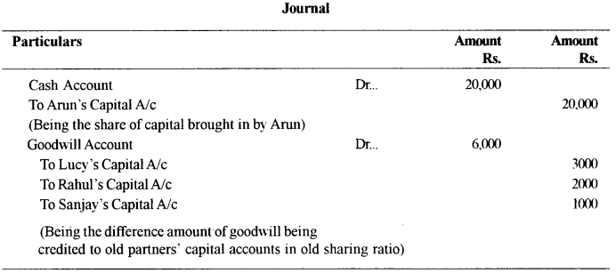

Working Notes :

ISC Accounts Question Paper 2010 Solved for Class 12 2

= Rs 30,000

Goodwill already in the books = Rs 24,000

Goodwill to be increased by Rs 6,000

**Part – II**

Question 3. [14]

Anita, Kiran and Mina were partners sharing profits and losses in the ratio , of 3:2: 1. They decided to dissolve the partnership due to insolvency of all the partners. Their Balance Sheet as on 31st December, 2009 was as follows :

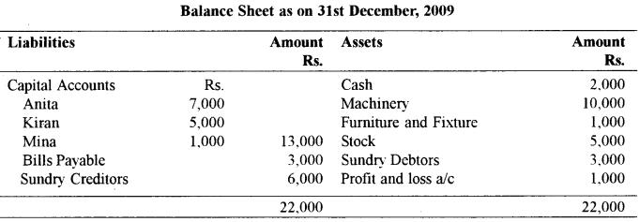

The assets were realized as follows :

Machinery — Rs. 5, 000 and

Stock — Rs 3,000

Realization expenses were Rs. 1,000.

Prepare necessary accounts to close the books of the firm.

Answer:

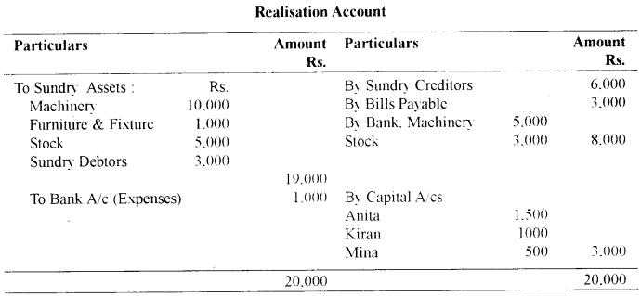

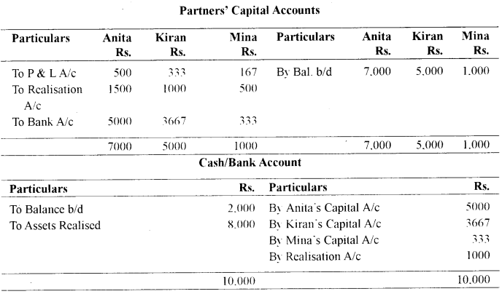

Question 4. [14]

Prepare a Cost-Sheet from the following particulars :

Particulars:

Opening stock of raw material — Rs. 2,500

Opening stock of work in progress — Rs. 3,600

Opening stock finished goods (800 units) — Rs. 12,900

Purchase of raw material — Rs. 20,000

Productive wages — Rs. 27,000

Factor} expenses — Rs. 14,400

Establishment expenses — Rs. 6,400

Depreciation on delivery van — Rs. 9,000

Sales (.3000 units) — Rs. 90,000

Closing stock of raw material — Rs. 4,500

Closing stock of work in progress — Rs. 5,400

Closing stock of finished goods (1000 units) — ?

Answer:

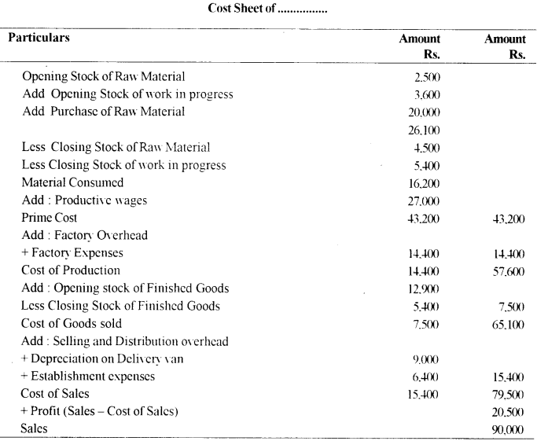

Question 5. [14]

Andrew and Rohan entered into a joint venture and agreed to share profits and losses in the ratio of 4:3. Andrew supplied goods worth Rs. 13,000 from his own stock. He spent Rs. 900 on freight and insurance and drew a bill on Rohan for Rs. 9,000 for three months. Rohan accepted the bill which was discounted by Andrew @ 12%p.a. Rohan paid Rs.600 tow ards clearing charges and Rs.700 for rent. Goods were sold by Rohan for Rs.21,000. Rohan was entitled to a commission of 6%. Rohan sent the draft to Andrew towards settlement of his account

Prepare in the books of Andrew :

(a) Joint Venture Account

(b) Rohan’s Account

Answer:

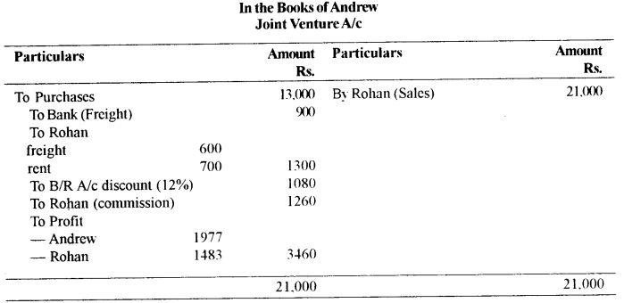

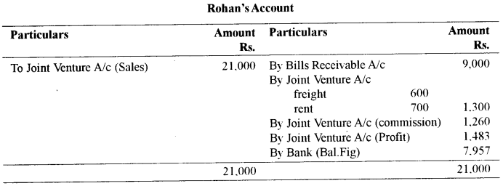

Question 6.

Given below are the extracts from the books of Greg Steels Limited :

Particulars:

Opening balance of debtors — Rs. 23,000

Opening balance of creditors — Rs. 17,000

Credit sales — Rs. 9,500

Credit purchases — Rs.10,500

Paid to creditors — Rs. 12,000

Transfer from sales ledger to purchases ledger — Rs. 250

Bills receivable received — Rs. 4,750

Sales returns — Rs. 425

Purchases — Rs. 250

Cash received from debtors — Rs. 15,500

Bills payable accepted — Rs. 2,500

Bad debts — Rs. 850

Interest charged to customers — Rs. 320

From the above details prepare the Sales Ledger Adjustment Account and the Purchases Ledger Adjustment Account in the General Ledger.

Answer:

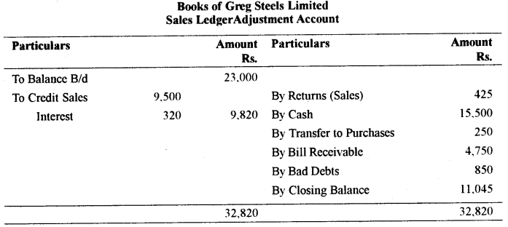

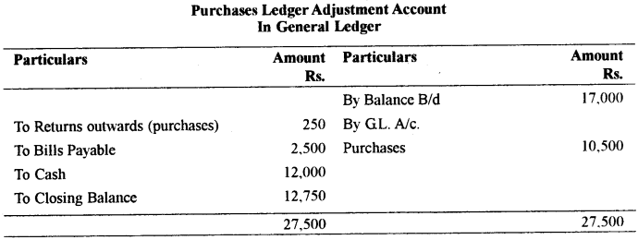

Question 7. [14]

Raman Ltd, issued 20,000 shares of Rs 10 each at a discount of 10% payable as follows :

(i) Rs 2.50 on application payable on 1st May, 2009

(ii) Rs 1.50 on allotment payable on 1st July, 2009

(iii) Rs 2 on first call payable on 1st Oct, 2009

(iv) Balance on second call payable on 1st Feb.2010

All these shares were subscribed and amounts received.

Shareholder ‘A’ who had been allotted 200 shares, paid the amount of the first and second calls with allotment.

Another shareholder ‘B’ holding 100 shares did not pay the final call till the date of the Balance Sheet. According to the Articles of Association of the company, interest at the rate of 4% p.a. is payable by the company on any calls in advance. The interest was paid by the company to the shareholder on 1st Feb.2010.

Pass the necessary Journal Entries (including interest) in the books of the company.

Answer:

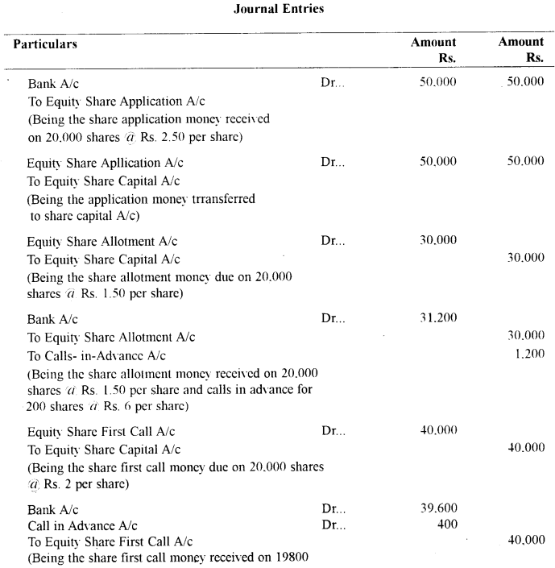

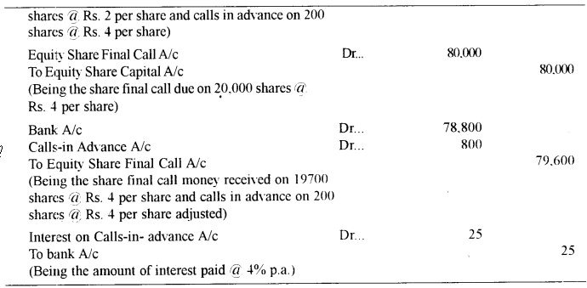

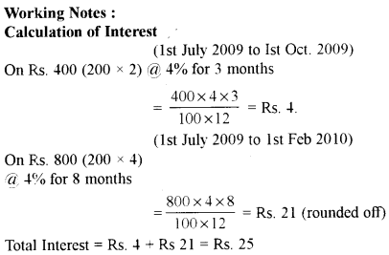

Question 8. [14]

Calculate the following Ratios from the Financial Statements of Annie Foods Limited:

(i) Gross profit ratio

(ii) Net profit ratio

(iii) Working capital turnover ratio

(iv) Stock turnover ratio

(v) Quick ratio

(vi) Proprietary ratio

(viii) Current ratio

Profit & Loss Account of Annie Foods Limited for the year ending 31st March 2009

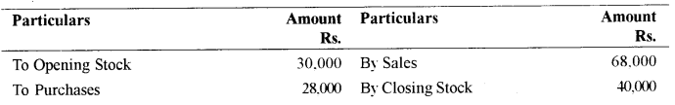

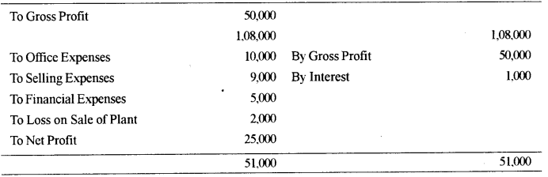

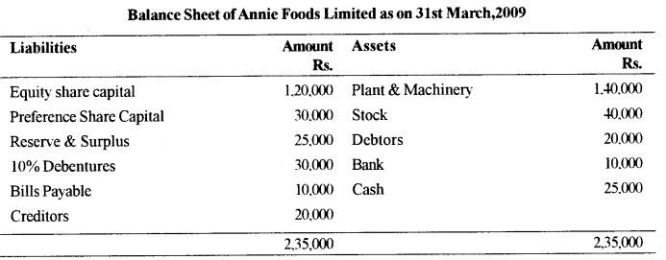

Note : All calculations are to be made to two places of decimal

Answer:

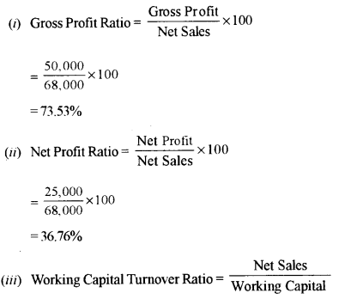

=

68,000

65,000

=1.05

Working Capital = Current Assets – Current Liabilities

Current Assets = Rs. 40,000 + Rs. 20,000 + Rs. 10,000 + Rs. 25,000 = Rs. 95,000

Current Liabilities=Rs. 10,000+Rs. 20,000 = Rs. 30,000

Working Capital = Rs. 95,000 – Rs. 30,000 = Rs. 65,000

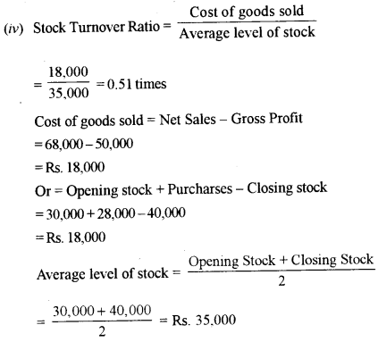

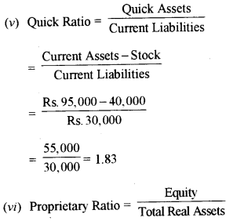

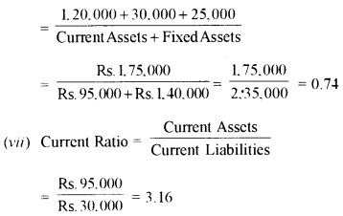

Question 9. [14]

Given below is the Balance Sheet of M/s Victor Limited.

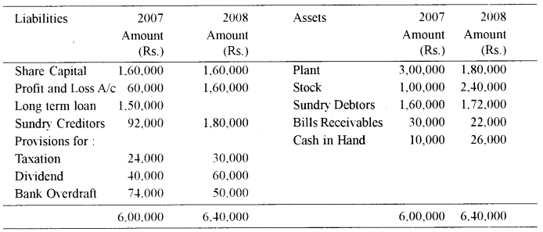

Additional Information :

(a) Loan was paid in the beginning of the year 2007.

(b) Depreciation provided on Plant during the year was Rs. 20,000.

From the above information prepare a cash flow statement as per Accounting Standard – 3.

Answer:

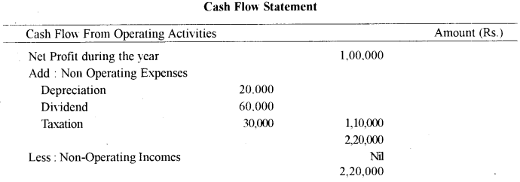

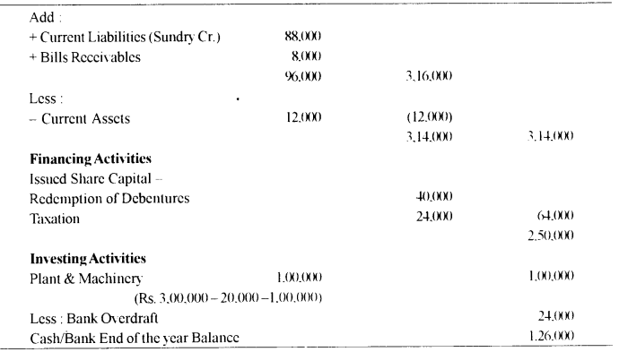

Question 10. [14]

Mehra Brothers has two petrol pumps, one in Kerala and the other in Punjab. The method of valuation of closing stock followed by both the pumps are FIFO and LIFO, respectively A periodic inventory of petrol is taken when the books are closed at the end of each month.

The following information is available for the month of December, 2009.

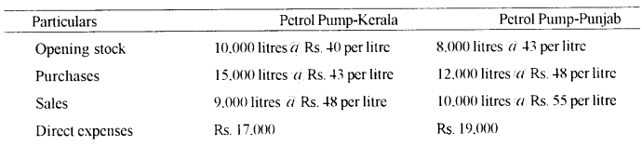

From the above information, prepare a Trading account to calculate the profit made by the above petrol pumps for the month of December. 2009.

Answer:

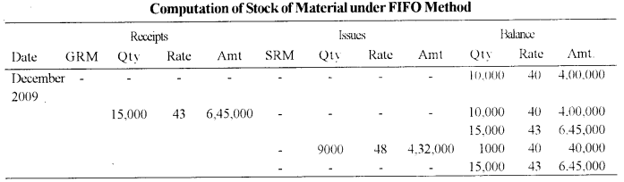

Value of Closing stock = Rs. 40,000+Rs. 6,45,000 =Rs. 6,85,000

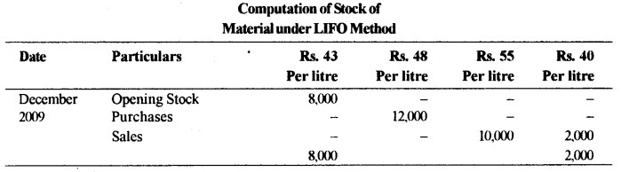

Stock of Material as per Computation (petrol) = 8,000 +12,000 = 20,000 liter.

Value of Closing stock (i) 8,000 × 43 = Rs.3,44,000

(ii) 2,000 × 48 = Rs 96,000 = Rs. 4,40,000

