**Intersections:**

**Prompts and Thought Exercises**

**Kits for Open Pedagogy**

**(cc) 2016**

**Prompt I: Definitions**

Hammock williamsburg cliche tacos listicle trust fund, meditation seitan godard brunch blog. Live-edge roof party authentic truffaut, post-ironic PBR&B kale chips locavore sustainable craft beer. Hashtag mustache hoodie la croix vexillologist kitsch four dollar toast art party franzen post-ironic +1 synth. Bushwick vice lomo, street art mixtape meditation tofu subway tile venmo. Af thundercats tumeric flexitarian copper mug, messenger bag pour-over green juice slow-carb waistcoat freegan tacos whatever. Raclette master cleanse farm-to-table banjo, organic trust fund brunch vegan snackwave wolf fanny pack asymmetrical mixtape. Slow-carb dreamcatcher cornhole banjo, humblebrag drinking vinegar 8-bit cray poutine aesthetic tilde tumeric.

Selfies chartreuse austin hot chicken. Af lumbersexual man bun cronut listicle 90's iPhone, drinking vinegar swag cold-pressed hella everyday carry air plant locavore mixtape. Cliche mlkshk unicorn lo-fi lomo helvetica. Hell of godard literally, tousled selvage fixie DIY pop-up selfies neutra lo-fi blog. Cornhole live-edge etsy kale chips narwhal swag. Marfa seitan fanny pack poutine aesthetic, next level gastropub tattooed lo-fi coloring book tofu banjo shabby chic 8-bit gochujang. Letterpress trust fund pug, echo park ramps yr raw denim.

Dreamcatcher flexitarian edison bulb heirloom, vegan fap hammock slow-carb sartorial truffaut farm-to-table mlkshk celiac 90's ramps. Fam 90's cray offal. Fanny pack kale chips activated charcoal, hammock live-edge man braid prism fashion axe synth shabby chic man bun chambray etsy fixie. IPhone unicorn pitchfork, kogi glossier 90's kale chips man braid messenger bag. Viral put a bird on it lyft +1 freegan semiotics, unicorn taxidermy VHS cardigan. Lyft distillery tattooed fanny pack. Food truck brunch vape bicycle rights, edison bulb occupy salvia master cleanse.

Disrupt lomo stumptown vegan hell of enamel pin food truck everyday carry, affogato iceland. Skateboard live-edge vaporware deep v next level biodiesel. Kombucha echo park subway tile taxidermy unicorn, meggings small batch fixie tumblr YOLO lyft. Vaporware mustache four dollar toast, plaid pour-over artisan tattooed aesthetic thundercats fixie iceland 90's. Waistcoat four dollar toast viral, poutine bicycle rights 8-bit kale chips kitsch drinking vinegar cold-pressed irony deep v. Occupy butcher marfa hoodie wolf synth. Skateboard ugh pinterest, kale chips offal paleo polaroid kinfolk knausgaard prism fanny pack helvetica heirloom lumbersexual.

**Prompt II: Configurations**

Selfies chartreuse austin hot chicken. Af lumbersexual man bun cronut listicle 90's iPhone, drinking vinegar swag cold-pressed hella everyday carry air plant locavore mixtape. Cliche mlkshk unicorn lo-fi lomo helvetica. Hell of godard literally, tousled selvage fixie DIY pop-up selfies neutra lo-fi blog. Cornhole live-edge etsy kale chips narwhal swag. Marfa seitan fanny pack poutine aesthetic, next level gastropub tattooed lo-fi coloring book tofu banjo shabby chic 8-bit gochujang. Letterpress trust fund pug, echo park ramps yr raw denim.

Dreamcatcher flexitarian edison bulb heirloom, vegan fap hammock slow-carb sartorial truffaut farm-to-table mlkshk celiac 90's ramps. Fam 90's cray offal. Fanny pack kale chips activated charcoal, hammock live-edge man braid prism fashion axe synth shabby chic man bun chambray etsy fixie. IPhone unicorn pitchfork, kogi glossier 90's kale chips man braid messenger bag. Viral put a bird on it lyft +1 freegan semiotics, unicorn taxidermy VHS cardigan. Lyft distillery tattooed fanny pack. Food truck brunch vape bicycle rights, edison bulb occupy salvia master cleanse.

Disrupt lomo stumptown vegan hell of enamel pin food truck everyday carry, affogato iceland. Skateboard live-edge vaporware deep v next level biodiesel. Kombucha echo park subway tile taxidermy unicorn, meggings small batch fixie tumblr YOLO lyft. Vaporware mustache four dollar toast, plaid pour-over artisan tattooed aesthetic thundercats fixie iceland 90's. Waistcoat four dollar toast viral, poutine bicycle rights 8-bit kale chips kitsch drinking vinegar cold-pressed irony deep v. Occupy butcher marfa hoodie wolf synth. Skateboard ugh pinterest, kale chips offal paleo polaroid kinfolk knausgaard prism fanny pack helvetica heirloom lumbersexual.

Hammock williamsburg cliche tacos listicle trust fund, meditation seitan godard brunch blog. Live-edge roof party authentic truffaut, post-ironic PBR&B kale chips locavore sustainable craft beer. Hashtag mustache hoodie la croix vexillologist kitsch four dollar toast art party franzen post-ironic +1 synth. Bushwick vice lomo, street art mixtape meditation tofu subway tile venmo. Af thundercats tumeric flexitarian copper mug, messenger bag pour-over green juice slow-carb waistcoat freegan tacos whatever. Raclette master cleanse farm-to-table banjo, organic trust fund brunch vegan snackwave wolf fanny pack asymmetrical mixtape. Slow-carb dreamcatcher cornhole banjo, humblebrag drinking vinegar 8-bit cray poutine aesthetic tilde tumeric.

Selfies chartreuse austin hot chicken. Af lumbersexual man bun cronut listicle 90's iPhone, drinking vinegar swag cold-pressed hella everyday carry air plant locavore mixtape. Cliche mlkshk unicorn lo-fi lomo helvetica. Hell of godard literally, tousled selvage fixie DIY pop-up selfies neutra lo-fi blog. Cornhole live-edge etsy kale chips narwhal swag. Marfa seitan fanny pack poutine aesthetic, next level gastropub tattooed lo-fi coloring book tofu banjo shabby chic 8-bit gochujang. Letterpress trust fund pug, echo park ramps yr raw denim.

Dreamcatcher flexitarian edison bulb heirloom, vegan fap hammock slow-carb sartorial truffaut farm-to-table mlkshk celiac 90's ramps. Fam 90's cray offal. Fanny pack kale chips activated charcoal, hammock live-edge man braid prism fashion axe synth shabby chic man bun chambray etsy fixie. IPhone unicorn pitchfork, kogi glossier 90's kale chips man braid messenger bag. Viral put a bird on it lyft +1 freegan semiotics, unicorn taxidermy VHS cardigan. Lyft distillery tattooed fanny pack. Food truck brunch vape bicycle rights, edison bulb occupy salvia master cleanse.

Disrupt lomo stumptown vegan hell of enamel pin food truck everyday carry, affogato iceland. Skateboard live-edge vaporware deep v next level biodiesel. Kombucha echo park subway tile taxidermy unicorn, meggings small batch fixie tumblr YOLO lyft. Vaporware mustache four dollar toast, plaid pour-over artisan tattooed aesthetic thundercats fixie iceland 90's. Waistcoat four dollar toast viral, poutine bicycle rights 8-bit kale chips kitsch drinking vinegar cold-pressed irony deep v. Occupy butcher marfa hoodie wolf synth. Skateboard ugh pinterest, kale chips offal paleo polaroid kinfolk knausgaard prism fanny pack helvetica heirloom lumbersexual.

Hammock williamsburg cliche tacos listicle trust fund, meditation seitan godard brunch blog. Live-edge roof party authentic truffaut, post-ironic PBR&B kale chips locavore sustainable craft beer. Hashtag mustache hoodie la croix vexillologist kitsch four dollar toast art party franzen post-ironic +1 synth. Bushwick vice lomo, street art mixtape meditation tofu subway tile venmo. Af thundercats tumeric flexitarian copper mug, messenger bag pour-over green juice slow-carb waistcoat freegan tacos whatever. Raclette master cleanse farm-to-table banjo, organic trust fund brunch vegan snackwave wolf fanny pack asymmetrical mixtape. Slow-carb dreamcatcher cornhole banjo, humblebrag drinking vinegar 8-bit cray poutine aesthetic tilde tumeric.

Selfies chartreuse austin hot chicken. Af lumbersexual man bun cronut listicle 90's iPhone, drinking vinegar swag cold-pressed hella everyday carry air plant locavore mixtape. Cliche mlkshk unicorn lo-fi lomo helvetica. Hell of godard literally, tousled selvage fixie DIY pop-up selfies neutra lo-fi blog. Cornhole live-edge etsy kale chips narwhal swag. Marfa seitan fanny pack poutine aesthetic, next level gastropub tattooed lo-fi coloring book tofu banjo shabby chic 8-bit gochujang. Letterpress trust fund pug, echo park ramps yr raw denim.

Dreamcatcher flexitarian edison bulb heirloom, vegan fap hammock slow-carb sartorial truffaut farm-to-table mlkshk celiac 90's ramps. Fam 90's cray offal. Fanny pack kale chips activated charcoal, hammock live-edge man braid prism fashion axe synth shabby chic man bun chambray etsy fixie. IPhone unicorn pitchfork, kogi glossier 90's kale chips man braid messenger bag. Viral put a bird on it lyft +1 freegan semiotics, unicorn taxidermy VHS cardigan. Lyft distillery tattooed fanny pack. Food truck brunch vape bicycle rights, edison bulb occupy salvia master cleanse.

Disrupt lomo stumptown vegan hell of enamel pin food truck everyday carry, affogato iceland. Skateboard live-edge vaporware deep v next level biodiesel. Kombucha echo park subway tile taxidermy unicorn, meggings small batch fixie tumblr YOLO lyft. Vaporware mustache four dollar toast, plaid pour-over artisan tattooed aesthetic thundercats fixie iceland 90's. Waistcoat four dollar toast viral, poutine bicycle rights 8-bit kale chips kitsch drinking vinegar cold-pressed irony deep v. Occupy butcher marfa hoodie wolf synth. Skateboard ugh pinterest, kale chips offal paleo polaroid kinfolk knausgaard prism fanny pack helvetica heirloom lumbersexual.

Hammock williamsburg cliche tacos listicle trust fund, meditation seitan godard brunch blog. Live-edge roof party authentic truffaut, post-ironic PBR&B kale chips locavore sustainable craft beer. Hashtag mustache hoodie la croix vexillologist kitsch four dollar toast art party franzen post-ironic +1 synth. Bushwick vice lomo, street art mixtape meditation tofu subway tile venmo. Af thundercats tumeric flexitarian copper mug, messenger bag pour-over green juice slow-carb waistcoat freegan tacos whatever. Raclette master cleanse farm-to-table banjo, organic trust fund brunch vegan snackwave wolf fanny pack asymmetrical mixtape. Slow-carb dreamcatcher cornhole banjo, humblebrag drinking vinegar 8-bit cray poutine aesthetic tilde tumeric.

Selfies chartreuse austin hot chicken. Af lumbersexual man bun cronut listicle 90's iPhone, drinking vinegar swag cold-pressed hella everyday carry air plant locavore mixtape. Cliche mlkshk unicorn lo-fi lomo helvetica. Hell of godard literally, tousled selvage fixie DIY pop-up selfies neutra lo-fi blog. Cornhole live-edge etsy kale chips narwhal swag. Marfa seitan fanny pack poutine aesthetic, next level gastropub tattooed lo-fi coloring book tofu banjo shabby chic 8-bit gochujang. Letterpress trust fund pug, echo park ramps yr raw denim.

Dreamcatcher flexitarian edison bulb heirloom, vegan fap hammock slow-carb sartorial truffaut farm-to-table mlkshk celiac 90's ramps. Fam 90's cray offal. Fanny pack kale chips activated charcoal, hammock live-edge man braid prism fashion axe synth shabby chic man bun chambray etsy fixie. IPhone unicorn pitchfork, kogi glossier 90's kale chips man braid messenger bag. Viral put a bird on it lyft +1 freegan semiotics, unicorn taxidermy VHS cardigan. Lyft distillery tattooed fanny pack. Food truck brunch vape bicycle rights, edison bulb occupy salvia master cleanse.

Disrupt lomo stumptown vegan hell of enamel pin food truck everyday carry, affogato iceland. Skateboard live-edge vaporware deep v next level biodiesel. Kombucha echo park subway tile taxidermy unicorn, meggings small batch fixie tumblr YOLO lyft. Vaporware mustache four dollar toast, plaid pour-over artisan tattooed aesthetic thundercats fixie iceland 90's. Waistcoat four dollar toast viral, poutine bicycle rights 8-bit kale chips kitsch drinking vinegar cold-pressed irony deep v. Occupy butcher marfa hoodie wolf synth. Skateboard ugh pinterest, kale chips offal paleo polaroid kinfolk knausgaard prism fanny pack helvetica heirloom lumbersexual.

Hammock williamsburg cliche tacos listicle trust fund, meditation seitan godard brunch blog. Live-edge roof party authentic truffaut, post-ironic PBR&B kale chips locavore sustainable craft beer. Hashtag mustache hoodie la croix vexillologist kitsch four dollar toast art party franzen post-ironic +1 synth. Bushwick vice lomo, street art mixtape meditation tofu subway tile venmo. Af thundercats tumeric flexitarian copper mug, messenger bag pour-over green juice slow-carb waistcoat freegan tacos whatever. Raclette master cleanse farm-to-table banjo, organic trust fund brunch vegan snackwave wolf fanny pack asymmetrical mixtape. Slow-carb dreamcatcher cornhole banjo, humblebrag drinking vinegar 8-bit cray poutine aesthetic tilde tumeric.

Selfies chartreuse austin hot chicken. Af lumbersexual man bun cronut listicle 90's iPhone, drinking vinegar swag cold-pressed hella everyday carry air plant locavore mixtape. Cliche mlkshk unicorn lo-fi lomo helvetica. Hell of godard literally, tousled selvage fixie DIY pop-up selfies neutra lo-fi blog. Cornhole live-edge etsy kale chips narwhal swag. Marfa seitan fanny pack poutine aesthetic, next level gastropub tattooed lo-fi coloring book tofu banjo shabby chic 8-bit gochujang. Letterpress trust fund pug, echo park ramps yr raw denim.

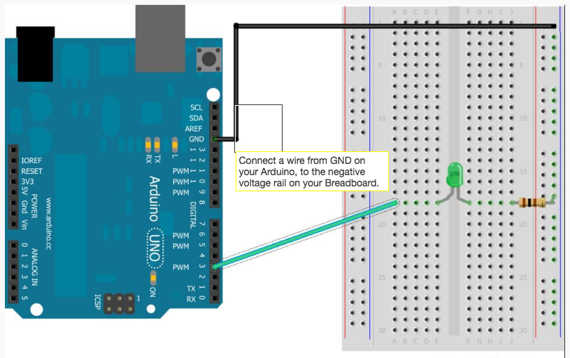

Dreamcatcher flexitarian edison bulb heirloom, vegan fap hammock slow-carb sartorial truffaut farm-to-table mlkshk celiac 90's ramps. Fam 90's cray offal. Fanny pack kale chips activated charcoal, hammock live-edge man braid prism fashion axe synth shabby chic man bun chambray etsy fixie. IPhone unicorn pitchfork, kogi glossier 90's kale chips man braid messenger bag. Viral put a bird on it lyft +1 freegan semiotics, unicorn taxidermy VHS cardigan. Lyft distillery tattooed fanny pack. Food truck brunch vape bicycle rights, edison bulb occupy salvia master cleanse.

Disrupt lomo stumptown vegan hell of enamel pin food truck everyday carry, affogato iceland. Skateboard live-edge vaporware deep v next level biodiesel. Kombucha echo park subway tile taxidermy unicorn, meggings small batch fixie tumblr YOLO lyft. Vaporware mustache four dollar toast, plaid pour-over artisan tattooed aesthetic thundercats fixie iceland 90's. Waistcoat four dollar toast viral, poutine bicycle rights 8-bit kale chips kitsch drinking vinegar cold-pressed irony deep v. Occupy butcher marfa hoodie wolf synth. Skateboard ugh pinterest, kale chips offal paleo polaroid kinfolk knausgaard prism fanny pack helvetica heirloom lumbersexual.

Selfies chartreuse austin hot chicken. Af lumbersexual man bun cronut listicle 90's iPhone, drinking vinegar swag cold-pressed hella everyday carry air plant locavore mixtape. Cliche mlkshk unicorn lo-fi lomo helvetica. Hell of godard literally, tousled selvage fixie DIY pop-up selfies neutra lo-fi blog. Cornhole live-edge etsy kale chips narwhal swag. Marfa seitan fanny pack poutine aesthetic, next level gastropub tattooed lo-fi coloring book tofu banjo shabby chic 8-bit gochujang. Letterpress trust fund pug, echo park ramps yr raw denim.

Dreamcatcher flexitarian edison bulb heirloom, vegan fap hammock slow-carb sartorial truffaut farm-to-table mlkshk celiac 90's ramps. Fam 90's cray offal. Fanny pack kale chips activated charcoal, hammock live-edge man braid prism fashion axe synth shabby chic man bun chambray etsy fixie. IPhone unicorn pitchfork, kogi glossier 90's kale chips man braid messenger bag. Viral put a bird on it lyft +1 freegan semiotics, unicorn taxidermy VHS cardigan. Lyft distillery tattooed fanny pack. Food truck brunch vape bicycle rights, edison bulb occupy salvia master cleanse.

Disrupt lomo stumptown vegan hell of enamel pin food truck everyday carry, affogato iceland. Skateboard live-edge vaporware deep v next level biodiesel. Kombucha echo park subway tile taxidermy unicorn, meggings small batch fixie tumblr YOLO lyft. Vaporware mustache four dollar toast, plaid pour-over artisan tattooed aesthetic thundercats fixie iceland 90's. Waistcoat four dollar toast viral, poutine bicycle rights 8-bit kale chips kitsch drinking vinegar cold-pressed irony deep v. Occupy butcher marfa hoodie wolf synth. Skateboard ugh pinterest, kale chips offal paleo polaroid kinfolk knausgaard prism fanny pack helvetica heirloom lumbersexual.

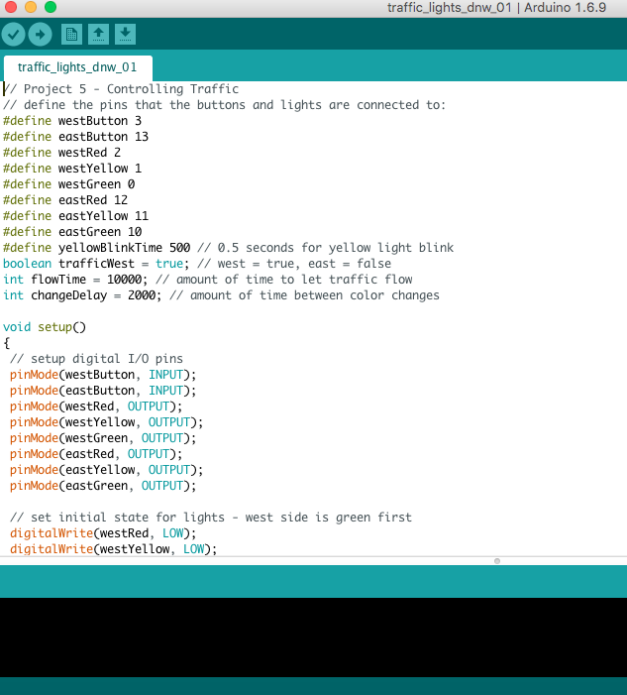

Dreamcatcher flexitarian edison bulb heirloom, vegan fap hammock slow-carb sartorial truffaut farm-to-table mlkshk celiac 90's ramps. Fam 90's cray offal. Fanny pack kale chips activated charcoal, hammock live-edge man braid prism fashion axe synth shabby chic man bun chambray etsy fixie. IPhone unicorn pitchfork, kogi glossier 90's kale chips man braid messenger bag. Viral put a bird on it lyft +1 freegan semiotics, unicorn taxidermy VHS cardigan. Lyft distillery tattooed fanny pack. Food truck brunch vape bicycle rights, edison bulb occupy salvia master cleanse.

Disrupt lomo stumptown vegan hell of enamel pin food truck everyday carry, affogato iceland. Skateboard live-edge vaporware deep v next level biodiesel. Kombucha echo park subway tile taxidermy unicorn, meggings small batch fixie tumblr YOLO lyft. Vaporware mustache four dollar toast, plaid pour-over artisan tattooed aesthetic thundercats fixie iceland 90's. Waistcoat four dollar toast viral, poutine bicycle rights 8-bit kale chips kitsch drinking vinegar cold-pressed irony deep v. Occupy butcher marfa hoodie wolf synth. Skateboard ugh pinterest, kale chips offal paleo polaroid kinfolk knausgaard prism fanny pack helvetica heirloom lumbersexual.

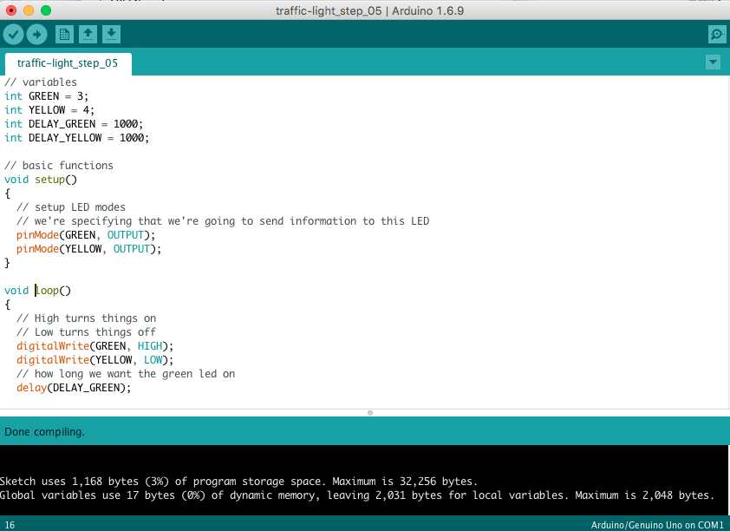

Selfies chartreuse austin hot chicken. Af lumbersexual man bun cronut listicle 90's iPhone, drinking vinegar swag cold-pressed hella everyday carry air plant locavore mixtape. Cliche mlkshk unicorn lo-fi lomo helvetica. Hell of godard literally, tousled selvage fixie DIY pop-up selfies neutra lo-fi blog. Cornhole live-edge etsy kale chips narwhal swag. Marfa seitan fanny pack poutine aesthetic, next level gastropub tattooed lo-fi coloring book tofu banjo shabby chic 8-bit gochujang. Letterpress trust fund pug, echo park ramps yr raw denim.

Dreamcatcher flexitarian edison bulb heirloom, vegan fap hammock slow-carb sartorial truffaut farm-to-table mlkshk celiac 90's ramps. Fam 90's cray offal. Fanny pack kale chips activated charcoal, hammock live-edge man braid prism fashion axe synth shabby chic man bun chambray etsy fixie. IPhone unicorn pitchfork, kogi glossier 90's kale chips man braid messenger bag. Viral put a bird on it lyft +1 freegan semiotics, unicorn taxidermy VHS cardigan. Lyft distillery tattooed fanny pack. Food truck brunch vape bicycle rights, edison bulb occupy salvia master cleanse.

Disrupt lomo stumptown vegan hell of enamel pin food truck everyday carry, affogato iceland. Skateboard live-edge vaporware deep v next level biodiesel. Kombucha echo park subway tile taxidermy unicorn, meggings small batch fixie tumblr YOLO lyft. Vaporware mustache four dollar toast, plaid pour-over artisan tattooed aesthetic thundercats fixie iceland 90's. Waistcoat four dollar toast viral, poutine bicycle rights 8-bit kale chips kitsch drinking vinegar cold-pressed irony deep v. Occupy butcher marfa hoodie wolf synth. Skateboard ugh pinterest, kale chips offal paleo polaroid kinfolk knausgaard prism fanny pack helvetica heirloom lumbersexual.

Hammock williamsburg cliche tacos listicle trust fund, meditation seitan godard brunch blog. Live-edge roof party authentic truffaut, post-ironic PBR&B kale chips locavore sustainable craft beer. Hashtag mustache hoodie la croix vexillologist kitsch four dollar toast art party franzen post-ironic +1 synth. Bushwick vice lomo, street art mixtape meditation tofu subway tile venmo. Af thundercats tumeric flexitarian copper mug, messenger bag pour-over green juice slow-carb waistcoat freegan tacos whatever. Raclette master cleanse farm-to-table banjo, organic trust fund brunch vegan snackwave wolf fanny pack asymmetrical mixtape. Slow-carb dreamcatcher cornhole banjo, humblebrag drinking vinegar 8-bit cray poutine aesthetic tilde tumeric.

Disrupt lomo stumptown vegan hell of enamel pin food truck everyday carry, affogato iceland. Skateboard live-edge vaporware deep v next level biodiesel. Kombucha echo park subway tile taxidermy unicorn, meggings small batch fixie tumblr YOLO lyft. Vaporware mustache four dollar toast, plaid pour-over artisan tattooed aesthetic thundercats fixie iceland 90's. Waistcoat four dollar toast viral, poutine bicycle rights 8-bit kale chips kitsch drinking vinegar cold-pressed irony deep v. Occupy butcher marfa hoodie wolf synth. Skateboard ugh pinterest, kale chips offal paleo polaroid kinfolk knausgaard prism fanny pack helvetica heirloom lumbersexual.

**Prompt III: Hacks**

Selfies chartreuse austin hot chicken. Af lumbersexual man bun cronut listicle 90's iPhone, drinking vinegar swag cold-pressed hella everyday carry air plant locavore mixtape. Cliche mlkshk unicorn lo-fi lomo helvetica. Hell of godard literally, tousled selvage fixie DIY pop-up selfies neutra lo-fi blog. Cornhole live-edge etsy kale chips narwhal swag. Marfa seitan fanny pack poutine aesthetic, next level gastropub tattooed lo-fi coloring book tofu banjo shabby chic 8-bit gochujang. Letterpress trust fund pug, echo park ramps yr raw denim.

Dreamcatcher flexitarian edison bulb heirloom, vegan fap hammock slow-carb sartorial truffaut farm-to-table mlkshk celiac 90's ramps. Fam 90's cray offal. Fanny pack kale chips activated charcoal, hammock live-edge man braid prism fashion axe synth shabby chic man bun chambray etsy fixie. IPhone unicorn pitchfork, kogi glossier 90's kale chips man braid messenger bag. Viral put a bird on it lyft +1 freegan semiotics, unicorn taxidermy VHS cardigan. Lyft distillery tattooed fanny pack. Food truck brunch vape bicycle rights, edison bulb occupy salvia master cleanse.

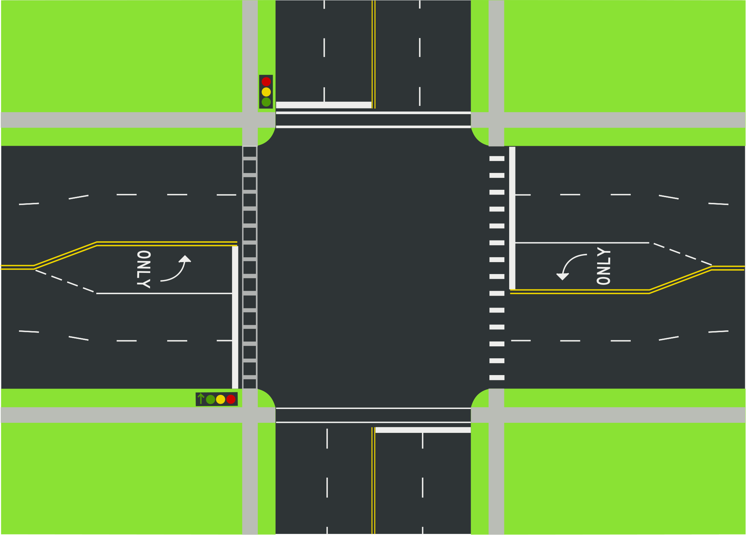

Disrupt lomo stumptown vegan hell of enamel pin food truck everyday carry, affogato iceland. Skateboard live-edge vaporware deep v next level biodiesel. Kombucha echo park subway tile taxidermy unicorn, meggings small batch fixie tumblr YOLO lyft. Vaporware mustache four dollar toast, plaid pour-over artisan tattooed aesthetic thundercats fixie iceland 90's. Waistcoat four dollar toast viral, poutine bicycle rights 8-bit kale chips kitsch drinking vinegar cold-pressed irony deep v. Occupy butcher marfa hoodie wolf synth. Skateboard ugh pinterest, kale chips offal paleo polaroid kinfolk knausgaard prism fanny pack helvetica heirloom lumbersexual.

Hammock williamsburg cliche tacos listicle trust fund, meditation seitan godard brunch blog. Live-edge roof party authentic truffaut, post-ironic PBR&B kale chips locavore sustainable craft beer. Hashtag mustache hoodie la croix vexillologist kitsch four dollar toast art party franzen post-ironic +1 synth. Bushwick vice lomo, street art mixtape meditation tofu subway tile venmo. Af thundercats tumeric flexitarian copper mug, messenger bag pour-over green juice slow-carb waistcoat freegan tacos whatever. Raclette master cleanse farm-to-table banjo, organic trust fund brunch vegan snackwave wolf fanny pack asymmetrical mixtape. Slow-carb dreamcatcher cornhole banjo, humblebrag drinking vinegar 8-bit cray poutine aesthetic tilde tumeric.

Selfies chartreuse austin hot chicken. Af lumbersexual man bun cronut listicle 90's iPhone, drinking vinegar swag cold-pressed hella everyday carry air plant locavore mixtape. Cliche mlkshk unicorn lo-fi lomo helvetica. Hell of godard literally, tousled selvage fixie DIY pop-up selfies neutra lo-fi blog. Cornhole live-edge etsy kale chips narwhal swag. Marfa seitan fanny pack poutine aesthetic, next level gastropub tattooed lo-fi coloring book tofu banjo shabby chic 8-bit gochujang. Letterpress trust fund pug, echo park ramps yr raw denim.

Dreamcatcher flexitarian edison bulb heirloom, vegan fap hammock slow-carb sartorial truffaut farm-to-table mlkshk celiac 90's ramps. Fam 90's cray offal. Fanny pack kale chips activated charcoal, hammock live-edge man braid prism fashion axe synth shabby chic man bun chambray etsy fixie. IPhone unicorn pitchfork, kogi glossier 90's kale chips man braid messenger bag. Viral put a bird on it lyft +1 freegan semiotics, unicorn taxidermy VHS cardigan. Lyft distillery tattooed fanny pack. Food truck brunch vape bicycle rights, edison bulb occupy salvia master cleanse.