FINAL PROJECT = Culminates in a Digital Exhibition of Written Culture of Pompeii in its Spatial and Archaeological Context

                                                How do we get there?

Inspiration = See Pompeii exhibition at Science Museum of VA first week of seminar; explore Digital Work on Pompeii throughout semester (Dr. Damer will present)

[Science Museum Pompeii Exhibit](https://www.smv.org/explore/exhibits/pompeii-the-immortal-city)

Project 1 = Create 10 records (critical editions of texts, with photographs or line drawings where available) to publish on EDR (database management, back end of scholarly database)

Help update design on [AncientGraffiti.org](http://ancientgraffiti.org/)

Project 2 = Use Omeka to house images and descriptions of objects, finds, painting, writing associated with your particular space in Pompeii that you will link to the PMBP.

Final Project =

a) Build .xlsx database housing the ranges you want to pop up as a layer joined onto PMBP.

b) Use [Pompeii Mapping and Bibliography Project](https://www.arcgis.com/apps/webappviewer/index.html?id=084ee7adbe8440078311a48ad12e43cb&extent=1610443.8646%2C4974625.3444%2C1615030.0863%2C4976734.5286%2C102100) on ArcGISOnline

            This Database has open data that we can add to, using Join Features, by building additional layers to interface with the existing richly developed map.

            (this currently features a lot of spatial data, and bibliography. We’ll build links that pop up when you hover over the Pompeii map to our Omeka spaces)

The first image is an example of mapping a particular phenomenon across the site (my example is Women’s Names in Graffiti)

The second image shows how an individual space and its links pop up on PMPB. 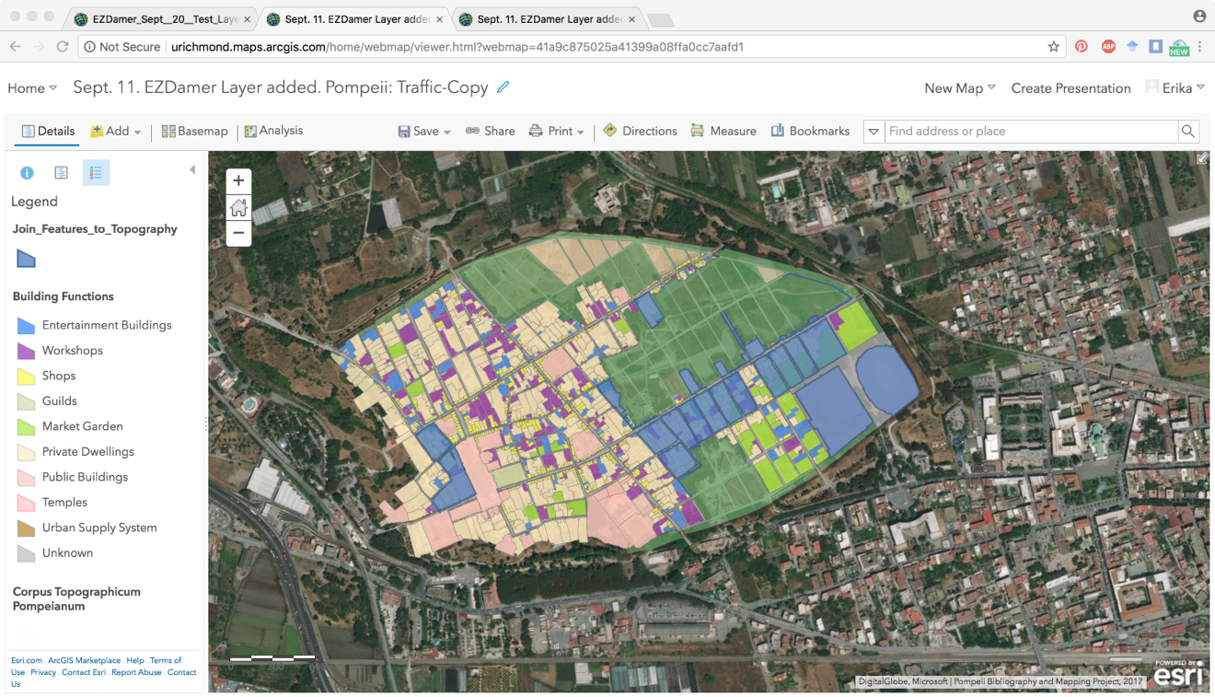

The second image shows how an individual space and its links pop up on PMPB.

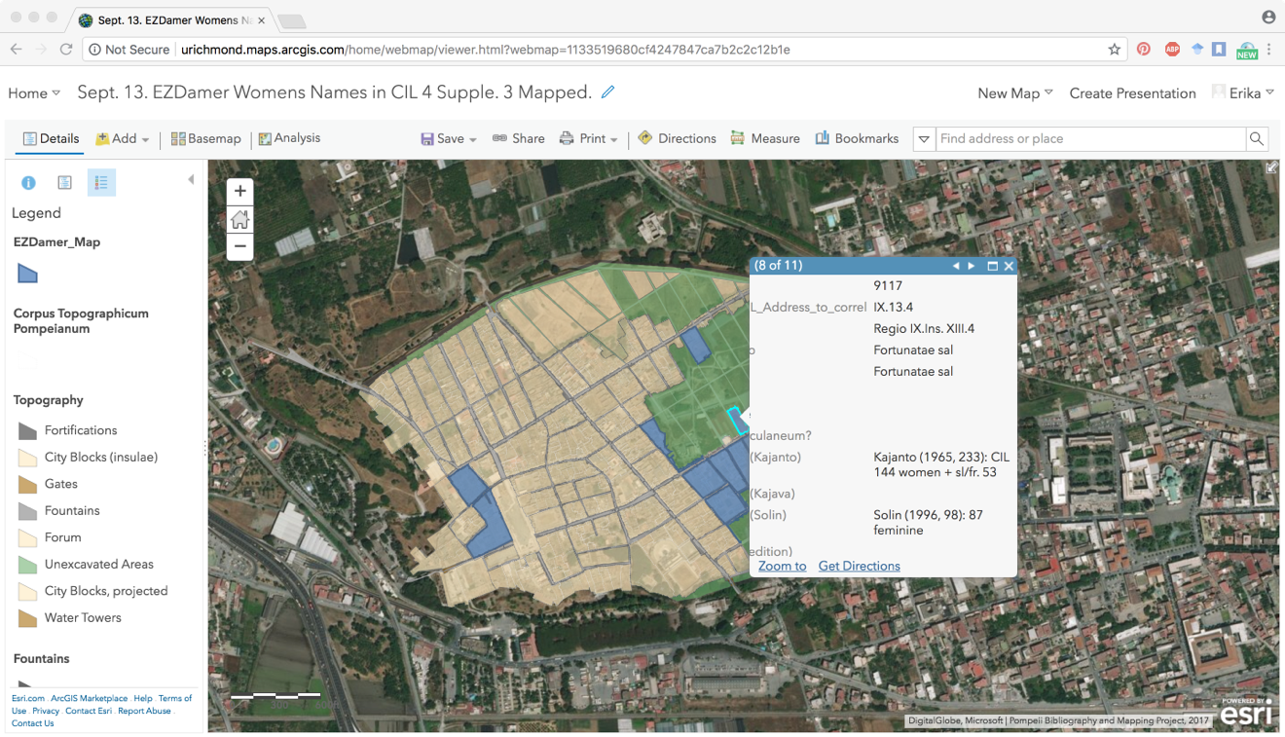

Problems still in designing this work for students:

            1) How to get our maps to stay put on PMBP data

            2) How to make this visually appealing (*i.e.* legible to people not in the seminar)

            3) How to share this work for assessment & how to stage this work so we crash only one stage at a time