Automated Level 4 marking template

## What is this?

The aim is to create a semi-automated way of producing highlighted feedback rubrics for each student. The process is set up to take the results from a spreadsheet and combine them with a template feedback form, producing a pdf document for each student containing a highlighted rubric and their mark.

The Rubric folder contains:

* marks_data.xls – a spreadsheet for the marks
* RubricBlank.docm – a blank template file for the feedback form
* UserGuide.doc – this guide!
* A folder called Feedback where individual student feedback files are saved.

The template will work ‘out of the box’ if you want to try it. Just skip to the To *output the feedback forms* section at the end of this doc.

## How does it work?

It works using the built in MailMerge function in Word. It hijacks the process to add the formatting to the documents and save separate feedback documents.

## Why do it?

The aim is to make generating feedback documentation more efficient. Keeping rubric level marks data as numbers (rather than highlights in a box) also means we can look at the numbers across the cohort and identify specific areas of strength or weakness.

# Setting things up.

It’s recommended that you create a new folder for each assignment.

Copy the whole rubric folder and rename it with the unit name.

Whenever you move or share the rubrics, you should move the whole folder.

## Setting up the mark spreadsheet

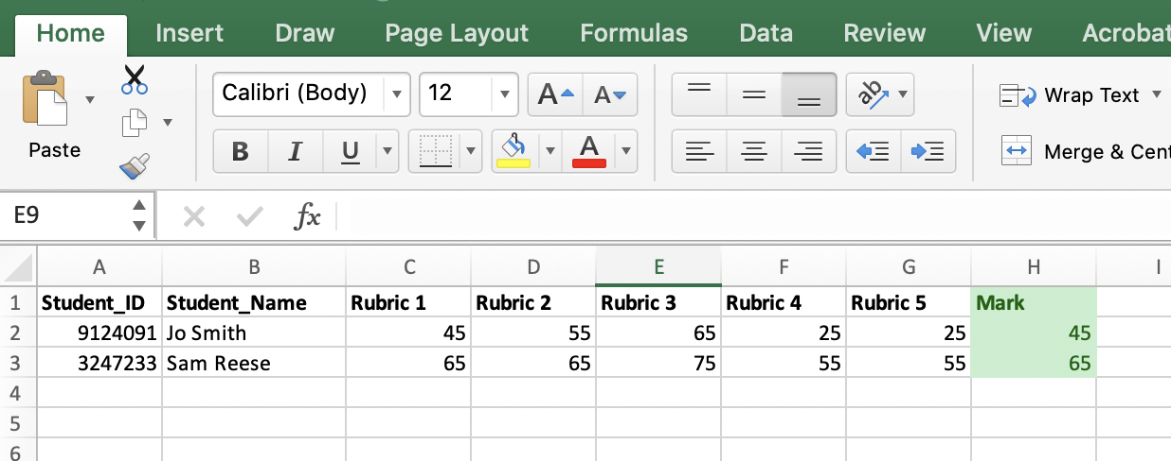

Open marks_data.xls and delete the demo content.

The spreadsheet is based on a rubric with five criteria. You can add or remove criteria by adding or deleting a column. But additional columns should follow the naming convention Rubric <number>

The **Mark** column is calculated by taking the average of the rubrics column and banding it to the nearest ‘5’.

If you do add columns then you may need to adjust the highlighted part of the Marks formula to ensure you include all the columns in the average.

=MROUND((AVERAGE(C2:G2)), 5)

You can also overwrite the marks here by adding a value to the box. This won’t affect the feedback form.

When you make changes to the basic marks sheet you can simply overwrite the file in the folder.

## Setting up the rubric template.

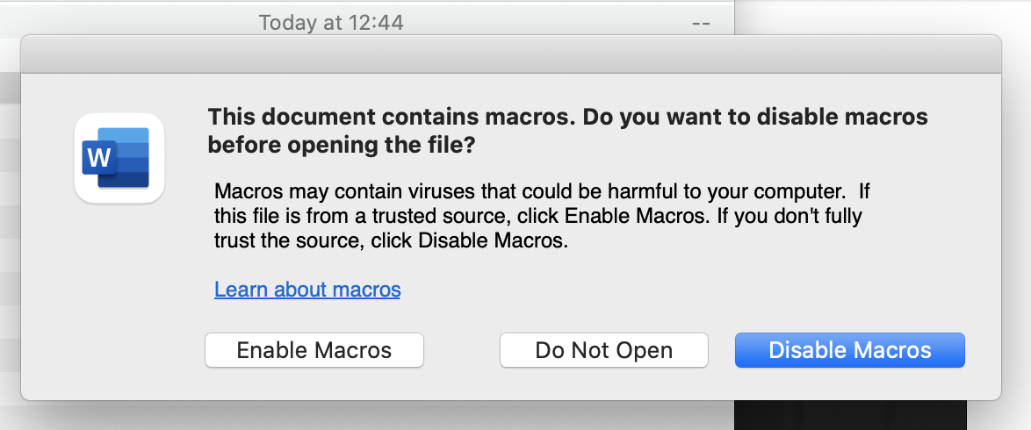Open the word document RubricBlank.docm

You may be prompted to enable Macros. Make sure you select Enable Macros. This allows the extra formatting code to work.

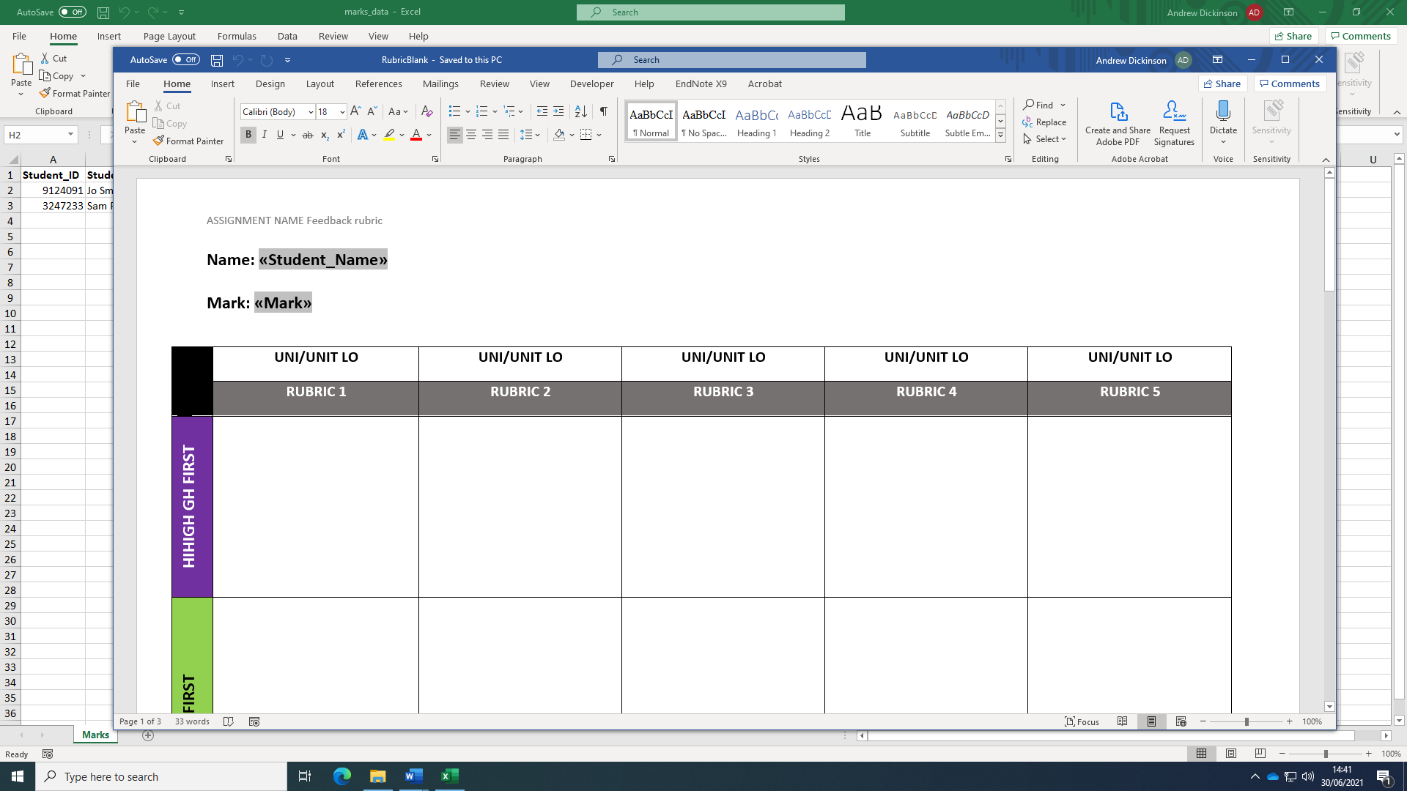

Once loaded you can edit the table cells. You don’t need to edit the name or marks text. These are updated in the individual student documents.

You can also delete the table and add your own if you have one already prepared. However, to work with the automatic features, it needs to follow this basic structure (sorry!)

* The first two rows must be header information
* The actual rubric cells should start at row 3.
* The first column must be grade band labels. Rubric criteria should start at column 2.
* There should be no split or merged cells in the table.

Once you have updated the template, simply save the document overwriting the original.

## Generating feedback

Before generating feedback, you should:

* Check you have all the student marks in the spreadsheet
* Check your template feedback form is complete and correctly formatted.
* Check the number of rubric columns in your spreadsheet matches those in your template feedback form.

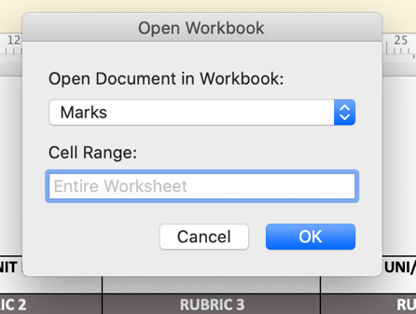Once you’re satisfied you have all the elements you can connect the spreadsheet

* Open the **Mailings** tab
* Click **Select Recipients > Use an existing list**
* Navigate the folder with your updated marks_data.xls file and select it
* Click **OK** if you are prompted on permissions
* Click **OK** on the Open Workbook prompt

You can then check your spreadsheet is connected:

* Select the **Mailings** Tab
* Click the **Preview Results** button. The name and mark should be replaced by the first result in your spreadsheet.

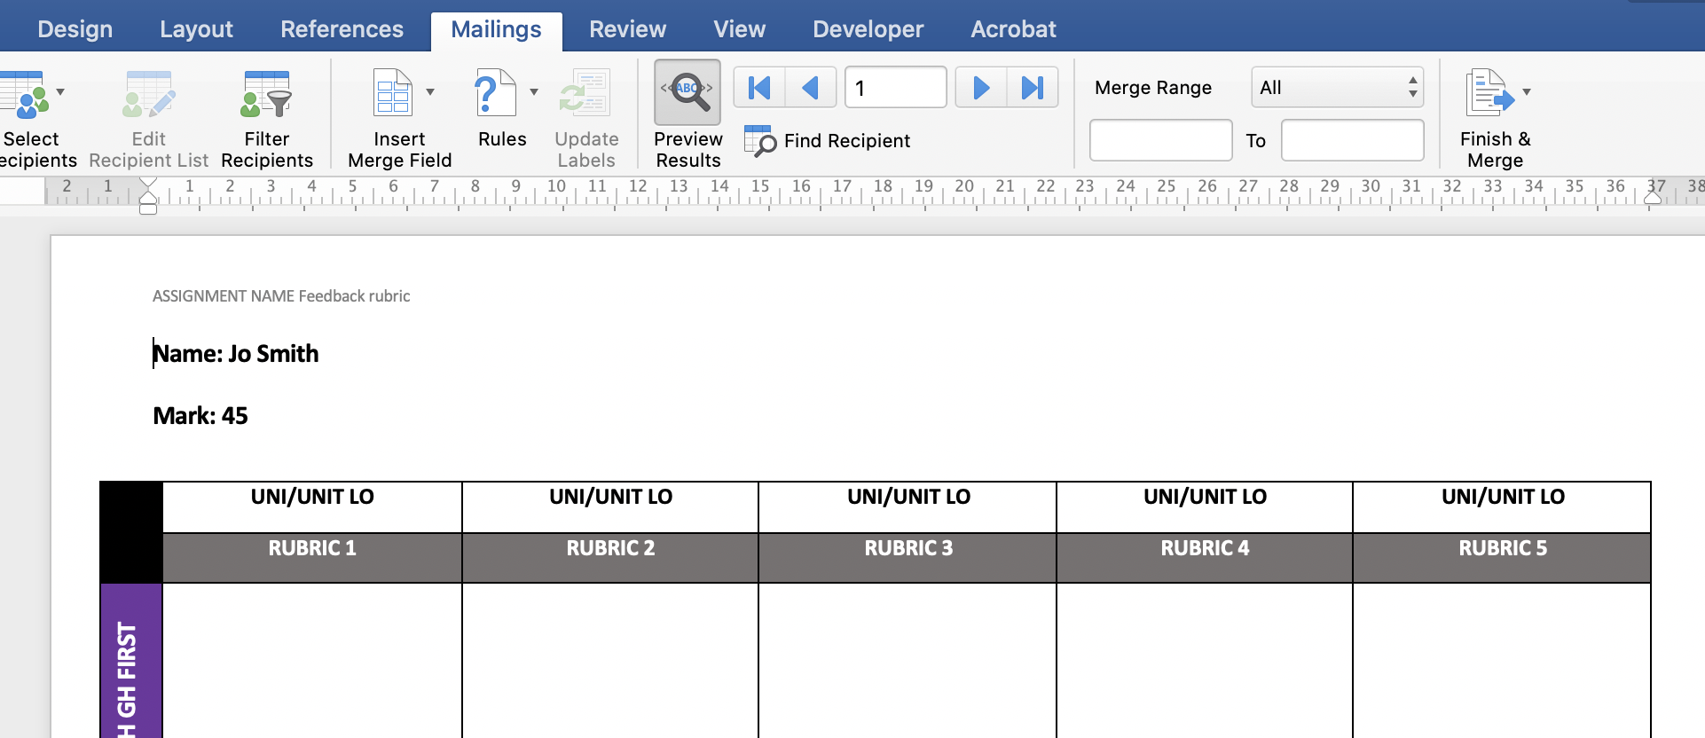

## To output the feedback forms.

* Check the Merge Range is set to All
* Select **Finish and Merge > Edit Individual Documents**
* You may be prompted to give permission to write to the Feedback folder.
  + Click **Select** and then **Grant Access**.

The screen will flash a few times and you should get the following message.

