Automated Level 4 marking template

## What is this?

The aim is to create a semi-automated way of producing highlighted feedback rubrics for each student. The process is set up to take the results from a spreadsheet and combine them with a template feedback form, producing a pdf document for each student containing a highlighted rubric and their mark.

The Rubric folder contains:

* marks_data.xls – a spreadsheet for the marks
* RubricBlank.docm – a blank template file for the feedback form
* UserGuide.doc – this guide!
* A folder called Feedback where individual student feedback files are saved.

The template will work ‘out of the box’ if you want to try it. Just skip to the To *output the feedback forms* section at the end of this doc.

# Setting things up.

It’s recommended that you create a new folder for each assignment.

Copy the whole rubric folder and rename it with the unit name.

Whenever you move or share the rubrics, you should move the whole folder.

## Setting up the mark spreadsheet

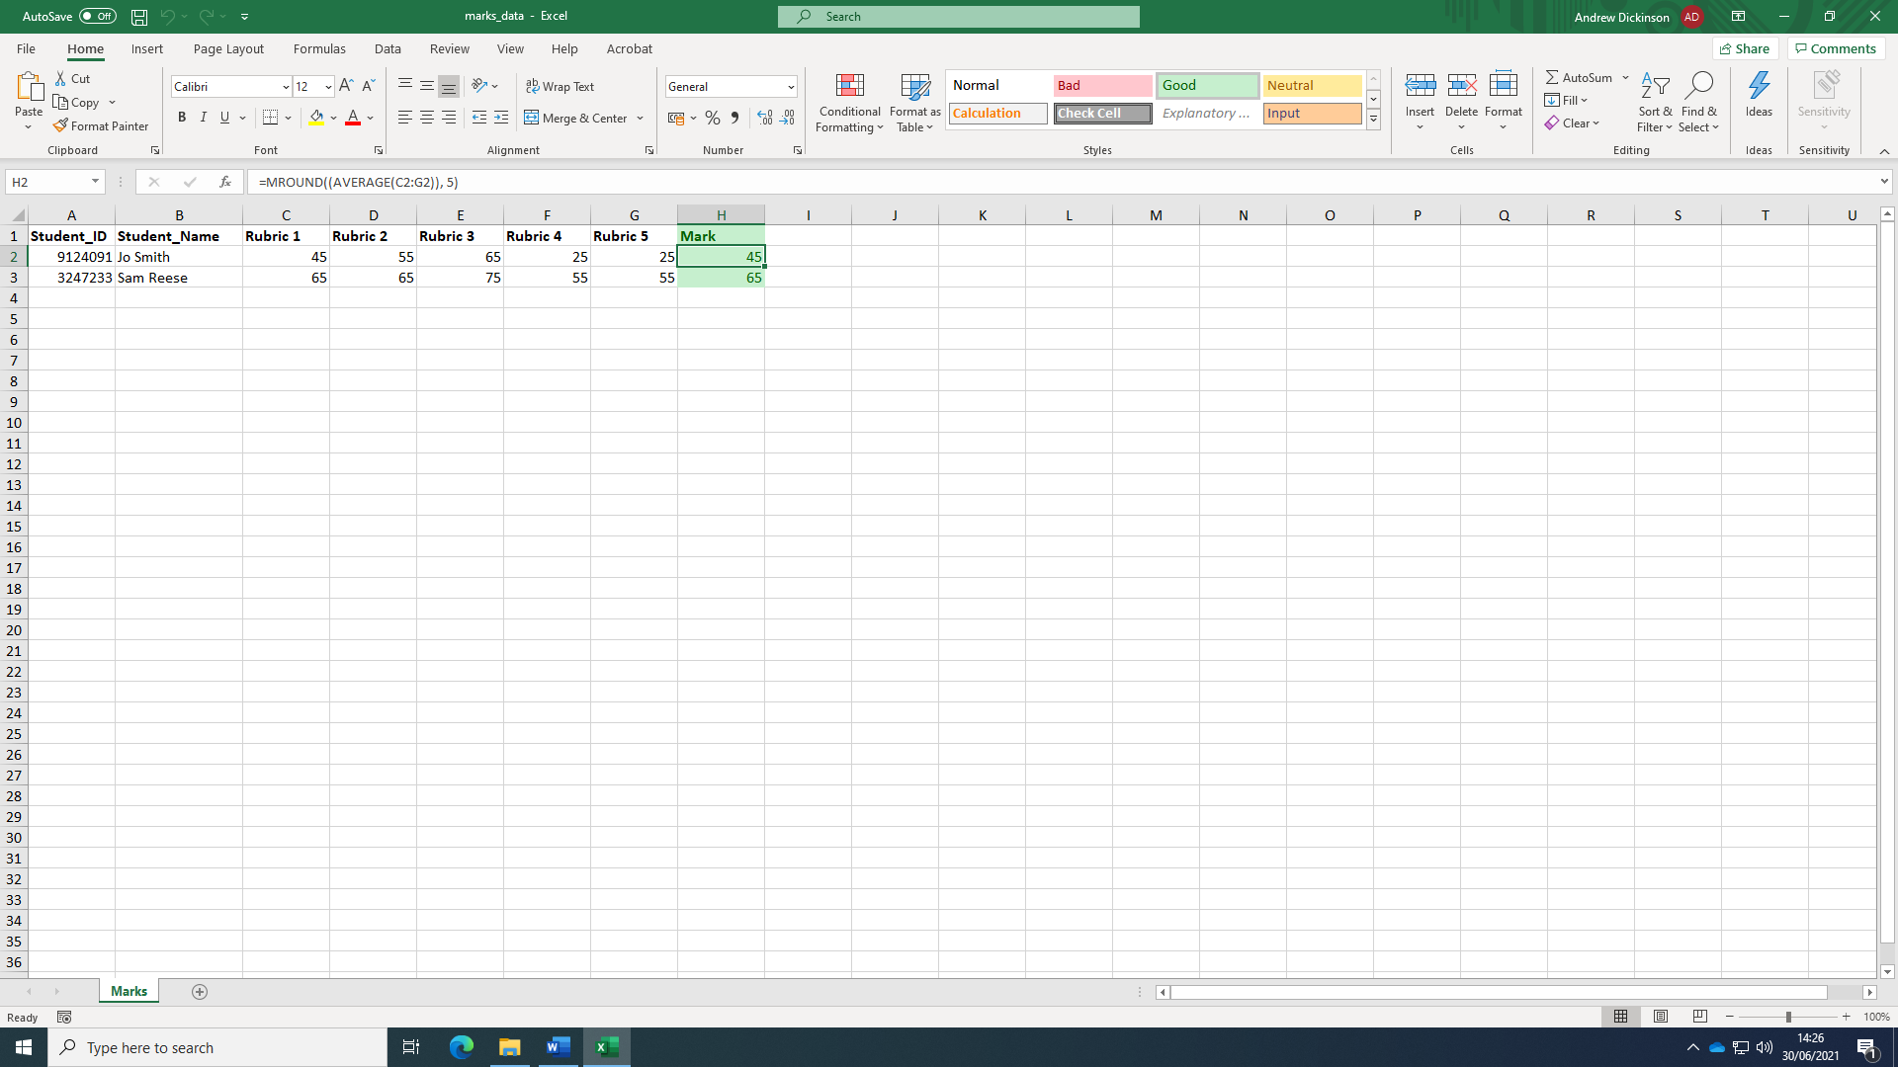

Open marks_data.xls and delete the demo content.

The spreadsheet is based on a rubric with five criteria. You can add or remove criteria by adding or deleting a column. But additional columns should follow the naming convention Rubric <number>

The **Mark** column is calculated by taking the average of the rubrics column and banding it to the nearest ‘5’.

**Important: In line with the mid-point marking at Lvl 4, he rubric is set up to only accept the marks 25, 45, 55, 65, 75 and >75 in the rubric columns. The final mark can be any value.**

If you do add columns, then you may need to adjust the highlighted part of the Marks formula to ensure you include all the columns in the average.

=MROUND((AVERAGE(C2:G2)), 5)

You can also overwrite the overall marks here by adding a value to the box. This won’t affect the feedback form.

When you make changes to the basic marks sheet you can simply overwrite the file in the folder.

## Setting up the rubric template.

Open the word document RubricBlank.docm

You may also be prompted to give permission for developer code to run. This is fine. The document contains extra code to format the rubric. Click **Enable Content**

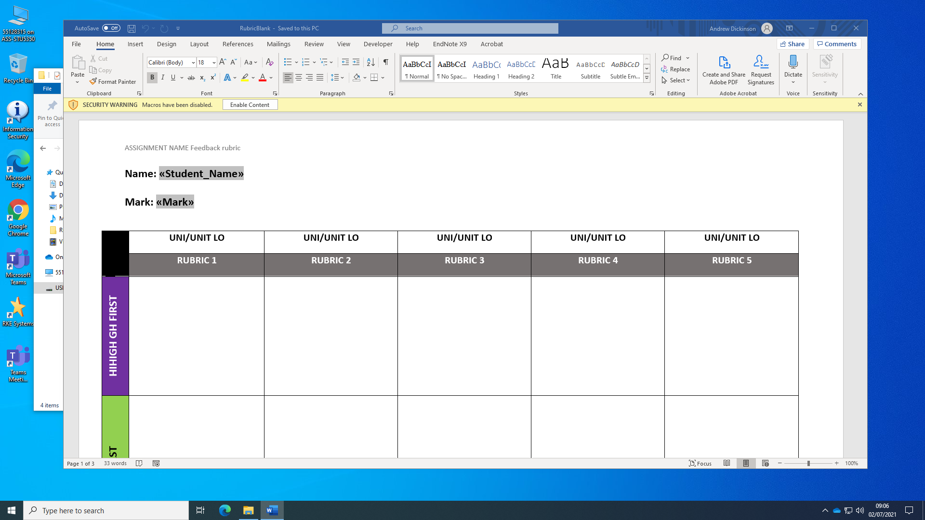

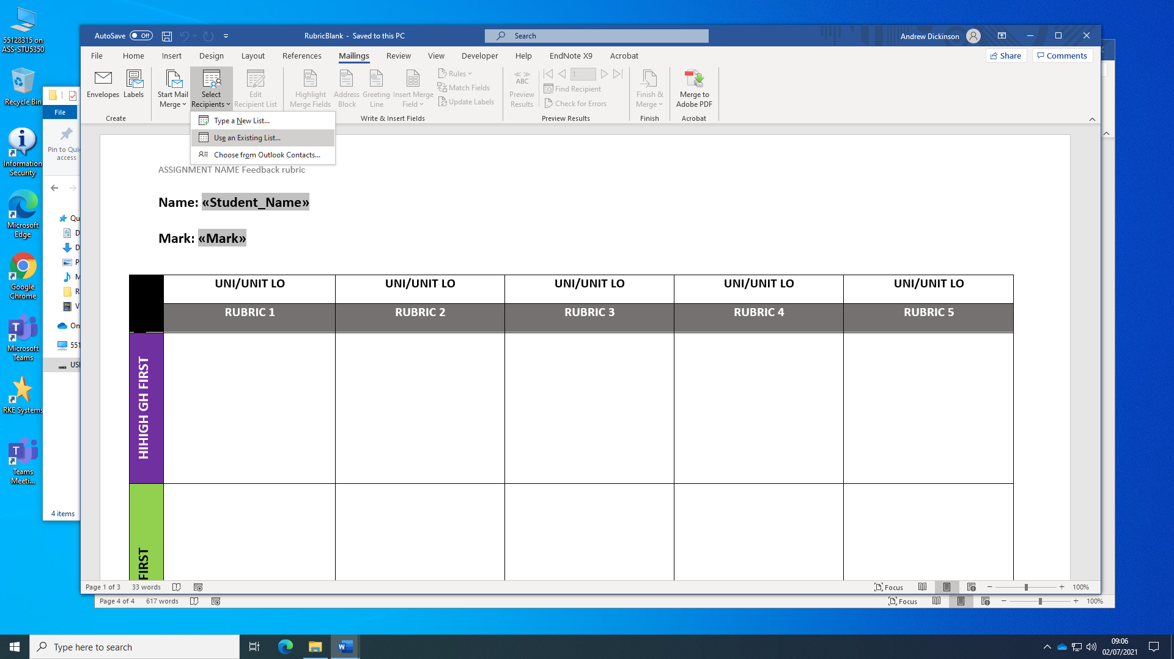Next, we need to connect the spreadsheet to the form.

* Opening the **Mailings** tab
* Click **Select Recipients > Use an existing list**
* Navigate the folder with your updated marks_data.xls file and select it
* 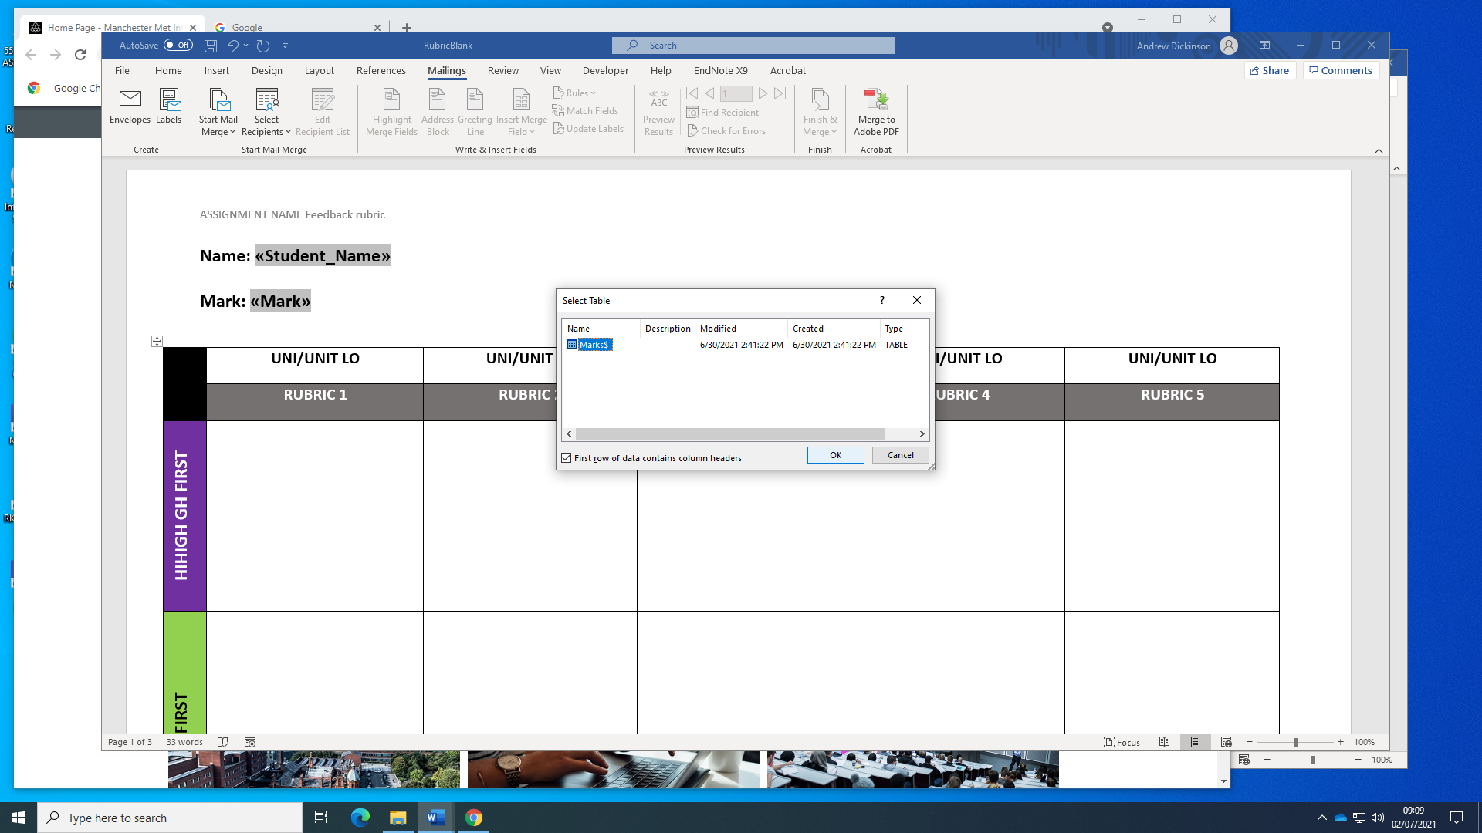Click **OK** when prompted to select a table.

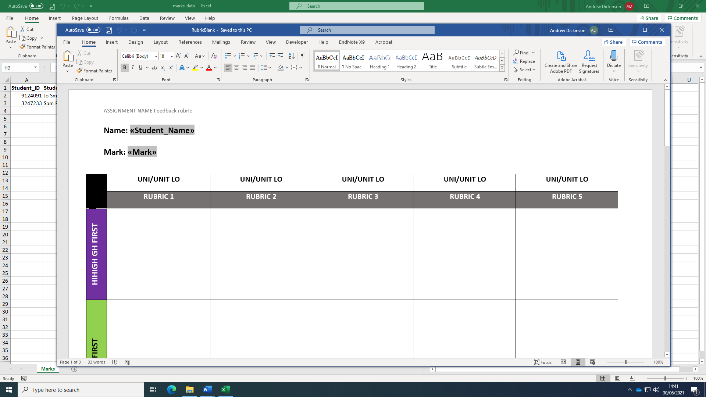

Once loaded you can edit the table cells. You don’t need to change the name or marks text (unless you want to tweak the size or the font!). These are updated in the individual student documents.

You can also add as much extra text or content as you want anywhere in the document. E.g. add a copy of the general feedback points or add the ‘what to do to progress’ information.

You can also delete the table and add your own if you have one already prepared. However, to work with the automatic features, it needs to follow this basic structure (sorry!)

* The first two rows must be header information
* The actual rubric cells should start at row 3.
* The first column must be grade band labels. Rubric criteria should start at column 2.
* There should be no split or merged cells in the table.

Once you have updated the template, simply save the document overwriting the original.

## Generating feedback

Before generating feedback, you should:

* Check you have all the student marks in the spreadsheet
* Check your template feedback form is complete and correctly formatted.
* Check the number of rubric columns in your spreadsheet matches those in your template feedback form and they follow the right format.

Once you’re satisfied you have all the elements

* Check that the spreadsheet is connected by selecting the **Mailings** Tab
* Click the **Preview Results** button. The name and mark should be replaced by the first result in your spreadsheet.

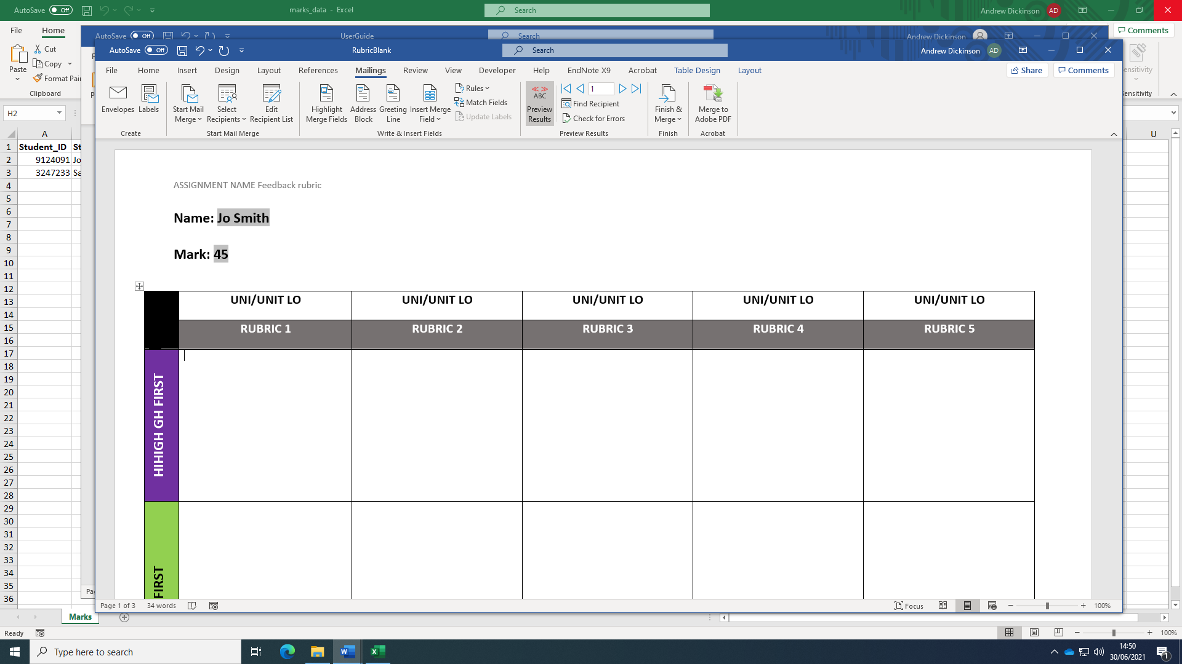

## To output the feedback forms.

Select **Finish and Merge > Edit Individual Documents**

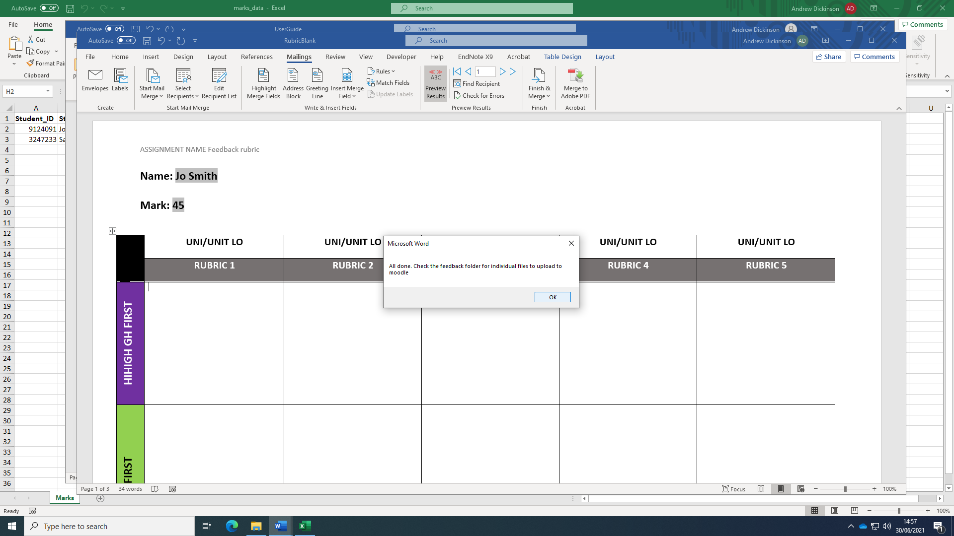The screen will flash a few times and you should get the following message.

Individual feedback forms should be in the Feedback folder with the student’s name as the filename.