USB Type-C Interface
This circuit provides a minimal USB Type-C interface for ESP32-based boards, enabling 5 V power input and USB 2.0 data communication.
USB Power Delivery (USB PD) is not supported. The circuit is designed for use with a standard USB Type-C cable, providing 5 V power and USB-to-Serial connectivity via interfaces such as the CH340.
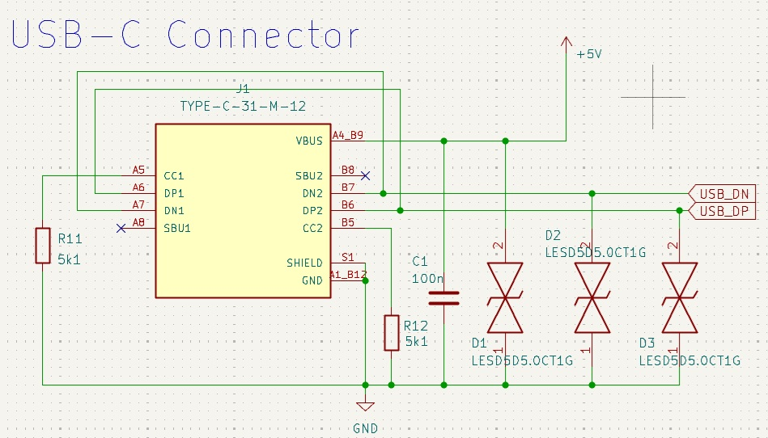

Circuit Overview

1. USB Type-C Connector (J1)
Component
TYPE-C-31-M-12
Why This Component Was Chosen
- Low-cost and widely available USB Type-C connector
- Suitable for most ESP32 boards that use only USB 2.0
- Supports cable insertion in either orientation
- Ideal for simple 5 V devices that do not require USB Power Delivery (PD)
Pins Used
Pin | Function
VBUS | +5 V Input
GND | Ground
DP1 / DP2 | USB D+
DN1 / DN2 | USB D−
CC1 / CC2 | USB Configuration Channel
Shield | Connector Shield

2. CC Resistors (R11, R12)
Component
5.1 kΩ
Why This Component Was Chosen
According to the USB Type-C specification, a power-consuming device (UFP, Upstream Facing Port) must connect a 5.1 kΩ pull-down (Rd) resistor to both the CC1 and CC2 pins.
These resistors allow the USB host to recognize that:
"This is a power-consuming device."
Since the USB Type-C cable can be inserted in either orientation, identical resistors are connected to both CC1 and CC2.
The connections are as follows:
CC1 → 5.1 kΩ → GND
CC2 → 5.1 kΩ → GND

3. USB Data Line Connections
Because USB Type-C supports reversible plug insertion, the connector contains two pairs of USB data pins:
DP1
DP2
DN1
DN2
The circuit connects them as follows:
DP1 + DP2 → USB_DP
DN1 + DN2 → USB_DN
This arrangement ensures that the same USB signals are available regardless of the cable orientation.
It is the most commonly used wiring method for USB 2.0 Type-C interfaces.

4. VBUS
VBUS is the +5 V power supplied by the USB host.
This power is typically connected to:
- 3.3 V regulator
- Battery charging IC
- Power source selection circuit

5. C1 (100 nF)
Component
100 nF Ceramic Capacitor
Why This Component Was Chosen
Placed between VBUS and GND, this capacitor acts as a decoupling capacitor to:
- Filter high-frequency noise
- Reduce transient voltage fluctuations
- Improve power stability during USB connection
For the best performance, this capacitor should be placed as close to the USB connector as possible.

6. ESD Protection (D1, D2, D3)
Component
LESD5D5.0CT1G
Why This Component Was Chosen
Because the USB connector is directly exposed to the outside environment, it is highly susceptible to electrostatic discharge (ESD).
These TVS diodes protect the circuit against:
- IEC 61000-4-2 ESD events
- Transient surges generated during cable insertion
- Static electricity from user contact
In this design, protection is provided for:
- D+
- D−
- VBUS
For maximum effectiveness, the ESD protection devices should be placed as close to the USB connector as possible.

Design Goals
This project was designed as a reusable USB Type-C input circuit that is simple enough for beginners to understand while remaining suitable for use in their own projects.
The following design principles were applied:
- Simplified the circuit by excluding USB Power Delivery (PD)
- Optimized for ESP32 projects that require only USB 2.0
- Supports reversible USB Type-C cable insertion
- Uses standard 5.1 kΩ CC pull-down resistors
- Includes ESD protection circuitry
- Achieves broad compatibility with a minimal number of components
This circuit is a general-purpose USB Type-C interface that can be reused not only with ESP32, but also with most USB 2.0-based microcontroller boards, including STM32, RP2040, AVR, CH340, CP2102, and FT232 platforms.

Regulator
This circuit is a power regulator designed to convert the +5 V supply provided by the USB Type-C connector into the +3.3 V supply required by the ESP32 and its peripheral circuits.
Its simple design follows a standard LDO (Low Dropout Regulator) configuration that is widely used in a variety of electronic projects.
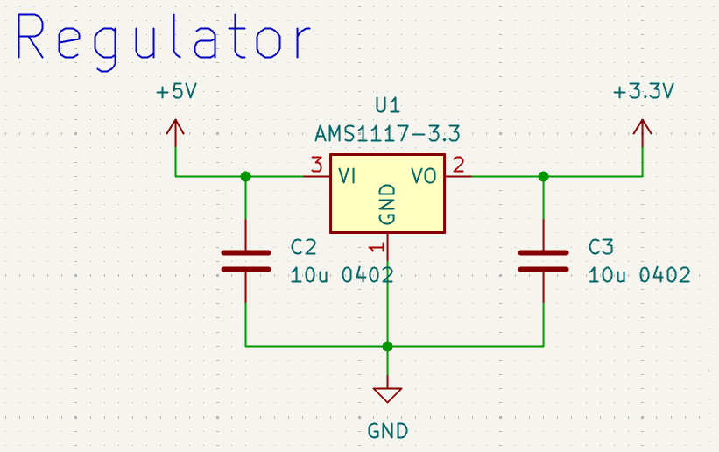

Circuit Overview

1. LDO Regulator (U1)
Component
AMS1117-3.3
Why This Component Was Chosen
The AMS1117-3.3 is one of the most widely used 3.3 V linear regulators (LDOs).
It was selected for the following reasons:
- Very low cost
- Supported by the SMT assembly services of most PCB manufacturers
- Readily available
- Requires only a minimal number of external components
- A proven device widely used on ESP32 development boards
The regulator accepts the USB +5 V supply as its input and provides a stable +3.3 V output.
The pin configuration is as follows.
Pin | Function
VI | +5 V Input
GND | Ground
VO | +3.3 V Output

2. Input Capacitor (C2)
Component
10 μF Ceramic Capacitor (0402)
Why This Component Was Chosen
When a USB cable is connected or the load changes, transient noise and voltage drops may occur on the input supply.
The input capacitor provides the following functions:
- Stabilizes the input voltage
- Supplies transient current during load changes
- Filters high-frequency noise
For best performance, the capacitor should be placed as close as possible to the regulator's input pin.

3. Output Capacitor (C3)
Component
10 μF Ceramic Capacitor (0402)
Why This Component Was Chosen
An output capacitor is essential for the stable operation of the regulator.
Its primary functions are:
- Stabilizes the output voltage
- Improves transient response to load changes
- Reduces output voltage ripple
- Prevents oscillation
The output capacitor should also be placed as close as possible to the regulator's output pin.

Design Considerations When Using the AMS1117
Since the AMS1117 is a linear regulator (LDO), the voltage difference between the input and output is dissipated as heat.
For example:
Input Voltage: 5 V
Output Voltage: 3.3 V
Output Current: 300 mA
The resulting power dissipation is:
P = (5 V − 3.3 V) × 0.3 A = 0.51 W
As the output current increases, heat generation also increases. Therefore, for applications that continuously draw high current, it is recommended to provide sufficient PCB ground copper area to improve heat dissipation.
The AMS1117 performs reliably in most general-purpose ESP32 applications. However, because of its relatively low efficiency, it is not the best choice for battery-powered, low-power devices where maximizing battery life is important.

Design Goals
The objective of this project is to provide a versatile 3.3 V power supply circuit using components that are inexpensive, readily available, and widely proven in a variety of electronic projects.
The following design principles were applied:
- Uses the low-cost and readily available AMS1117 regulator
- Requires only a minimal number of external components
- Converts USB +5 V into a stable +3.3 V supply
- Features a simple circuit that is easy for beginners to understand
- Can be reused in most 3.3 V microcontroller projects, including ESP32, STM32, RP2040, and AVR platforms
For future low-power or battery-operated designs, replacing the AMS1117 with a high-efficiency buck converter or a low quiescent current (Low-IQ) LDO can significantly improve battery life.

Firmware Download
This circuit is designed to download firmware to the ESP32 and provide serial communication using the CH340C USB-to-UART bridge.
It also uses the DTR and RTS control signals to automatically enter Download Mode, allowing firmware to be uploaded directly from the Arduino IDE or ESP-IDF without the need to manually press any buttons.
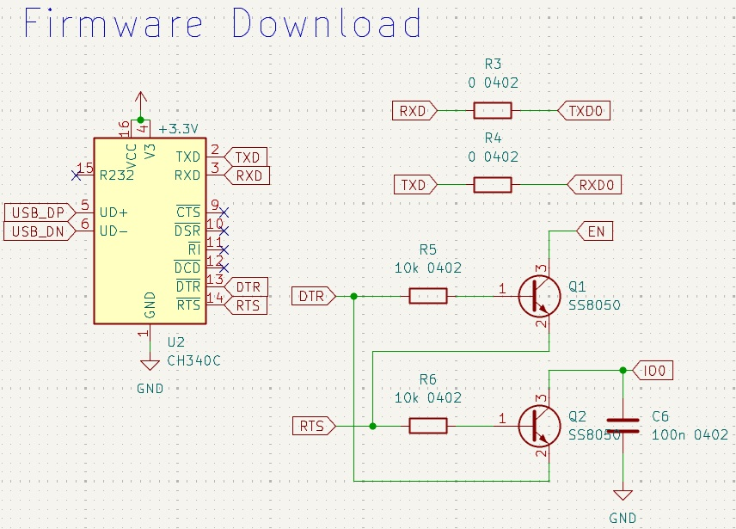

Circuit Overview

1. USB-UART Bridge (U2)
Component
CH340C
Why This Component Was Chosen
The CH340C is one of the most widely used USB-to-UART bridge ICs.
It was selected for the following reasons:
- Very low cost
- Supported by JLCPCB SMT assembly services
- Does not require an external crystal oscillator
- Driver support is available for most operating systems
- One of the most commonly used USB-to-UART ICs on ESP32 development boards
Its primary functions include:
- USB-to-UART conversion
- Firmware download
- Serial Monitor communication
- Automatic reset support

2. UART Signals
The CH340C communicates with the ESP32 through a UART interface.
The connections are as follows:
TXD → ESP32 RXD0
RXD → ESP32 TXD0
ESP32 UART0 is the primary UART used by both the bootloader and the Serial Monitor.

3. 0 Ω Jumper Resistors (R3, R4)
Component
0 Ω Resistor (0402)
Why This Component Was Chosen
0 Ω resistors are inserted in the UART signal lines.
This provides several advantages:
- Simplifies future PCB modifications
- Allows the UART lines to be easily disconnected if necessary
- Makes oscilloscope measurements more convenient
- Simplifies replacement with a different UART device
In production, these resistors simply function as jumpers.

4. Auto Download Circuit
To enter Download Mode, the ESP32 requires the following two pins to be controlled in a specific sequence:
EN
IO0
This circuit uses the CH340C control signals:
DTR
RTS
Two NPN transistors (SS8050) automatically control these signals as follows:
DTR → EN
RTS → IO0
When a firmware download is started from the Arduino IDE or ESP-IDF, the following sequence is performed automatically:
- EN Reset
- IO0 Low
- Enter Download Mode
As a result, there is no need to manually press either the Reset or Boot button.

5. Base Resistors (R5, R6)
Component
10 kΩ (0402)
Why This Component Was Chosen
These resistors limit the base current of the transistors.
Their functions include:
- Limiting base current
- Protecting the CH340C outputs
- Ensuring reliable transistor switching
A value of 10 kΩ is the most commonly used for this application.

6. Auto Reset Transistors (Q1, Q2)
Component
SS8050
Why This Component Was Chosen
The SS8050 is a general-purpose NPN transistor.
It was selected for the following reasons:
- Very low cost
- Readily available
- Adequate switching speed
- Commonly used in ESP32 Auto Download circuits
In this circuit, the transistors function solely as electronic switches.

7. IO0 Capacitor (C6)
Component
100 nF Ceramic Capacitor
Why This Component Was Chosen
This capacitor reduces noise on the IO0 line, making entry into Download Mode more reliable.
It also helps prevent unintended operation caused by transient signal fluctuations.

Design Goals
This project was designed to provide a USB-to-UART download circuit that delivers the same user experience as a typical ESP32 development board.
The following design principles were applied:
- Uses the CH340C, which does not require an external crystal oscillator
- Supports automatic firmware download
- Supports automatic reset
- Requires only a minimal number of external components
- Improves maintainability by including 0 Ω jumpers on the UART lines
- Provides a simple, reusable circuit that is easy for beginners to understand
This circuit can be used almost identically with most ESP32-family MCUs, including the ESP32-WROOM, ESP32-S3, and ESP32-C3. It can also be directly applied to the design of USB-to-UART-based development boards and IoT devices.

Buttons
This circuit provides a Reset button and a User Button for basic control of the ESP32.
Both buttons use an active-low configuration. Under normal conditions, the signals are held at a logic High level by pull-up resistors. When a button is pressed, the corresponding signal is connected to GND, producing a logic Low input.
The circuit also incorporates RC filtering to reduce noise and ensure more stable and reliable button operation.
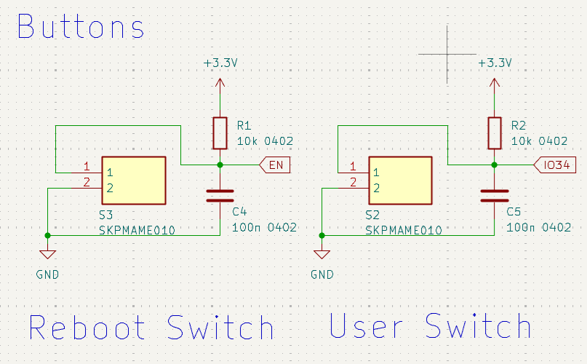

Circuit Overview

1. Reset Button (S3)
Component
SKPMAME010 Tactile Switch
Why This Component Was Chosen
The Reset button directly controls the ESP32 EN (Enable) pin.
When the button is pressed, the EN pin is pulled Low, resetting the ESP32. Releasing the button returns the EN pin to High, allowing the ESP32 to boot normally.
This is the standard reset configuration used on most ESP32 development boards.

2. User Button (S2)
Component
SKPMAME010 Tactile Switch
Why This Component Was Chosen
The User Button is connected to ESP32 GPIO34.
Since GPIO34 is an input-only pin, it is well suited for use as a user input button.
Depending on the application, the button can be assigned to functions such as:
- User input
- Menu selection
- Configuration changes
- Start BLE pairing
- Reset Wi-Fi settings
- Factory reset
- Any other user-defined function
Its function can be freely customized to suit the requirements of the project.

3. Pull-up Resistors (R1, R2)
Component
10 kΩ (0402)
Why This Component Was Chosen
The ESP32 EN and GPIO34 pins must normally remain at a logic High level.
To achieve this, each pin is connected to a 10 kΩ pull-up resistor.
Normal state:
+3.3 V
↓
10 kΩ
↓
GPIO
When the button is pressed:
GPIO
↓
Button
↓
GND
The GPIO is therefore pulled Low.
A value of 10 kΩ is the most commonly used pull-up resistance because it provides an excellent balance between low power consumption and good noise immunity.

4. Noise Filtering Capacitors (C4, C5)
Component
100 nF Ceramic Capacitor
Why This Component Was Chosen
Mechanical push buttons produce contact bounce, where the electrical contacts rapidly make and break connection when the button is pressed or released.
The 100 nF capacitor helps to:
- Reduce button bounce
- Filter transient noise
- Improve reset reliability
- Prevent unintended GPIO triggering
In particular, the capacitor in the reset circuit helps maintain a stable EN signal during power-up.

Button Design Considerations
The ESP32 EN pin is an active-low input.
Pressing the Reset button immediately resets the ESP32, and releasing it allows the device to boot normally.
GPIO34 is also used as an active-low input. Therefore, the firmware typically interprets the button state as follows:
- Button released → Logic High
- Button pressed → Logic Low
To compensate for mechanical switch bounce, it is recommended to implement software debouncing with a delay of approximately 10–30 ms.

Design Goals
This project adopts the same button circuitry found on most ESP32 development boards, making it easy for beginners to understand and reuse in their own designs.
The following design principles were applied:
- Uses a standard active-low button configuration
- Maintains a stable default state with 10 kΩ pull-up resistors
- Reduces noise and switch bounce using 100 nF capacitors
- Implements a standard reset circuit using the ESP32 EN pin
- Provides a general-purpose user input button using GPIO34
- Offers a reusable design suitable for a wide range of ESP32 projects
This circuit can be used not only with the ESP32, but also with most other microcontrollers, including STM32, RP2040, and AVR devices. It serves as a practical, reusable template for implementing both button input and reset circuitry.

LEDs
This circuit provides both a Power LED and a User LED to indicate the operating status of the board.
The Power LED indicates that the board is receiving power correctly, while the User LED can be freely controlled by the firmware to provide visual feedback for various operating states.
Both LEDs are configured as active-low, allowing them to be driven easily by the ESP32.
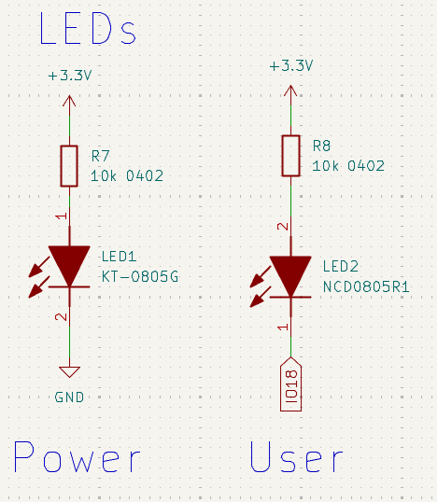

Circuit Overview
- Power LED (LED1)
Component
KT-0805G (Green LED)
Why This Component Was Chosen
The Power LED indicates whether the +3.3 V supply is being delivered to the board correctly.
It remains illuminated whenever power is present and can be used for the following purposes.
• Confirming that power is being supplied
• Checking for power-related faults
• Monitoring the power status during debugging
Because it allows the power status to be checked immediately, it is very useful during development and maintenance.

- User LED (LED2)
Component
NCD0805R1 (Red LED)
Why This Component Was Chosen
The User LED is connected to ESP32 GPIO18 and can be freely controlled by the firmware.
It can be used for the following purposes.
• Indicating that the boot process is complete
• Indicating BLE advertising status
• Indicating Wi-Fi connection status
• Indicating data transmission and reception
• Indicating errors
• Indicating firmware update status
• Indicating user-defined operating states
It can be assigned to various functions depending on the purpose of the project.

- Current-Limiting Resistors (R7, R8)
Component
10 kΩ (0402)
Why This Component Was Chosen
LEDs must always be used with current-limiting resistors.
In this circuit, 10 kΩ resistors are used to significantly reduce the LED brightness.
This value was selected for the following reasons.
• Reduces unnecessary power consumption
• Extends battery operating time
• Reduces glare in indoor environments
• Provides sufficient brightness for status indication
General-purpose development boards commonly use resistor values between 330 Ω and 1 kΩ. However, status LEDs that remain continuously illuminated do not need to be excessively bright.
In battery-powered IoT devices, even a difference of several hundred microamperes can affect battery life over extended periods. Therefore, higher resistance values are used in this design to reduce power consumption.

LED Operation
Power LED
The Power LED is connected between +3.3 V and GND.
It remains illuminated whenever power is supplied.
+3.3 V
↓
R7
↓
LED
↓
GND

User LED
The User LED is connected between +3.3 V and GPIO18.
When GPIO18 is driven Low, current flows through the LED and turns it on.
+3.3 V
↓
R8
↓
LED
↓
GPIO18
↓
GND
Therefore,
GPIO18 = Low → LED ON
GPIO18 = High → LED OFF
The User LED operates in an active-low configuration.
This is one of the most widely used LED connection methods on ESP32 development boards.

Design Goals
This project was designed to provide a status indication circuit suitable for low-power IoT devices.
The following design principles were applied.
• Provides a Power LED for immediate confirmation of the power status
• Provides a general-purpose User LED controlled through a GPIO pin
• Uses high resistor values to minimize power consumption
• Uses an active-low configuration consistent with common ESP32 development boards
• Provides a simple circuit that beginners can easily understand and reuse
This circuit can be used not only with the ESP32, but also with most microcontroller platforms, including STM32, RP2040, and AVR. It is a general-purpose LED circuit suitable for both development boards and battery-powered IoT products.

ESP32-WROOM-32E Module
This circuit implements the minimum system required for an ESP32-WROOM-32E module.
It includes the essential power decoupling circuitry and the basic boot configuration required for reliable operation. In addition, all major ESP32 GPIO pins are brought out to external connectors, making it easy to interface with a wide variety of sensors and peripheral devices.
The design is intended to serve as a general-purpose template that can be used as the starting point for new ESP32-based projects.
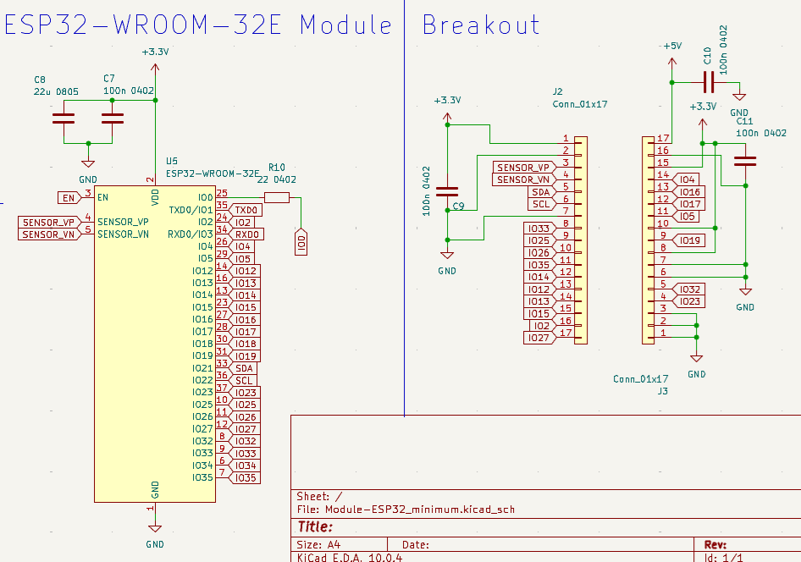

Circuit Overview

1. ESP32-WROOM-32E Module (U5)
Component
ESP32-WROOM-32E
Why This Component Was Chosen
The ESP32-WROOM-32E is Espressif's flagship Wi-Fi and Bluetooth (BLE) module.
It was selected for the following reasons:
- Built-in Wi-Fi and Bluetooth Low Energy (BLE)
- Large number of available GPIO pins
- Supported by both Arduino IDE and ESP-IDF
- Extensive software libraries and example projects
- One of the most widely used ESP32 modules worldwide
- Supported by JLCPCB SMT assembly services
In this project, most of the ESP32 GPIO pins are brought out to external connectors, making the board suitable for a wide variety of applications.

2. Power Decoupling Capacitors (C7, C8)
Components
- C7: 100 nF Ceramic Capacitor (0402)
- C8: 22 μF Ceramic Capacitor (0805)
Why These Components Were Chosen
The ESP32 can draw instantaneous currents of several hundred milliamps during Wi-Fi transmission.
To ensure a stable power supply, two different capacitors are used.
C7 (100 nF)
A high-frequency decoupling capacitor.
Placed close to the ESP32 VDD pins, it suppresses high-frequency switching noise generated inside the module.
C8 (22 μF)
A bulk capacitor that supplies transient current during sudden increases in power demand.
It helps minimize voltage drops during Wi-Fi or Bluetooth transmissions, ensuring stable operation of the ESP32.

3. IO0 Jumper Resistor (R10)
Component
0 Ω Resistor (0402)
Why This Component Was Chosen
IO0 is an important pin that determines the ESP32 boot mode.
Adding a 0 Ω resistor provides several advantages:
- Allows the IO0 circuit to be modified easily
- Simplifies circuit debugging
- Makes it easy to isolate the GPIO function from the boot function when required
- Improves accessibility for measurements and prototyping

Breakout Connectors
Most of the ESP32 GPIO pins are routed to external connectors (J2 and J3), allowing expansion modules and peripheral devices to be connected easily.

4. Breakout Connectors (J2, J3)
Component
Conn_01x17
Why This Component Was Chosen
Most of the ESP32 GPIO pins are brought out to external headers for:
- Sensor connections
- Actuator connections
- Debugging
- Prototyping
- Expansion board connections
This arrangement is particularly convenient when using breadboards or jumper wires during development.

5. Power Pins
The breakout connectors also provide the following power connections.
+5 V
Power supplied directly from the USB connector.
+3.3 V
Regulated power supplied by the onboard voltage regulator.
GND
Multiple ground pins are provided to simplify connections to sensors and peripheral modules.

6. Dedicated I²C Pins
The following pins are assigned as the default I²C interface.
GPIO21 (SDA)
GPIO22 (SCL)
These assignments match the default configuration of the ESP32 Wire library, allowing most I²C sensors to be connected without additional software configuration.

7. ADC Inputs
The following pins are arranged for convenient analog input connections.
SENSOR_VP
SENSOR_VN
GPIO34
GPIO35
These pins are well suited for sensor inputs, analog signal acquisition, and voltage measurement applications.

Power Bypass Capacitors

C9
Component
100 nF Ceramic Capacitor
Placed near the +3.3 V supply on the breakout connector, this capacitor reduces noise that may be introduced by externally connected sensors and peripheral modules.

C10
Component
100 nF Ceramic Capacitor
A bypass capacitor for the +5 V power rail.
It filters high-frequency noise from the USB power supply, providing a cleaner and more stable supply for external devices.

C11
Component
100 nF Ceramic Capacitor
A decoupling capacitor for the +3.3 V supply located on the opposite side of the breakout connectors.
It helps suppress noise generated by externally connected sensors and modules.

Design Considerations When Using the ESP32
Some ESP32 GPIO pins serve special functions during the boot process as boot strapping pins.
Examples include:
- GPIO0
- GPIO2
- GPIO5
- GPIO12
- GPIO15
These pins can affect the boot mode of the ESP32 and should therefore be used with care when connecting external circuitry.
In addition, GPIO34 through GPIO39 are input-only pins, which means they cannot be used to drive output devices such as LEDs or relays.
Considering these GPIO characteristics during the design phase can help prevent unexpected boot issues and hardware conflicts.

Design Goals
This project was designed as a general-purpose minimum system that can serve as the starting point for most ESP32-based IoT and embedded applications.
The following design principles were applied:
- Implements the standard minimum system for the ESP32-WROOM-32E
- Includes a stable power supply suitable for Wi-Fi operation
- Brings all major GPIO pins out to breakout connectors
- Provides convenient access to I²C and ADC pins
- Uses sufficient decoupling capacitors to ensure power stability
- Features a simple, reusable design that is easy for beginners to understand
This circuit serves as a versatile hardware template for a wide range of ESP32-based projects, including IoT devices, sensor nodes, data loggers, environmental monitoring systems, and Bluetooth Low Energy (BLE) applications.

