Process Documentation
Antonio Spajic
WEEK 1
// {"P5LIVE":{"name":"Week 1 ","mod":1779129420662}}

// {"P5LIVE":{"name":"molnar day 3 ","mod":1777467312501}}

let dimX = 453
let dimY = dimX
let num = 17
let reduction = dimX / num
let posX = 0
let posY = 0

function setup() {
createCanvas(windowWidth, windowHeight)
background(255)
rectMode(CENTER)
angleMode(DEGREES)
posX = width / 2
posY = height / 2
}

function draw() {
background(255, 100,50)
noFill()
strokeWeight(3)
stroke(0)
let numX = 27
for(let i = 0; i < numX; i++){
let dimension = width / numX
let posX = dimension / numX + (i * dimension)
for (let j = 0; j < 18; j++){
let posY = dimension / 2 + (j * dimension)
tmcs(posX, posY, 4, dimension, 10)
}
}
// animation!
// calculate the dimension of the square
// based on a sin function

// for

}
// this function draws squares at position
// x and y, and they move randomly
// a tiny bit
function tmcs(x, y, speed, dim, num){

let dimension = dim + sin(frameCount * speed) * 10
// num = 10
let reduction = dimension / num

for(let i = 0; i < num; i++) {
let offsetX = random(7)
let offsetY = random(7)
let col = color (random(255),random(255),random(255))
stroke(col)
strokeWeight(1)
square(
x + offsetX,
y + offsetY,
(dimension) - (reduction * i)
)
}
}
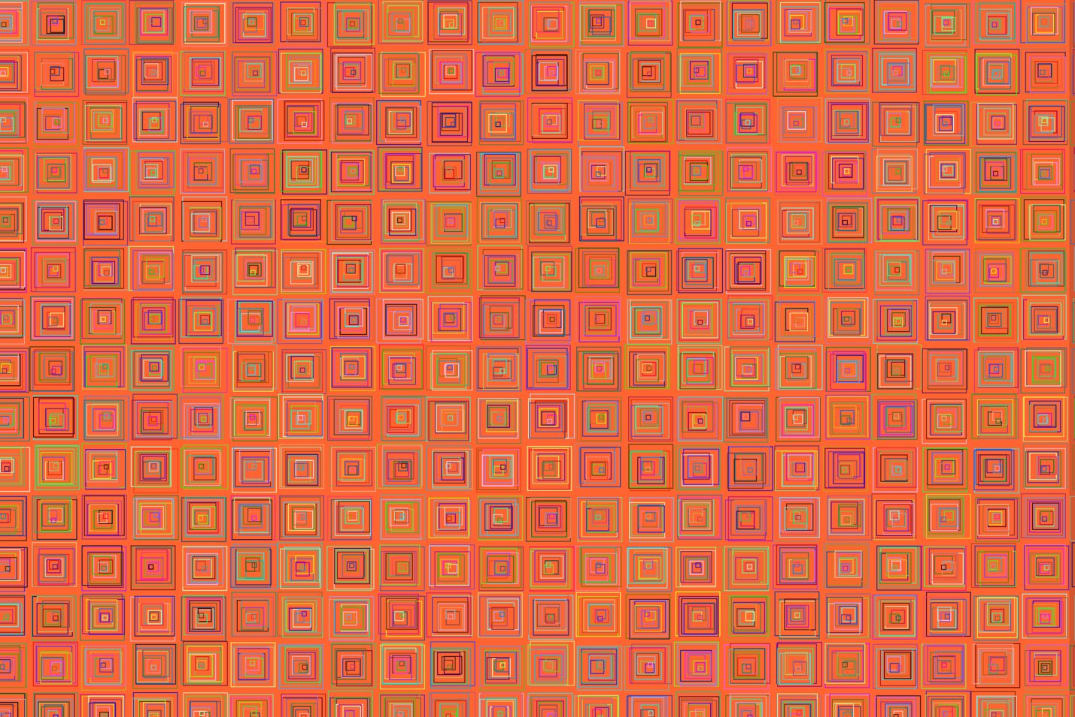
// {"P5LIVE":{"name":"Week 1,2","mod":1779129420662}}

// {"P5LIVE":{"name":"molnar day 3 ","mod":1777468155606}}

let dimX = 453
let dimY = dimX
let num = 17
let reduction = dimX / num
let posX = 0
let posY = 0

function setup() {
createCanvas(windowWidth, windowHeight)
background(255)
rectMode(CENTER)
angleMode(DEGREES)
posX = width / 2
posY = height / 2
}

function draw() {
background(255, 100,50)
noFill()
strokeWeight(3)
stroke(0)
let numX = 27
for(let i = 0; i < numX; i++){
let dimension = width / numX
let posX = dimension / numX + (i * dimension)
for (let j = 0; j < 18; j++){
let posY = dimension / 2 + (j * dimension)
tmcs(posX, posY, 4, dimension, 10)
}
}
// animation!
// calculate the dimension of the square
// based on a sin function

// for

}
// this function draws squares at position
// x and y, and they move randomly
// a tiny bit
function tmcs(x, y, speed, dim, num){

let dimension = dim + sin(frameCount * speed) * 10
// num = 10
let reduction = dimension / num

for(let i = 0; i < num; i++) {

let offsetX = random(7)
let offsetY = random(7)
let col = color (random(255),random(255),random(255))
stroke(col)
strokeWeight(1)
square(
x + offsetX,
y + offsetY,
(dimension) - (reduction * i), 10, 80, 50, 100
)
}
}
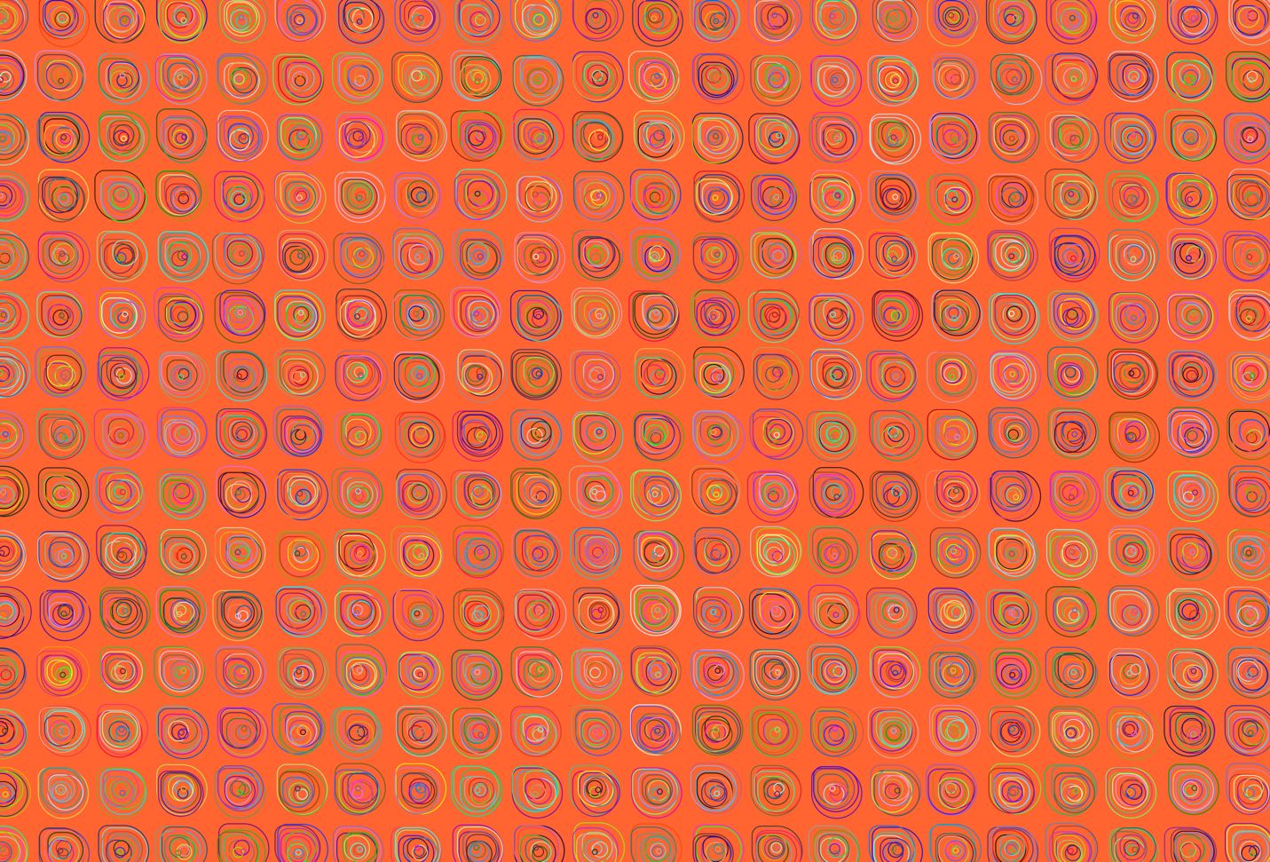
// {"P5LIVE":{"name":"Week 1, 3","mod":1779129420662}}

// {"P5LIVE":{"name":"paint","mod":1777381569164}}

function setup() {
createCanvas(windowWidth, windowHeight)
background(230)
rectMode(CENTER)
}

function draw() {
let dim = 200
let reduction = 10
let posX = 700
let posY = 400

noFill()
strokeWeight(1)
stroke(0)
square(posX, posY, dim)
square(posX, posY, dim - (reduction))
square(posX, posY, dim - (reduction * 1))
square(posX, posY, dim - (reduction * 2))
square(posX, posY, dim - (reduction * 3))
square(posX, posY, dim - (reduction * 4))
square(posX, posY, dim - (reduction * 5))
square(posX, posY, dim - (reduction * 6))

// for loop
for(let i = 0; i < 10; i++) {
square(posX+300, posY, dim - (reduction *i))
}

for (let i = 0; i < 10; i++){
}
}

// {"P5LIVE":{"name":"Week 1, 4","mod":1779129420662}}

// {"P5LIVE":{"name":"paint","mod":1777382157292}}

// let list
let dim = 200
let reduction = 10
let posX = 0
let posY = 0

function setup() {
createCanvas(windowWidth, windowHeight)
background(180)
rectMode(CENTER)
posX = windowWidth / 2
posY = windowHeight / 2
}

function draw() {

noFill()
strokeWeight(1)
stroke(0)
square(posX, posY, dim)
square(posX, posY, dim - (reduction))
square(posX, posY, dim - (reduction * 1))
square(posX, posY, dim - (reduction * 2))
square(posX, posY, dim - (reduction * 3))
square(posX, posY, dim - (reduction * 4))
square(posX, posY, dim - (reduction * 5))
square(posX, posY, dim - (reduction * 6))

// for loop
for(let i = 0; i < 10; i++) {
square(posX+300, posY, dim - (reduction *i))
}
}

// {"P5LIVE":{"name":"Week 1, 5","mod":1779129420662}}

// {"P5LIVE":{"name":"paint","mod":1777384261392}}

// let list
let dim = 200
let num = 10
let reduction = dim / num
let posX = 0
let posY = 0

function setup() {
createCanvas(windowWidth, windowHeight)
background(250,200,250)
rectMode(CENTER)
frameRate(15)
posX = width / 2
posY = height / 2
}

function draw() {
background(250,200,250)
noFill()
strokeWeight(1)
stroke(0)
dim = 100 + (sin(frameCount * 0.1) * 100)
num = 10
reduction = dim / num
// for loop
for(let i = 0; i < num; i++) {
square(posX, posY, dim - (reduction *i))
}
}
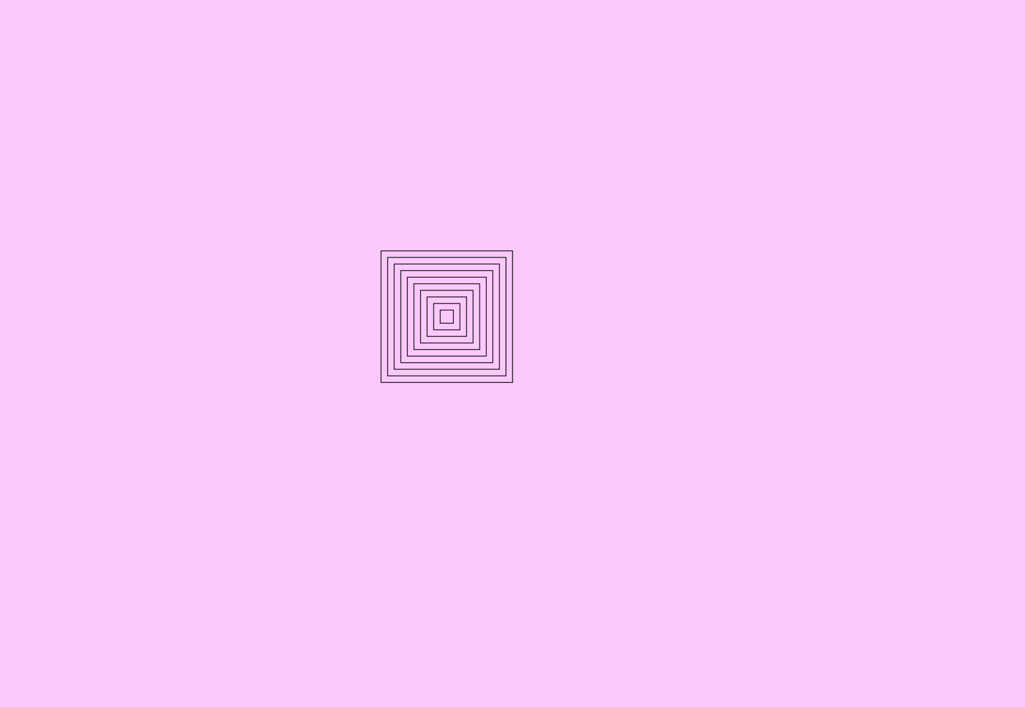
WEEK 2
// {"P5LIVE":{"name":"Week 2, 1","mod":1779129420662}}

// {"P5LIVE":{"name":"_hy5_p5_hydra_001","mod":1778077029543}}

/*
_HY5_p5_hydra // cc teddavis.org 2024
pass p5 into hydra
docs: https://github.com/ffd8/hy5
*/

let libs = ['https://unpkg.com/hydra-synth', 'includes/libs/hydra-synth.js', 'https://cdn.jsdelivr.net/gh/ffd8/hy5@main/hy5.js', 'includes/libs/hy5.js']

// sandbox - start
H.pixelDensity(2) // 2x = retina, set <= 1 if laggy

s0.initP5() // send p5 to hydra
P5.toggle(0) // optionally hide p5
shape(4, 0.5, 0.1)
osc(27).rotate(10)
.kaleid(4).out();
// sandbox - end

function setup() {
createCanvas(windowWidth, windowHeight)
}

function draw() {
// clear()
circle(mouseX, mouseY, 100)
}

// {"P5LIVE":{"name":"Week 2, 2","mod":1779129420662}}

// {"P5LIVE":{"name":"_hy5_p5_hydra_001","mod":1778079238913}}

/*
_HY5_p5_hydra // cc teddavis.org 2024
pass p5 into hydra
docs: https://github.com/ffd8/hy5
*/

let libs = ['https://unpkg.com/hydra-synth', 'includes/libs/hydra-synth.js', 'https://cdn.jsdelivr.net/gh/ffd8/hy5@main/hy5.js', 'includes/libs/hy5.js']

// sandbox - start
H.pixelDensity(2) // 2x = retina, set <= 1 if laggy

s0.initP5() // send p5 to hydra
P5.toggle(0) // optionally hide p5

osc(27, 0.3, 3.9).kaleid(4).out(o0)
noise(2).pixelate(27, 12).out(o1)

render(o0) // show stripes
render(o) // show noise

// sandbox - end

function setup() {
createCanvas(windowWidth, windowHeight)
}

function draw() {
// clear()
circle(mouseX, mouseY, 100)
}
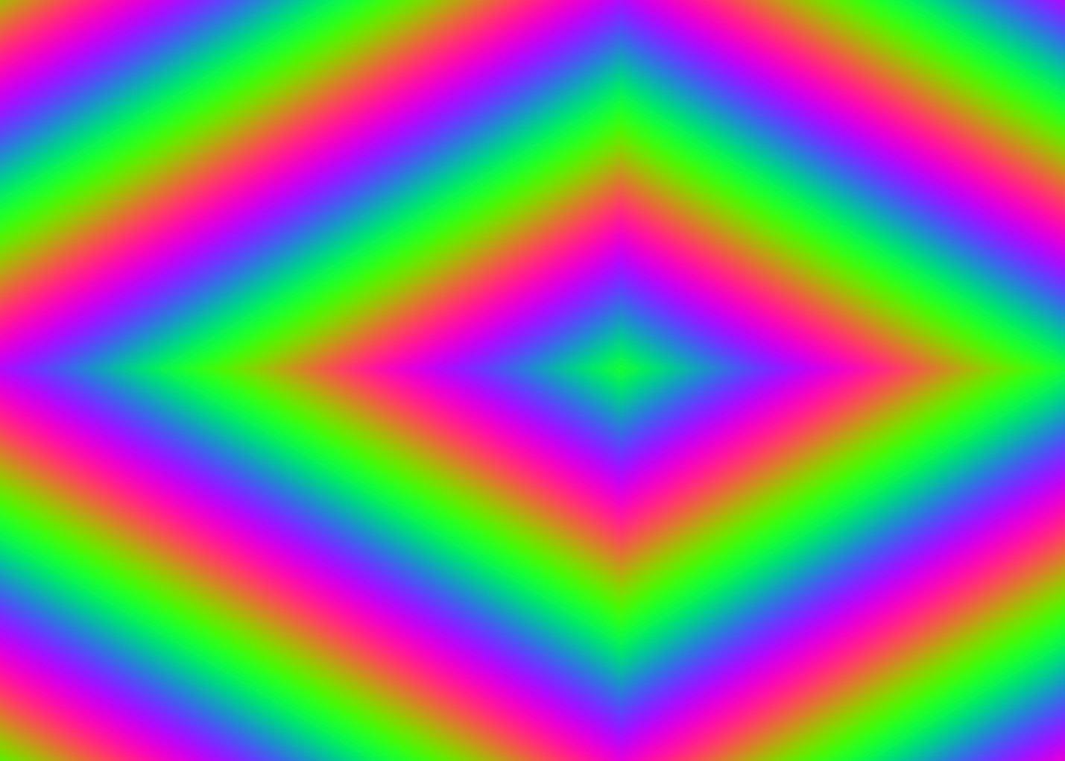
// {"P5LIVE":{"name":"Week 2, 3","mod":1779129420662}}

// {"P5LIVE":{"name":"new_002","mod":1778160653734}}

function setup() {
createCanvas(windowWidth, windowHeight)

}

function draw() {
let live = frameCount%10;
let words = ["creative", "hslu", "coding","antonio", "antonio", "antonio", "antonio", "antonio"]
let rand = random(words)

frameRate(5)
background(230, 50, 300)
fill(10)
textSize(100)
textWrap(WORD)
textFont('american typewriter')
textAlign(CENTER)
textStyle(NORMAL)
textLeading(100)
text(words[live] ,800,400)
windowWidth/1.1, windowHeight;

}
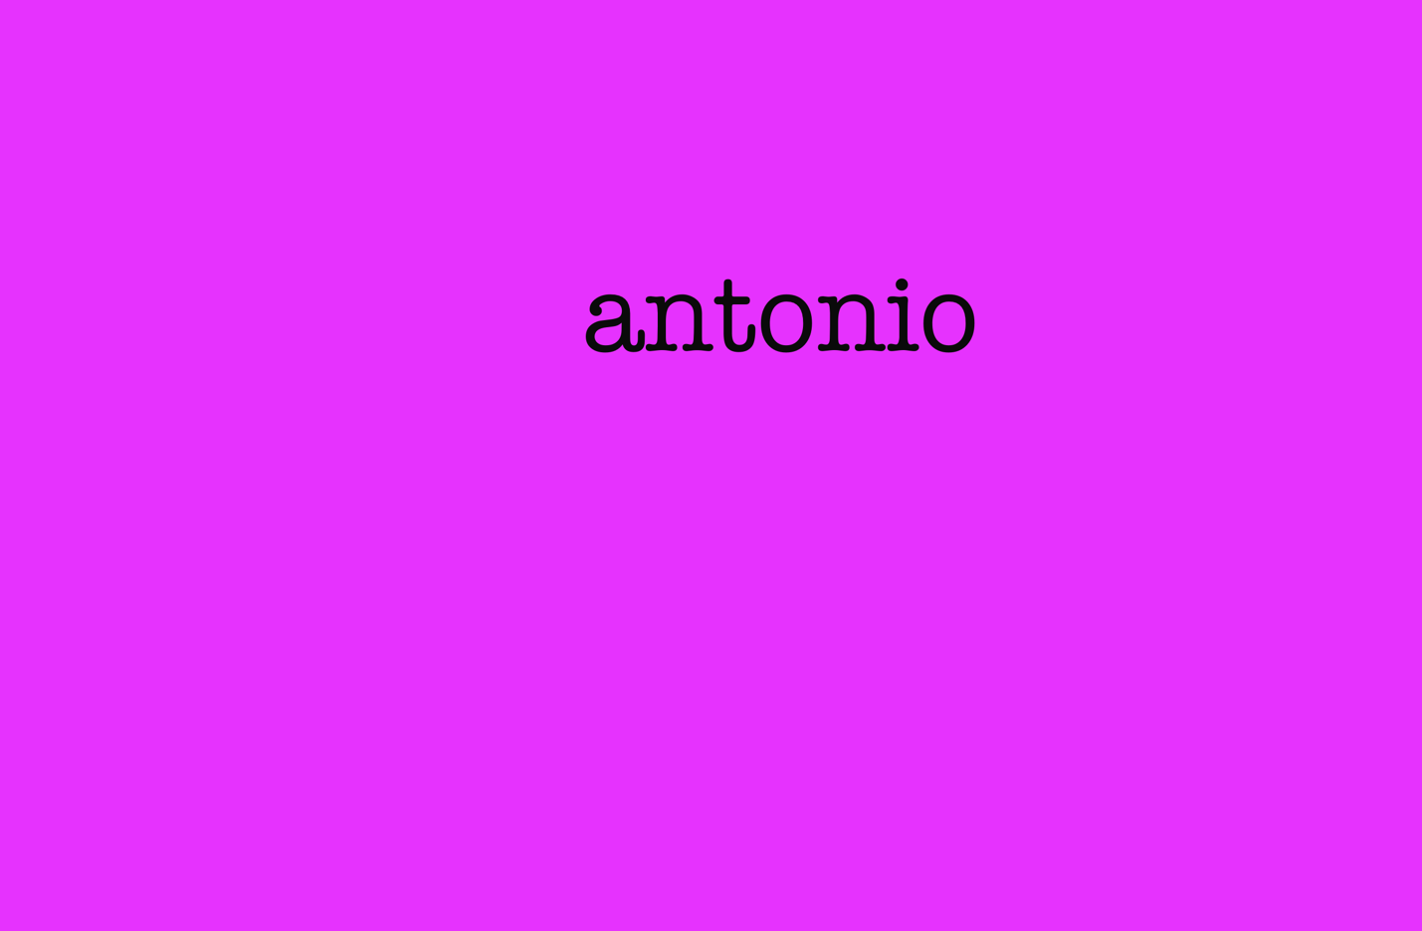
// {"P5LIVE":{"name":"Week 2, 4","mod":1779129420662}}

// {"P5LIVE":{"name":"text","mod":1778153322582}}

function setup() {
createCanvas(windowWidth, windowHeight)

}

function draw() {
background (230);
fill(10);
textSize(100)
textWrap(WORD)
textFont ("american typewriter")
textAlign (CENTER)
textLeading(240)
text("creative coding hslu ", 0, 400, windowWidth, windowHeight)
}
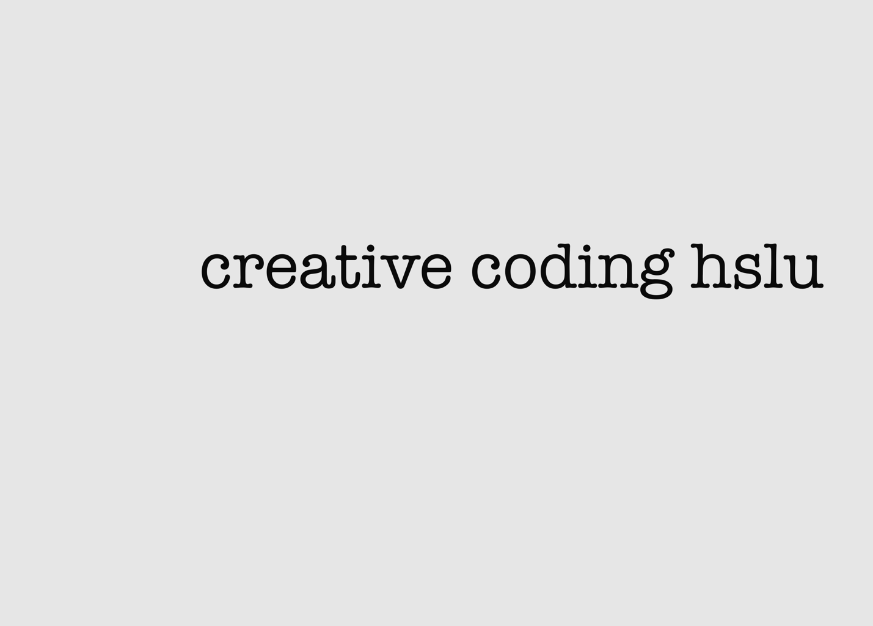
// {"P5LIVE":{"name":"Week 2, 5","mod":"1778584813603"}}

function setup() {
createCanvas(windowWidth, windowHeight);
frameRate(3);
noSmooth();
}

function draw() {
background(10);
fill(mouseX % 255, 80, 80);
let count = frameCount % 20;
let comma = "0";
let space = [""];
let commaline;
let size = 50;
textSize(windowWidth / 50);
textFont("monospace");
textWrap(CHAR);
for (let i = 0; i < 20; i++) {
space.push("11");
comma = comma + space[i];
commaline = comma.repeat(count + 1 + 33);
text(commaline, 10, commaline.length, windowWidth, windowHeight);
}
}
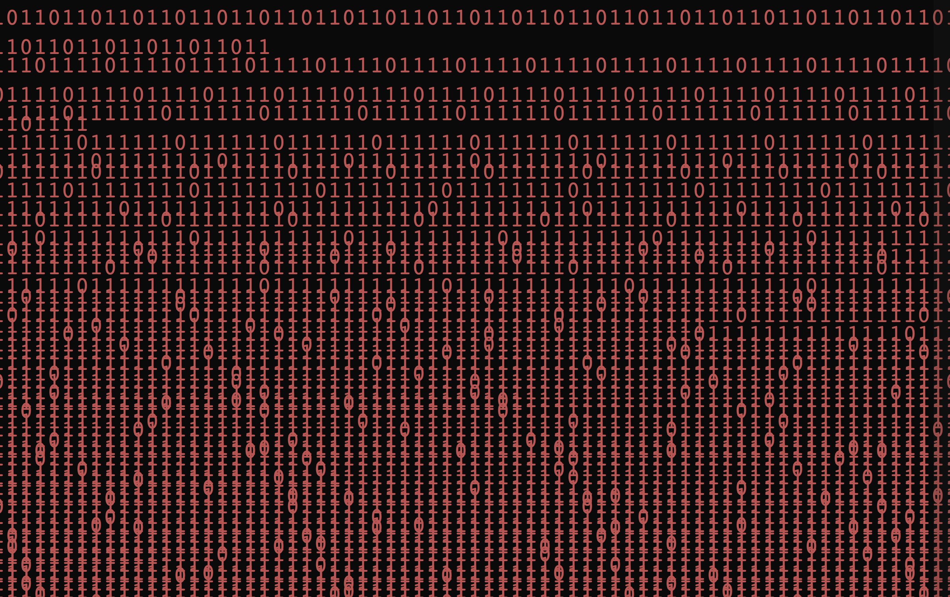
// {"P5LIVE":{"name":"Week 2, 6","mod":"1778666584824"}}

let libs = ['https://unpkg.com/ml5@1/dist/ml5.min.js'];
let video, handPose, hands = [];

function preload() {
handPose = ml5.handPose({ maxHands: 1, flipHorizontal: true });
}

function setup() {
createCanvas(windowWidth, windowHeight);
video = createCapture(VIDEO, { flipped: true });
video.size(width, height);
video.hide();
handPose.detectStart(video, r => hands = r);
}

function draw() {
frameRate(5);
background(200);

let leading = 32;
let r = 0, g = 100, b = 255;

if (hands.length > 0) {
let tip = hands[0].keypoints[8];
leading = map(tip.y, 0, height, 100, 5);
r = map(tip.x, 0, width, 0, 255);
b = map(tip.x, 0, width, 255, 0);
}

fill(r, g, b);
textSize(100);
textWrap(CHAR);
textFont('monospace');
textAlign(LEFT);
textStyle(ITALIC);
textLeading(leading);
text("cretaive coding hslu".repeat(100), 10, 10, windowWidth / 1.1, windowHeight);
}
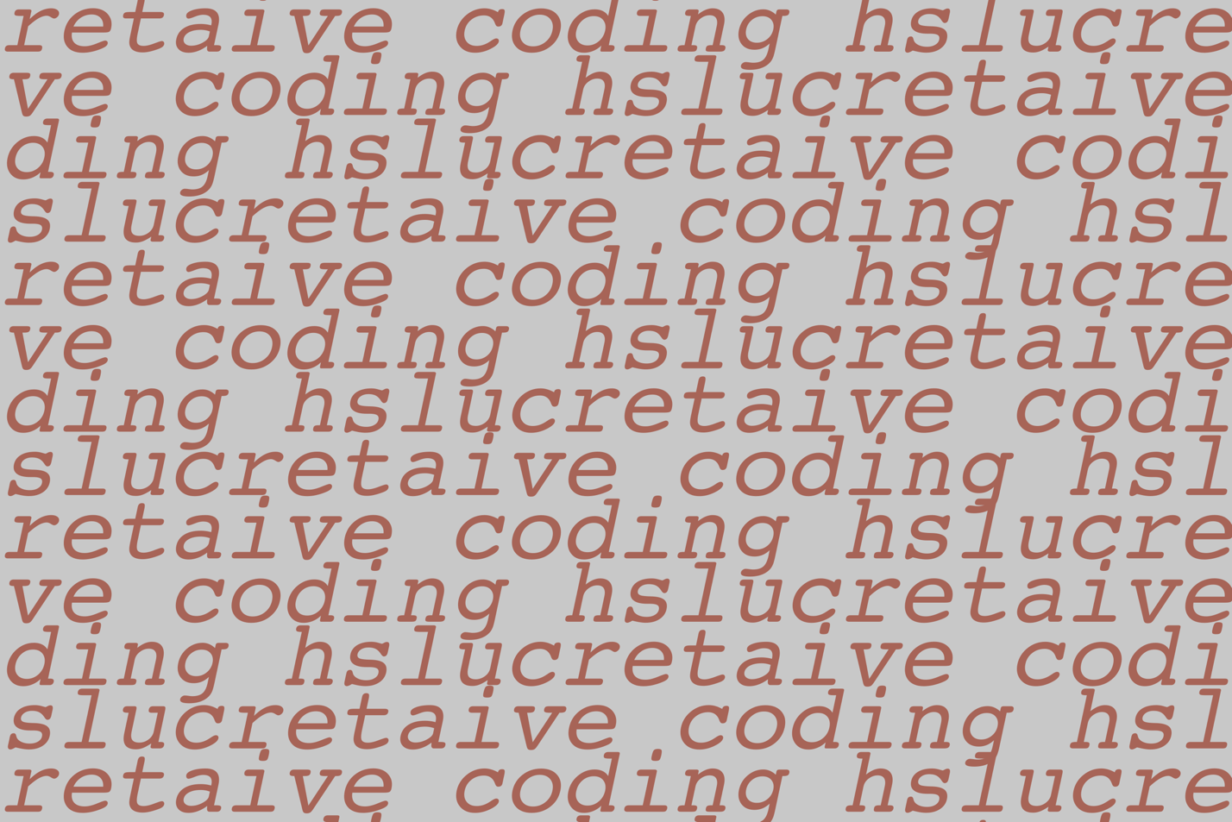
// {"P5LIVE":{"name":"Week 2, 7 ","mod":"1778584964583"}}

function setup() {
createCanvas(windowWidth, windowHeight);
frameRate(10);
textFont("monospace");
textSize(18);
}
function draw() {
background(10);
let line = "10".repeat(80);
for (let i = 0; i < 30; i++) {
let y = (frameCount * 4 + i * 30) % height;
if ((i + floor(frameCount / 5)) % 2 === 0) {
fill(0, 220, 80); // green
} else {
fill(220, 40, 40); // red
}
text(line, 0, y);
}
}
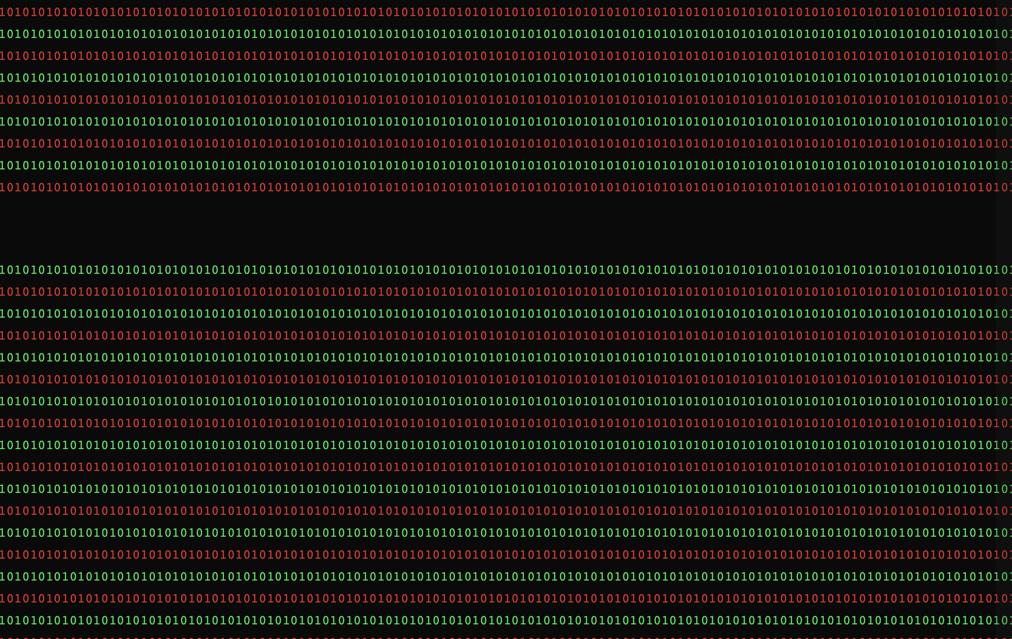
// {"P5LIVE":{"name":"Week 2, 8","mod":"1779129420662"}}

function setup() {
createCanvas(windowWidth, windowHeight);
background(200);
stroke(0);
}

function draw() {

let pen1 = map(sin(frameCount*0.025),-1,1,2,100)
if (mouseIsPressed) {
stroke(0);
strokeWeight(pen1);
line(prevX, prevY, mouseX, mouseY);
// ellipse(mouseX,mouseY, pen1, pen1)
}
prevX = mouseX;
prevY = mouseY;
}

function keyPressed(){
if(key == 'S'){
save('drawing.png')
}
}

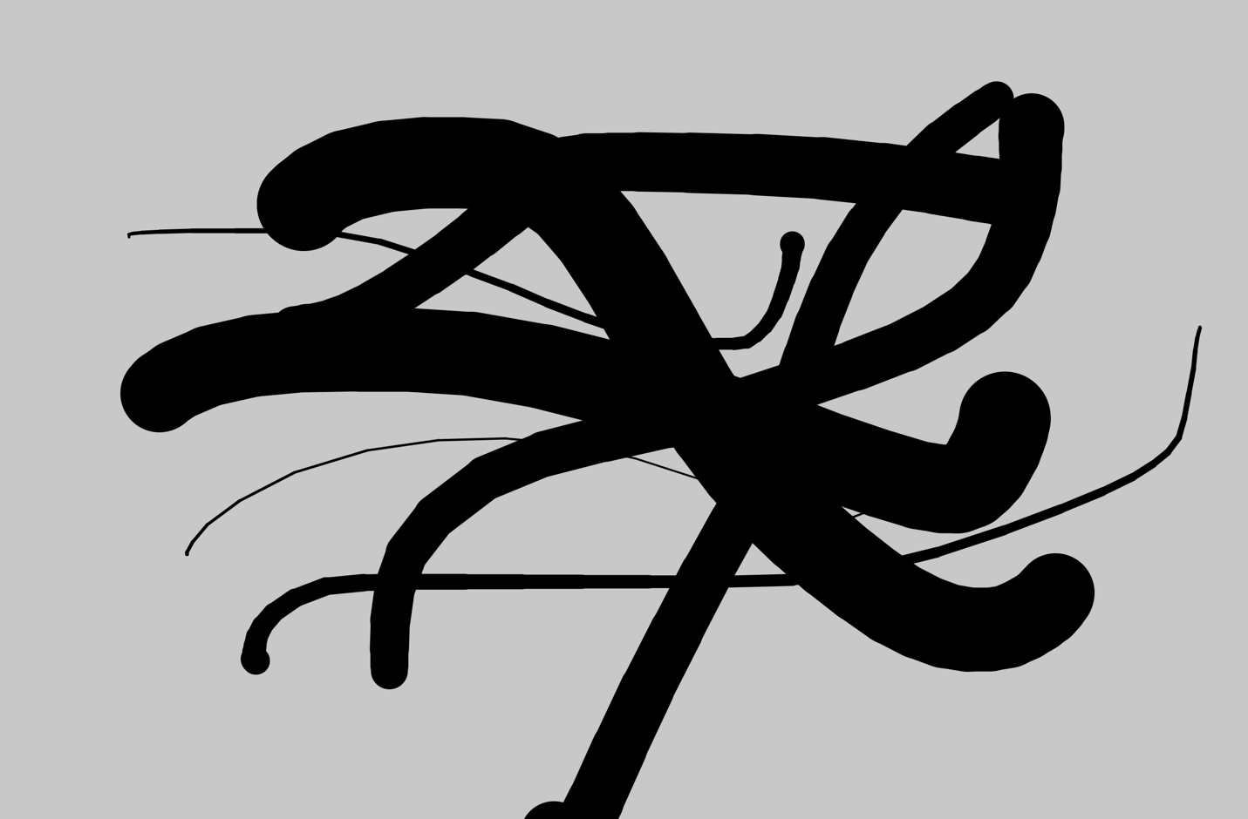
// {"P5LIVE":{"name":"Week 2, 9","mod":"1779129420662"}}

let libs = ['https://unpkg.com/ml5@1/dist/ml5.min.js'];

let video;
let state = 'starting...';
let handPose;
let hands = [];
let options = { maxHands: 2, flipHorizontal: true };
let pScale = 20

function preload() {
handPose = ml5.handPose(options);
}

function setup() {
createCanvas(windowWidth, windowHeight);

video = createCapture(VIDEO, { flipped: true });
video.size(width, height);
video.hide();

handPose.detectStart(video, gotHands);
state = 'detecting hands';
}

function draw() {
background(20, 100);

for (let i = 0; i < hands.length; i++) {
const hand = hands[i];
for (let j = 0; j < hand.keypoints.length; j++) {
const kp = hand.keypoints[j];
const x = kp.x;
const y = kp.y;
fill(map(j, 0, hand.keypoints.length, 0, 255), 255, map(j, 0, hand.keypoints.length, 255, 0));
noStroke();
circle(x, y, pScale * sin(frameCount * 0.1 + j) % pScale);
}
}

noStroke();
fill(255);
text(state, 10, height - 10);
}

function gotHands(results) {
hands = results;
}
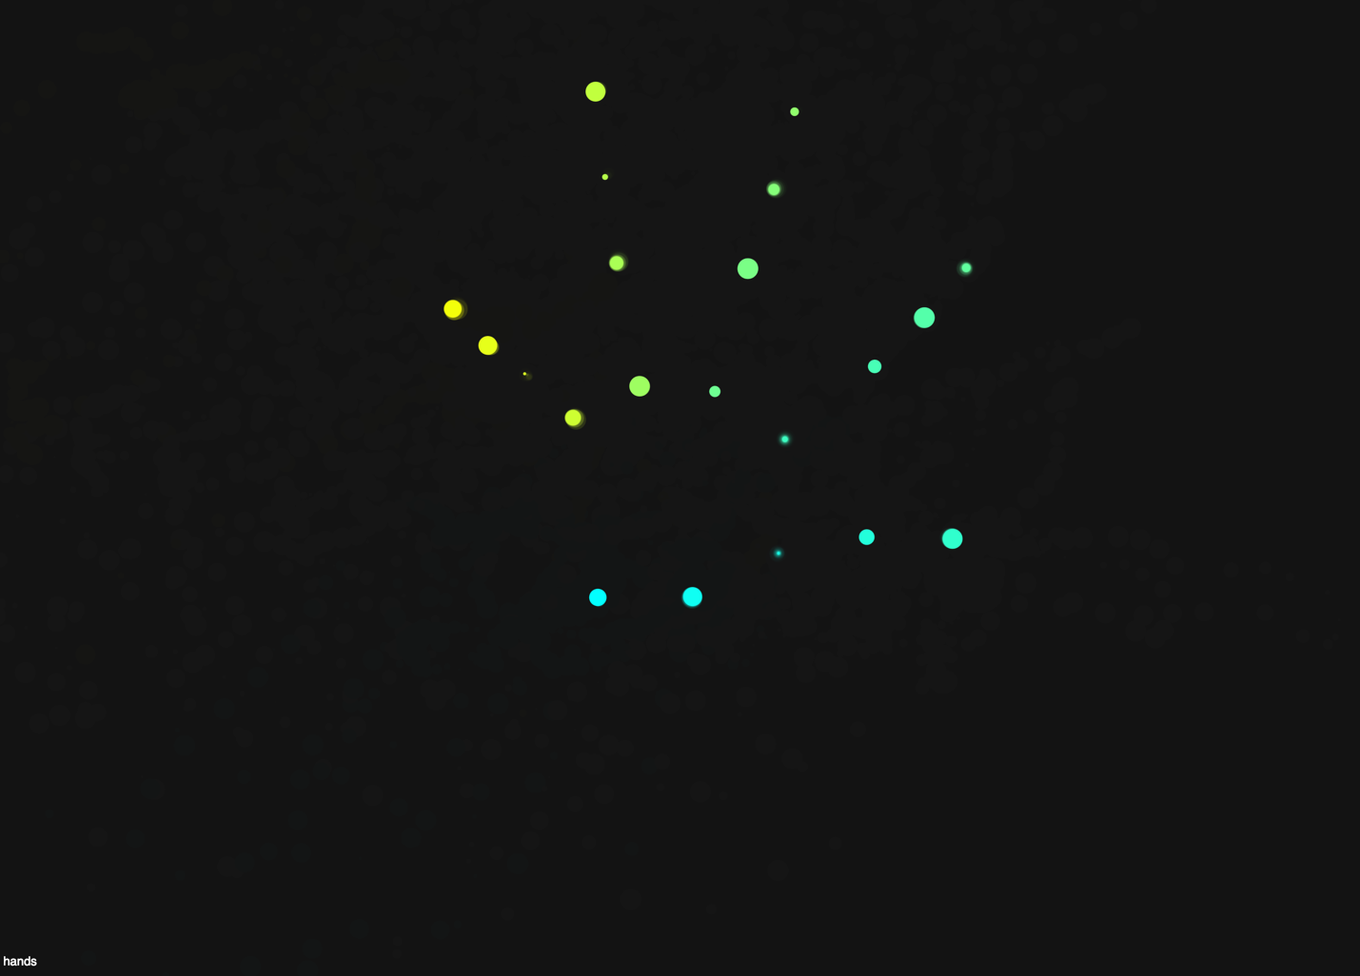
// {"P5LIVE":{"name":"Week 2, 10","mod":"1779129420662"}}

let libs = ['https://unpkg.com/ml5@1/dist/ml5.min.js'];

let video;
let detector;
let detections = [];

function preload() {
// COCO SSD model ‚Äî 80 common objects
// https://github.com/tensorflow/tfjs-models/blob/master/coco-ssd/src/classes.ts
detector = ml5.objectDetection('cocossd');
}

function setup() {
createCanvas(960, 540);
background(0);

video = createVideo(
'https://raw.githubusercontent.com/digitalideation/colabor2026/main/2026_05_08-Paulina_Zybinska/code/objectDetection/assets/rainyday2.mp4'
);
video.size(width, height);
video.hide();
video.loop();
video.volume(0);

detector.detectStart(video, gotDetections);
}

function gotDetections(results) {
detections = results;
}

function draw() {
background(0);

let scaleX = width / video.elt.videoWidth;
let scaleY = height / video.elt.videoHeight;

//clip path made of all detection rectangles
/* drawingContext.save();
drawingContext.beginPath();
for (let i = 0; i < detections.length; i++) {
let d = detections[i];
drawingContext.rect(
d.x * scaleX,
d.y * scaleY,
d.width * scaleX,
d.height * scaleY
);
}
drawingContext.clip();*/

image(video, 0, 0, width, height);

drawingContext.restore();

// outlines + labels on top
for (let i = 0; i < detections.length; i++) {
let d = detections[i];
let x = d.x * scaleX;
let y = d.y * scaleY;
let w = d.width * scaleX;
let h = d.height * scaleY;

stroke(0, 255, 0);
strokeWeight(2);
blendMode(DIFFERENCE)
fill(255)
rect(x, y, w, h);

noStroke();
fill(255);
textSize(24);
text(d.label, x + 10, y + 24);
}

blendMode(BLEND)
}

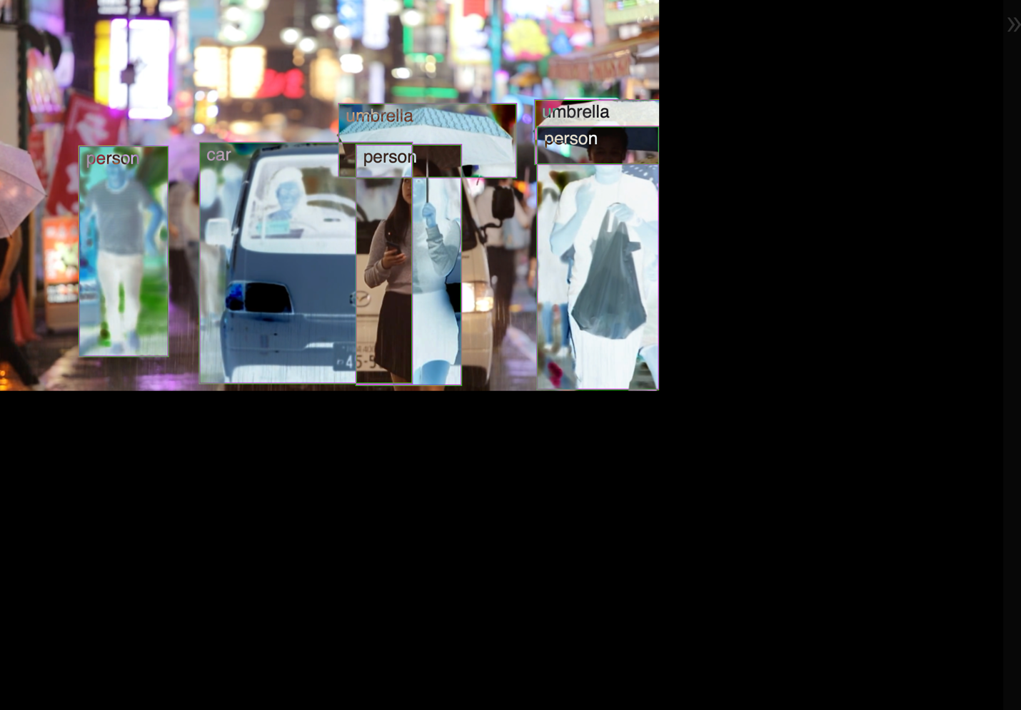
WEEK 3
Mid-term Presentations
// {"P5LIVE":{"name":"Welcome:)_001","mod":"1779096674369"}}

function setup() {
createCanvas(windowWidth, windowHeight)

}

function draw() {
let live = frameCount%10;

frameRate(5)
background(200);
fill(0, 100, 255);
textSize(100);
textWrap(CHAR)
textFont('monospace')
textAlign(LEFT)
textStyle(ITALIC)
textLeading(32*(live/5));
text("CREATIVE CODING".repeat(100), 10, 10,
windowWidth/1.1, windowHeight);

}

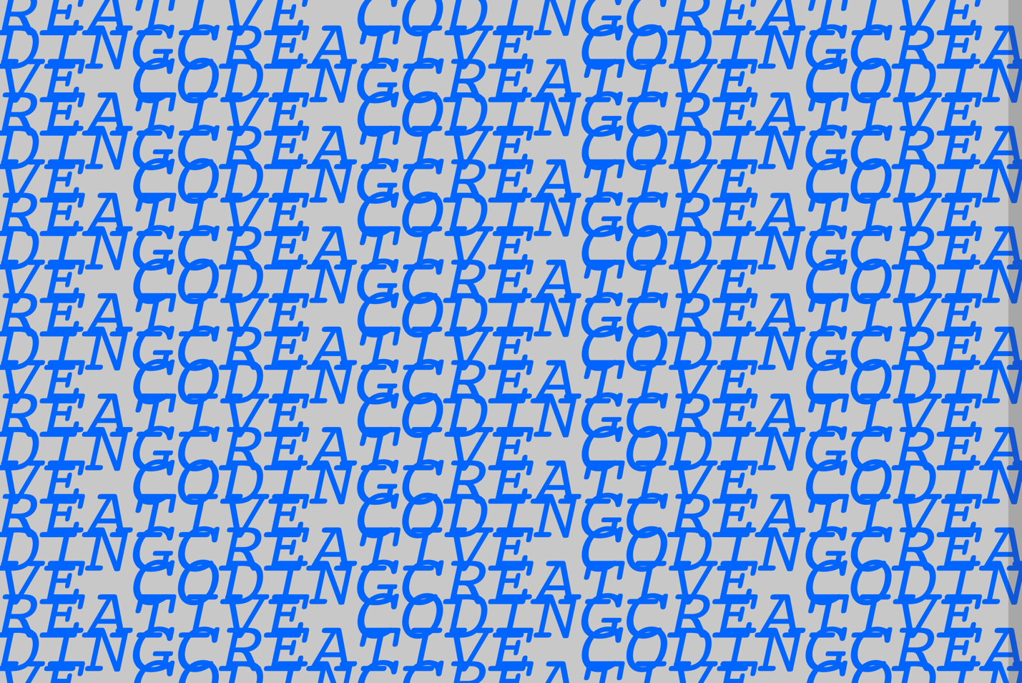
// {"P5LIVE":{"name":"Monday Pres_004","mod":"1779053434846"}}

//the matrix code, but the wall listens back

function setup() {
createCanvas(windowWidth, windowHeight);
frameRate(5);
textFont("monospace");
textSize(windowWidth / 60);
noSmooth();
}
//background brightness reacts to vertical mouse position
function draw() {
background(mouseY/4);
text_lines();
}

function text_lines() {
//text color reacts to horizontal mouse paints
fill(0, 255, mouseX % 255);
let count = frameCount % 30;
let chars = ["0", "1", "1", "0", " "];
let line = "";
let ts = windowWidth / 60;
textWrap(CHAR);
textAlign(LEFT, TOP);
for (let i = 0; i < 25; i++) {
let pick = chars[(i + count) % chars.length];
line += pick.repeat(2);
}
let needed = ceil((windowWidth * windowHeight) / (ts * ts * line.length)) + 5;
let full = line.repeat(needed);
text(full, 0, 0, windowWidth, windowHeight);
}
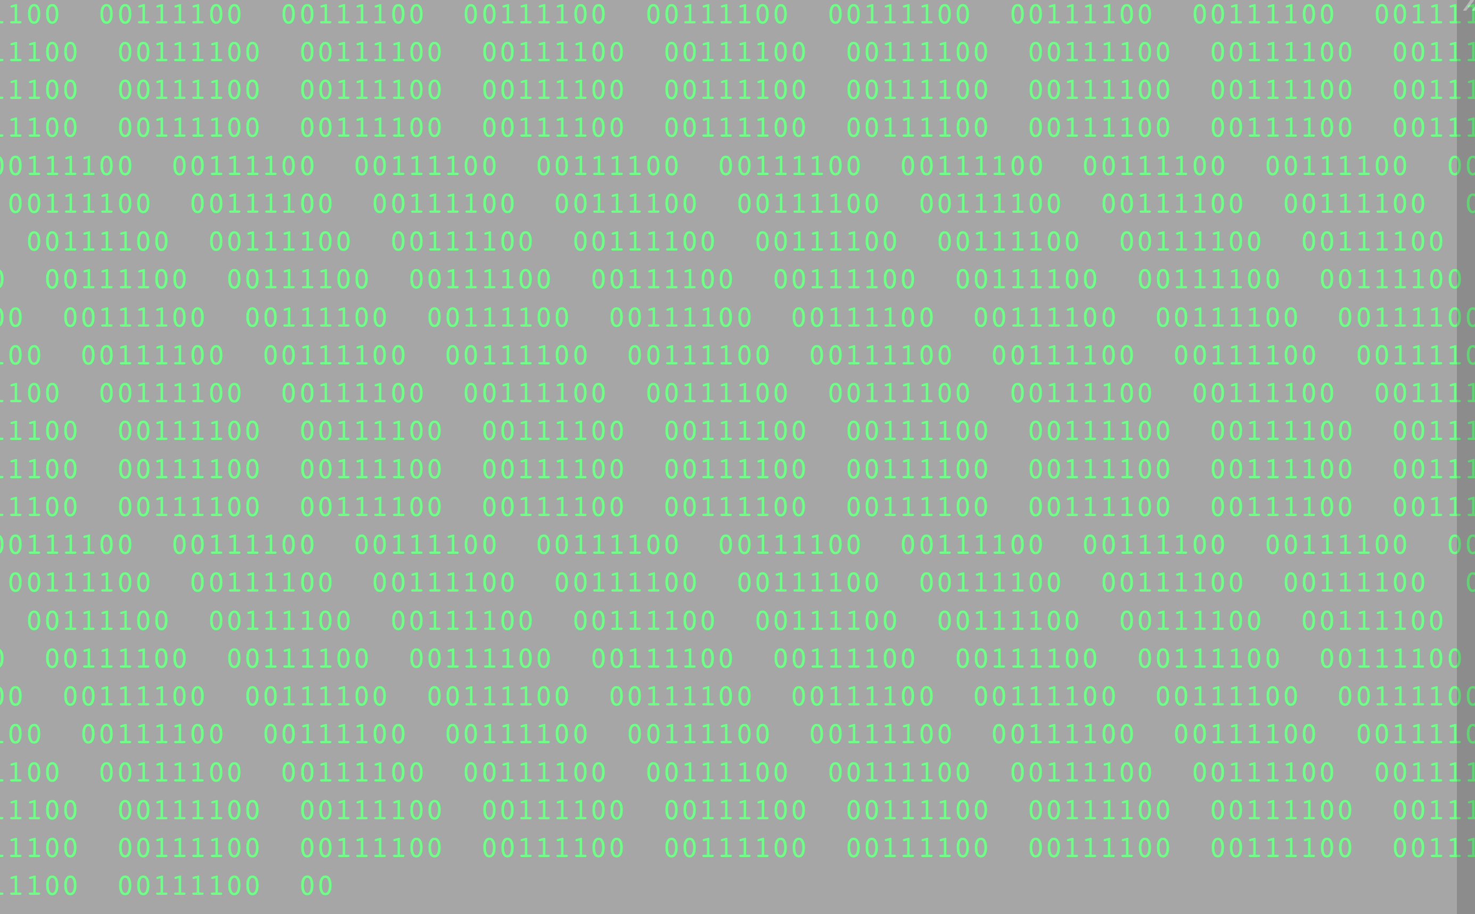
Week 1
The first week was about getting used to the basics. We started with drawing grids of squares that move a bit and change size with sin functions. I made a few different versions, smaller squares, different colors, animations. Most of the time I was just trying to understand how loops and functions actually work, because this was really the first time I wrote code.

Week 2
Week 2 was a lot at once. We tried Hydra, text stuff, hand tracking with ml5, object detection, drawing with the mouse. The day with Jasmin Meerhoff (nervousdata) was the one that really stayed with me. The way she works with text as a material made coding actually click for the first time. After that, I started doing my own text experiments, including the matrix style wall of zeros and ones that I later showed at the mid-term.

Week 3 + Mid-term Presentations
In week 3 my colleague Julian and I worked on our code and the snippets that we later used in the mid-term presentation. We showed two pieces, the breathing "CREATIVE CODING" text and the matrix wall of zeros and ones that reacts to the mouse. The narrative we landed on was "the matrix code, but the wall listens back". During the live coding part, I changed the frameRate, the breathing cycle and the text on screen, just to show how small changes can shift the whole feeling of the piece.
Our idea was simple: it's like the matrix code, but this time the wall reacts to you.

