Photoresistor Manual

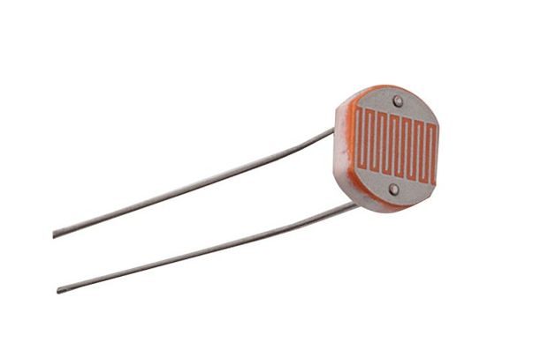

General Information

This Sensor is a Resistor that is changing its resistance depending on the light received. The Resistor has a lower resistance the more light it receives. If receiving a bright light it can‘t provide a resistance and therefore you risk to short out a circuit if not having a resistor in the loop.

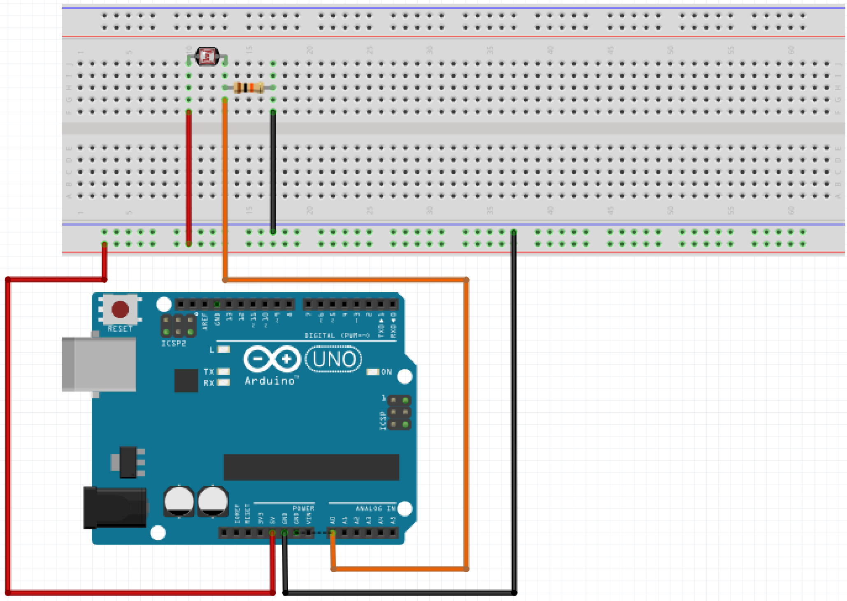
The Loop
Red wire = 5V
Black wire = GND
Orange wire = meassure (Analog input)

