KY-018 Photo resistor / light dependend resistor

Price: ca. 1.- CHF

URL: https://hobbyking.com/en_us/keyes-ky-018-photo-resistor-module-for-arduino.html?___store=en_us

# Overview

The KY-018 photo resistor, sometimes also referred to as light dependent resistor (LDR) is a sensor used to measure light intensity. The sensor is changing its resistance based on the light intensity. The lower the intensity is the higher the resistance will be, which means the sensors is reciprocally proportional.

# Technical Specifications

Operating Voltage: 3.3V to 5V

Output type: Analog Signal in the Range from zero to

Pinout(right to left): GRD, +5V In, Signal out (S)

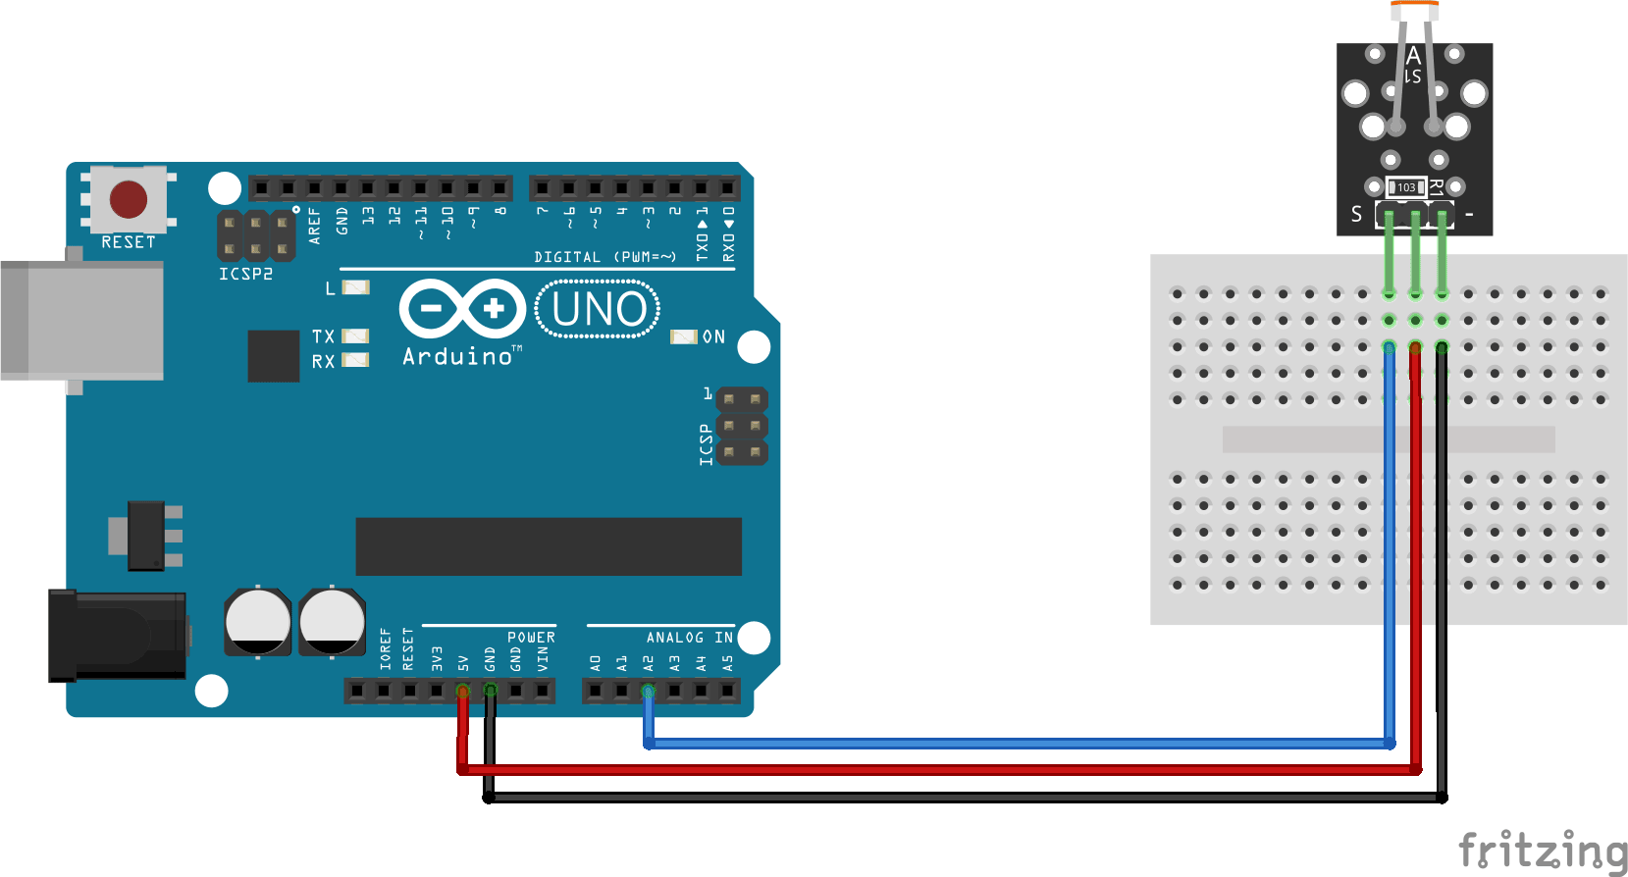

Quelle: arduinomodules.info

# Example

int brightness = 0;

void setup() {

// put your setup code here, to run once:

pinMode(A0,INPUT);

}

void loop() {

// put your main code here, to run repeatedly:

brightness = analogRead(A0);

Serial.println(brightness);

}