**TopBest Documentation Guide**

**Theme Options** – Theme Options is the core of the theme itself, everything is controlled in the using the theme options. To access the theme options go to your wordpress admin dashboard and under **Appearance** < **Theme Options.**

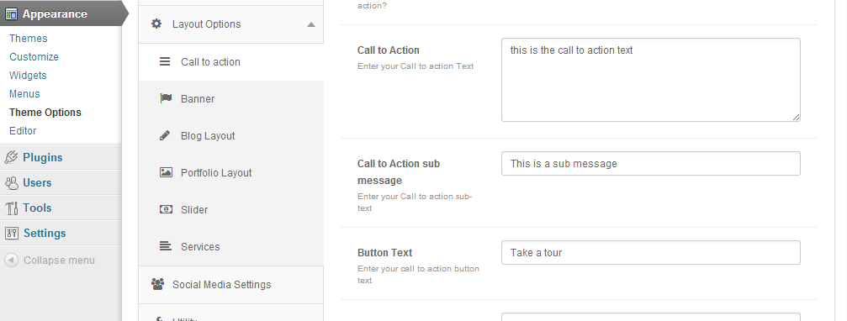

Below each option and sections will be explained and how you can use them.

General Settings

**Upload Theme Logo** – Lets you upload your own logo for your website.

**Company Email** – Enter your personal or company email, please take note that it will show on every header of the design.

**Company Number** – Enter your personal or company number, please take note that it will show on every header of the design.

**Copyright text** – You can enter a copyright or any other label or credit, this will be displayed on the bottom of the footer.

**Enable Pagination** – lets you choose between a standard pagination and a numbered pagination.

**Enable Post Author** – Lets you enable and disable the information of the author that wrote the blog post.

Layout Manager

Layout manager lets you choose between 5 different layouts, but before it can be show in the homepage you will need to create a page associated with that layout, more will be explained below on how to properly setup the homepage.

Call to action

**Enable Call to action** – Enable or disable the call to action button.

**Call to Action** – Enter the main message or text for your call to action.

**Sub Message** – youcan also enter the sub message for your call to action text.

**Button Text** – Enter the label for your call to action button

**Button Link** – Enter your call to action button link.

Banner

**Enable Banner** – Enable or disable the banner text.

**Banner Text** – Lets you enter the text message for the banner, take note the call to action and the banner text are two different functions.

Blog Layout

**Enable Blog** – Enable or Disable the blog layout on the homepage.

**Blog Header** – Enter the text for the header or label of the recent blog post on the homepage.

Portfolio Layout

**Enable Portfolio** – Enable or Disable the Portfolio layout on the homepage.

**Portfolio Header** – Enter the text for the header or label of the recent portfolio post on the homepage.

Slider

Enable Slider – Enable or Disable the Image Slider on the homepage.

Services

**Enable Services** - Enable or Disable the Portfolio layout on the homepage.

Socia Media Settings

Enter the url for each page you have associated with those different social media website.

Setting up the Slider

Before you can see the slider in the homepage first we need to create slides and uploading images attached in the slide, to do this we first need to go to your wordpress dashboard and look for the sliders custom post.

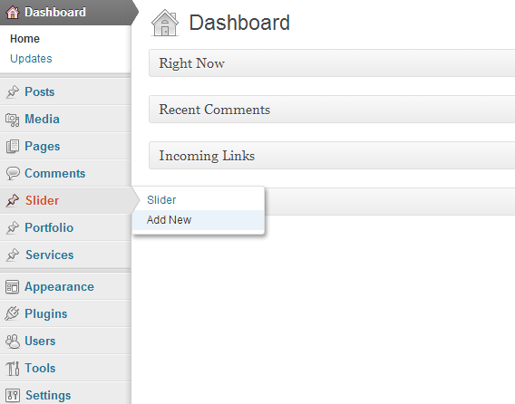

Click add new and enter the title for that slider, take note that the title will be displayed as the slider’s title, now next we need to attach an image so that it will represent as the image for that certain slide. To do this you need to click on the featured image and upload a picture.

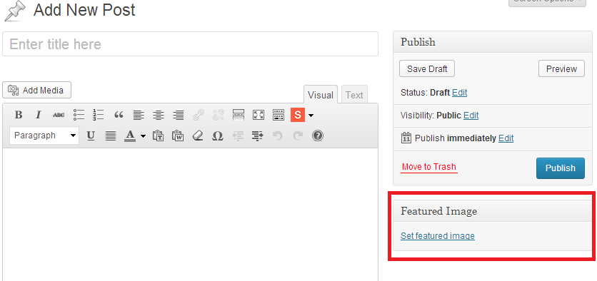

After you have saved the it, add a few bunch of them, when your ready go to your theme options and under the sliders in layout options you need to enable the slider before you can see it in your homepage.

Setting up the portfolio

To setup the portfolio, we need to create portfolio custom posts please read the slider section so you know how to setup the portfolio as well it has the same process and steps. I recommend you to read it first before settings this up.

After you have created some portfolio we need to enable them on your homepage, go to your theme options and enable the portfolio in your homepage.

**Setting up the portfolio gallery** – to do this we simply create a new page name the page anything you want as long as its related to the portfolio, then before saving we need to select a page template, there are four different page templates to choose from select the one that fits your style and click publish.

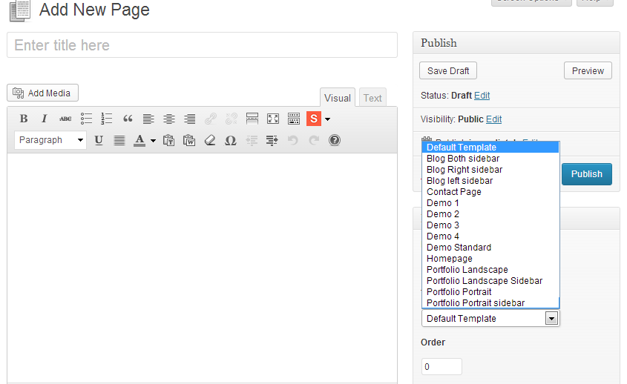

Setting up the blog

You can setup the blog posts on a different page other than the homepage, to do this first you need to create a new page with any title as long as the title is related to the blog name. Then we need to select a page template to be able to create the page. There are three types of page template for the blog post you can pick up the one that suits your needs.



Setting up the homepage

Before we can learn to setup the homepage you must know that this theme uses wordpress’ static page function if you already know about how to create that you don’t need to read this. Now let’s create a new page and name it homepage or something like that.

Next before saving we need to select a page template, select the homepage template and click publish. After doing so we need to setup the static page. Go to you admin dashboard and under the settings select Reading.

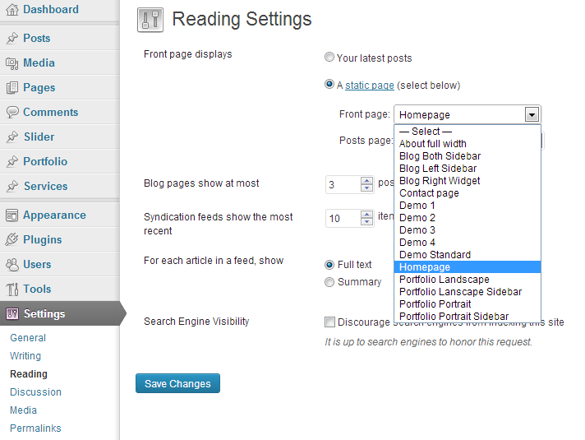

Use the A Static homepage and select the page we created earlier which is the homepage, click save and you are finished.

Support

If you have questions or need more support you can contact me anytime using this link.

<http://themesmarts.com/>