Course Chatbot
- CSV-based course chatbot (improved dataset)
- train_model.py to train the model
- Flask backend (app.py)
- HTML UI (index.html)
- Using TfidfVectorizer for better text handling

📁 Project Structure
course-chatbot/
│
├── intents.csv
├── train_model.py
├── app.py
├── model.pkl
├── vectorizer.pkl
└── templates/
└── index.html

1️⃣ intents.csv (Improved Dataset)
question,intent,response
What courses do you offer,course_list,"We offer Python, Data Science, Web Development, MS Office, Tally with GST, Advanced Excel, Full Stack Development, and Digital Marketing courses."
List all courses,course_list,"We offer Python, Data Science, Web Development, MS Office, Tally with GST, Advanced Excel, Full Stack Development, and Digital Marketing courses."
Which courses are available,course_list,"We offer Python, Data Science, Web Development, MS Office, Tally with GST, Advanced Excel, Full Stack Development, and Digital Marketing courses."
Tell me about Python course,python_info,"Python course covers basics to advanced topics including projects."
Give details of Python course,python_info,"Python course covers basics to advanced topics including projects."
What is included in Python course,python_info,"Python course covers basics to advanced topics including projects."
What is fee for Python course,python_fee,"Python course fee is ₹10,000."
Python course fees,python_fee,"Python course fee is ₹10,000."
How much is Python course,python_fee,"Python course fee is ₹10,000."
Python course duration,python_duration,"Duration of Python course is 3 months."
How long is Python course,python_duration,"Duration of Python course is 3 months."
What is duration of Python course,python_duration,"Duration of Python course is 3 months."
Do you offer Data Science course,data_info,"Yes, we offer Data Science course with practical training."
Tell me about Data Science course,data_info,"Yes, we offer Data Science course with practical training."
Data Science course fees,data_fee,"Data Science course fee is ₹25,000."
What is fee for Data Science,data_fee,"Data Science course fee is ₹25,000."
Tell me about MS Office course,ms_info,"MS Office includes Word, Excel, PowerPoint and basic computer skills."
MS Office course details,ms_info,"MS Office includes Word, Excel, PowerPoint and basic computer skills."
MS Office fees,ms_fee,"MS Office course fee is ₹5,000."
What is fee for MS Office,ms_fee,"MS Office course fee is ₹5,000."
MS Office duration,ms_duration,"Duration is 1 month."
How long is MS Office course,ms_duration,"Duration is 1 month."
Tell me about Tally with GST,tally_info,"Tally course covers accounting, GST filing and business management."
Tally course details,tally_info,"Tally course covers accounting, GST filing and business management."
Tally course fees,tally_fee,"Tally course fee is ₹8,000."
What is fee for Tally,tally_fee,"Tally course fee is ₹8,000."
Tally course duration,tally_duration,"Duration is 2 months."
How long is Tally course,tally_duration,"Duration is 2 months."
Tell me about Advanced Excel,excel_info,"Advanced Excel covers formulas, pivot tables, dashboards and automation."
Advanced Excel details,excel_info,"Advanced Excel covers formulas, pivot tables, dashboards and automation."
Advanced Excel fees,excel_fee,"Advanced Excel course fee is ₹7,000."
What is Excel course fee,excel_fee,"Advanced Excel course fee is ₹7,000."
Excel duration,excel_duration,"Duration is 1.5 months."
How long is Excel course,excel_duration,"Duration is 1.5 months."
Tell me about Full Stack Development,fullstack_info,"Full Stack includes frontend and backend technologies like HTML, CSS, JavaScript and Python."
Full stack course details,fullstack_info,"Full Stack includes frontend and backend technologies like HTML, CSS, JavaScript and Python."
Full stack fees,fullstack_fee,"Full Stack course fee is ₹30,000."
What is fee for full stack,fullstack_fee,"Full Stack course fee is ₹30,000."
Full stack duration,fullstack_duration,"Duration is 6 months."
How long is full stack course,fullstack_duration,"Duration is 6 months."
Tell me about Digital Marketing,dm_info,"Digital Marketing includes SEO, social media marketing and ads."
Digital marketing course details,dm_info,"Digital Marketing includes SEO, social media marketing and ads."
Digital marketing fees,dm_fee,"Digital Marketing course fee is ₹20,000."
What is fee for digital marketing,dm_fee,"Digital Marketing course fee is ₹20,000."
Digital marketing duration,dm_duration,"Duration is 3 months."
How long is digital marketing course,dm_duration,"Duration is 3 months."
Hi,greeting,"Hello! How can I help you?"
Hello,greeting,"Hi there! Ask me anything about courses."
Hey,greeting,"Hello! How can I help you?"

2️⃣ train_model.py (Train Model)
import pandas as pd
from sklearn.feature_extraction.text import TfidfVectorizer
from sklearn.linear_model import LogisticRegression
import joblib
# Load CSV
data = pd.read_csv('intents.csv')
# Drop empty rows
data = data.dropna(subset=['question'])
data = data.reset_index(drop=True)
# Features & labels
X = data['question'].astype(str)
y = data['intent']
# Vectorizer
vectorizer = TfidfVectorizer()
X_vec = vectorizer.fit_transform(X)
# Model
model = LogisticRegression(max_iter=1000)
model.fit(X_vec, y)
# Save
joblib.dump(model, 'model.pkl')
joblib.dump(vectorizer, 'vectorizer.pkl')
print("Model trained successfully!")

Chatbot into a ChatGPT-style web UI with:
- A scrollable chat window
- User and bot messages clearly separated
- Typing animation for bot responses
- Fallback response if the bot doesn’t understand
I’ll give the full updated HTML + minor Flask tweaks.

1️⃣ app.py (Add fallback & JSON response)
from flask import Flask, render_template, request, jsonify
import joblib
import pandas as pd
app = Flask(__name__)
# Load model and vectorizer
model = joblib.load('model.pkl')
vectorizer = joblib.load('vectorizer.pkl')
# Load CSV responses
data = pd.read_csv('intents.csv')
@app.route('/')
def home():
return render_template('chat.html') # renamed template
@app.route('/get', methods=['POST'])
def chatbot():
user_input = request.form['message']
# Transform input
input_vec = vectorizer.transform([user_input])
# Predict intent
intent = model.predict(input_vec)[0]
# Get response
responses = data[data['intent'] == intent]['response'].values
if len(responses) > 0:
response = responses[0]
else:
response = "Sorry, I didn't understand. Can you rephrase?"
return jsonify({'response': response})
if __name__ == "__main__":
app.run(debug=True)

2️⃣ New templates/index.html (ChatGPT-style UI)
<!DOCTYPE html>
<html>
<head>
<title>Course Enquiry Chatbot</title>
<style>
body { font-family: Arial; background: #f0f0f0; }
.chat-container { width: 400px; margin: 50px auto; background: #fff; border-radius: 8px; padding: 20px; box-shadow: 0 0 10px #aaa; }
.chat-box { height: 400px; overflow-y: auto; border: 1px solid #ddd; padding: 10px; }
.user-msg { text-align: right; margin: 10px 0; }
.bot-msg { text-align: left; margin: 10px 0; }
.msg { display: inline-block; padding: 8px 12px; border-radius: 15px; max-width: 80%; }
.user-msg .msg { background: #0084ff; color: white; }
.bot-msg .msg { background: #e5e5ea; color: black; }
#userInput { width: 80%; padding: 10px; }
#sendBtn { width: 18%; padding: 10px; background: #0084ff; color: white; border: none; cursor: pointer; }
</style>
</head>
<body>
<div class="chat-container">
<h3>Course Enquiry Bot</h3>
<div class="chat-box" id="chatBox"></div>
<input type="text" id="userInput" placeholder="Ask something...">
<button id="sendBtn">Send</button>
</div>
<script>
const chatBox = document.getElementById('chatBox');
const input = document.getElementById('userInput');
const btn = document.getElementById('sendBtn');
function appendMessage(sender, message) {
const div = document.createElement('div');
div.classList.add(sender + '-msg');
div.innerHTML = `<span class="msg">${message}</span>`;
chatBox.appendChild(div);
chatBox.scrollTop = chatBox.scrollHeight;
}
function sendMessage() {
const message = input.value;
if (message.trim() === '') return;
appendMessage('user', message);
input.value = '';
// Typing animation
appendMessage('bot', 'Typing...');
const typingDiv = chatBox.lastChild;
fetch("/get", {
method: "POST",
headers: { "Content-Type": "application/x-www-form-urlencoded" },
body: "message=" + encodeURIComponent(message)
})
.then(response => response.json())
.then(data => {
typingDiv.remove(); // remove typing
appendMessage('bot', data.response);
});
}
btn.addEventListener('click', sendMessage);
input.addEventListener('keypress', function(e){
if(e.key === 'Enter') sendMessage();
});
</script>
</body>
</html>

3️⃣ Features Added
✅ Scrollable chat window
✅ User and bot messages in bubbles
✅ “Typing...” animation before bot responds
✅ Enter key also sends message
✅ Fallback message if intent not found

4️⃣ Run Steps
- Make sure your model is trained:
python train_model.py
- Run Flask:
python app.py
- Open browser:
http://127.0.0.1:5000/
Output:-

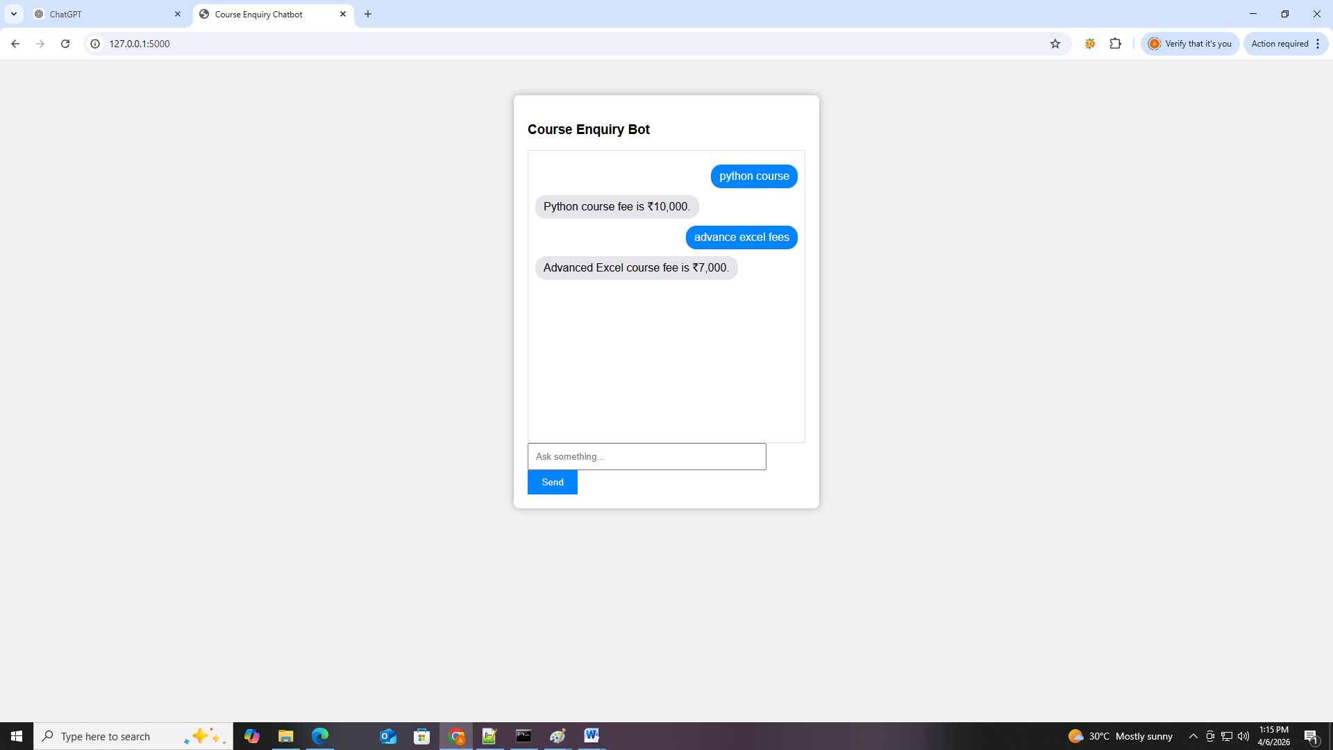

Locally:-

pip install -r requirements.txt

- Push project on github using git:
git init
git add .
git commit -m "initial commit"
git push -u origin main

Deploy to Render
- Sign up at render.com
- Connect your GitHub repo
- Set start command: gunicorn app:app
- Deploy → Get public URL

Let’s focus on why TfidfVectorizer is used in your chatbot project and how it works step by step.

1️⃣ What is TfidfVectorizer?
TfidfVectorizer is a text feature extractor from scikit-learn. It converts text (words) into numbers so that machine learning models can understand them.
- TF = Term Frequency → How often a word appears in a sentence.
- IDF = Inverse Document Frequency → Words that appear in many sentences (like “is”, “the”) get lower weight.
- TF-IDF = TF × IDF → Emphasizes important words for each sentence.

2️⃣ Why we use it in your chatbot
Your chatbot gets user input in text form, like:
"What is the fee for Python course?"
But your ML model cannot understand plain text. It only works with numbers.
TfidfVectorizer solves this by:
- Learning a vocabulary from all your training questions.
- Converting each new user input into a vector of numbers representing word importance.

Example
from sklearn.feature_extraction.text import TfidfVectorizer
# Training questions
questions = [
"What courses do you offer?",
"Tell me about Python course",
"What is the fee for Python course?"
]
# Initialize vectorizer
vectorizer = TfidfVectorizer()
# Learn vocabulary & transform training data
X = vectorizer.fit_transform(questions)
print("Vocabulary:", vectorizer.get_feature_names_out())
print("Vector shape:", X.shape)
Output:
Vocabulary: ['about', 'courses', 'do', 'fee', 'offer', 'python', 'tell', 'the', 'what']
Vector shape: (3, 9)
- Each sentence is now a 9-dimensional vector.
- The ML model can now classify which intent (like course_list or python_fee) the question belongs to.

3️⃣ How it fits in your chatbot pipeline
- Training phase:
vectorizer = TfidfVectorizer()
X_train_vec = vectorizer.fit_transform(X_train_texts) # convert all questions to numbers
model.fit(X_train_vec, y_train) # train classifier
- Save vectorizer for deployment:
joblib.dump(vectorizer, 'vectorizer.pkl')
- Prediction phase (Flask app):
vectorizer = joblib.load('vectorizer.pkl')
model = joblib.load('model.pkl')
user_input = "Tell me about Python course"
input_vec = vectorizer.transform([user_input]) # convert user input to vector
prediction = model.predict(input_vec)[0] # predict intent
✅ Without TfidfVectorizer, the model cannot convert text to numbers, and it will fail to understand any user input.

What is inside vectorizer.pkl
When you run:
from sklearn.feature_extraction.text import TfidfVectorizer
import joblib
vectorizer = TfidfVectorizer()
X_train_vec = vectorizer.fit_transform(training_questions)
# Save vectorizer
joblib.dump(vectorizer, 'vectorizer.pkl')
The vectorizer.pkl file stores the trained TfidfVectorizer object.

It includes:
- Vocabulary
  - All the words the vectorizer learned from your training data
  - Example: ['python', 'course', 'fee', 'data', 'science', 'offer']
  - Each word is mapped to a specific index in the vector.
- IDF weights
  - The “importance” of each word across all training questions
  - Common words like “is” or “the” get lower weights
  - Rare or meaningful words get higher weights
- Vectorization rules
  - How to handle lowercase/uppercase
  - Tokenization rules (splitting sentences into words)
  - Stopwords removal (if enabled)

Why it’s saved
- Consistency: During prediction, you must use the same vectorizer so that each word is mapped to the same index as the training phase.
- No retraining needed: You don’t have to fit it again every time; just load it.

