Cotton
Cotton is a pest-loving plant and due to this habit it has become a problematic crop for the farmers. Major cotton pest's are the Tobacco caterpillars , pink, spotted and American bollworms, aphids, whitefly, jassids, mealy bugs and the spider mite. The bollworm/budworm complex is a primary insect pest problem with larvae attacking squares and bolls causing significant yield losses if left uncontrolled. The cotton whitefly is a pest of primary importance for fibre, horticultural and ornamental crops worldwide. It can cause extensive damage through direct feeding, honeydew production and as a viral vector.
1.Spotted Bollworms
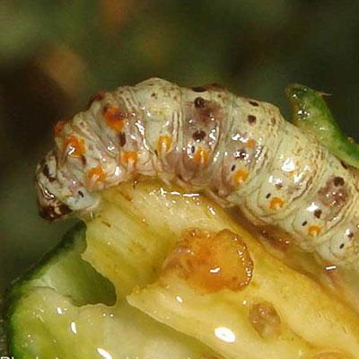
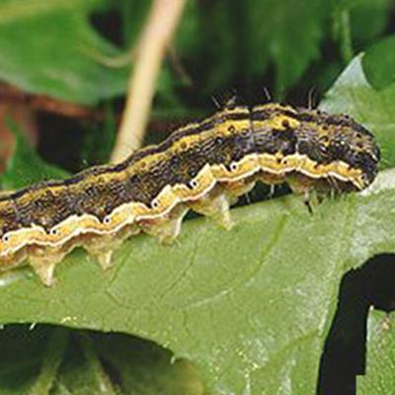

Largo

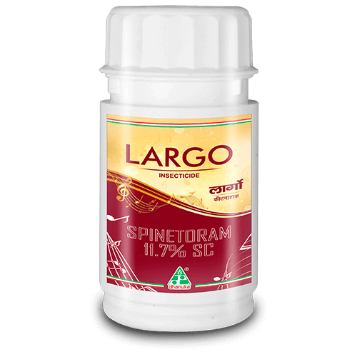
Largo belongs to the spinosyn class of insect management tools which is naturalists in origin . Largo Contains Spinetoram 11.7% SC as an active ingredient. Largo is Derived from the fermentation of saccharoplyspora spinosa ( a common soil bacterium) and is then chemically modified. Largo provides broad-spectrum insect control (Thrips & Lepidopteran insects) with excellent residual activity on a variety of crop.
Spinetoram has a unique mode of action no other group of insecticide acts on this perticuler site of nervous system, the active ingredient in Largo does not interact with the known binding sites of other classes of insecticide.

PACK SIZE

20 ml, 100 ml, 180 ml

FEATURES & BENEFITS
- Largo is a broad spectrum of activity & very efficient against multiple insect growth stages.
- Largo contains contact and stomach poison with synthetic modifications of the ingredients.
- Largo faster in action with better efficacy and longer duration of control.
- Broad spectrum insect control (Thrips & Lepidopteran insect) with excellent residual activity.

2.Aphids
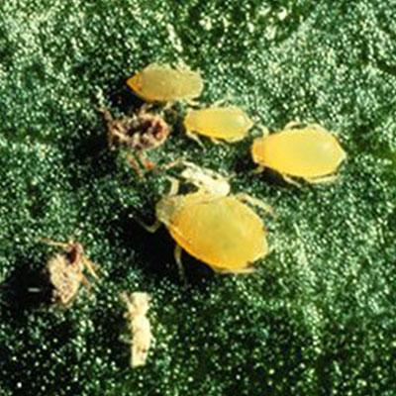
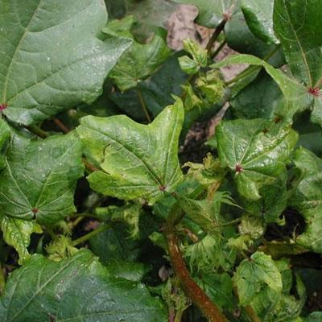

D-One

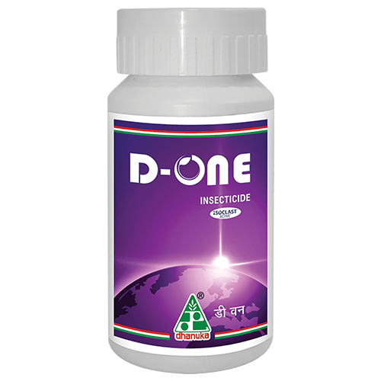
D-One exhibits complex and unique interactions with insect nervous system that are distinct from those observed in other classes of insecticides. Along with contact action, D-One displays xylem-mobile movement in plant system and shows translaminar activity
D-One belongs to a new chemical class of insecticides-sulfoximines. D-One has unique mode of action and it shows three way activity-contact, translaminar and systemic. It is developed globally for use in major crops to control economically important sucking insect pests.

PACK SIZE

75 ml, 150 ml, 500 ml

FEATURES & BENEFITS
- D-one is a one stop solution for three major problems of cotton crop ( Jassid, Aphid, Mealy bug)
- D-One leads to fast action with excellent residual control.
- Application of D-One leads to lowering down overall insecticide cost & labor cost due to its excellent efficacy against pest.
3.WHITEFLY
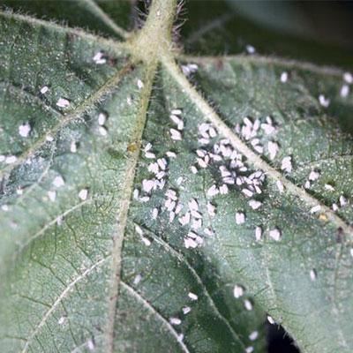
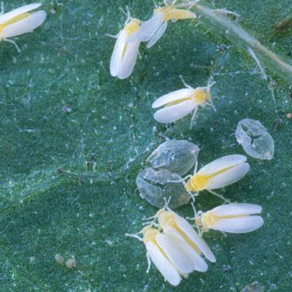
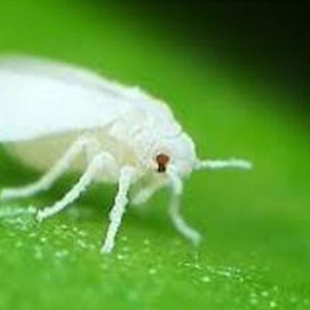

Bullon

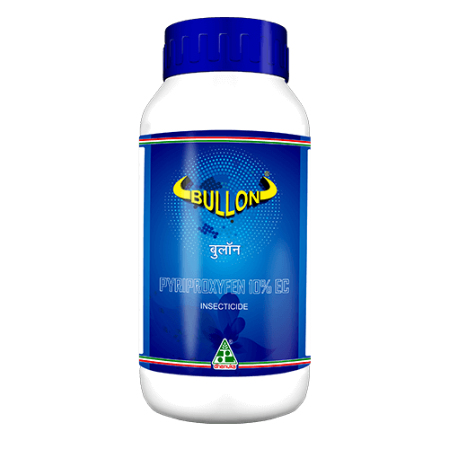
Bullon (Pyriproxyfen 10% Ec) is an insect growth regulator that regulates the transition from one developmental stage to another in Whitefly. Thus gives excellent efficacy and duration of control.
Bullon is an insect growth regulator that mimics the action of Juvenile hormone (JH), that regulates the transition from one developmental stage to another. Bullon causes embryogenesis to stop in exposed eggs and in the female reproductive system. 1. Supressor of Embryogenesis 2. Inhibition of metamorphosis 3. Inhibitor of reproduction

PACK SIZE

100 ml, 250 ml, 500 ml, 1 Ltr

FEATURES & BENEFITS
- It controls all stages of white fly –Egg, Nymph and adult.
- It prevents spread of cotton leaf curl virus by controlling its vector white fly.
- It has translaminar activity which helps to control white fly on lower surface of leaf.
- It gives longer duration of control
4.Pink Bollworms
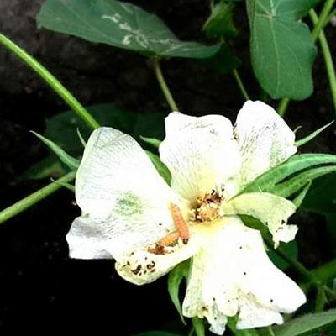
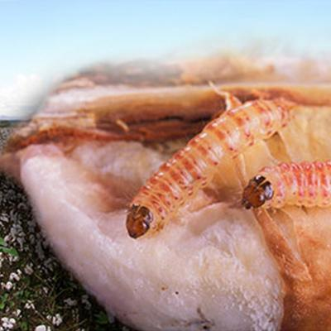
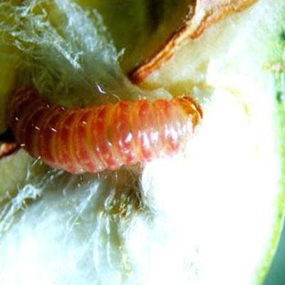

Superkiller 10%EC
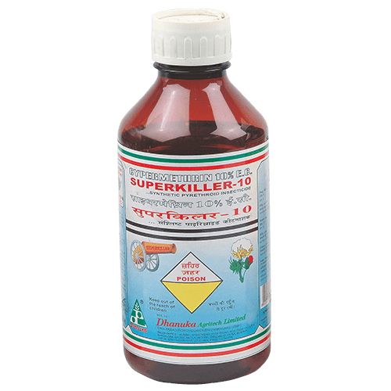
Superkiller (CYPERMETHRIN 10% EC) belongs to Pyrethriod ester group of insecticides.
Superkiller controls the insects by its contact and stomach poison action.

PACK SIZE

50 ml, 100 ml, 250 ml, 500 ml, 1 ltr

FEATURES & BENEFITS
- Superkiller is very effective in controlling the insects immediately after application even at lower doses.
- Superkiller does not leave residue in the crops and due to this quality it can be applied a week before the harvest of the crop.

