Paddy
Paddy(Oryza sativa) cultivation is the most important agricultural operation in the country, not only interms of food security but also in terms of livelihood. It plays a major part in the diet,economy, employment, culture and history of India.India is one of the world's largest producers of rice and brown rice, accounting for 20% of all world rice production, It grows in almost all states in India (West bengal, Uttar pradesh,Punjab, Haryana, Andhra Pradesh,Tamilnadu & Chhattisgarh are the major states). It is a tropical plant, it flourishes comfortably in hot and humid climate. It is mainly grown in rain fed areas that receive heavy annual rainfall. That is why it is fundamentally a kharif crop in India. It is also grown through irrigation in those areas that receives comparatively less rainfall.
1.Narrow leaf weeds,Broad Leaves Weeds & Sedges
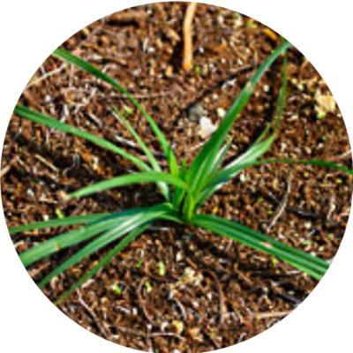
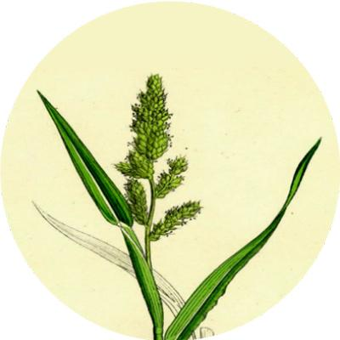

Chempa
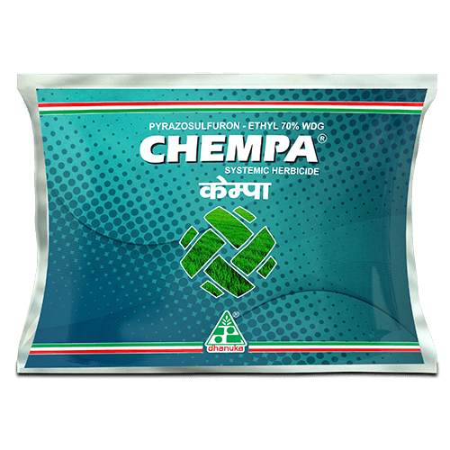
Chempa (Pyrazosulfuron-Ethyl 70% WDG) is a broad spectrum herbicide for paddy, which effectively controls major broadleaf weeds, Sedges and Grassy Weeds. It is a pre and early postemergence Herbicide which gives the longer duration of control by inhibiting shoot growth and killing the weeds.
It inhibits the catalysis of Acetolactate synthase (ALS) in the biosynthesis of Valine, Leucine and isoleucine & stops cell division of roots and kills weeds.

PACK SIZE

3 gm, 6 gm,12 gm

FEATURES & BENEFITS
- Longer duration of control on broadleaf weeds, sedges and grassy weeds.
- It is a selective and systemic herbicide.
- It has a wide application window.
- It is safe to Environment.
2.Stem Borer
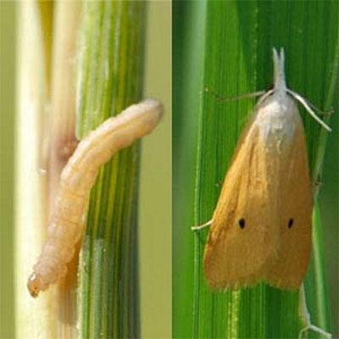
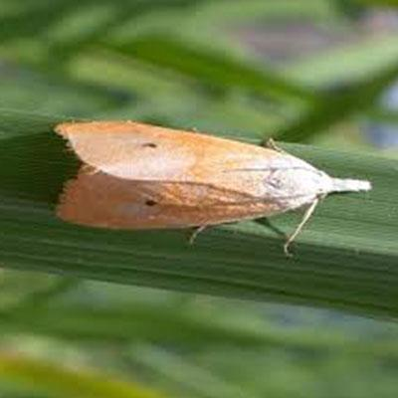
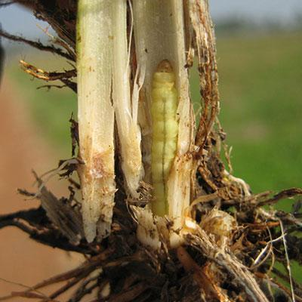

Mortar

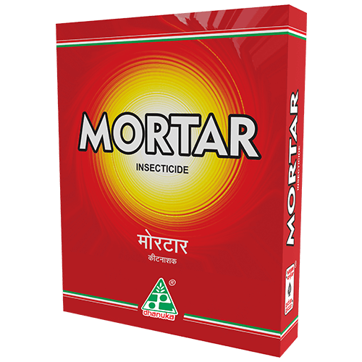
MORTAR attacks on Central nervous system through its unique NTX action and causes paralysis by blocking central nervous system of insects. It is having systemic, contact and translaminar action.
Formulated with superior Japanese Technology, MORTAR is an exclusive SG formulation with Unique NTX Mode of Action. It's ovicidal, larvicidal & adulticidal action against the target pest leads to excellent control of target pest.

PACK SIZE

100 gm, 250 gm, 500 gm, 1 Kg

FEATURES & BENEFITS
- Mortar controls all stages of insects (egg, larva, adult).
- Mortar gives complete protection via sytemic, contact and translaminar action.
- Mortar breaks the insect resistance and gives excellent resistance management (IRM)
- Mortar is safe for beneficial insect, thus useful for IPM.
3.Blast
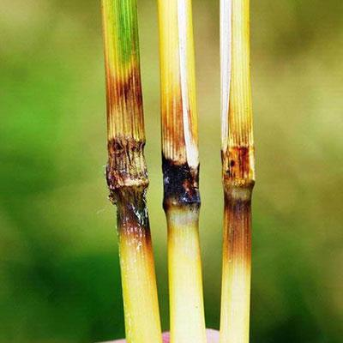
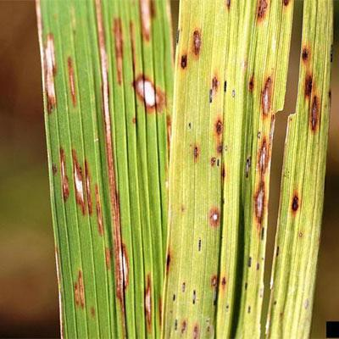

Godiwa Super
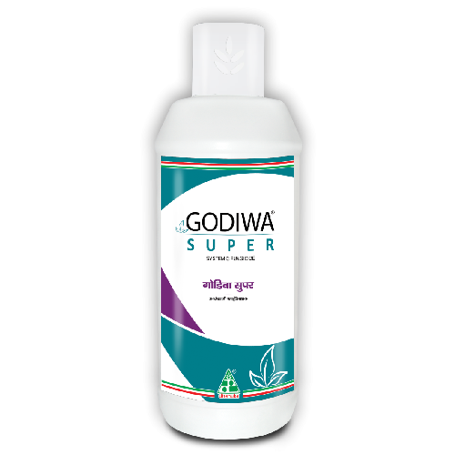
It’s a dual systemic fungicide which inhibits spore germination at the early stage of fungal development. Thus, it protects the crop against invasion by fungal pathogens. It’s taken up by the plants and acts on the fungal pathogen during penetration and haustoria formation. Thus, it stops the development of fungi by interfering with the biosynthesis of sterols in the cell membrane.
Godiwa Super is a new generation combination fungicide containing Azoxystrobin 18.2% W/W & Difenoconazole 11.4% W/W SC. It’s a dual systemic broad-spectrum fungicide with protective and curative action. It offers not only disease control but also improves crop health, quality and yield of a crop.

PACK SIZE

200 ml, 500 ml, 1 L

FEATURES & BENEFITS
- Synergy of two advanced chemistry and have multisite action.
- Dual mode of action, hence effective and provides longer duration control on diseases.
- It’s an excellent tool for resistance management.
- More photosynthesis and healthy crop.
4.BPH
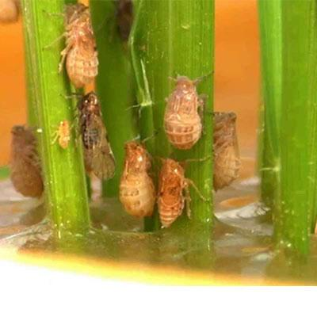
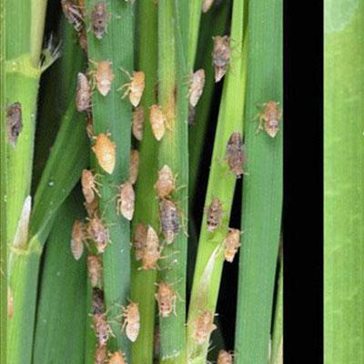
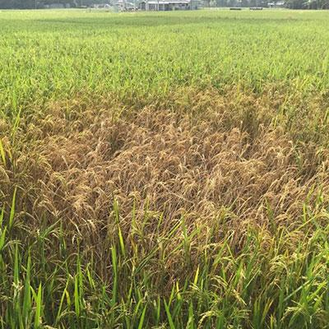

Apply

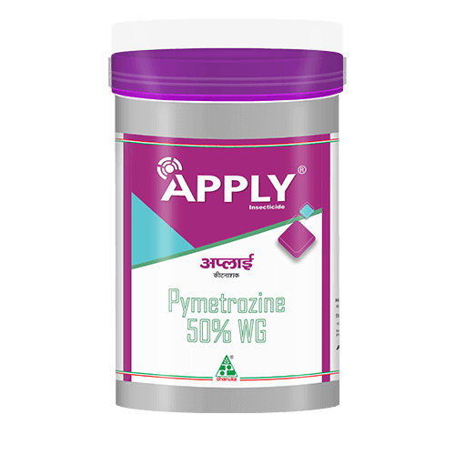
Apply (Pymetrozine 50% WG) has the best known chemistry for effective control on BPH, It is a systemic and trans laminar insecticide which paralysis the hoppers, stops egg-laying and the insects got killed from starvation.
Immediate crop protection through permanent inhibition of the feeding system. It paralyses hind legs of pests, results in dropping from plants & then pests die later from starvation.
It checks next generation by blocking egg-laying of pests.

PACK SIZE

120 gm, 250 gm, 500 gm, 1 kg

FEATURES & BENEFITS
- It is a world class technology which gives immediate and effective control of BPH.
- It has systemic and translaminar action which gives a longer duration of control.
- It is safe to the environment.
5.Leaf Folder
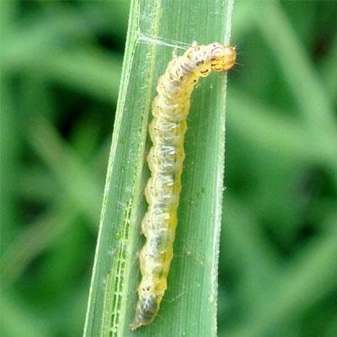
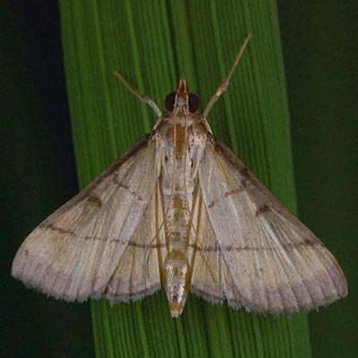

Caldan 4G

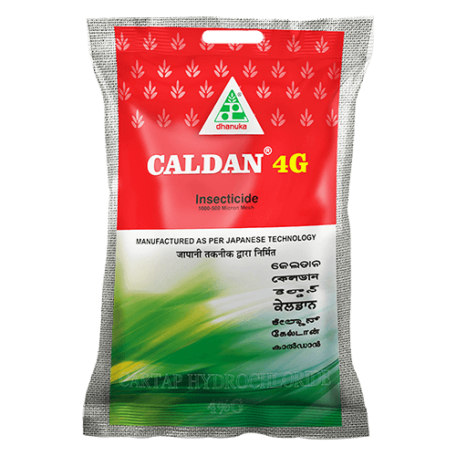
Caldan 4G (Cartap Hydrochloride 4% G) is an insecticide of Nereistoxin analogue group, which gives effective control on insects pests through its contact, systemic and stomach poison action. Caldan 4G has remarkable capacity to control caterpillars. It is safe for environment and is also suitable for Integrated Pest Management (IPM) system. It is a persistent insecticide and controls the insect pests for a longer period.
Caldan is of Nereistoxin analogue group, which gives effective control on insects pests through its contact, systemic and stomach poison action. Caldan 4G has remarkable capacity to control caterpillars. It is safe for environment and is also suitable for Integrated Pest Management (IPM) system. It is a persistent insecticide and controls the insect pests for a longer period.

PACK SIZE

1 kg, 5 kg, 7.5 kg

FEATURES & BENEFITS
- It controls all stages of insects ( egg, larva, adult)
- It gives complete protection via systemic, contact and translaminar action.
- It breaks the insect resistance and gives excellent resistance management ( IRM)
- It is safe for beneficial insect, thus useful for IPM.
- It leads to higher yield and high income.

