**Assigning Staff as Instructors in Moodle via SITS**

**Please note:**

* To be able to assign a staff as an instructor the staff member must exist (have a Personnel or **PRS code**) in SITS.
* Staff who are on the HR system will automatically go into SITS (i.e., get a PRS code).
* A staff member who has been assigned to a module in SITS, whether as an 'Assessment Marker' (on the MKR screen) or as the 'Module Tutor' (within the MAV screen), will be automatically enrolled as an 'Instructor' of the corresponding module shell in Moodle. (School/Department administrators can use either the MKR screen to attach staff, or via the MAV screen).
* This data (like the student enrolments) is passed from SITS to Moodle twice daily on weekdays, so access is gained quickly. Data gets extracted from SITS at 11:30am; Moodle gets updated with this data one hour later at 12:30pm, and data gets extracted from SITS at 6.00pm; Moodle gets updated with this data at 4:30am

Enrolment to a single module

Assigning a member of staff as an instructor on a module is done through the **MAV** (Module Availability) Screen in **SITS** (and the associated **MKR** screen).

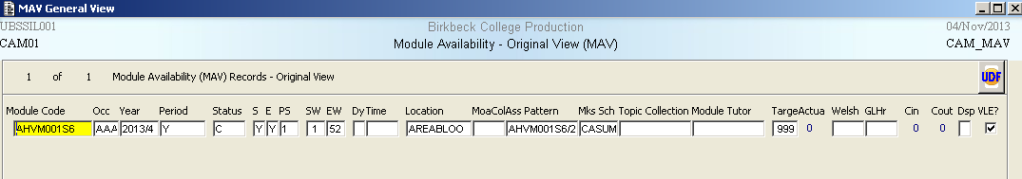

Instructors can be added by going to Other-Assessment Marker, which will open up the MKR screen with some details completed.

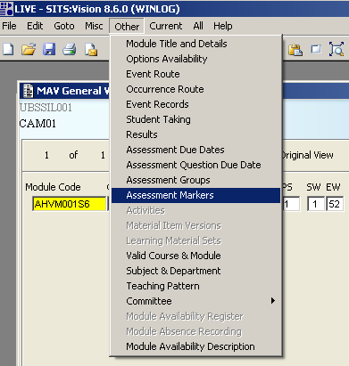

For the first instructor, put the PRS code into the code field on MKR. Then hit Tab and the Sequence number will be filled in automatically. Then press F6 to Store. For subsequent instructors in MKR select File-Add (or Control-N) to get a new record ready for input.

If you do not know the staff member’s PRS (Personnel) Code press F2, or double click, on the Code field and the below screen will appear:

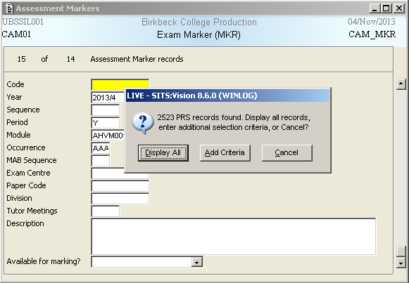

Click on Add Criteria to access part of the PRS Screen:

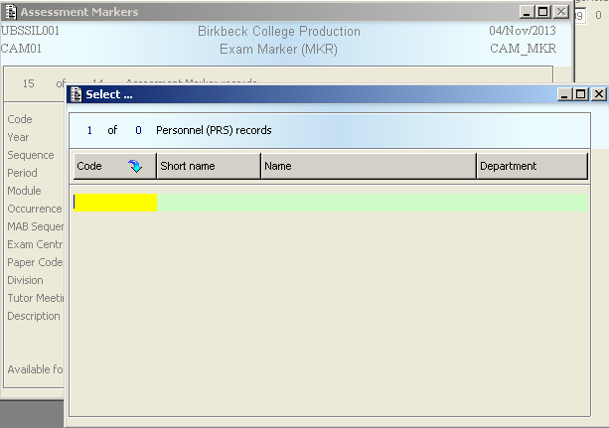

Click in the Name field and enter the Staff member’s surname, ensuring that there is an any character wildcard either side of the surname:

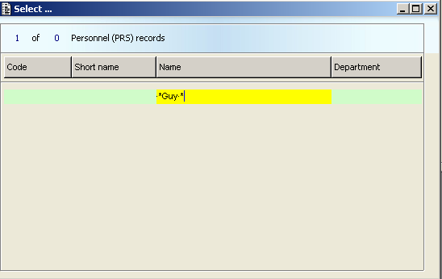

Once entered press F5 to Retrieve the list of staff members matching the above criteria:

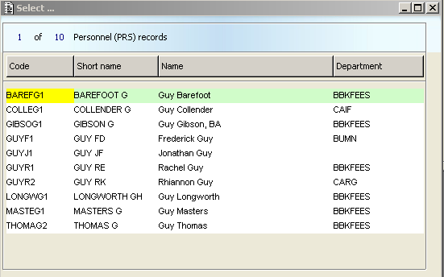

Highlight the member of staff you wish to assign and either double click, or press F3, to accept. This will take you back to the MKR screen. Then hit Tab and the Sequence number will be filled in automatically. Then press F6 to Store. For subsequent instructors in MKR select File-Add (or Control-N) to get a new record ready for input and repeat the above process.

Module Tutors can be added directly on the MAV screen by entering the relevant PRS Code. If you do not know what the Code is press F2, or double click, on the Module Tutor field and follow the above instructions.

In instances where Modules have multiple occurrences if the Module has been split in Moodle then the staff member needs to be assigned to each of the appropriate Occurrences. If the Module only has one Moodle shell then the staff member one needs to be assigned to one Occurrence, and we would recommend that this should be the first Occurrence in MAV.

Bulk enrolment to all modules in a range

You can bulk enrol staff to all modules in their subject area(s). To add someone to all modules in a range (for example Administrative staff may need to be added to all Modules within a Department), call up the MKR1 screen (from the main menu instead of MAV etc) and enter in the Personnel (PRS) Code, Year, and Module range/Module prefix you wish to assign the staff member to (i.e. ABCD*), and Use Availability is set to Use MAV (Y).

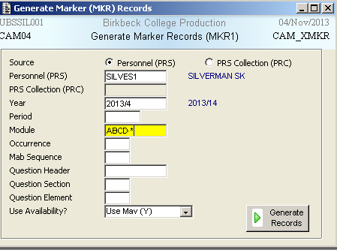

If you do not know the staff member’s PRS (Personnel) Code press F2, or double click, on the Code field and the below screen will appear:

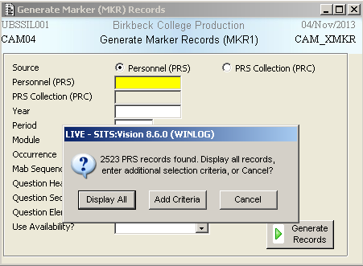

Click on Add Criteria to access part of the PRS Screen:

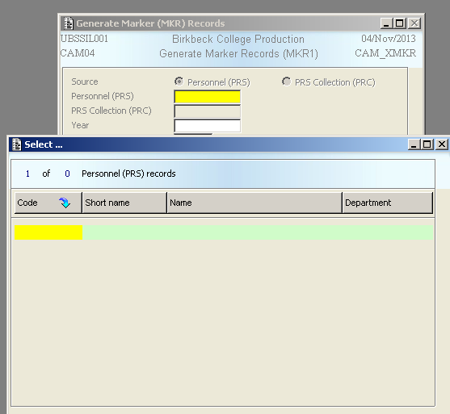

Click in the Name field and enter the Staff member’s surname, ensuring that there is an any character wildcard either side of the surname:



Once entered press F5 to Retrieve the list of staff members matching the above criteria:



Highlight the member of staff you wish to assign and either double click, or press F3, to accept. This will take you back to the MKR1 screen. Once all the information has been entered hit Generate Records.

**Note regarding removal from MKR**: Admin and Learning Technology staff have **add**, but not **remove** permissions from MKR records. Once a staff member is attached to a module code via MKR, only the BSIS team can remove them. Should you need to remove someone from an MKR please contact BSIS Help. They are also able to bulk remove from a range.

Programme and Department Areas

If you want to use Moodle courses which contain all the students on a programme or studying in a department and instructors need to be assigned for these, then please contact Ali Parvin or Peter Leffek in ITS (moodle@bbk.ac.uk).