# E-Store web application – Programming Secure Code Homework

## Kosta Hristov F49581

# General Overview

E-Store is a last generation mega-cool web application, written for convenient and easy access of our clients to our store. Using it, they can view all the products available, their descriptions, prices, and separate them by categories. There is also a cool shopping cart available !

For the eager administrator, we have implemented an administration panel which allows quick and easy management of the whole system ! In the next sections we will give a brief overview of the general available functionality.

# Technologies used

**Platform :** .NET 4.0

**Language :** C Sharp

**Framework :** Asp.net MVC 3

**ORM Technology :** Entity Framework

**The usual web stack :** HTML/CSS/JavaScript/JQuery

# The Products List

Yep, that’s the product list. You can see that there is the name of the product available, the description and the price, of course. On the right, there is an Add to cart button which we will explore later !

# The Category List

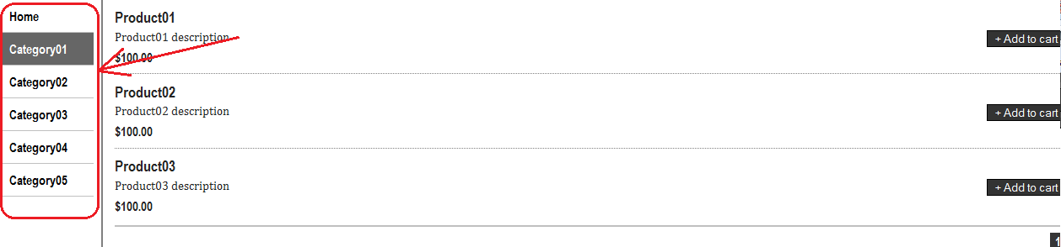

That’s the category list. You can also see products by category only !

# The Shopping Cart List

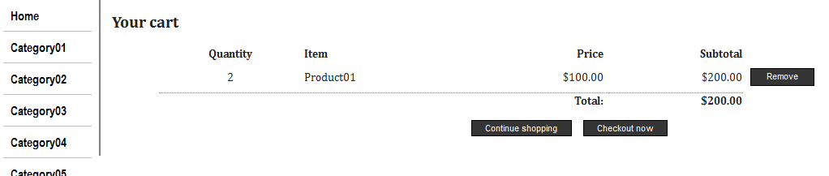

We also have a shopping cart. As you can see, that’s a grid with a Quantity, Item (name), Price and a Total Price columns, with a remove functionality ! You can, of course, checkout everything from here.

# The whole main screen

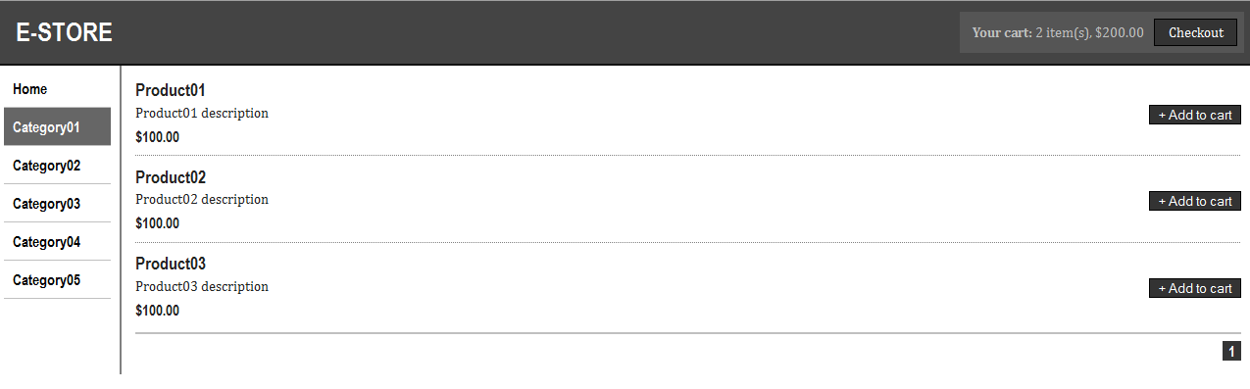

That’s the whole main screen, just to summarize the things. As you can see, there is a Checkout button in the top right corner. It leads to the shopping cart screen.

# The administration area

You can log on the administration console through the following URL : <http://localhost:57499/Account/LogOn>

Once you’re there, you’ll see a login screen:

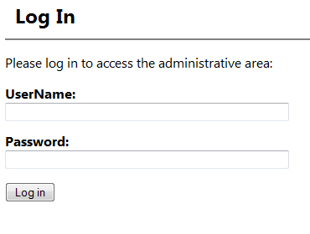

You can log in with the following credentials : Admin/secret

From there, you can easily manage all the products using the following screens :

