**A**

**PROJECT REPORT**

**On**

**“DIGITAL TABLE SERVICE”**

**Submitted By**

**Ms. MAYURI MALI(190240320060)**

**Ms. PRAVIN PANCHAL (190240320080)**

**MS. PRATIBHA KARANDE (190240320076)**

**Ms. RUTUJA GAIKWAD(190240320096)**

**Mr. PAPPU KAPGATE(190240320071)**

**Ms. DAKSHTA MHATRE (190240320034)**

**Ms. POOJA SHIMPI(19024032001072)**

**Under the Guidance Of**

**MUKUND KAKADE.**

**MADHUR INGALE.**

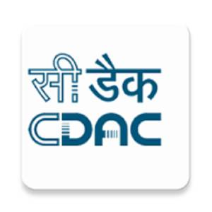

**CENTER FOR DEVELOPMENT IN ADVANCED COMPUTING,CDAC KHARGHAR**

**2019**