Hi,

We’d appreciate participation in a new industry effort to better understand the current state of SDR and HDR consumer viewing.

With this goal, NBCUniversal has created display luminance and MODE surveys for both SDR and HDR along with **reference media for testing**.

* **For the simple Picture/Display Mode Survey, please check picture mode using menu or setup buttons**
  + Picture/Display Modes are typically something like this: ***Standard, Cinema, Movie, ISF Bright/Dark, Natural***, etc.
* **The luminance survey for experts requires a spot meter, and that all three squares are measured for luminance levels:**
  + **SDR**
    - **MidGray Left**- Using linear scaling method (NBCU LUT3)
    - **PeakWhite** - 100% nominal signal level
    - **MidGray Right** - Using non-linear scaling (BBC LUT 9C)
  + **HDR (native reference levels as defined in ITU-R BT.2408)**
    - **1,000cd/m2** (most common peak white in live workflows/Normalized HLG)
    - **203cd/m2** (graphic/reference white)
    - **26cd/m2** (Midgray)

**All the instructions, media files and survey links are included in the Github README file and the repository here:**

**<https://github.com/digitaltvguy/SDR-Display-Luminance-Survey>**

Understanding what display mode is most common for consumer viewing, combined with the results of the expert measurements survey results, will allow us to understand how images will be viewed and/or tonemapped between HDR and SDR.

The surveys include SDR still graphics files for full range RGB testing and YCbCr movies for narrow range testing of SDR and HDR. Still graphics files currently have no support for HDR signaling and therefore are not useful for the HDR testing. Please use the movie files for HDR.

**There are three surveys to choose from:**

* + **Survey 1: SDR Simple Display MODE Survey for ANYONE**
  + **Survey 2: SDR Luminance Measurement Survey (requires SPOT meter)**
  + **Survey 3: HDR Luminance Measurement Survey (requires SPOT meter)**

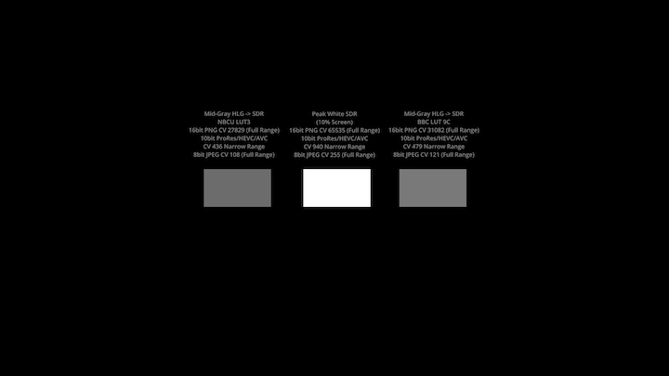

**HDR Test File Thumbnail Preview**

