This **Display MODE and luminance surveys** will allow us to understand how consumers are viewing our content. To accomplish this the following reference points are measured:

* **For the simple Picture/Display Mode Survey, please check picture mode using menu or setup buttons**
  + Picture/Display Modes are typically something like this: Standard, Cinema, Movie, ISF Bright/Dark, Natural, etc.
* **The luminance surveys for experts with spot meters, will measure these values:**
  + **SDR**
    - **PeakWhite** - 100% nominal signal level
    - **MidGray** - Using the two tone-mapping methods described in BT.2408.
  + **HDR (native reference levels as defined in ITU-R BT.2408)**
    - **1,000cd/m2** (most common peak white in live workflows/Normalized HLG)
    - **203cd/m2** (graphic/reference white)
    - **26cd/m2** (Midgray)

**All the instructions, media files and survey links are included in the Github README file and the repository here:**

**<https://github.com/digitaltvguy/SDR-Display-Luminance-Survey>**

Understanding what display mode is most common for consumer viewing, combined with the results of the expert measurements survey results, will allow us to understand how images will be viewed and/or tonemapped.

The surveys include SDR still graphics files for full range RGB testing and YCbCr movies for narrow range testing of SDR and HDR. Still graphics files currently have no support for HDR signaling and therefore are not useful for the HDR testing. Please use the movie files for HDR.

**There are three surveys to choose from:**

* + **Survey 1: SDR Simple Display MODE Survey for ANYONE**
  + **Survey 2: SDR Luminance Measurement Survey (requires SPOT meter)**
  + **Survey 3: HDR Luminance Measurement Survey (requires SPOT meter)**

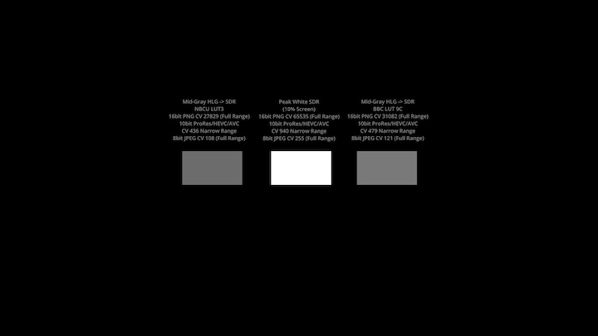

**HDR Test File Thumbnail Preview**

