Dear,

We are the Chinese Client and do researching on the audio domain. Now we are carrying out a project which need the hiss reduction function. We have known that **‘Adobe Audition CC’** has a function called **‘Hiss Reduction’**. As the following figure shows:

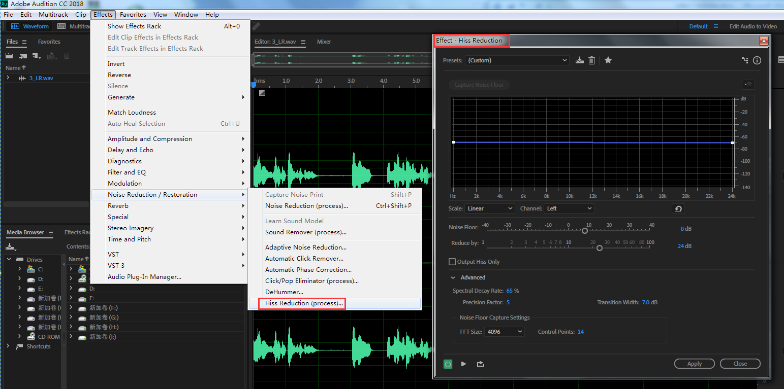

We hope to use the **hiss reduction function independently as one of our project function**. Could you please tell me how to get the hiss reduction function, regardless it’s opened or charged.

In addition, We saw a **‘Technology Partner Program’** on the adobe website. What is the **Partner** about. Can we obtain the hiss reduction function through this way?

We hope to your reply at early as you can.

Please accept my sincere thanks.

WangYini

E-mail: 1592164936@qq.com

Mobile: +86 15810904698

Tel: +86-010-86098065

Add: No.2, Fuxingmenwai Ave, Xicheng District, Beijing, China