**Build a flow using Desktop Actions:**

Build a flow to show Desktop, open Notepad, enter text, save the Notepad, close the Notepad and switch back to the Studio.

**Prerequisites**

To build a flow you must already have done the following:

1. Register with Techforce.ai
2. Install Techforce.ai studio. (link here to the Register/download page)

**Actions Used to implement the use case:**

1. Keyboard shortcuts
2. Open App
3. Close App
4. Switch App

**Procedure:**

1. Creating an action Flow:
2. Click on the  NEW icon, to create a new action flow.
3. Enter a name for the action flow and click on SAVE.
4. A new action flow is created with a stage in the developer panel.
5. Rename the stage as per requirement in the properties panel.
6. Drag and drop **Keyboard Shortcuts** action to show the desktop.
7. You can see modifier keys such as Control, Windows, Alt, and Shift in the properties panel.
8. You can also notice custom keys and standard keys.
9. Keyboard shortcuts action helps to enter or type the text or commands either in the combination of modifier and alphanumeric keys or in the combination of modifier and function keys or navigation keys. It can also type or enter alphanumeric text.
10. To show the desktop Windows + d is the command. Select the Windows modifier key, then custom keys and enter "d".

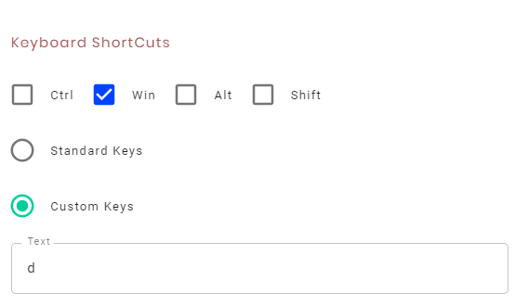

1. Drag and drop the **OPEN APP** action to open notepad.
2. You can see an option in the properties panel to enter the file path of the application.
3. OPEN APP action is used to open any standard Windows-based applications like Notepad, Chrome, Command prompt and so on.
4. It is also used to open any file by providing its full path.
5. To open a new notepad, enter "**notepad.exe**" in the file path text box.

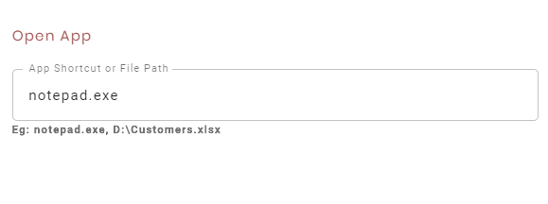

1. Drag and drop **KEYBOARD SHORTCUT** action, to enter the text into the notepad.
2. Select custom keys
3. Enter “Hi, Welcome to Techforce.ai Studio” in the textbox.
4. Drag and drop another **KEYBOARD SHORTCUT** action, to save the notepad.
5. To save the Notepad, select the control modifier key.
6. Select custom keys and enter "S" in the text box.
7. Drag and drop one more **KEYBOARD SHORTCUT** action, to name the Notepad.
8. Select custom keys.
9. Enter the text as “intro” and give “Enter” in the curly braces in the textbox.

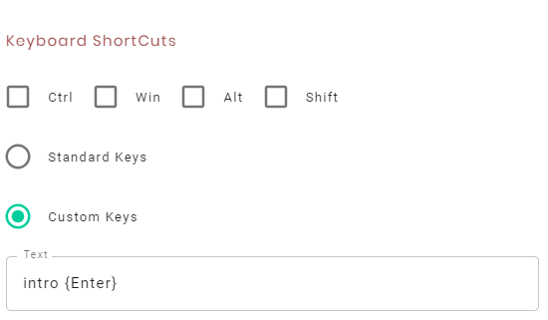

1. Drag and drop **CLOSE APP** action to close the specified application.
2. In the title name textbox, enter the title of the notepad.
3. Enter the Notepad title as “intro - Notepad” in the textbox.

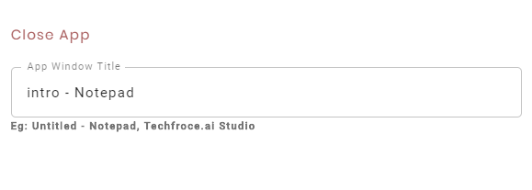

1. Drag and drop **SWITCH APP** action to switch from one application to another application.
2. Enter the title of the application to which you need to switch.
3. Enter the studio title as "Tekforce.ai Studio" in the Title textbox.

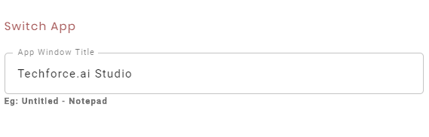

1. To **SAVE** the action flow click on the on  Icon.
2. To **EXECUTE** the action flow, click on the  icon.
3. The execution process shows the desktop, opens the Notepad, enters the text in the Notepad, saves the file, closes the file and redirects to the Studio.