**Build a flow using Excel Actions:**

Build a flow to filter data from an Excel sheet based on two different column values and save the data into a variable. Write the filtered data into a new sheet in the same workbook. Again, filter the data based on two different column values and save it into another variable. Append the data to the same new sheet. Then, get the complete data from the Excel sheet and write it into another Excel sheet. Delete a range of data from the newly created Excel sheet.

**Prerequisites**

To build a flow you must already have done the following:

1. Register with Techforce.ai
2. Install Techforce.ai studio. (link here to the Register/download page)

**Actions Used to implement the use case:**

1. Open Spreadsheet,
2. Filter Column,
3. Write Range,
4. Append Range,
5. Get Range,
6. Delete Range.

**Procedure:**

1. Creating an action Flow:
2. Click on the  icon, to create a new action flow.
3. Enter a name for the action flow and click on SAVE.
4. A new action flow is created with a stage in the developer panel.
5. Rename the stage as per requirement in the properties panel.
6. Example Excel sheet from which the data is to be filtered.
7. Filter the data based on Gender as Female and Country as France.(Ex excel sheet link).

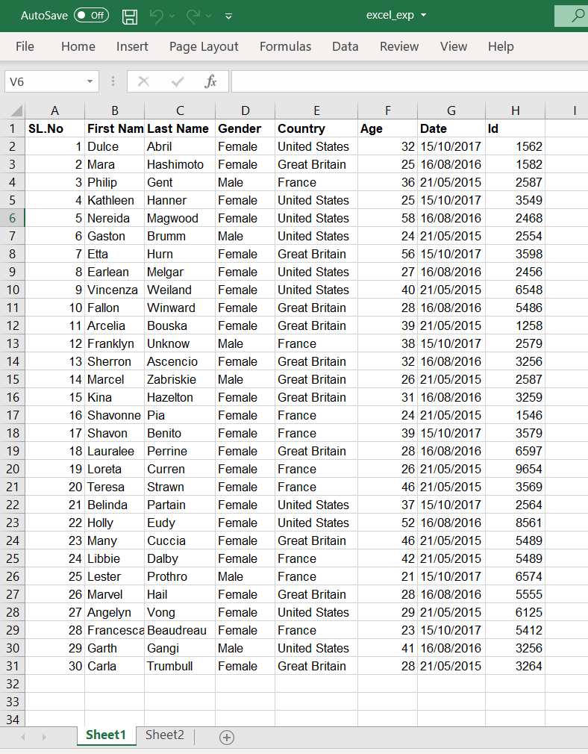

1. Drag and drop **OPEN SPREADSHEET** action into the developer panel.
2. The Open spreadsheet action is used to Open the selected Excel sheet in the headless mode.
3. Provides scope for Excel actions on the same sheet.
4. Click the browse option in the properties panel and select the Excel sheet.

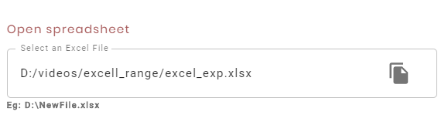

1. Drag and drop the **FILTER COLUMN** action into the "open spreadsheet" action.
   1. The Filter column action is used to filter the data from the excel sheet as per the
   2. Enter the sheet name from which the data is to be filtered in the "Sheet name" textbox.
   3. Check the  I**nclude Headers** checkbox to add the headers' data.
   4. In the "column name" textbox, enter the name of the column.
   5. Enter the value for the column name, based on which the data needs to be filtered.
   6. The  button is used to add or apply more filters.
   7. The  icon is used to delete the created headers if not required.
   8. Capture the filtered data into the Data Table type variable.
   9. To create a data table type variable, click on the symbol in the variable Panel.
   10. Rename the variable as "filterData" and select the type as dataTable, as the data to be captured is in the combination of rows and columns.

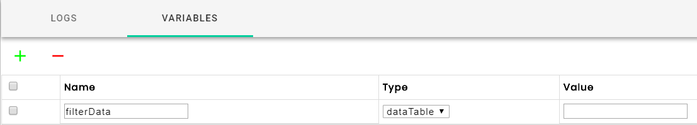

* 1. In the properties panel of filter-column action, select the " filterData " variable in the "Select variable" dropdown.

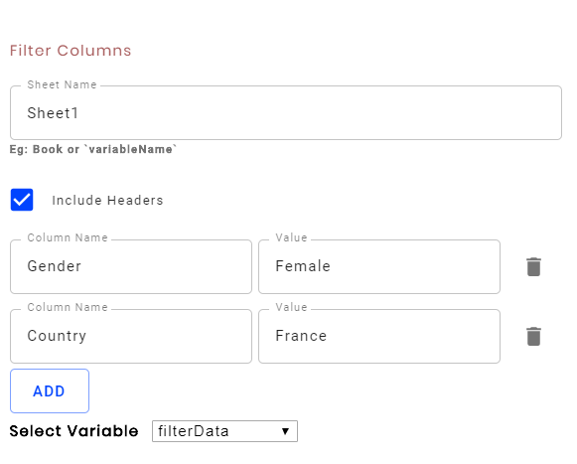

1. Drag and drop the **WRITE RANGE** action into the "Open spreadsheet" action.
2. Write range action to write the data into another new sheet in the same Excel workbook.
3. In the properties panel of Write range action enter the sheet name as "Sheet2".
4. The Write action creates a sheet with the given name and writes the data into that sheet from the given cell address.
5. Select the variable from which the data is to be written into the sheet from the "Select Variable" dropdown.

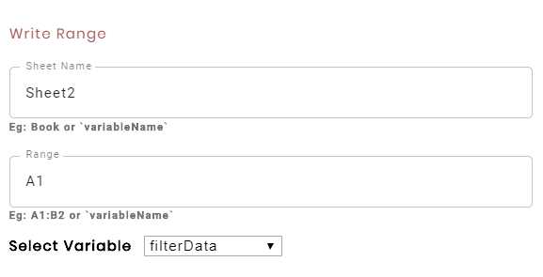

1. Again, filter the data with the country as the United States, and Gender as Female and capture the result into a dataTable type variable with another **FILTER COLUMN** action.

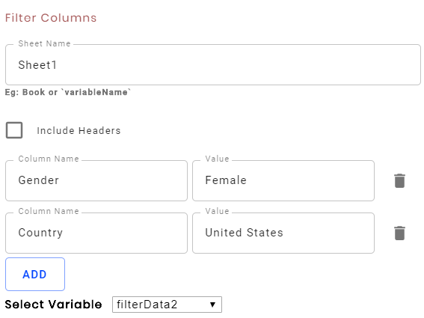

1. Drag and drop **APPEND RANGE** action into Open Spreadsheet action.
2. Append range action is to append the data into the selected sheet, from the selected data table type variable.
3. Enter the sheet name as sheet2 and select the "filterData 2" variable from the dropdown.

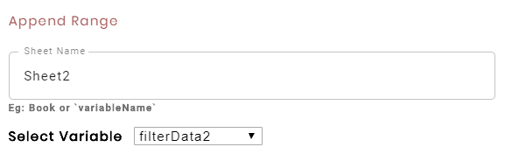

1. Save the flow by clicking on  Icon.
2. Execute it by clicking on the  button.
3. Check the Excel sheet for result.
4. The data of France and the United States is filtered and added into new sheet.

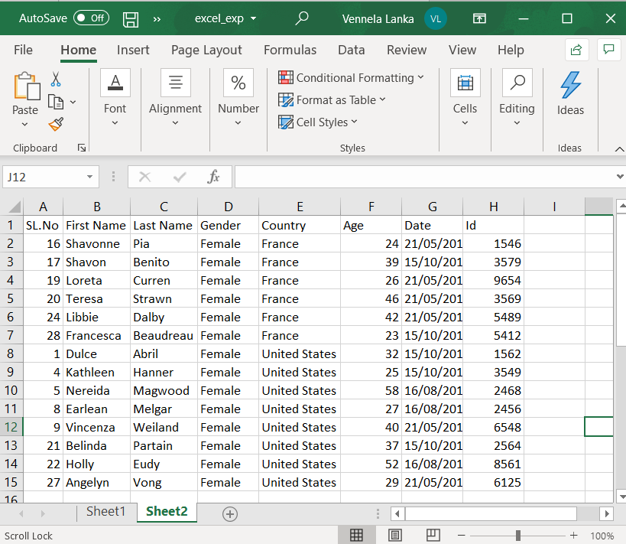

1. Now, let’s see how to get complete data from the existing sheet and delete a range of data.
2. Drag and drop the **GET RANGE** action into the "Open spreadsheet" action.
3. Get Range action is used to get the entire data from the Excel sheet or a selected range of data from the excel sheet.
4. In the sheet name text box, enter the sheet name from which the data is to be retrieved.
5. The range text box is optional. If specified, it gets the given range or the complete data from the sheet.
6. Select include the headers checkbox to get the header data.
7. Select the Text format checkbox to display the data in the row-wise format in the logs panel.
8. Select the variable to store the result data.
9. Enter Sheet1 in the sheet name textbox.
10. Leave the "From range" textbox "empty", to retrieve the complete data.
11. Select "Include headers" checkbox to include the headers' data also.
12. Create one more variable in the variable panel and rename it as getData of dataTable type.
13. Select the getData variable in the "Select variable" list.

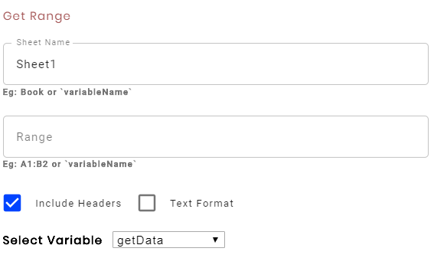

1. Drag and drop the **WRITE RANGE** action into the developer panel, below the open spreadsheet action.
2. Write range action is used to write the data into an Excel sheet,
3. Enter the full path of the Excel sheet in the full path text box.
4. Enter the sheet name, range, and select the getData variable to write the retrieved data into the new sheet.

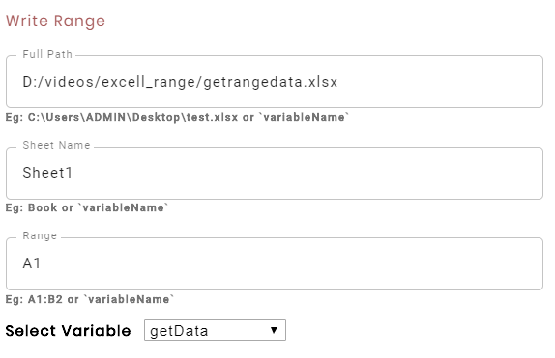

1. **Save** the flow and **Execute** it.
2. Check the new Excel sheet, The complete data is added.

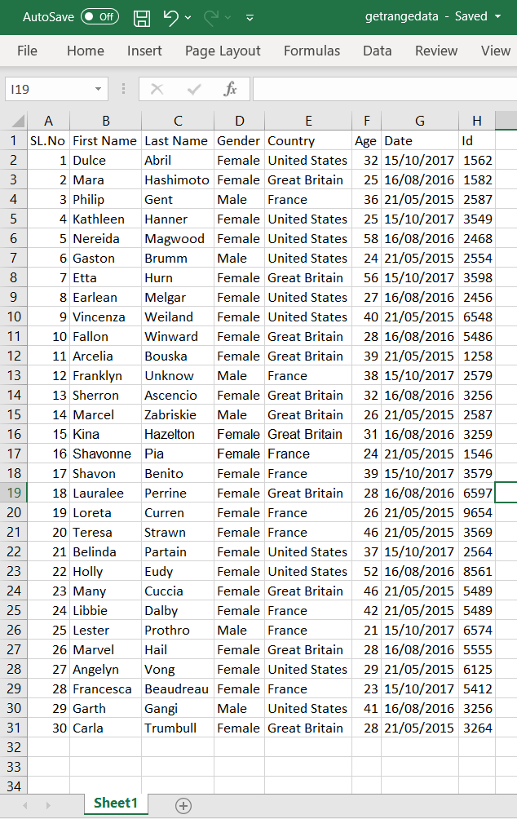

1. Now, let’s see the delete range action by deleting the data from A16 to F17.
2. Drag and drop the **DELETE RANGE** action into the developer panel.
3. The delete range action deletes the specified range of data from the excel sheet.
4. Enter the path of the Excel sheet in the full path textbox, sheet name in the sheet name textbox, and enter the range of data to be deleted in the "From Range" textbox.

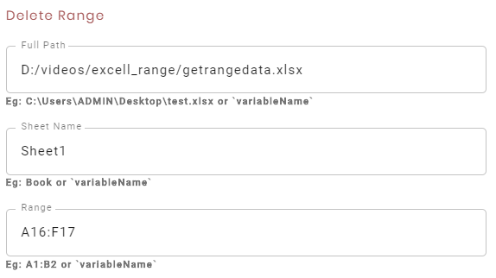

1. **Save** and **Execute** the flow.
2. You can see the data from A16 to F17 has been deleted.

