**Build a flow using files and folders:**

Build a flow to get today’s date and retrieve the Excel files downloaded with today’s date from a folder. Compare the file names with specified data, rename the file, and copy it to the required folder. Then delete the downloaded files.

**Prerequisites**

To build a flow you must already have done the following:

1. Register with Techforce.ai
2. Install Techforce.ai studio. (Provide a link here to the Register/download page)

**Actions Used to implement the use case:**

1. Date Format,
2. Get Folder content,
3. For loop,
4. If-Else,
5. Else-If,
6. Copy File/Folder,
7. Delete File/Folder.
8. Creating an action flow.
9. Click on the  NEW icon, to create a new action flow.
10. Enter a name for the action flow and click on SAVE.
11. A new action flow is created with a stage in the developer panel.
12. Rename the stage as per requirement in the properties panel.
13. Here are the different files that need to be renamed and copied into folders based on the name of the country.

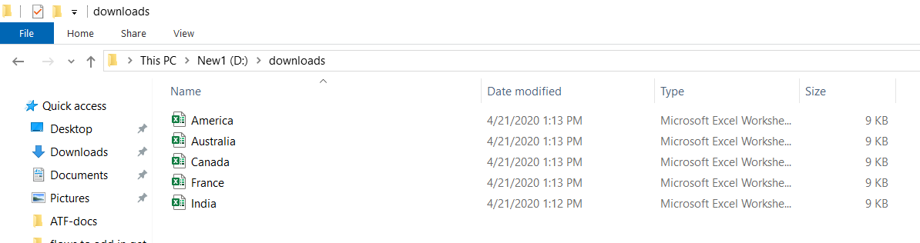

1. Drag and drop **DATE FORMAT** action into the Developer Panel.
2. Date format action is used to get different dates like Yesterday, Today, Tomorrow, Week start, Month start, Quarter start, and Year start dates.
3. You can also specify the required date format in the date format text field.
4. In the variable panel, create a variable of string type. Click on the to create a new variable.

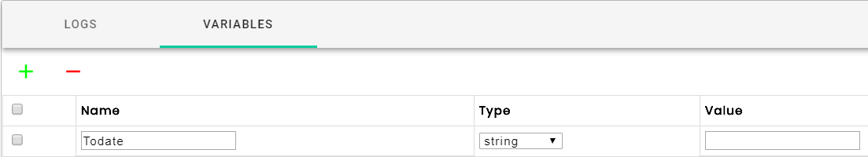

1. In the properties panel of the date format action, select the created variable from the variable list, then in the next drop-down box, select today as the option. Specify the required date format in the date format text box.

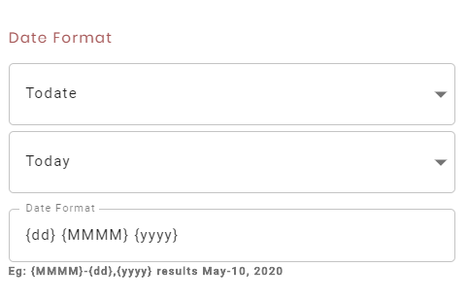

1. Now drag and drop a **GET FOLDER CONTENT** action into the developer panel.
2. Get folder contents action is used to retrieve the files or folders from the specified folder based on the given filter criteria.
3. Specify the folder path from where the files need to be retrieved in the folder path text box.

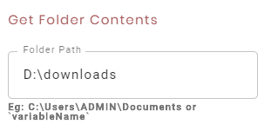

1. In the variable panel, create a variable of list type with name Country_data.



1. In the properties panel, specify the created list variable name in the variable textbox.

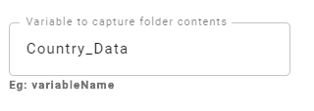

1. Select the **Files** radio button to get the list of files, and in the filter criteria textbox enter the files extension as *.xlsx to filter and retrieve the Excel files only.

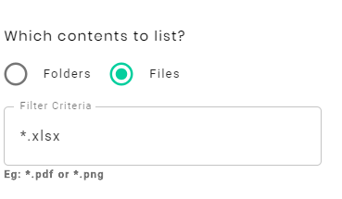

1. Date modified option is used to filter the files based on static and dynamic dates.

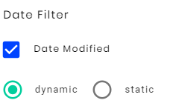

1. Click on the date modified checkbox, select the **dynamic** radio button, and specify the **Todate** variable in both **From** and **To** date textboxes to retrieve the files that are created on the current date.

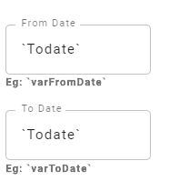

1. Drag and drop **FOR LOOP** action into the developer panel.
2. For Loop action is used to execute a series of actions for a specified number of iterations or till the target result is reached.
3. In the Element textbox, specify the index variable value as I, initial value as 0, and range value as `Country_data.length-1`.

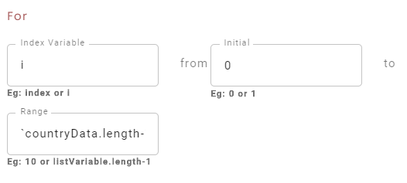

1. Drag and drop an **IF-ELSE CONDITION** into the For Loop.
2. If/Else action executes the block of code in then or else branches based on the outcome of the conditional expression.
3. Custom, Present, Visible, and Count are the supported target types in If/Else action.

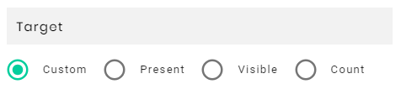

1. The Custom option is to evaluate the conditional expression based on variables and string literals.
2. The Present option is to check whether the given XPath element or selected image is present on the page.
3. The Visible option is to check whether the given XPath element or image is visible on the page.
4. The Count option is to check for the count of the XPath element on the page.
5. Select the Custom radio button and pass Country_data[i] value into the variable textbox, select contain option from the condition dropdown box and enter the value as India in double-quotes in the Value textbox as the requirement is to check if the file name contains the value “India” in it or not.

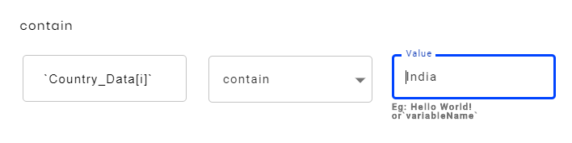

1. Drag and drop **COPY FILE/FOLDER** action into the **THEN** block.
2. The Copy File/Folder action is used to copy or move a file or folder from one location to another. It can be copied with the same name or can be renamed while copying.
3. Select the **File** radio button to copy or move files, and **Folder** radio button to copy or move folders.

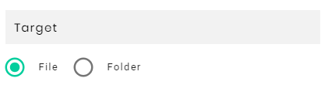

1. Enter the source and destination paths of files or folders to be copied or moved.

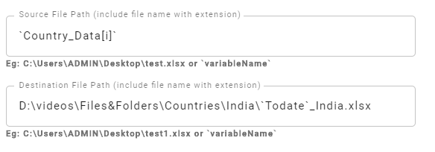

1. Select **Copy** mode to copy and **Move** mode to move files or folders.

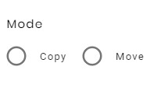

1. Users can also overwrite or skip if the destination path already exists by selecting the “Overwrite” or “Skip” options.

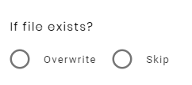

1. Now, to rename the file and copy it into the specified country folder based on the file name, select the **File** radio button, enter Country_data of I in the Source path.
2. Enter the desired target path in the Destination path. Select the **Copy** radio button to select copy mode and the **Skip** radio button to skip copying the file if it already exists in the destination path.
3. Drag and drop **DELETE FILE/FOLDER** action into THEN action.
4. The Delete File or Folder action is used to delete a file or folder from the specified path.
5. Select the **File** radio button to delete a file and **Folder** radio button to delete a folder and enter the path of the file or folder in the path text box.
6. As per our requirement, to delete the file, select the **File** radio button and pass the file path as Country_data of I in the path textbox.

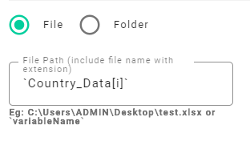

1. Drag and drop **ELSE-IF** action into the if-Else action.
2. Else-if action is used to model the **If-Elseif-Else** condition. If the condition in if-else fails then the flow checks the conditions in the Else-If block.
3. Else-if is a combination of **if** and **else**. Like else, it extends an if statement to execute a different statement in case the original if expression evaluates to false. However, unlike else, it will execute that alternative expression only if the else-if conditional expression evaluates to true.
4. Check if the file name contains another country name as a value in the else-if block.

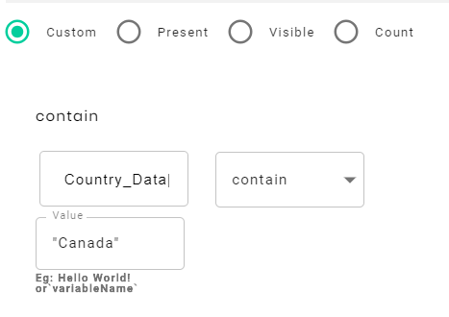

1. Drag and drop **COPY FILE/FOLDER** and **DELETE FILE/FOLDER** actions into **Else-if** action.
2. If the else-if condition is satisfied, it will rename the file and copy it into the specified country folder and delete the copied file.
3. The same process repeats for other country files also.
4. To **SAVE** the action flow, click on the SAVE Icon.
5. To **EXECUTE** the action flow, click on the  PLAY Icon.
6. You can see the execution of the action flows.
7. The files from the specified folder are retrieved, saved into their respective country folders, renamed with today's date and country name, and deleted from the source folder.