**Build a flow using Web actions:**

Build a flow to open a webpage, click on an element, scroll the page down, take the snapshot of a page, print the text of an HTML element in the logs, capture the column data from a web table into a variable and print it in logs. Then go back to the previous page.

**Prerequisites**

To build a flow, you must already have done the following:

1. Register with Techforce.ai
2. Install Techforce.ai studio. (Give a link here to the Register/download page)

**Actions Used to implement the use case:**

1. Open Webpage
2. DOM
3. Scroll
4. Snap
5. Show
6. Read table
7. Back,
8. Echo
9. Wait

**Procedure:**

1. Creating an action flow.
2. Click on the  (NEW) icon, to create a new action flow.
3. Enter a name for the action flow and click on SAVE.
4. A new action flow is created with a stage in the developer panel.
5. Rename the stage as per requirement in the properties panel.
6. Drag and drop the **OPEN WEBPAGE** action into the developer panel
7. Open webpage action is to open a specified URL with the selected browser.
8. Google Chrome, Mozilla Firefox, and Microsoft Edge are the supported browsers. The headless option is to execute the action flow in background mode
9. Select Google Chrome and Enter ‘https://www.countries-ofthe-world.com/’ in the "Page address" text box in the properties panel.
10. If you wish to download any files from the given website, mention the desired location in ‘Folder Path to Download Files’ text box

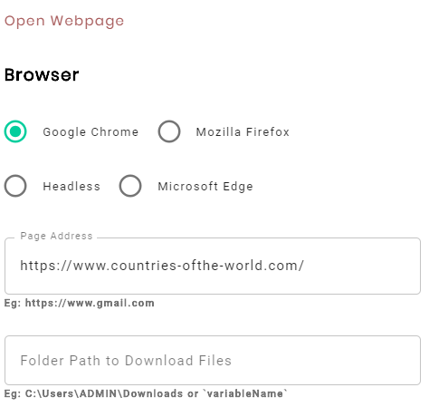

1. Drag and drop **WAIT** action into the developer panel
2. Wait action is to pause the execution of the action flow for the specified amount of time.
3. Enter 3 seconds in the properties panel text box to pause the execution for 3 seconds

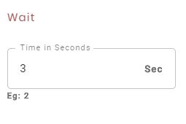

1. Drag and drop **DOM** action into the developer panel.
2. DOM action helps to get control over the web page’s document object model and accesses the specified element.
3. To capture the JS path of the element on which you wish to click, Right-click on the target text and select “**INSPECT**”. A developer tool window with the selected element highlighted will open.

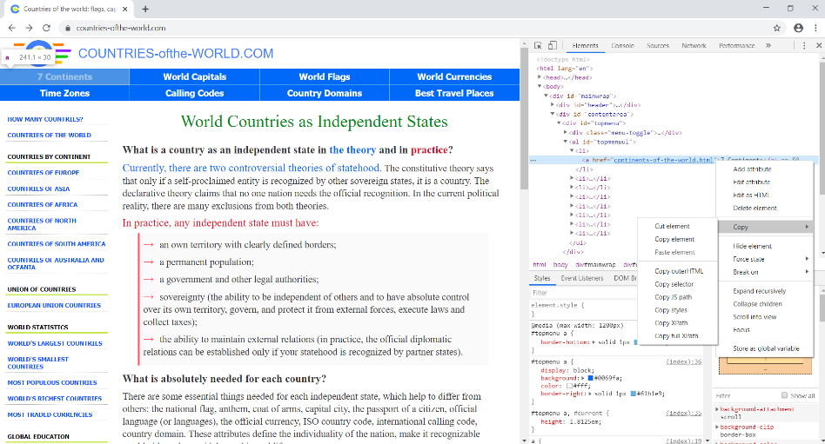

1. Right-click on the highlighted HTML element and click Copy, Copy JSPath.
2. Paste the copied JS Path value into the “Element JS path” text box in the properties panel.

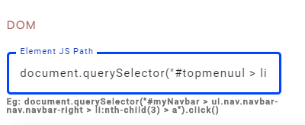

1. Drag and drop one more **WAIT** action into the developer panel and enter 3 seconds in the properties.
2. Drag and drop a **SCROLL** action into the developer panel.
3. Scroll action is used to scroll the web page up or down to the required element.
4. To scroll till the table element, right-click on the table element, select inspect, right-click on the highlighted table element in the developer tools and click COPY and copy XPath.
5. Select the **Scroll if Needed** radio button and paste the copied XPath in the Element XPath textbox.

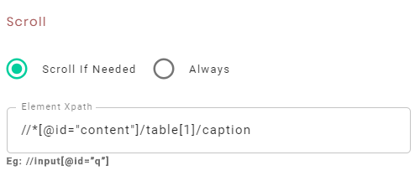

1. Drag and drop one more **WAIT** action into the developer panel and enter 2 seconds in the properties.
2. Drag and drop **SNAP** action into the developer panel.
3. Snap action is used to take the snap of a page or specified element.
4. The **Page** radio button is used to take a snap of the complete page and the **Custom** radio button is used to take snap of the selected element.
5. Select the **Page** radio button, provide a name to the image file in the text box.

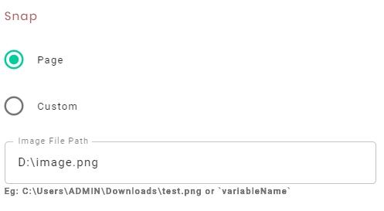

1. Drag and drop one more **WAIT** action into the developer panel and enter 2 seconds in the properties.
2. Drag and drop **SHOW** action into the developer panel.
3. Show action is used to read the text from a web element and print it in the logs.
4. Capture the HTML element from which the text needs to be printed in the logs, by copying its XPath.
5. Paste the copied XPath into the “HTML element” text box in the properties panel.

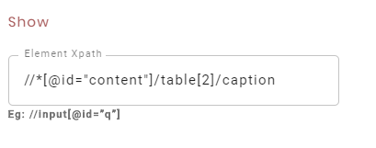

1. Drag and drop **READ TABLE** action to developer panel.
2. Read Table action is used to read the column content from a web table.
3. Capture the XPath of the Table element, paste it in the Table XPath text box.
4. If the web table is embedded in any Frame, capture the frame name and paste it in the Iframe name text box.
5. Enter the column name of the web table from which you want to retrieve the data.
6. Click the variable panel and create a new variable to store the retrieved data.
7. To create a list type variable, click on the symbol in the variable Panel. Select **LIST** in the type dropdown.

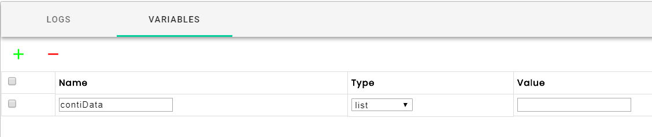

1. Select the newly created variable in the “Variable” dropdown.

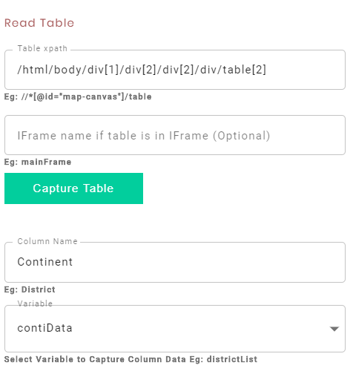

1. Drag and drop the **ECHO** action into the developer panel.
2. The Echo action is used to print the data to the logs panel
3. Select the variable radio button and then select the “**Continent**” variable from the variable drop-down list.

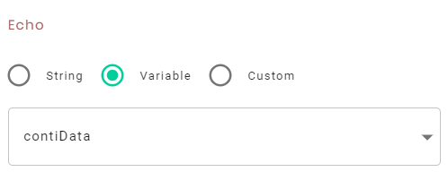

1. Drag and drop the **BACK** action into the developer panel. The back action is used to navigate back to the previous page.
2. Click on  Icon to **SAVE** the action flow.
3. To **EXECUTE** the action flow, click on the  PLAY Icon.
4. During execution, you can notice the action flow opens the website, waits for 3 seconds, clicks on the specified element, scrolls down, takes a snap of the specified page, reads the data from the specified elements, prints the data to the logs panel and navigates back to the home page.
5. Here is the snapshot of the element and the data printed in the logs.

