Fab Copilot
Phase 1~2 System Design Specification
Version 4.1

Dual-Layer Architecture: Document RAG (Common) + Equipment Diagnostics (Per-Equipment)
3-Tier Hybrid Knowledge Predictive Diagnostics
+ LLM DLP / Progressive Response / HA Failover

LLM: Configurable (Ollama / HuggingFace TEI) | Client GUI: ChatGPT-Style + Equipment Dashboard

Revision History
Version | Date | Changes | Author
v2.2 | 2025-01 | Query Router, Dual-Gate, Telemetry | -
v3.0 | 2025-02 | Table Parsing, Image Strategy, Embedding Eval, Latency, Security, Cache, Runbook | -
v3.1 | 2025-02 | Citation Pane, Full Korean Localization | -
v3.2 | 2025-02 | E2E Latency extended to 3min, Timeout Policy | -
v3.3 | 2025-02 | Precise Citation, Ghost Citation Prevention (Gate C) | -
v3.4 | 2025-02 | BGE-M3/KURE Embedding, Dual-Index, Model Comparison | -
v3.5 | 2025-02 | Config-based LLM Server Selection | -
v3.6 | 2025-02 | Page-less Citation (Chapter/Section/Line based) | -
v4.0 | 2025-02 | Dual-Layer Architecture, Equipment Diagnostics (Phase 2.x), 3-Tier Hybrid Knowledge Predictive Diagnostics, Integrated GUI Refactoring | -
v4.1 | 2025-02 | LLM DLP (Input/Output Guardrail), Safety Feedback Escalation, Multi-Stage Progressive Response, LLM Server HA + SLM Conditional Failover, media_link Field Pre-provisioning | -

Table of Contents

PART I — Overview

1. Overview

1.1 Vision and Dual-Layer Architecture
Fab Copilot is an AI-based equipment support system for semiconductor manufacturing. The system adopts a Dual-Layer architecture that clearly separates document-based knowledge retrieval from equipment-specific real-time diagnostics.

Category | Layer 1: Document RAG | Layer 2: Equipment Diagnostics
Data Source | Manuals, Troubleshooting Guides, Spec Docs (Static) | Sensor Logs, Event Logs, Alarm History (Dynamic)
Index Scope | All-Equipment Common Single Index | Per-Equipment Instance Independent Data Store
Update Cycle | Document Revision (Weeks~Months) | Real-time ~ Minute-level Streaming
Search Method | Hybrid (Vector + BM25) | Time-series Query + Pattern Matching + ML Inference
Example Query | "Error E-1023 cause and action" | "CMP-07 pressure trend last 7 days?"
Equipment Filter Role | Search condition (metadata filter) | Data partition key (physical separation)
Phase | 1.x (Current) | 2.x (New)

1.2 Phase 1.x Goals (Document RAG — All-Equipment Common)
- High-precision retrieval of equipment manuals and troubleshooting guides
- Error code-based immediate response and resolution suggestions
- Document-grounded responses (Hallucination minimization): Answer rejection logic when search results are insufficient
- Citation Pane: Click citations in responses to auto-display original PDF with highlighted evidence areas
- End-to-end response latency target: P95 < 3 minutes (180 seconds)

1.3 Phase 2.x Goals (Equipment Diagnostics — Per-Equipment)
- Per-equipment instance data collection pipeline (SECS/GEM, OPC-UA)
- Time-series trend analysis and anomaly detection (statistical + ML)
- Alarm pattern analysis and error code correlation analysis
- 3-Tier Hybrid Knowledge-based predictive diagnostics (RUL, failure probability)
- Cross-Layer Linking: Anomaly detection auto-triggers Layer 1 RAG to attach manual evidence
- Integrated Dashboard GUI with real-time sensor charts and diagnostic summaries

1.4 Out of Scope (Phase 3)
- Multimodal image recognition-based troubleshooting (photo/video input)
- AR overlay maintenance procedures
- Knowledge graph construction

1.5 Cross-Layer Linking
When Layer 2 detects an anomaly, it automatically generates a query to Layer 1 to present relevant manual evidence together:

1. Layer 2 detects anomaly: "CMP-07 Chamber Pressure trend deviation (±3σ, last 2 hours)"
2. Auto-query generation → Layer 1 RAG: "CMP chamber pressure abnormal cause and action"
3. Layer 1 returns manual evidence: [MNL-2025-001-Ch5-S5.3.2-{Line:201-215}]
4. Integrated response: Sensor data analysis + Manual evidence + Recommended action

1.6 Terminology
Term | Definition
RAG | Retrieval-Augmented Generation
BM25 | Best Matching 25 — Probabilistic keyword search algorithm
MMR | Maximal Marginal Relevance — Diversity-based result selection
HNSW | Hierarchical Navigable Small World — Approximate neighbor index
EPD | End Point Detection — Semiconductor process endpoint detection
CMP | Chemical Mechanical Planarization
RAGAS | Retrieval-Augmented Generation Assessment Framework
RBAC | Role-Based Access Control
Citation Pane | Panel displaying original PDF with highlights when citation is clicked
RUL | Remaining Useful Life — Predicted remaining operational time of consumable/component
SECS/GEM | SEMI Equipment Communication Standard / Generic Equipment Model
OPC-UA | Open Platform Communications Unified Architecture
Cross-Layer | Automatic linking between Layer 1 (RAG) and Layer 2 (Diagnostics)
Fusion Engine | Engine integrating evidence from multiple knowledge tiers for diagnosis

2. System Architecture Overview

2.1 End-to-End Block Diagram (Dual-Layer)
The system consists of Layer 1 (Document RAG) for all-equipment common document retrieval, Layer 2 (Equipment Diagnostics) for per-equipment real-time analysis, and an Integrated GUI Shell that provides seamless switching between Chat and Dashboard modes.

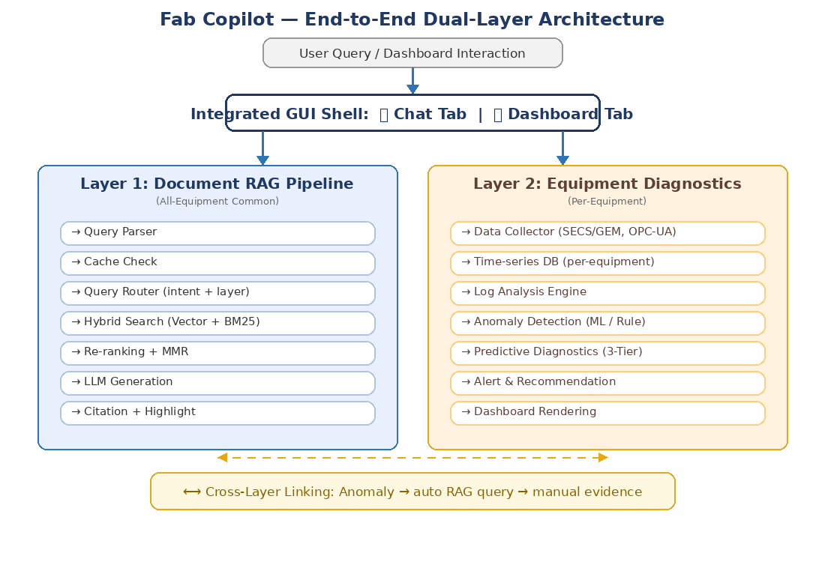

2.2 Layer Separation Principles
- Layer 1 (Document RAG): All equipment manuals in a single shared index. Equipment differentiation via metadata filters only, not separate indices.
- Layer 2 (Equipment Diagnostics): Physically partitioned by equipment_id. Each equipment instance has independent data storage namespace.
- Cross-Layer: Layer 2 anomaly events trigger automatic Layer 1 queries. Results are merged in the GUI.

2.3 Technology Stack

2.3.1 Layer 1 Stack (RAG)
Layer | Primary | Alternative
Search Engine | Elasticsearch 8.x | OpenSearch 2.x
Vector DB | Qdrant (on-prem, HNSW) | Weaviate / Milvus
LLM Serving | Ollama / HuggingFace TEI (Config) | Hot-swap via config file
Embedding | Ollama→Snowflake / TEI→BGE-M3 (default) | KURE (manual config)
Re-ranker | BGE-Reranker-v2-M3 | Cross-encoder/ms-marco
Cache | Redis 7.x | In-memory LRU
PDF Viewer | pdf.js v4.x (Citation Pane) | PSPDFKit
Monitoring | Prometheus + Grafana | ELK Stack

2.3.2 Layer 2 Stack (Diagnostics)
Layer | Primary | Alternative | Notes
Time-series DB | InfluxDB 2.x (OSS) | TimescaleDB / QuestDB | Per-equipment bucket
Streaming Ingest | Apache Kafka | RabbitMQ / MQTT | SECS/GEM bridge required
Anomaly Detection | PyOD + Scikit-learn | Custom models | On-prem priority
Predictive Models | PyTorch / ONNX Runtime | TensorFlow Serving | Per-equipment serving
Model Management | MLflow | W&B | Experiment/version/deploy tracking
Dashboard Charts | Apache ECharts | Plotly / Grafana Embed | Time-series specialized
Alerting | Alertmanager (Prometheus) | Custom alert service | Multi-channel routing
Equipment Comm. | py-secs / secsgem | Vendor SDK | SEMI standard compliance

2.4 LLM/Embedding Server Configuration Management
Config file (YAML/JSON) enables selecting LLM serving server and Embedding model, with hot-reload without service restart.

Config Value | LLM Server | Default Embedding | Notes
llm_server: ollama | Ollama | Snowflake Arctic Embed | Lightweight deployment
llm_server: huggingface_tei | HuggingFace TEI | BGE-M3 | High-quality multilingual

- Hot-Reload: Config changes apply without service restart (in-flight requests complete with old config)
- Embedding model change: Requires full document re-indexing (zero-downtime via Dual-Index strategy, see 4.3.2)
- LLM server change: No re-indexing needed, immediate switchover
- Fallback: Auto-switch to fallback_server if primary is unresponsive

2.5 Deployment Topology
- Air-gapped deployment option for secure Fab environments
- All components on-premise deployable
- Layer 1 and Layer 2 can be deployed on separate server groups for resource isolation

2.5.1 LLM Server High Availability
The LLM serving server is a single point of failure (SPOF) in the response pipeline. The following HA measures are required:
- Primary/Secondary LLM server dual deployment (Active-Standby or Active-Active)
- Health-check module: Periodic heartbeat + inference latency monitoring (interval: 10s)
- Auto-failover: Primary unresponsive > 30s triggers automatic switchover to secondary
- Health status exposed via /health endpoint for Prometheus scraping

2.5.2 SLM Conditional Failover
When both primary and secondary LLM servers are unavailable, a lightweight Small Language Model (SLM) provides degraded but safe service. Critical constraints apply:

Constraint | Rationale
SLM responses must display explicit quality warning: "Generated by backup model. Accuracy may be reduced. Verify against manual directly." | Prevents engineers from trusting low-quality output for critical equipment decisions
SLM returns Layer 1 RAG chunk text verbatim (no LLM generation) | Raw chunk text is safer than poorly generated summaries in equipment context
Layer 2 predictive diagnostics DISABLED during SLM failover | Incorrect RUL/failure predictions are more dangerous than no predictions
SLM mode triggers Critical alert to Admin for immediate attention | SLM is emergency-only; normal service must be restored promptly

PART II — Layer 1: Document RAG (All-Equipment Common)

3. Document Preprocessing Pipeline

3.1 Structure-Based Chunking (Table-Aware)
- Table parsing: Convert in-manual table data to Markdown, preserving structure
- Image anchoring: Attribute drawing/photo position info to metadata
- Hierarchy preservation: Chapter > Section > Procedure > Error Code

3.2 Table Parsing Pipeline
Tool | Best For | Limitations | Fallback
Camelot (lattice) | Grid-lined tables | Fails on borderless | Switch to stream mode
Camelot (stream) | Borderless tables | Lower accuracy on complex layouts | Manual annotation
Tabula | Simple tables | Cell merge issues | Post-processing script
Google Document AI | Complex multi-span | Cloud dependency, cost | On-prem OCR

3.3 Chunking Rules
- Procedure/Cause/Action chunks: 10~20% overlap
- Each chunk includes parent_context (1~2 line summary of parent section)
- Table chunks: Must include table title + column headers + units
- Maximum: 512 tokens / Minimum: 64 tokens
- Citation Pane integration: Each chunk must contain {doc_id, chapter, section, line_start, line_end, char_offset_start/end, bbox}

3.4 Metadata Field Definition
Field | Description | Category
equipment | Equipment name/identifier | Core
doc_type | Document type | Core
chapter/section | Hierarchical position in document | Core
model_version | Equipment sub-version differentiation | Core
language | Korean/English filtering | Core
last_updated | Latest revision date | Core
doc_id/revision | Document ID and revision code | Extended
is_superseded | Superseded status | Extended
option_kit | Applicable option/kit | Extended
chunk_type | text/table/image_ref/procedure | Extended
highlight_coords | {doc_id, chapter, section, line_start, line_end, char_offset_start/end, bbox} | Core

3.5 Technical Synonym Dictionary Management
- Vacuum → Vac, Vv, V/V | Pressure → Press, P, PRESS | Carrier Film → CF, Membrane
- Initial construction → Quarterly review → Feedback-based immediate addition → Git version control

3.6 Common Index Design Principles
All equipment manuals are indexed into a single shared index. Equipment differentiation is achieved exclusively through metadata filters at search time, not through separate indices. This ensures:
- Cross-equipment search capability (e.g., comparison queries between equipment types)
- Simplified index management and reduced storage overhead
- Consistent embedding space across all documents

4. Retrieval Pipeline

4.1 Hybrid++ Search Strategy Overview
# | Component | Purpose
1 | Vector Search | Semantic similarity search (context understanding)
2 | BM25 Keyword Search | Precise matching for error codes, part numbers
3 | Technical Synonym Dictionary | Field abbreviation and term mapping
4 | Re-ranking (Cross Encoder) | Result re-ordering for improved accuracy
5 | Query Router (Intent-based) | Query type branching and weight optimization
6 | Diversity Selection (MMR) | Deduplication and evidence diversity
7 | Result Cache Layer | Reduced response latency for frequent queries

4.2 Query Router (Intent-Based)

4.2.1 Intent Classification
Intent | Strategy | Example Query
error | Error Lookup + BM25 weight↑ | "Error E-1023 occurred"
procedure | Procedure/work sequence section weight↑ | "Head cleaning procedure"
part | Part number/consumable + normalization rules | "O-ring P/N 12345"
definition | Terminology/Glossary section priority | "What is EPD?"
spec | Spec/limit/table chunk priority | "Pressure spec range"
comparison | Multi-document cross-reference + version comparison | "Rev.A vs Rev.B differences"
general | General hybrid search | "Slurry system operating principle"

4.2.2 Layer Routing
The Query Router now includes an additional Layer routing step that determines whether a query should be handled by Layer 1 (Document RAG), Layer 2 (Equipment Diagnostics), or both:
Query Pattern | Target Layer | Example
Manual/procedure/spec/error lookup | Layer 1 only | "E-1023 cause and action"
Sensor trend/statistics/anomaly | Layer 2 only | "CMP-07 pressure trend 7 days"
Current anomaly + manual reference | Layer 2 + Layer 1 (Cross-Layer) | "Why is CMP-07 pressure rising?"
Predictive/RUL queries | Layer 2 + Layer 1 (Cross-Layer) | "CMP-07 membrane replacement needed?"

4.3 Embedding Model Selection and Evaluation

4.3.1 Available Models
Model | Characteristics | Default Server | Strengths
Snowflake Arctic Embed | Lightweight high-performance | Ollama (default) | Native Ollama support, fast inference
BGE-M3 | Multilingual, Dense+Sparse+ColBERT | HuggingFace TEI (default) | Excellent cross-language retrieval
KURE | Korean-specialized Retrieval | Manual designation | Superior Korean technical document accuracy

4.3.2 Dual-Index Transition Architecture
- Embedding Abstraction Layer: Switch models via Config without code changes
- Dual-Index Strategy: Maintain active and standby indices in parallel
- Transition: Re-index with new model → Pass evaluation tests → Switch active → Keep old for rollback
- Auto-rollback: If Recall@10 degradation detected, auto-revert to previous model

4.3.3 Evaluation Criteria and Fine-tuning
- Metrics: Recall@10, MRR@10, NDCG@10 (separated by intent)
- Cross-language evaluation: Korean query → English docs, and vice versa
- Inference latency: P95 inference time comparison (within 1,000ms budget)
- Domain suitability: Semiconductor equipment terminology/abbreviation accuracy
- Fine-tuning trigger: Recall@10 < 80%, minimum 5,000 positive pairs

4.4 Hybrid Search (Vector + BM25 + Structured Filter)
Combines vector similarity search with BM25 keyword matching, enhanced with structured metadata filters for equipment, document type, language, and model version.

4.5 Re-ranking + MMR (Diversity)
Cross-encoder re-ranking on top-50 candidates, followed by MMR diversity selection to ensure evidence variety in final results.

4.6 Result Cache Strategy
- Cache scope: (equipment, intent, normalized_query) tuple
- TTL: 24 hours or document revision update, whichever is shorter
- Invalidation: Auto on re-indexing / Manual API purge
- Cache hit rate target: error intent > 30% within 3 months of deployment

5. Response Generation and Quality Assurance

5.1 End-to-End Flow (8-Step)
1. User query input
2. Query Parser: synonym expansion, error code/part number extraction
3. Cache check: if cache hit, skip to step 8
4. Query Router: intent classification + Layer routing
5. Hybrid Search: Vector + BM25 + Structured Filter
6. Threshold Filtering + Re-ranking (Cross Encoder) + MMR
7. LLM Generation: Evidence-based response + citations + highlight_coords
8. Post-processing: Citation formatting, confidence check, cache update

5.2 LLM Prompt Rules
- No Source, No Answer: Document-based responses only, no speculation
- Flow: Root cause analysis → Manual evidence verification → Solution
- All responses require precise citation: [DOC_ID-Chapter-Section-{Line:FromLine-ToLine}]
- Preserve numeric values, units (°C, MPa, etc.) and proper nouns from source
- Document conflicts: Specify priority based on revision/last_updated + notify conflict
- Respond in same language as user query
- Table data: Preserve original structure when reproducing
- All citations must include citation_id, highlight_coords, line_range, display_ref
- Ghost Citation absolutely prohibited: Never include non-existent doc_id, chapter, section, or line numbers

5.3 Dual-Gate + Gate C Response Policy
- Gate A (Search Confidence): Evaluate candidate document quality via hybrid score + intent suitability
- Gate B (Evidence Confidence): Final decision based on whether actual citable evidence exists
- Gate C (Citation Verification): Post-processing verification that all citations reference actually existing documents/chapters/sections/line numbers

On rejection: "Insufficient evidence" / "Additional information needed" / Suggest alternative queries

5.4 Ghost Citation Prevention
- Document ID verification: Confirm doc_id exists in indexed document DB
- Section/Chapter verification: Confirm cited chapter/section matches document TOC
- Line range verification: Confirm from/to is within actual line count of section
- Content match verification: Verify cited area text semantically matches actual chunk content
- On failure: Remove citation from response, display "Source unverifiable", log to telemetry

5.5 Citation System: Chapter/Section/Line Based
Format: [DOC_ID-Chapter-Section-{Line:FromLine-ToLine}]
Example: [MNL-2025-001-Ch3-S3.2.1-{Line:142-158}]

5.6 Response Format (Strict)
# | Item | Description
1 | Summary | 1-line summary of action items
2 | Detail | Step-by-step resolution procedure (tables/lists)
3 | Reference Section & Images | Reference section title + diagrams/photos (clickable links)
4 | Source Citation | [DOC_ID-Chapter-Section-{Line:From-To}] format → Click opens Citation Pane
5 | Confidence Check | If evidence insufficient: "No information in manual" + guidance for additional input

PART III — Layer 2: Equipment Diagnostics (Per-Equipment)

6. Equipment Data Collection and Management

6.1 Data Collection Architecture

6.1.1 Target Data Types
- Sensor time-series: pressure, temperature, flow rate, RPM, torque, thickness, etc.
- Event/alarm logs: error codes, warnings, state transitions
- Process recipe execution history
- PM (Preventive Maintenance) history
- Consumable replacement history: pad, slurry, O-ring, membrane, etc.
- Media links (Phase 3 pre-provisioning): media_link field on all event logs for future photo/video attachment. Field is nullable and unused in Phase 2, but schema-ready for multimodal integration.

6.1.2 Collection Protocols
Protocol | Description | Use Case
SECS/GEM (SEMI E5/E37) | Standard semiconductor equipment communication | Primary interface for fab equipment
OPC-UA | Industrial automation standard | Equipment with OPC-UA server support
File-based (CSV/FDC dump) | Batch file upload | Legacy equipment, manual data migration
Equipment Vendor API | Vendor-specific REST/proprietary API | Vendor-provided data endpoints

6.1.3 Data Partitioning Strategy
- Partition key: equipment_id (per-equipment instance)
- Each equipment instance has an independent storage namespace
- Retention policy: Hot (7 days, SSD) → Warm (90 days, HDD) → Cold (Archive)

6.2 Equipment Registry

6.2.1 Equipment Master Information
Each equipment instance is registered with: equipment_id, equipment_type, model, serial, fab, bay, location, installation date, last PM date, operating status (Running/Idle/Down/PM).

6.2.2 Equipment-Document Mapping (Layer 1 Connection)
- equipment_type → Related doc_id list (manuals, specs)
- Used for Cross-Layer automatic query generation

6.2.3 Per-Equipment Diagnostic Model Binding
- equipment_id → Applied model version, training data range, threshold profile

6.3 Data Quality Management
- Missing/outlier preprocessing: gap filling, spike removal
- Sensor drift correction criteria
- Collection latency monitoring: alarm on > 5-minute gaps

7. Log Analysis Engine

7.1 Time-Series Analysis

7.1.1 Trend Analysis
- Moving average, exponential smoothing, change point detection (CUSUM, PELT)
- Per-equipment baseline auto-learning (based on 30 days of normal operation)

7.1.2 Anomaly Detection
Approach | Method | Characteristics
Statistical | ±3σ, IQR, Mahalanobis Distance | Simple, interpretable, fast
ML-based | Isolation Forest, AutoEncoder | Per-equipment training, multivariate
Rule-based | Engineer-defined thresholds | SEMI spec integration, domain-specific

7.1.3 Correlation Analysis
- Multi-variate sensor correlation analysis (e.g., pressure ↔ flow)
- On anomaly detection: auto-highlight correlated sensors

7.2 Event/Alarm Analysis

7.2.1 Alarm Pattern Analysis
- Frequent alarm Top-N / time-of-day distribution
- Alarm sequence pattern mining: detect A→B→C cascading patterns

7.2.2 Error Code Statistics and Correlation
- Per-error-code occurrence frequency, MTBF (Mean Time Between Failures)
- Error code ↔ sensor anomaly timestamp cross-analysis

7.2.3 Layer 1 Auto-Connection
- Detected error codes/anomalies → Auto-generate Layer 1 RAG query
- Auto-attach manual evidence (Cross-Layer Linking)

7.3 Process Quality Correlation (Future Extension)
- Wafer metrology data integration (CMP: thickness, non-uniformity)
- SPC (Statistical Process Control) chart linkage

8. Predictive Diagnostics (3-Tier Hybrid Knowledge)

8.1 Hybrid Knowledge Architecture Overview
Predictive diagnostics relies not on a single knowledge source but on a hierarchical combination of three knowledge tiers. This resolves cold start, verification, and scalability limitations of any single-source approach.

Tier | Name | Source | Cold Start | Strengths | Weaknesses
Tier 1 | Data-Driven | Sensor data auto-learning | Requires 30+ days | Scalable, no human bias, multivariate | Hard to interpret, slow to bootstrap
Tier 2 | Expert Knowledge | Engineer experience input | Requires accumulation | Conditional causality, unit-specific, reduces false alarms | Input burden, causal illusion, limited scalability
Tier 3 | Document-Grounded | Auto-extracted from manuals | Available Day 1 | Immediate availability, official procedures | Generic (not unit-specific), limited to documented knowledge

8.1.1 Design Principles
- No single knowledge source dependency: Each tier compensates for others' weaknesses
- Cross-tier verification: Tier 2 (expert rules) are verified against Tier 1 (data) for accuracy
- Day 1 operability: Tier 3 ensures predictive diagnostics work from deployment day

8.1.2 Cold Start Resolution
Timeline | Tier 1 (Data) | Tier 2 (Expert) | Tier 3 (Document) | Diagnostic Capability
Day 1 (Deploy) | ✗ | ✗ | ✓ | Manual-based basic diagnostics immediately available
Month 1 | △ (Training) | △ (Initial input) | ✓ | Manual + initial expert rules
Month 6 | ✓ (1st model) | △ (Accumulating) | ✓ | 3-Tier fusion begins
Year 1+ | ✓ (Mature) | ✓ (Mature) | ✓ | Full Hybrid operation

8.2 Tier 1: Data-Driven Models

8.2.1 Per-Equipment Model Management
- Independent model per equipment instance (individual training even for same type)
- Model versioning: model_id, equipment_id, train_date, data_range

8.2.2 Model Types
Model Type | Purpose | Output
RUL (Remaining Useful Life) | Consumable lifespan prediction (pad, membrane, O-ring) | Remaining hours/percentage
Failure Probability | Probability of specific error within next N hours | Probability percentage
Performance Degradation | Drift-based PM timing recommendation | Recommended PM window

8.2.3 Training Pipeline
- Data collection → Preprocessing → Feature engineering → Training → Evaluation → Deployment
- Per-equipment periodic retraining (monthly or after PM)
- A/B testing: New model vs. existing model parallel operation

8.3 Tier 2: Expert Knowledge Base
The core insight is valid: conditional causal relationships known only through field experience (e.g., "E-1023 within 3 days of slurry change on CMP-07 means purge failure, not O-ring") are critical for accurate diagnostics. However, this knowledge must be systematically captured, verified, and lifecycle-managed.

8.3.1 Structured Knowledge Input
Minimizing engineer input burden is critical. Free-text input is replaced with structured templates:

Field | Description | Example
Equipment Scope | All units of type or specific instance | CMP-07 (specific)
Symptom (When) | Observed sensor + condition + preceding event | Chamber Pressure rising trend, > 2 hours, within 3 days after slurry change
Cause (Why) | Estimated root cause | Slurry line purge incomplete
Evidence Type | Manual reference / Field experience / Data analysis | Field experience
Confidence (Self-assessed) | Registrant's confidence level | ★★★★☆
Action (What) | Recommended action | Re-purge slurry line (5 min)
Caution | What NOT to do | O-ring replacement is unnecessary in this case
Experience Count | Times confirmed in practice | 3+ times confirmed
Related Error Code | Associated error codes | E-1023

8.3.2 Passive Knowledge Collection
In addition to active input, knowledge is naturally collected from daily workflow:

Path 1: Chat Conversation Mining
Engineer types in Layer 1 Chat: "This is a slurry purge issue"
→ NLP extracts symptom-cause pair candidate
→ Popup: "Register this as an expert rule?"

Path 2: Action History Auto-Linking
Alarm occurs → Engineer takes action → Normal recovery
→ Alarm pattern + action content auto-generated as candidate rule
→ Auto-suggested when same pattern repeats 3+ times

Path 3: Feedback-Based Learning
Predictive diagnostic result receives "Accurate" / "Inaccurate" feedback
→ On "Inaccurate": Prompt for actual cause input
→ New rule candidate auto-registered

8.3.3 Automatic Verification Loop
This is the critical mechanism that addresses the "correlation vs. causation" and "unverifiable rules" problems. Expert-submitted rules are retrospectively verified against actual sensor data:

Verification Process:
1. Extract condition-matching cases from historical data
(e.g., "Pressure rise within 3 days of slurry change": 47 events found)
2. Cross-reference with actual root cause (PM history / action history)
(Purge failure confirmed: 38 cases = 81% | O-ring issue: 6 cases = 13% | Other: 3 cases)
3. Auto-calculate precision: 81% → Rule validated (threshold: > 70%)
4. Auto-annotate exceptions: "13% of cases were actually O-ring issues"

Rules with precision < 70% are flagged for senior engineer review before activation.

8.3.4 Knowledge Lifecycle Management
Stage | Activity | Auto/Manual
Registration | Engineer inputs via structured template | Manual
Verification | Data-based retrospective case matching | Auto
Approval | Precision > 70%: Auto-activate / < 70%: Senior review | Semi-auto
Operation | Apply matching rules during diagnosis, track hit rate | Auto
Refresh | Trigger re-verification when hit rate declines | Auto
Retirement | Hit rate < 50% for 6 months → Deactivate + notify registrant | Semi-auto

8.3.5 GUI: Expert Knowledge Management (see 9.5.7~9.5.8)
Dashboard integration includes Quick Entry button ("I know this cause") and Knowledge Base Browser showing active rules, confidence scores, hit rates, and edit capabilities.

8.4 Tier 3: Document-Grounded Knowledge
Automatically extracts diagnostic causal knowledge from manuals already indexed in Layer 1 RAG, providing a baseline knowledge set available from Day 1 of deployment.

8.4.1 Auto-Extraction Targets
Source in Manual | Extraction | Usage
Troubleshooting Section | Symptom → Cause → Action triples | Diagnostic rule baseline
Error Code Table | Error code → Cause → Action mapping | Error-specific diagnosis
PM Procedure | Recommended replacement intervals | RUL initial thresholds (e.g., Membrane: 500h)
Spec/Limit Tables | Sensor normal ranges per equipment type | Anomaly detection initial thresholds (±3σ substitute)

8.4.2 Cold Start Resolution via Tier 3
With Tier 3, predictive diagnostics are operational from deployment day. If a manual states "Membrane replacement interval: 500 hours," then a simple operating hour counter provides Day 1 RUL estimation without any ML model.

8.4.3 Layer 1 RAG Integration (Cross-Layer)
- Tier 3 knowledge is automatically refreshed when documents are re-indexed in Layer 1
- Diagnosis results always include Layer 1 citation links for manual evidence

8.5 Fusion Engine

8.5.1 Evidence Integration Logic
When a diagnostic situation occurs, the Fusion Engine collects evidence from all three tiers and produces a ranked multi-hypothesis diagnosis:

Example: CMP-07 Chamber Pressure Rising Trend

Tier 1 (Data): Isolation Forest anomaly score 0.87 (anomalous)
Similar past pattern: 3 cases linked to Membrane degradation
Tier 2 (Expert): Matching rule: "Pressure rise within 3 days of slurry change
→ Line purge failure" (Precision: 81%)
Current: Slurry changed 2 days ago → Condition met
Tier 3 (Document): Manual reference: "Sustained pressure rise
→ Check exhaust valve [MNL-Ch5-S5.3.2]"
PM spec: Membrane 500h, current 487h operating

Fusion Output:
Rank 1: Slurry line purge incomplete (Overall confidence: 78%)
Evidence: Expert rule (81%) + Timing match + Sensor pattern consistent
Action: Re-purge slurry line 5 min
Source: Expert Rule #127 (registered by Kim XX)

Rank 2: Membrane degradation (Overall confidence: 45%)
Evidence: Operating 487h/500h + 3 similar past patterns
Action: Inspect membrane condition, prepare replacement
Source: Manual [MNL-Ch7-S7.4.2] + Data analysis

Rank 3: Exhaust valve blockage (Overall confidence: 30%)
Evidence: Manual default diagnostic path
Source: [MNL-Ch5-S5.3.2-{Line:201-215}]

8.5.2 Evidence Weighting Principles
Priority | Condition | Rationale
Tier 2 first | Expert rule conditions exactly match + precision > 70% | Conditional causality is more precise than generic models
Tier 1 first | No matching Tier 2 rules + anomaly score > threshold | Unknown patterns are detected faster by data models
Tier 3 always included | All cases | Official document-based actions are always a safe fallback
On conflict | Present as multi-ranked hypotheses + state conflict explicitly | Final judgment left to engineer

8.6 Alerts and Recommended Actions

8.6.1 Alert Policy
Grade | Condition | Action
Info | Anomaly score moderate, no matching rules | Dashboard display only
Warning | RUL < 20% or failure probability > 60% | Push notification + Dashboard highlight
Critical | RUL < 5% or failure probability > 90% | All channels: Push + Email/Slack/SMS + MES integration

8.6.2 Recommended Action Generation (Cross-Layer + Multi-Tier)
Each alert includes a multi-tier evidence package:
- Predictive diagnosis result with tier-by-tier evidence
- Layer 1 manual citation for official procedure
- Example: "CMP-07 Membrane RUL 15% → Replacement recommended. Procedure: [MNL-2025-001-Ch7-S7.4.2-{Line:312-328}]. Required part: P/N 12345-A."

8.6.3 Alert Channels
- GUI Dashboard push notification
- Email / Slack / SMS (configurable)
- MES/EAP integration interface (future)

8.7 Model and Knowledge Evaluation Metrics
Tier | Metric | Target
Tier 1 | Precision / Recall (prediction accuracy) | > 80% Precision
Tier 1 | False Alarm Rate | < 10%
Tier 1 | Lead Time (prediction ahead of actual failure) | > 24 hours
Tier 2 | Rule hit rate (actually matched and correct) | > 70%
Tier 2 | Verification pass rate (data-confirmed rules) | > 60%
Tier 2 | Coverage (fraction of anomalies with matching rules) | Increasing over time
Tier 3 | Extraction accuracy (correctly parsed triples) | > 85%
Tier 3 | Cold Start resolution rate (Day 1 diagnostic coverage) | > 50% of error codes
Fusion | Overall diagnostic accuracy (top-3 contains actual cause) | > 90%
Fusion | Tier contribution analysis (which tier provided winning evidence) | Tracked per diagnosis

PART IV — Integrated GUI

9. Integrated Client GUI

9.1 GUI Design Principles
- Single app shell with natural Layer 1 (Chat) / Layer 2 (Dashboard) switching
- Context preservation: Equipment selection → Chat query → Dashboard review flow without interruption
- Cross-Layer cards: Layer 2 anomaly detection auto-inserts cards into Chat with manual evidence

9.2 Overall Layout Structure
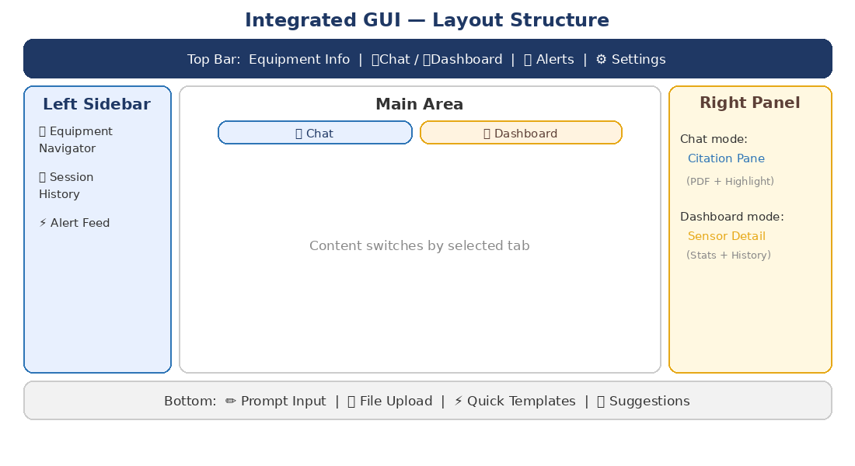

9.3 Left Sidebar (Common)

9.3.1 Equipment Navigator
- Hierarchy tree: Fab > Bay > Equipment Type > Instance
- Equipment selection switches both Chat and Dashboard to that equipment context
- Status icons: 🟢 Running / 🟡 Warning / 🔴 Down / 🟣 PM
- Favorites/pin: Pin assigned equipment to top

9.3.2 Session and History
- Chat session list (recent / favorites)
- Dashboard query history (recent analyses)

9.3.3 Real-time Alert Feed
- Layer 2 alert real-time stream (Warning/Critical)
- Click → Auto-navigate to that equipment's Dashboard
- Unread alert badge counter

9.4 Main Area — Chat Tab (Layer 1 Primary)

9.4.1 ChatGPT-Style Chat Window
- User messages (right-aligned) / Fab Copilot responses (left-aligned)
- Citation click → Right panel Citation Pane opens
- Code Block / Markdown Table / Image popup viewer
- Inline feedback: Like / Dislike / Dangerous + comment per response

Safety Feedback Escalation: The "Dangerous" feedback grade (distinct from "Dislike") triggers an immediate escalation workflow. If an engineer marks a response as "Dangerous," the response is flagged, removed from cache, and a Critical alert is sent to Admin + the original query/response pair is logged for mandatory review. This addresses the risk that incorrect maintenance advice could cause equipment damage or safety incidents. The "Dislike" grade continues to feed into the normal Expert Knowledge passive collection pipeline (8.3.2).

9.4.2 Cross-Layer Response Display
When Layer 2 detects an anomaly, an auto-inserted card appears in Chat:

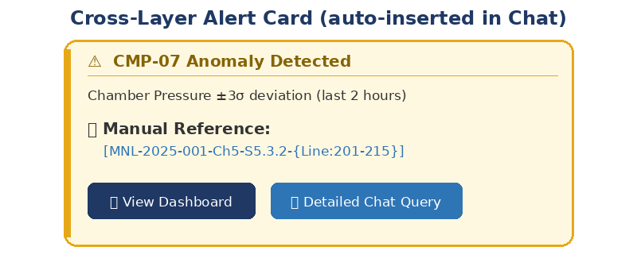

- "View Dashboard" → Switch to Dashboard tab + focus on relevant chart
- "Detailed Chat Query" → Auto-insert query text in prompt

9.5 Main Area — Dashboard Tab (Layer 2 Primary)

9.5.1 Dashboard Layout
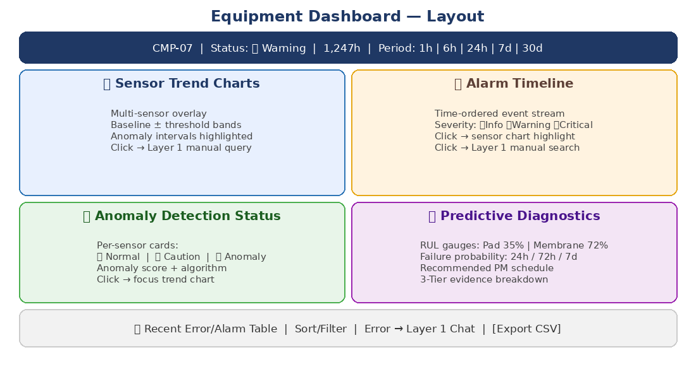

9.5.2 Sensor Trend Chart
- Multi-sensor simultaneous display (max 6 overlay)
- Normal range band display (baseline ± threshold)
- Anomaly interval red highlighting
- Zoom/pan, click specific timepoint → linked event display
- Click on chart → "Find manual reference for this timepoint" (auto Layer 1 query)

9.5.3 Alarm Timeline
- Time-axis-based event stream
- Severity colors: Info (gray) / Warning (yellow) / Critical (red)
- Event click → Highlight corresponding timepoint in sensor chart
- Event click → Auto-search related manual from Layer 1

9.5.4 Anomaly Detection Status Panel
- Per-sensor cards: Normal (🟢) / Caution (🟡) / Anomaly (🔴)
- Anomaly sensor click → Focus trend chart on that sensor
- Anomaly score and detection algorithm displayed

9.5.5 Predictive Diagnostics Summary Panel
- Per-consumable RUL gauge (circular progress bar): e.g., Pad 35% | Membrane 72% | O-ring 88%
- Failure probability bar chart (next 24h / 72h / 7d)
- Recommended PM schedule display
- "Detail" → Show model evidence, training data range, confidence interval, tier breakdown

9.5.6 Error/Alarm Table
- Columns: Time, Error Code, Severity, Sensor, Value, Manual Reference
- Sort/filter/search support
- Error code click → Auto-query to Layer 1 Chat
- CSV/Excel export

9.5.7 Expert Knowledge Quick Entry
While reviewing anomaly detection on Dashboard, engineer clicks "I know this cause" button:
- Current equipment/sensor/timepoint auto-populated in registration form
- After action completion: "How did you resolve this?" auto-prompt
- Minimal-friction path from observation to knowledge capture

9.5.8 Knowledge Base Browser
- List of active expert rules for current equipment
- Per-rule: Registrant, confidence score, hit rate, recent match history
- Rule edit/deactivate (requires permission)
- Tier 3 (document-based) rules displayed alongside (with source distinction)

9.6 Right Panel (Context-Aware Switching)

9.6.1 Chat Mode: Citation Pane
- pdf.js-based inline PDF renderer with section-level scrolling
- Highlight overlay: semi-transparent yellow (#FFF3CD, opacity 0.4)
- Multi-citation tab management
- Document info header: doc name, version, chapter, section
- Zoom 25%~400% for detailed drawing/table examination

9.6.2 Dashboard Mode: Sensor Detail Panel
- Selected sensor detailed statistics (mean/stddev/min/max)
- Histogram / distribution chart
- Recent anomaly history
- Related manual section shortcut (Layer 1 link)

9.7 Top Bar
- Current selected equipment info + status display
- Mode switching tabs: Chat | Dashboard
- Alert bell (unread Warning/Critical count)
- Search mode toggle: Hybrid / Strict Grounded
- Document version policy display
- Response latency indicator

9.8 Bottom Input Panel
- Prompt input (usable in both Chat and Dashboard modes)
- Dashboard mode: Natural language analysis queries supported (e.g., "Show pressure trend last 7 days")
- File upload (PDF/Image/CSV log files)
- Suggested queries / Quick templates
- Dashboard-specific templates: [Trend Analysis] [Anomaly Detection] [RUL Check] [Alarm Statistics]

9.9 Response Timeout UX

9.9.1 Stage-Based Alert UI
Stage | Trigger | User Alert
Progress Info | E2E 30s elapsed | "Searching and analyzing..." progress bar + step display
Delay Warning | E2E 60% consumed (~108s) | "Taking longer than expected" + wait/cancel buttons
Timeout Imminent | E2E 90% consumed (~162s) | "Approaching time limit" + extend/cancel options
Timeout | E2E limit exceeded (3 min) | "Time exceeded" + retry/extend/simplify options

9.9.2 User Time Adjustment Options
- Time extension: 2x current limit (3min → 6min), max 10 minutes
- Query simplification suggestion with examples
- Partial response: Show results generated so far + "Continue generating" button
- Cancel and retry with modified query
- Default timeout configurable: 1min / 3min / 5min / 10min

9.10 Responsive Design and Accessibility
- Mobile: Dashboard switches to card-stack layout
- Tablet: Collapsed left sidebar + main 2-split
- ARIA labels, full keyboard navigation support
- Dark mode support (for Fab lighting conditions)

PART V — Common Infrastructure

10. Response Latency and Timeout Policy

10.1 Layer 1 E2E Latency Budget (P95 < 3 min)
Stage | Target (P95) | Notes
Query parsing + routing | < 500 ms | Lightweight classifier + regex
Embedding generation | < 1,000 ms | Batch-optimized inference
Hybrid Search + Filter | < 2,000 ms | Elasticsearch/Qdrant composite
Re-ranking | < 3,000 ms | Top-50 candidates expandable
LLM Generation | < 160,000 ms | Complex reasoning allowed; streaming first token < 3,000 ms
Post-processing + Citation | < 500 ms | Citation formatting + highlight_coords
Total (E2E) | < 180,000 ms (3 min) | P95 target

10.2 Layer 2 Response Latency Targets
Operation | Target (P95) | Notes
Time-series query | < 5 seconds | InfluxDB/TimescaleDB optimized
Anomaly detection inference | < 10 seconds | Per-sensor model inference
Predictive diagnostics inference | < 30 seconds | 3-Tier Fusion Engine
Cross-Layer integrated response | < Layer 1 + 15 seconds | Layer 1 RAG + Layer 2 fusion

10.3 Multi-Stage Progressive Response
To minimize perceived wait time, the system delivers results progressively rather than holding all output until completion. The staging differs by Layer and scenario:

10.3.1 Layer 1 (RAG) Progressive Stages
Stage | Timing | Content Delivered | Notes
Stage 1 | T+3~5s | Query acknowledged + intent classification displayed + search initiated indicator | Immediate feedback that system is working
Stage 2 | T+15~30s | Top-3 retrieved chunks shown as preview cards (pre-LLM generation) | User can start reading source material while LLM generates
Stage 3 | T+30~180s | Full LLM-generated response with citations, streamed token-by-token | Streaming first token target < 3s after LLM starts

10.3.2 Layer 2 (Diagnostics) Progressive Stages
Stage | Timing | Content Delivered | Notes
Stage 1 | T+1~3s | Equipment status card + latest sensor values | From real-time cache, near-instant
Stage 2 | T+5~10s | Anomaly detection result + alarm match | Per-sensor inference complete
Stage 3 | T+10~30s | 3-Tier Fusion diagnosis + RUL gauges + Cross-Layer manual reference | Full predictive output

10.3.3 Cross-Layer Progressive Stages
When Layer 2 anomaly triggers a Layer 1 auto-query, stages interleave: Layer 2 results appear first (Stage 1-2), then Layer 1 manual evidence appends as it becomes available, and finally the Fusion Engine merges all into a unified diagnosis card.

10.4 Timeout Processing Policy (Backend)
- Timeout stages and user notification thresholds defined in 9.9.1
- Partial response generation: Return results completed at timeout point
- Async completion: Continue processing in background, notify when ready

10.5 Admin Settings
- Global default timeout: Admin-configurable (1/3/5/10 min)
- Per-equipment timeout: Different timeouts by equipment type/document complexity
- Max extension limit: Configurable upper bound (default: 10 min)
- Timeout statistics dashboard: Frequency, average response time, distribution by equipment/intent

11. Security and Access Control

11.1 Authentication
- Enterprise SSO (LDAP/SAML) integration
- Session timeout: Idle 30 minutes, max 8 hours

11.2 RBAC Permission Model
Role | Layer 1 (RAG) | Layer 2 (Diagnostics) | Admin
Operator | Query only | Dashboard view (assigned equip only) | None
Engineer | Query + feedback | Full dashboard + rule registration | None
Equipment Owner | Full | Full access for assigned equipment | Equipment config
Data Analyst | Query only | Log query (read-only, no config change) | None
Admin | Full | Full | Full system config

11.3 Per-Equipment Data Access Control
- Equipment data visible only to assigned team/individuals
- Cross-equipment comparison requires authorization for both equipment
- Expert knowledge rules: Visible to all with equipment access, editable by registrant + Admin

11.4 Data Encryption and Audit Trail
- All API: TLS 1.3
- Storage: AES-256 encryption
- Query logs: PII removal
- Audit trail: All queries, document access, admin operations, rule registrations

11.5 LLM Input/Output Data Loss Prevention (DLP)
Even in on-prem deployments, data flows between components (GUI → Query Parser → LLM server → response) may traverse internal networks and leave traces in logs. For hybrid/cloud configurations, external leakage paths exist. The following DLP controls are required:

11.5.1 Input Filter (Pre-LLM)
- Equipment ID masking: Before sending context to LLM, replace specific equipment_id with anonymized tokens (e.g., CMP-07 → [EQUIP_A]). De-anonymize in post-processing.
- Process parameter sanitization: Sensitive parameters (yield data, recipe details, proprietary thresholds) are stripped from LLM context if not directly relevant to the query.
- Configurable sensitivity rules: Admin defines which metadata fields are classified as sensitive via Config.

11.5.2 Output Guardrail (Post-LLM)
- Pattern scanner: Regex + NER-based scan of LLM output for sensitive patterns (yield percentages, proprietary recipe names, classified equipment configurations).
- On detection: Replace with [REDACTED] + log incident to security audit trail.
- Guardrail bypass: Admin can configure specific roles (e.g., Equipment Owner) to receive unredacted output for their assigned equipment only.

11.5.3 Scope and Limitations
DLP is most critical when external LLM APIs are used (future option). For fully on-prem Ollama/TEI deployments, the primary risk is internal log leakage rather than external transmission. The DLP layer is designed to be lightweight (< 50ms overhead) and configurable per deployment type.

12. Quality Monitoring and Evaluation

12.1 Layer 1 Search Telemetry
- Query text + intent + extracted error_code / part_no
- Top-k docs: doc_id / chapter / section / score / rerank_score
- Final citation chunk id / section / rejection reason
- User feedback (like/dislike)
- Per-stage latency + cache hit/miss
- Citation Pane usage: click count, pane dwell time, zoom usage
- Timeout metrics: count, user extension/cancel/simplify rate, by equipment/intent

12.2 Citation Hallucination Evaluation
Evaluation Item | Method and Criteria
Document ID existence | Verify all doc_ids exist in document DB. Target: 0% mismatch
Section/Chapter match | Confirm chapter/section matches document TOC. Target: < 2% mismatch
Line range validity | Confirm from/to within actual section line count. Target: < 3% mismatch
Content consistency | Semantic match between cited area and chunk content (LLM-as-Judge). Target: F1 > 90%
Non-existent document test | Query with fake error codes; verify rejection. Target: 100% rejection
Partial manipulation test | Query with altered values; verify correction from source. Target: > 95% correction

12.3 RAGAS Evaluation (Phase 1.5)
- RAGAS framework for quantitative search quality evaluation
- Ground Truth dataset: 100+ triples per equipment type, built in parallel with Phase 1

12.4 Layer 2 Operational Metrics
- Anomaly detection: Precision/Recall, False Alarm Rate
- Predictive diagnostics: Accuracy, Lead Time, Tier contribution analysis
- Expert Knowledge: Rule count, verification pass rate, hit rate trends
- Data collection: Uptime/availability per equipment
- Model retraining: History and performance trajectory

12.5 Operations Runbook
- Document re-indexing: Trigger conditions, expected downtime, rollback procedure
- Model update: A/B test protocol
- Cache purge / Synonym dictionary update deployment
- Incident response: Search quality degradation alert escalation path
- Layer 2 model retraining: Schedule, data requirements, rollback procedure
- Expert knowledge bulk import/export procedure

13. Development Roadmap

13.1 Phase 1.0 (Current — Document RAG Foundation)
- Document preprocessing: Table parsing + image anchoring + highlight_coords storage
- Technical synonym dictionary + maintenance process
- Hybrid search: Vector + BM25 + Query Router + Re-ranking + MMR
- Embedding model evaluation and selection / Result cache layer
- ChatGPT-style UI + Citation Pane (pdf.js-based)
- Grounded QA + Dual-Gate response policy
- Response timeout handling: Stage-based alerts + user time adjustment UI
- Telemetry + Citation Pane usage metrics
- RBAC + TLS + encryption / Ground Truth parallel construction / Runbook v1

13.2 Phase 1.5 (RAG Quality Enhancement)
- RAGAS-based search quality evaluation and optimization
- Embedding fine-tuning (if Recall@10 < 80%)
- Image OCR caption extraction + figure cross-reference parsing
- A/B testing framework

13.3 Phase 2.0 (Log Collection + Time-Series Analysis)
- Equipment data collection pipeline (SECS/GEM, OPC-UA bridge)
- Time-series DB deployment (InfluxDB/TimescaleDB)
- Equipment Registry and per-equipment data partitioning
- Basic trend analysis + alarm pattern analysis
- Dashboard tab v1 release (sensor charts, alarm timeline, error table)
- Cross-Layer Linking basic integration (anomaly → Layer 1 auto-query)
- Tier 3 auto-extraction from manuals (Cold Start bootstrap)

13.4 Phase 2.5 (Anomaly Detection + Predictive Diagnostics)
- ML-based anomaly detection model deployment (Tier 1)
- Expert Knowledge Base system (Tier 2): Structured input + Passive collection + Verification loop
- Fusion Engine: 3-Tier evidence integration
- Consumable RUL prediction model v1 (Tier 1 + Tier 3 baseline)
- Predictive diagnostics alert system (Info/Warning/Critical)
- Dashboard enhancement: Predictive summary panel, Knowledge Base browser
- Expert knowledge Quick Entry from Dashboard

13.5 Phase 3.0 (Multimodal + AR)
- Photo/video input troubleshooting (multimodal recognition)
- AR overlay maintenance procedures
- Knowledge graph construction
- MES/EAP deep integration for automated PM scheduling

