Video Processing Project | Project Web Hosting  Open Source Software

Please drop the Video Processing Project team a note if you use or find any of the offerings here useful. This will help us to determine if our contribution to the community is worthwhile.

Project Information

History
About this project:
This is the Video Processing Project.
This project was registered on SourceForge.net on Mar 23, 2009, and is described by the project team as follows:
Video processing source code for algorithms and tools used in software media pipelines (e.g. image scalers, colour converters, etc.) The currently available source code is written in C++ with their associated libraries and DirectShow™ Filters.

Background
This project was originally started by developers at the Council for Scientific and Industrial Research (CSIR) in South Africa as a mechanism for source code quality control. These functions and filters are used on various publicly funded projects and we felt that they might also be useful to the open source community as a whole. Your use of them and your comments or bug finds are a great help to us to improve the quality of our projects.
After 2020 the original CSIR seems to be death. This set of filters has been adopted in Digiteq Automotive to provide some filters that could be used together with FG4 frame grabber - https://fg4.digiteqautomotive.com/ . Support for RGB32 format has been added to all filters. All fitters have newly added IPersistStream interface that allows to access to properties from any 3rd party application.

Please drop us a note if you use or find any of the offerings here useful. This will help us to determine if our contribution to the community is worthwhile.
Our broad objective with the style of coding used is to balance the speed of execution with readable code that is easy to maintain. We have tried to hide our implementations behind well defined interfaces to promote system decoupling.

Filters
These are a set of general filters for scaling, cropping, colour conversion, etc. that are completed items and ready for use. The implementations provided are designed for use with Microsoft’s Direct Show™ framework and we have supplied some useful DirectShow™ base classes that further simplify the development effort.
The following filters are installed when running the DQ_VPP_DshowFiltersInstaller-1.7.27.exe download:
- Audio mixing filter
- Compare filter
- Crop filter
- Framerate display filter
- H264 encoder filter
- H264 decoder filter
- H264 source filter
- Picture in picture filter
- RGB 2 YUV converter
- Rotate filter
- RTSP source filter
- Scale filter
- Tee filter
- Timestamplogging filter
- Toggle filter
- Utility filter
- Video mixing filter
- Virtual mic
- YUV source filter
- YUV 2 RGB converter
These filters can also be downloaded individually and registered using the regsvr32 command. In Graphedit they will then appear in the DirectShow™ category with the prefix "DQ VPP". The filters can be configured using their property pages. The full source code is available in the subversion repository.
We encourage community contributions for faster implementations that sit behind the same interfaces.

Video file formats
- https://learn.microsoft.com/en-us/windows/win32/directshow/uncompressed-rgb-video-subtypes
High-order byte: Low-order byte:

RGB555
X R R R R R G G G G G B B B B B

X = Don't care, R = Red, G = Green, B = Blue

RGB565
High-order byte: Low-order byte:
R R R R R G G G G G G B B B B B

YUYV and YUY2
Both formats have a same contents
The term U is equivalent to Cb, and the term V is equivalent to Cr.
4:2:2 means 2:1 horizontal downsampling, with no vertical downsampling. Every scan line contains four Y samples for every two U or V samples.
In YUY2 format, the data can be treated as an array of unsigned char values, where the first byte contains the first Y sample, the second byte contains the first U (Cb) sample, the third byte contains the second Y sample, and the fourth byte contains the first V (Cr) sample, as shown in the following diagram.

UYVY
This format is the same as the YUY2 format except the byte order is reversed—that is, the chroma and luma bytes are flipped
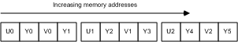

I422
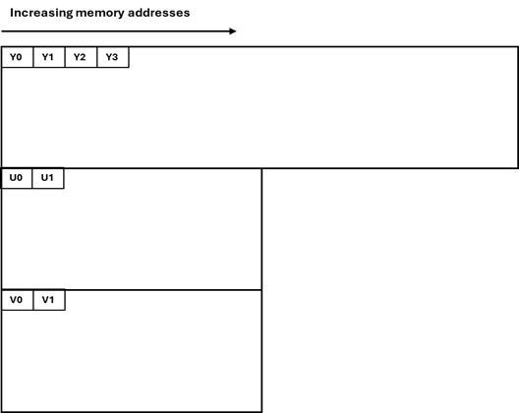
In I422 format, all of the Y samples appear first in memory as an array of unsigned char values. This array is followed immediately by all of the U (Cb) samples. The stride of the U plane is half the stride of the Y plane; and the U plane contains the same number of lines as the Y plane. The U plane is followed immediately by all of the V (Cr) samples, with the same stride and number of lines as the U plane, as shown in the following illustration. There is no padding for the Y/U/V planes.

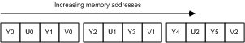
I420, YUV420P_S, YV12 and IYUV
Y samples appear first in memory as an array of unsigned char values. This array is followed immediately by all of the U (Cb) samples. U and V planes have half rows and half columns.

Filter overview

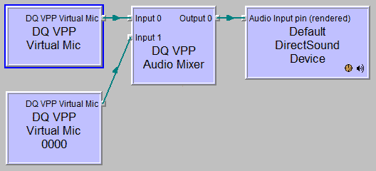
Audio mixing filter
Sample filter that shows how multiple PCM streams can be mixed together.

Compare filter
Filter that compares 2 video signals and outputs their difference.
A main purpose is to verify whether 2 video signals are equivalent.
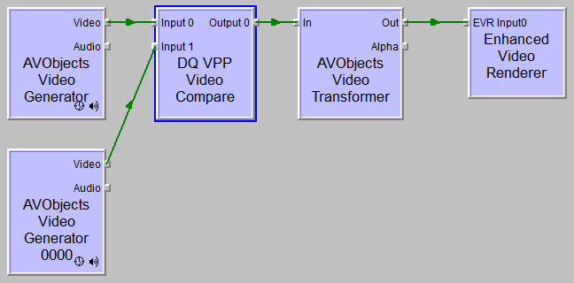 | 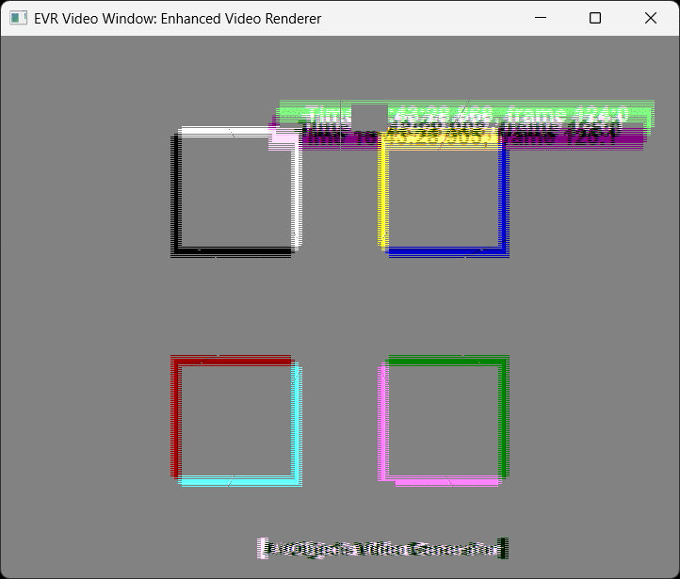
Input video formats supported:
- MEDIASUBTYPE_RGB24
- MEDIASUBTYPE_RGB32
- MEDIASUBTYPE_ARGB32
- MEDIASUBTYPE_YUY2; MEDIASUBTYPE_YUYV
- MEDIASUBTYPE_YVYU
- MEDIASUBTYPE_I420; MEDIASUBTYPE_YUV420P_S; MEDIASUBTYPE_YV1,
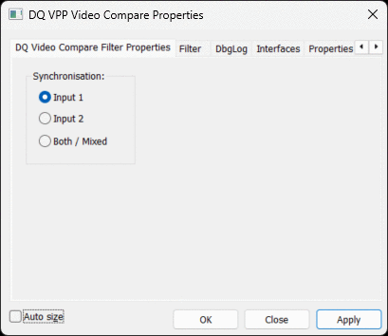
MEDIASUBTYPE_IYUV
- MEDIASUBTYPE_UYVY, MEDIASUBTYPE_HDYC,
- MEDIASUBTYPE_AYUV

Output format must be the same as input format with one exception, formats in equivalent group like: (I420, YUV420P and YV12); (YUY2 and YUYV); (UYVY and HDYC) could be mixed.
It is possible to choose frame generation on input 1 or input 2. Choosing “both” duplicates frame rate and it is not recommended.

Crop filter

Filter that crops RGB media.
User can choose how much pixels to cut from left, right top and bottom.
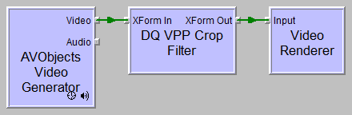 | 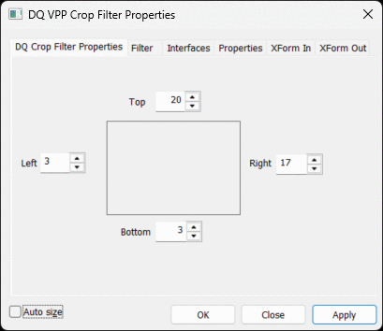
Supported videoformats:
- MEDIASUBTYPE_ARGB32
- MEDIASUBTYPE_RGB32
- MEDIASUBTYPE_RGB24
- MEDIASUBTYPE_AYUV
- MEDIASUBTYPE_YV24
- MEDIASUBTYPE_RGB555
- MEDIASUBTYPE_RGB565

Framerate display filter
Filter that estimates framerate and overlays it on the video using GDI.

H264 encoder filter
An H.264 encoder that implements the baseline profile. -- More info on codec -- -- More info on DirectShow filter --
Please note that this filter is still not fully tested, it is not recommended for use.

H264 decoder filter
An H.264 decoder designed for use with the provided encoder or H264 source filter. The decoder uses a custom media type which can be configured on the encoder and source filters. -- More info on codec -- -- More info on DirectShow filter --
Please note that this filter is still not fully tested, it is not recommended for use.

H264 source filter
Source filter that can read raw .264 files. Foreman sample file More info
This filter is not recommended to use and it is still in alpha stage.

Picture in picture filter
This filter can include one video into another video. Filter optionally rescalles included video.
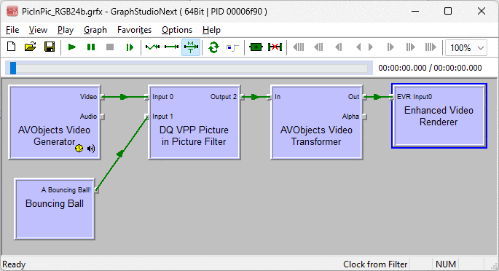 | 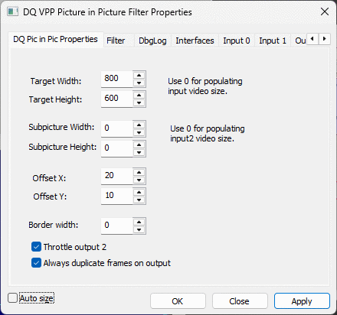
Supported videoformats:
- MEDIASUBTYPE_ARGB32
- MEDIASUBTYPE_RGB32
- MEDIASUBTYPE_RGB24
- MEDIASUBTYPE_AYUV
- MEDIASUBTYPE_YV24
- MEDIASUBTYPE_RGB555
- MEDIASUBTYPE_RGB565
- MEDIASUBTYPE_R16G16B16,
- MEDIASUBTYPE_B16G16R16,
- MEDIASUBTYPE_A16R16G16B16,
- MEDIASUBTYPE_A16B16G16R16
All pins must have the same videoformat.

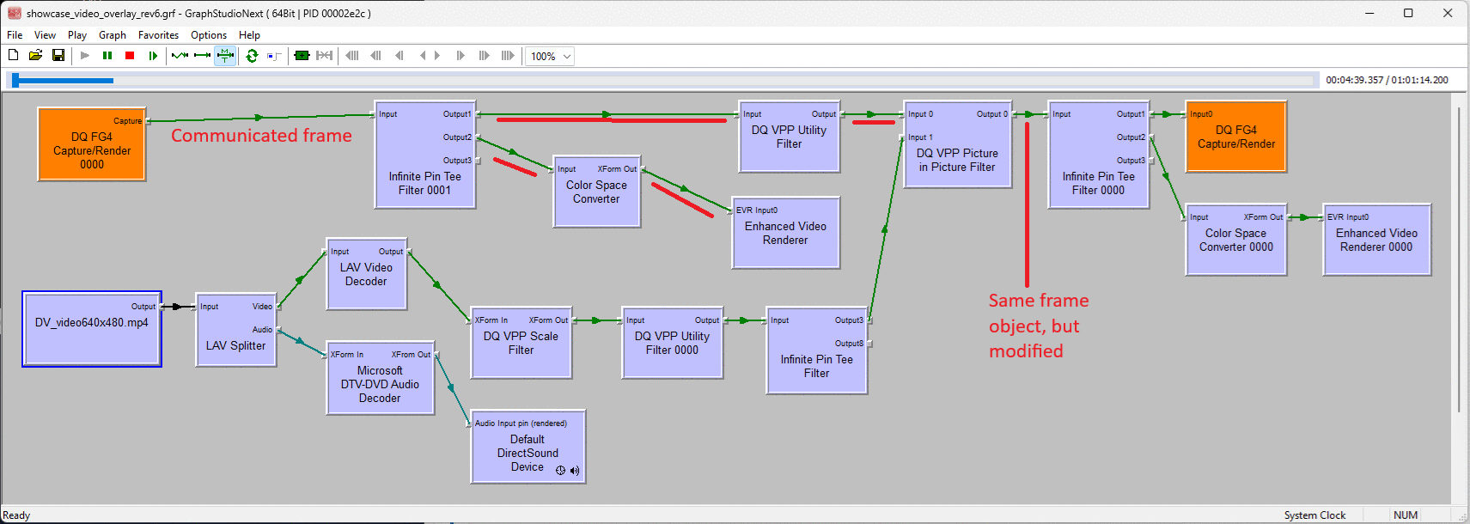
Option – Always duplicate frames on output
Sometimes video with inserted picture could get back propagated. In this case please check option “Always duplicate frames on output”. This option enforces video data copy. If you do not use Infinite tee pin filter or something like this, option causes only CPU slowdown. This checkbox has no sense when you turn on scaling. In such a case frames must be cloned.

Option – Throttle output 2
If you use 2nd online video sources like camera or FG4 frame grabber, this option should be unticked. But if you decide to mix another video sourced from a file, throttling ensures that time is synchronized.

PicInPic filter implements optional video flip when nasty downstream filter needs negative height.

RGB 2 YUV converter
RGB24 to YUV420 planar converter. This filter can be connected to a dump filter to create raw YUV files. More info
This converter has only one property – Image invert.
Input video format | Output video format
MEDIASUBTYPE_RGB24 | MEDIASUBTYPE_AYUV
MEDIASUBTYPE_RGB32 | MEDIASUBTYPE_YV24
MEDIASUBTYPE_ARGB32 | MEDIASUBTYPE_YUV420P_S
MEDIASUBTYPE_RGB555 | MEDIASUBTYPE_I420
MEDIASUBTYPE_RGB565 | MEDIASUBTYPE_YV12
 | MEDIASUBTYPE_IYUV
 | MEDIASUBTYPE_NV12
 | MEDIASUBTYPE_YUYV
 | MEDIASUBTYPE_YUY2
 | MEDIASUBTYPE_YVYU
 | MEDIASUBTYPE_UYVY
 | MEDIASUBTYPE_HDYC

You can use any combination of input and output formats.

RTSP source filter
RTSP source filter that supports 8/16-bit PCM, AMR (via Monogram AMR filters), mp3 and H.264. This filter uses the liveMedia streaminbg library for RTSP/RTP/RTCP available at www.live555.com

Rotate filter
Filter that rotates video by 90, 180, 270 degrees, as well as mirroring vertically and horizontally. There exists 8 possible operations of this type, see filter property page.
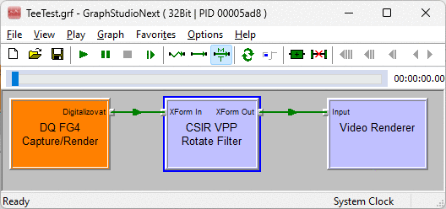  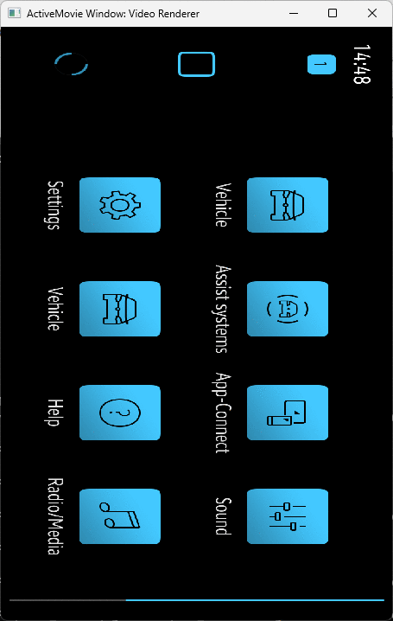 | 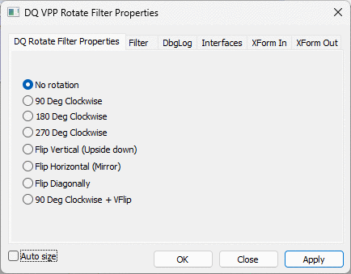
Supported input video formats:
- MEDIASUBTYPE_RGB24
- MEDIASUBTYPE_RGB32
- MEDIASUBTYPE_ARGB32
- MEDIASUBTYPE_AYUV
- MEDIASUBTYPE_YV24
- MEDIASUBTYPE_RGB555
- MEDIASUBTYPE_RGB565
- MEDIASUBTYPE_R16G16B16,
- MEDIASUBTYPE_B16G16R16,
- MEDIASUBTYPE_A16R16G16B16,
- MEDIASUBTYPE_A16B16G16R16
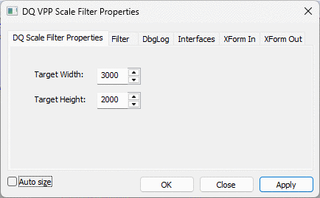
Output format must be the same as input format.

Scale filter
Scale filter that supports both upscaling and downscalling.
This filter has 2 properties width and height. When width and Height are set to 0, filter passes its input to output without resolution change.
Input video formats:
- MEDIASUBTYPE_RGB24
- MEDIASUBTYPE_RGB32
- MEDIASUBTYPE_ARGB32
- MEDIASUBTYPE_YUY2; MEDIASUBTYPE_YUYV
- MEDIASUBTYPE_YVYU
- MEDIASUBTYPE_I420; MEDIASUBTYPE_YUV420P_S; MEDIASUBTYPE_YV1,
MEDIASUBTYPE_IYUV
- MEDIASUBTYPE_UYVY, MEDIASUBTYPE_HDYC,
- MEDIASUBTYPE_AYUV
- MEDIASUBTYPE_YV24
- MEDIASUBTYPE_RGB555
- MEDIASUBTYPE_RGB565
Output format must be the same as input format with one exception: I420, YUV420P and YV12 could be mixed.
Scale filter implements optional video flip when nasty downstream filter needs negative height.

Tee filter
This filter has same functionality as infinite tee pin filter from Microsoft. https://learn.microsoft.com/en-us/windows/win32/directshow/infinite-pin-tee-filter
This filter delivers samples delivered to its input pin to a variable number of output pins. When an instance of the filter is created, it has one output pin. Each time an output pin is connected, the filter creates another output pin. All output pins share the same media type as the input pin.
In some cases you can find DQ VPP Tee more convenient. If can optionally duplicate frame contents.

Timestamplogging filter
Filter that logs sample timestamps to file with current time. This is useful to calculate DirectShow filter sample processing times.
Sample output:
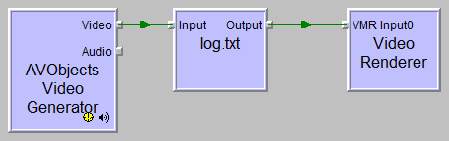
0 400000 400000 829440
400000 800000 400000 829440
800000 1200000 400000 829440
1200000 1600000 400000 829440
1600000 2000000 400000 829440
2000000 2400000 400000 829440
2400000 2800000 400000 829440
2800000 3200000 400000 829440
3200000 3600000 400000 829440
3600000 4000000 400000 829440

Toggle filter
Toggle filter allows to choose video from 2 different sources. Video can be periodically toggled.
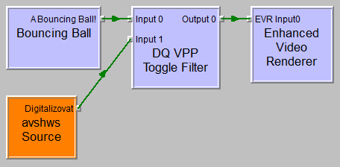 | 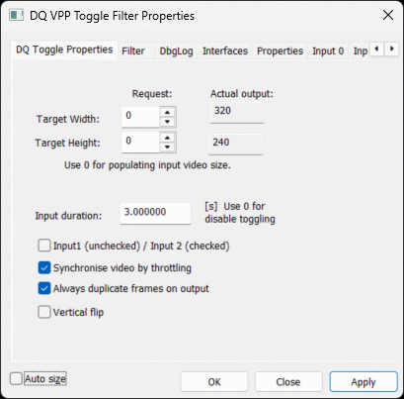
It is possible to run both video sources together. Normally it is possible to run either one video source or another video source.
This filter accepts any type of video on its input.

Utility filter
Utility filter inserts text watermarks into running video.
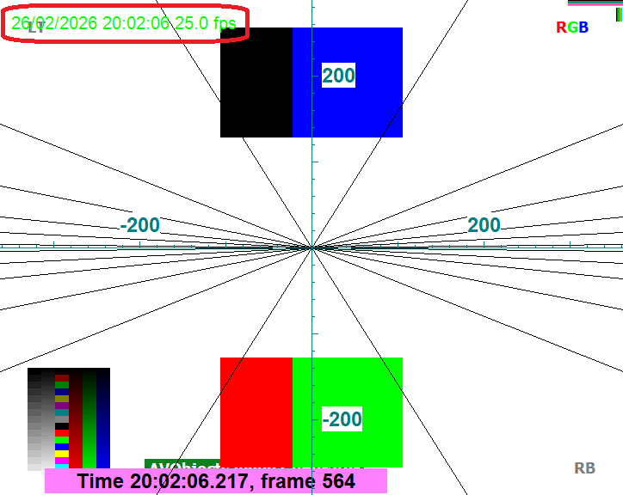 | 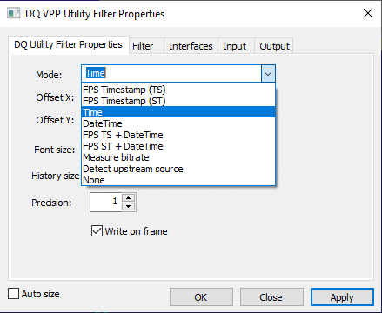

Video mixing filter
Sample video mixing filter that shows how multiple video streams can be mixed together.
Supported input video formats:
- MEDIASUBTYPE_RGB24
- MEDIASUBTYPE_RGB32
- MEDIASUBTYPE_ARGB32
- MEDIASUBTYPE_AYUV
- MEDIASUBTYPE_YV24
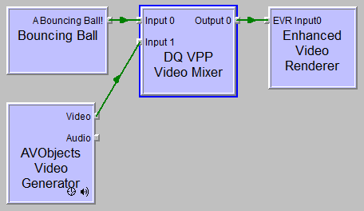  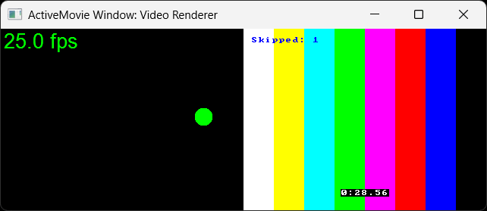 |  | 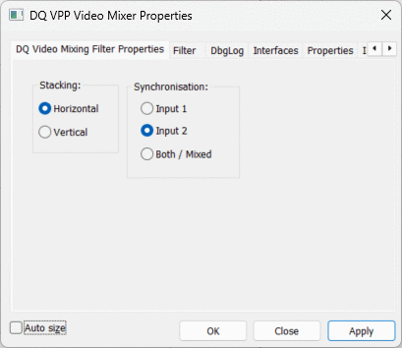
Video mixer can stack 2 videos horizontally or vertically.

Virtual Cam
Virtual cam is a simple video source.
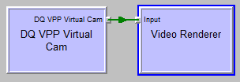 | 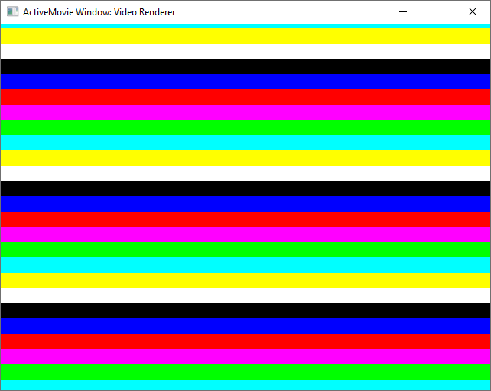 | 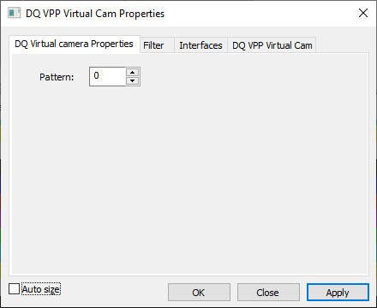

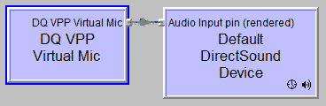
Virtual Mic
This filter generates test audio signal. It generates test beeps.
Supported output audio format:
- MEDIASUBTYPE_PCM

YUV source filter
Source filter for raw YUV media such as videos from the standard test sequences. More info
The raw video stream could be prepared with Microsoft’s sample dump filter: https://learn.microsoft.com/en-us/windows/win32/directshow/dump-filter-sample
precompiled version could be found here: https://sourceforge.net/projects/direct-show-demo-filters/files/SampleFilters/
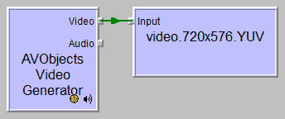 | 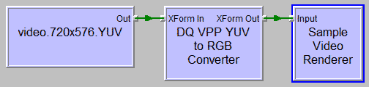
There is one trick, that filename must contain video frame resolution like “video.720x576.YUV”. Character ‘x’ is used to separate width and height.
It normally uses I420 media video. When file name contains “444”, then video is handled like it contains AYUV media format.
There are another tricks, that substring "qcif" in a filename switches resolution "176x144" and "cif" in a filename switches resolution "352x288" – see also https://www.videoexpertsgroup.com/glossary/what-is-qcif

YUV 2 RGB converter
Filter provides conversion from input to RGB based format. Can be used in conjunction with the YUV source filter. More info
This converter outperforms original CSIR VPP YUV420toRGB and YUV444toRGB filters. These filters has been removed.
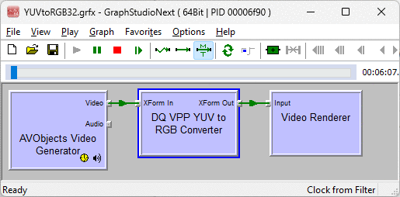 | 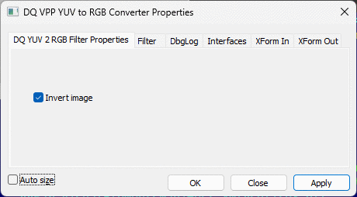

This converter has only one property – Image invert.
Input video format | Output video format
MEDIASUBTYPE_AYUV | MEDIASUBTYPE_RGB32
MEDIASUBTYPE_YV24 | MEDIASUBTYPE_ARGB32
MEDIASUBTYPE_YUV420P_S | MEDIASUBTYPE_RGB24
MEDIASUBTYPE_I420
MEDIASUBTYPE_YV12
MEDIASUBTYPE_IYUV
MEDIASUBTYPE_NV12
MEDIASUBTYPE_YUYV
MEDIASUBTYPE_YUY2
MEDIASUBTYPE_YVYU
MEDIASUBTYPE_HDYC

You can use any combination of input and output formats.

Codecs
An H.264 video codec (encoding and decoding) is currently under development using a bottom-up design approach.
2012/03/03: The first version of the H.264 codec is going to be released within the next month!
2012/03/15: The first version of the H.264 codec has been released!
The source code for the low level codec tools will appear and then be added to, periodically. We would like to offer these while the code is being developed to encourage comments early on in the design. Some of these raw classes may also be useful for other implementations.
We would like the community to contribute in conformance testing to the H.264 standard and faster implementations that use the defined interfaces.
Please note that the use of the H.264 video standard may require the payment of license fees. These are governed by the MPEG Licensing Authority and the rules may be found at www.mpegla.com. It is your responsibility, not the authors of this source code, to ensure that you comply.
Developers
Join this project:
To join this project, please contact the project administrators of this project, as shown on the project summary page.
Get the source code:
Source code for this project may be available as downloads or through the CVS or Subversion SCM repository used by the project, as accessible from the project summary page.

