**Manual**;

This type of irrigation is most effective in areas with high water tables. Manual irrigation. Water is distributed across land through manual labor and watering cans. This system is very labor intensive.

There are two functional components in this paper. They are moisture sensor and motor / pump. Arduino board is programmed using the Arduino IDE software. Humidity sensor is used to detect the soil moisture content. Motor pump is used to supply water to plants. Soil moisture and temperature predetermined range is set particularly for specific plants requirement, and according to that system is being operated. Microcontroller (ATmega328), is the brain of the system. Both humidity and temperature sensor is connected to the controller's input pin. Pump and servo motor coupled to the output pin. In case of soil_moisture value is less than threshold system automatically triggers water pump on till sensor meets threshold and then sets off automatically. The overall activity is reported to the user using mobile application.

**A. Detecting Moisture Content**:This will be achieved by soil moisture sensor. They are connected to an Arduino microcontroller board. Arduino board is program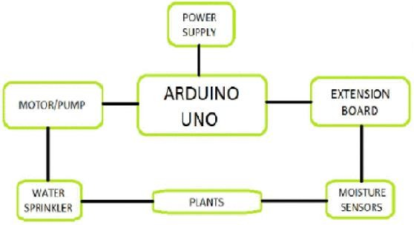med using the IDE software. Humidity sensor senses to indicate that the plant needs watering humidity levels in the soil, and sends the signal to the Arduino.

**B. Automatic Watering To The Plant And User Notifications:**

On receiving logic high signal, Arduino will notify the user by turning on the first buzzer. In this work we have used an Arduino microcontroller in combination with relay control switch to control the motor and overall functioning. Motor may be driven by external 9V battery with interfacing to microcontroller.