|  |
| --- |
| JG STUDIO & DIEGO-RODRIGUEZ |
| Street Runner |
| **[Assignment #3 – Unity Game** |
| Version #01  All work Copyright © 2016 by JG STUDIO & DIEGO-RODRIGUEZ.  All rights reserved. |
| **Diego Rodriguez & Jason Gunter** |
|  |



|  |
| --- |
| November 12th, 2016 |

**Table of Contents**

Contents

**Version History** 3

**I.** **Detailed Game Description** 3

***II.*** **Controls** 3

***III.*** **Interface Sketch** 3

**IV.** **Menu and Screen Descriptions** 4

**V.** **Characters / Vehicles** 4

**VI.** **Enemies** 5

**VII.** **Scripts** 5

***VIII.*** **Scoring** 5

**IX.** **Sound Index** 5

**X.** **Art / Multimedia Index** 5

# **Version History**

<https://github.com/digma89/Unity_3D_game_StreetRunner/commits/master>

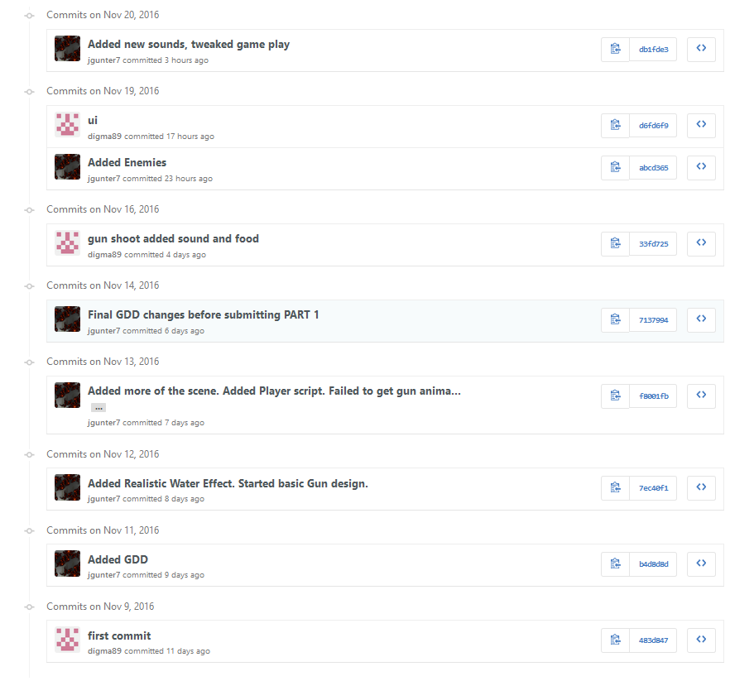

Here is a screenshot from our Github repository. This shows our commit history while working on this assignment.

1. **Detailed Game Description**

*The player must collect food and avoid enemies (Zombies) to stay alive. The player can shoot bullets at enemies to kill them. The player gains score buy killing enemies and increase their life points with food they collect, and they try to stay alive as long as they can.*

1. **Controls**

*The controls to move the player are default controls (W,A,S,D or arrow keys). The player can also sprint by holding the shift key. Jumping is performed when the player presses the space bar on their keyboard. The player can use the left mouse button or the “CTRL” button to shoot their weapon.*

1. **Interface Sketch**

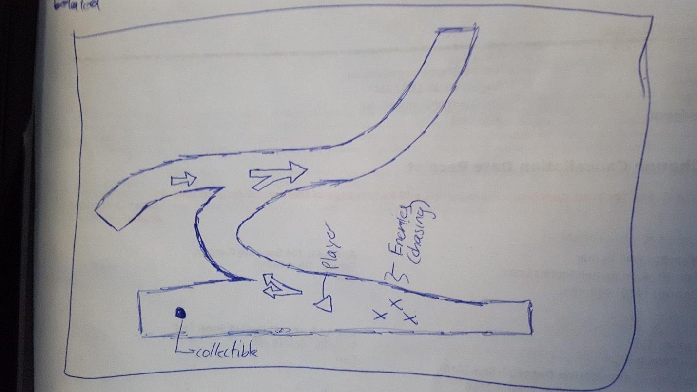

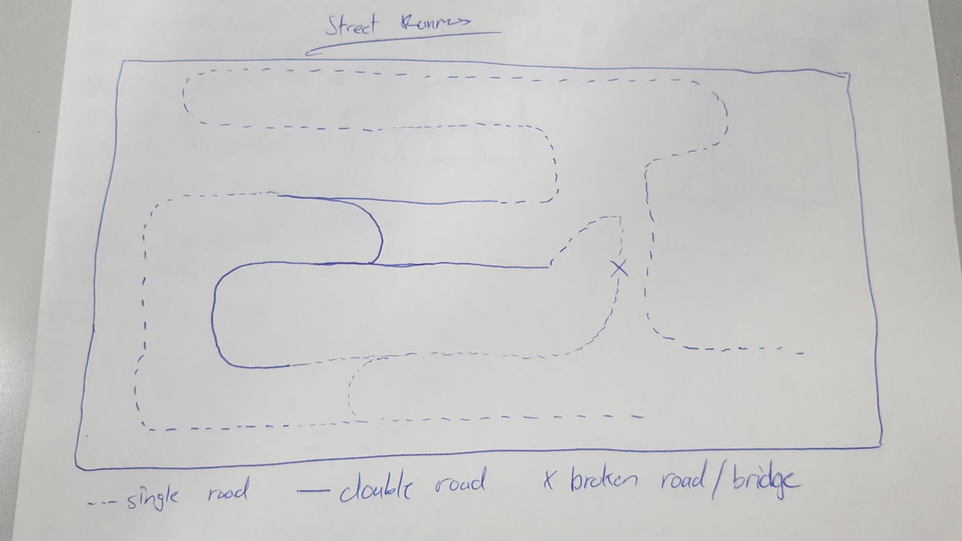

1. **Menu and Screen Descriptions**

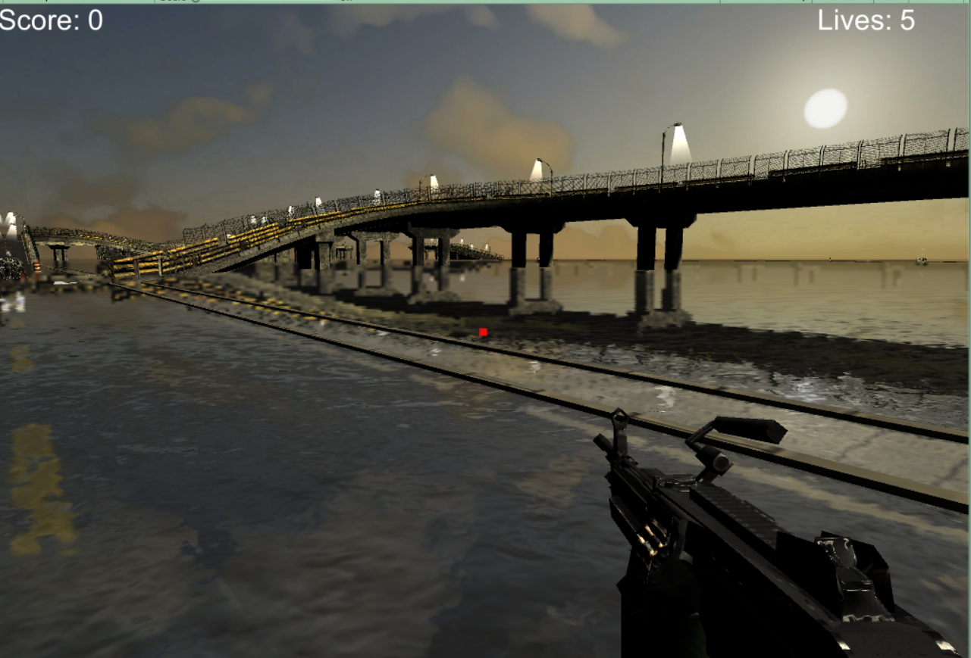The Score is in the left top corner and your life is in the right top corner.

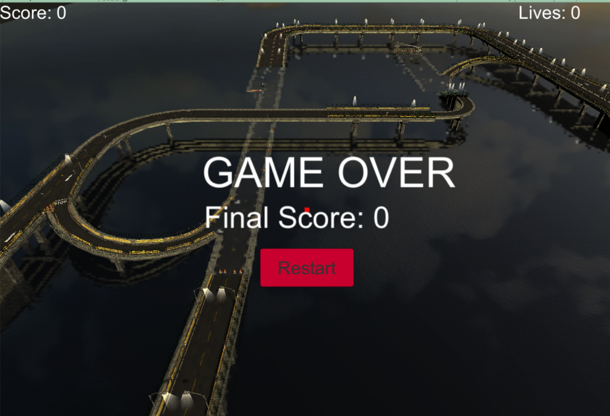

The game over screen show the final score and a button to restart

1. **Characters / Vehicles**

*The player controls their character from a first person perspective.*

1. **Enemies**

*The enemies in the game will chase the player and spawn randomly throughout the map. The player will lose health or life if the enemies hit them.*

1. **Scripts**

*Scripts within the game:*

|  |  |
| --- | --- |
| **Script** | **Description** |
| **EnemyScript** | **The behavior of the enemies is controlled with this script.** |
| **GameController** | **Basically the control of the UI and the enemy spawn.** |
| **PlayerController** | **The player behavior including action after collides with enemy or collectable.** |

1. **Scoring**

*The player can increase their score by killing enemies in the game.*

1. **Sound Index**

*Sounds within the game:*

|  |  |
| --- | --- |
| **Sound** | **Description** |
| **drown** | **When the player falls to the water** |
| **getHit** | **When the player gets hit** |
| **hitZombie** | **When the player shoots a zombie** |
| **ShootEffect** | **When the player shoots the weapon** |
| **Zombi_die** | **When a zombie die** |

1. **Art / Multimedia Index**

*Art within the game:*

|  |  |
| --- | --- |
| **Art/Asset** | **Description** |
| **Zombie** | **Enemies in the game** |
| **Weapon** | **Rifle that the player use to kill enemies** |
| **Food** | **Hamburgers that increase player life** |
| **Sky** | **Skybox image** |
| **Streets** | **Map** |