**Benford’s Law Analysis in R using R Studio (no packages)**

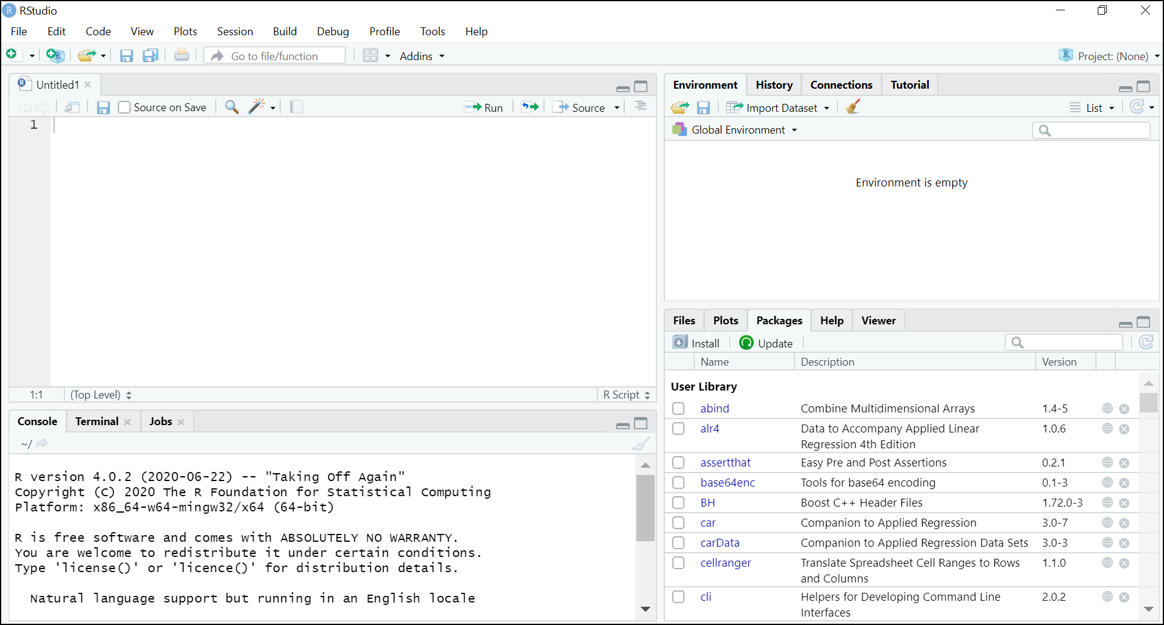

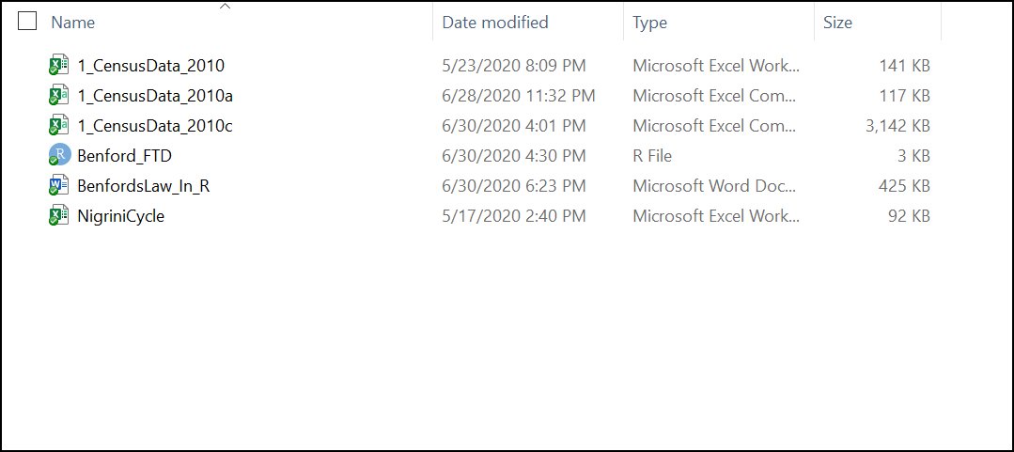

<https://tinyurl.com/BenfordsLaw-R>

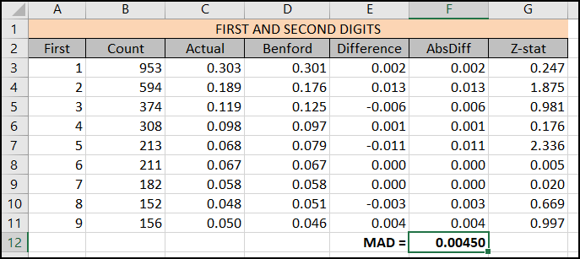

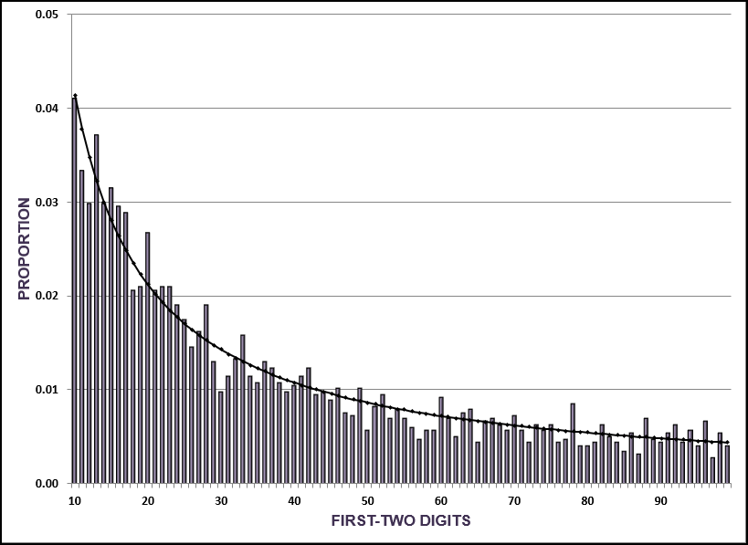



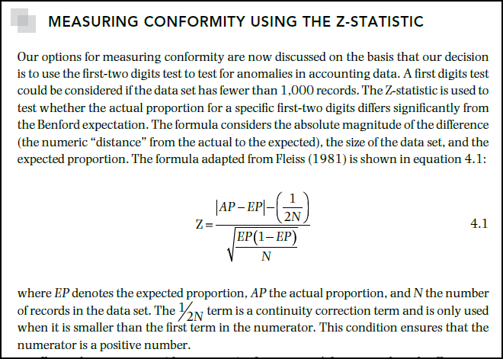

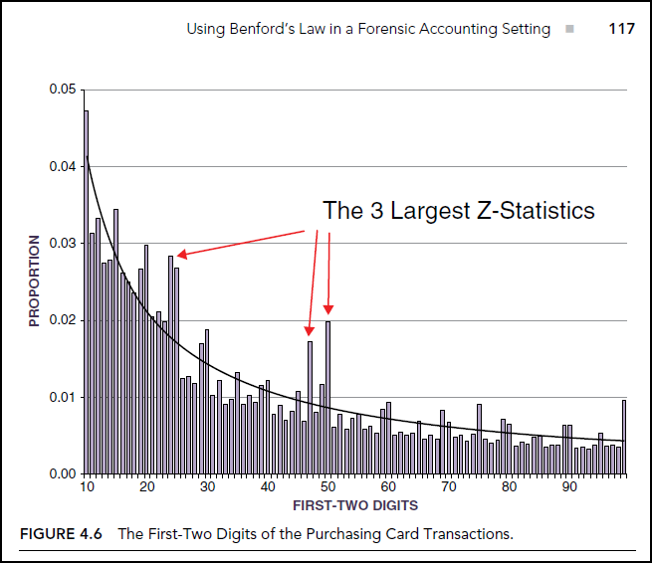

**Version 1**

**Written by Mark Nigrini with help from Brad Price, March 13-15, 2018**

**Version 2**

**Written by Mark Nigrini with help from Yuxing (Paul) Yan, June 25-30, 2020.**

**I would like someone to write the code to create the graph in R using ggplot or some other package.**

**Yuxing (Paul) Yan**

