EXPLORATORY ANALYSIS OF
BIQUAD FILTER DIRECT FORMS

To explore the topic an absolute error value between double precision and fixed point calculations for different filter topologies has been found. Input signal is a logarithmic sine sweep from 1 Hz to 24000 Hz with -12 dB amplitude. Output is measured for filter cutoff frequencies 20 Hz and 1000 Hz. Fixed point input is in Q1.31 format, filter coefficients are in Q4.28 format.
For direct forms II and I transposed, it’s necessary to increase the headroom of input signal to avoid overflow. For lower frequencies further increase is required. Experimentally it has been found that 12 integer bits are enough for filter to operate normally for frequencies higher than 200 Hz(table column (b), for 1000 Hz), depending on Q factor. For these filter topologies to be able to operate in frequencies bellow 200 Hz, increase up to 22 integer bits is required, which leads to lack of accuracy on higher frequencies (table column (a) for 1000 Hz).
Direct form I transposed seems to have the worst performance due to numerous quantization of state variables. In these terms direct form I and II are preferable, truncating result once.
Considering memory usage, direct form II and II transposed have two states less than another.
Overall, direct form I, and II transposed, are preferable for accuracy, however direct form II shows better result on extremely low frequencies.

LPF Cutoff | 20 Hz | 1000 Hz (a) | 1000 Hz (b)
 | Peak value, db | Peak value, db | Peak value, db
DF I | 32 | -Inf | -Inf
DF II | 31 | 27 | 2
DF It | 43 | 38 | 9
DF IIt | 35 | -Inf | -Inf
Peak value absolute error

Fixed point, LPF, f = 1000Hz, Q = 0.5 (a)
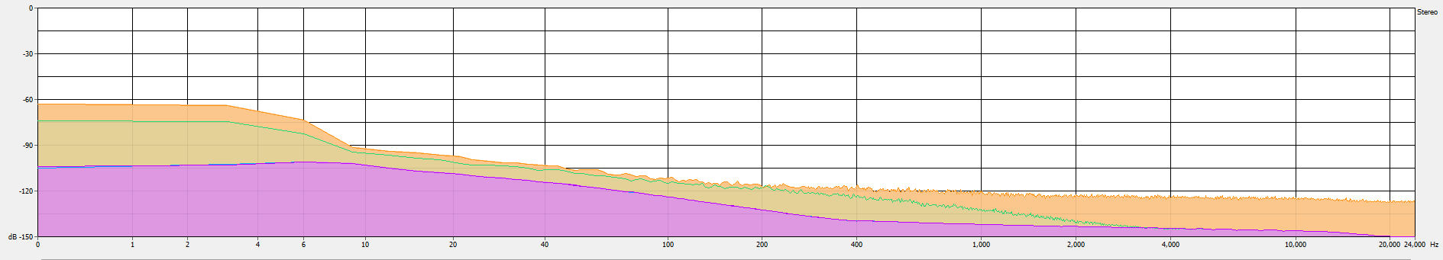
Blue – DF I, Green – DF II, Orange – DF It, Violet – DF IIt

Fixed point, LPF, f = 20Hz, Q = 0.5
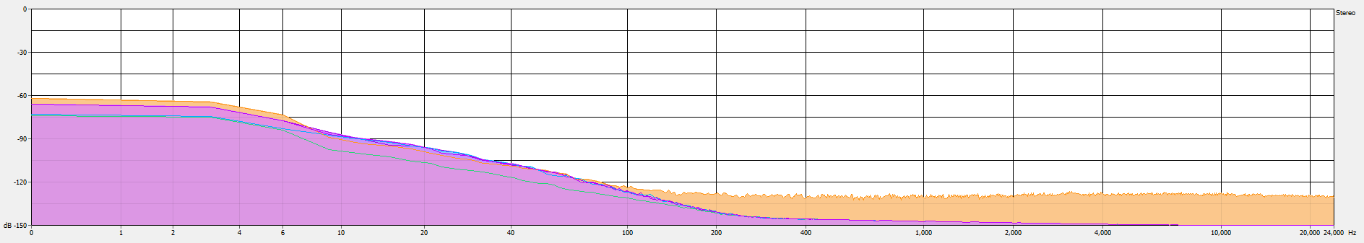
Blue – DF I, Green – DF II, Orange – DF It, Violet – DF IIt

Fixed point, LPF, f = 5Hz, Q = 0.1
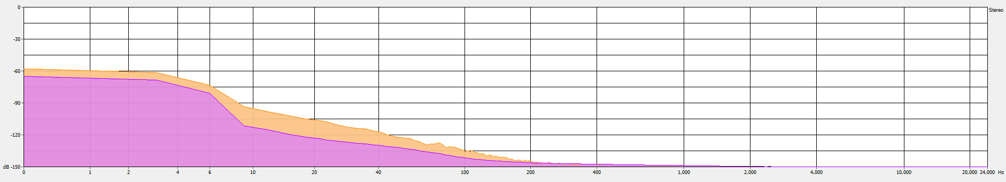
Orange – DF I, Violet - DF II

Floating point implementations perform as good as double on high frequencies. Direct form II and I transposed have higher noise floor on low frequencies. Overflow is possible in these forms.

Peak Cutoff | 20 Hz | 1000 Hz
 | Peak value, db | Peak value, db
DF I | 50 | -Inf
DF II | 31 | -Inf
DF It | 31 | -Inf
DF IIt | 49 | -Inf
Peak value absolute error

Floating point, Peak filter, f = 20Hz, amp = 12, Q = 6
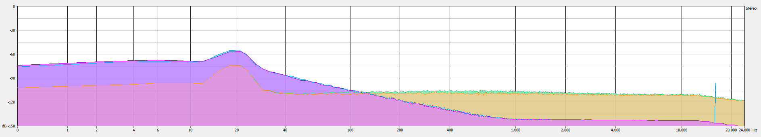
Blue – DF I, Green – DF II, Orange – DF It, Violet – DF IIt

Floating point, Peak filter, f = 400Hz, amp = 12, Q = 6
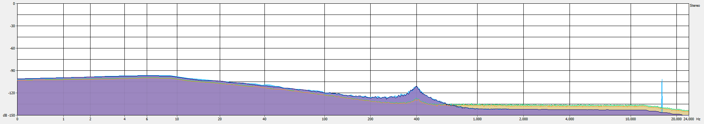
Blue – DF I, Green – DF II, Orange – DF It, Violet – DF IIt

