**Case study of “Shiv Shakti Mill”**

**A Proposal report for the BDM capstone Project**

**Submitted by**

**Name: Digpal Singh**

**Roll number: 21F3001362**



IITM Online BS Degree Program,

Indian Institute of Technology, Madras, Chennai

Tamil Nadu, India, 600036

**Declaration Statement**

I am working on a Project titled “**Business Data Management Capstone Project**”. I extend my appreciation to **Shiv Shakti Mill**, for providing the necessary resources that enabled me to conduct my project.

I hereby assert that the data presented and assessed in this project report is genuine and precise to the utmost extent of my knowledge and capabilities. The data has been gathered from primary sources and carefully analyzed to assure its reliability.

Additionally, I affirm that all procedures employed for the purpose of data collection and analysis have been duly explained in this report. The outcomes and inferences derived from the data are an accurate depiction of the findings acquired through thorough analytical procedures.

I am dedicated to adhering to the principles of academic honesty and integrity, and I am receptive to any additional examination or validation of the data contained in this project report.

I understand that the execution of this project is intended for individual completion and is not to be undertaken collectively. I thus affirm that I am not engaged in any form of collaboration with other individuals, and that all the work undertaken has been solely conducted by me. If plagiarism is detected in the report at any stage of the project's completion, I am fully aware and prepared to accept disciplinary measures imposed by the relevant authority.

I understand that all recommendations made in this project report are within the context of the academic project taken up towards course fulfillment in the BS Degree Program offered by **IIT Madras**. The institution does not endorse any of the claims or comments.



Signature of Candidate:

Name: Digpal Singh

Date: 2nd Mar’2024

# Executive Summary:

The store which I have selected for data analysis, is a mid-sized Kirana Store, located at Bhiwadi, Thada Road, Alwar district, Rajasthan. Here are below stated reasons for selecting above store:

* + I am well known to owner as a regular customer
  + Store is located nearby my house.
  + Owners’ co-operation to share the data

This business is B2C and deals in the segment of daily need goods and freshly baked products.

Data Collection:

For data collection, I visited the store multiple times and collected the data from

* + Store record books
  + Issued bills

Till now, I have collected approx. 30 days of data and still in process to reach at meaningful conclusion.

Here are the products whose data I have collected.

* + Bread
  + Biscuit
  + Rice
  + Wheat floor
  + Sugar
  + Egg
  + Ghee
  + Mustered oil
  + Refined oil
  + Milk and Dairy products (Milk, curd, paneer, cheese, butter etc.)
  + Dry fruits (Almond, cashew, fig, dates, pistachio nuts, ground nuts etc.)

Since there are products having extremely short life spans, need extra care in storing them. It arises a product management problem. The major business issues that the organization is facing, are related to low profit due to poor inventory management system and frequent shortage of products. Advertisement is also another factor which affecting the revenue of the store.

The aforesaid issues will be addressed by analyzing the data through different analytical approaches to get a feasible and fruitful outcome. The analytical approaches used in this project are inventory management, sales and customer analysis, cost analysis and quality check of products.

The desired outcome will help the business to reduce the unwanted inventory means to eliminate the money blockage. We are expecting improvements in customer experience, target on high profit and least important products.

# Organization Background:

*Pic of the store (Inside)*

*Pic of the store (Outside)*

Name : **Shiv Shakti Mill**

Owner : **Mr. Ramesh Yadav**

Address : Thada Road, Bhiwadi, Alwar, Rajasthan (301019)

The store sells all kind of all kinds of daily use products along with milk and dairy products. The store was established in the year 2017. The purpose of opening this store was to provide daily need products. Such store was not available nearby to this location when Mr. Yadav opened this store. In the start, store performed well as no competitor was exist at that time.

After having conversation with owner, I came to know that the performance of store depreciated after a while as online marketing system increased. It increased the competition a lot and made business challenging. However, the increment in the population, the number of customers increased as compared to earlier. Being an oldest store in that locality, “Shiv Shakti Mill” has a good trust of customers.

If, I summarize the store performance in terms of customer visits, 10~15 customers visit to the shop in an hour.

# Problem Statement

When we talk about a business, customer’s trust is the main factor of success. Through my regular visit to store and interaction with some of other customer, I came to know that store has managed a good image among all the customers and has managed to get good sales volume. But

* Store performance is not up to the mark when it comes to net profit.
* Inventory management is improper when it comes to product wastages, damage control.
* Marketing methodology is improper when it comes to attract new customers.

Considering above facts, problem statement can be comprised as

* Analyzing the net profit and measures to increase the same.
* Optimization of inventory considering intake, sales and self-life of products.
* Analyzing the marketing strategies considering other competitor

# Background of the Problem

* After having detailed discussion with store owner, I came to know that store was performing well before the boom of online shopping and because of covid lockdown many of the customers have shifted to online shopping considering discounts and home delivery. Hence store is not able to generate the enough profits.
* As store having daily consumption item having short expiry time, management of these products is quite difficult and several times these kinds of products got wasted affecting the overall profit. Hence inventory management task of such products is crucial, and this is where store is lacking.
* Somewhat poor marketing is also a factor for store performance. Marketing is a backbone of every business. After having conversation with several new customers, I came to know that most of the new residents in surrounding even don’t know about the store and its products.

# Problem Solving Approach

I have collected time series data. So, I will be having good scope for plotting all kind of trends and scatter plots. Using the tools like pivot table, I can plot pie chart and histograms to find some insights from the data.

Although, store sells a wide range of products, I have planned to only collect the data for 15, to make the data collection process conclusive. The variables, I have collected for above products are:

* **Sales Data Analysis :** to find the most selling, less selling, average selling, high profit and low profit products.
* **Promotions and Discounts :** to improve the sales of store as it will attract more customers, using this data we can find out the schemes which are more effective.
* **Customer voice system :** by using this technique we can enhance the product quality along with availability of products.

From above variables, I am planning to compute the key quantities such as revenue, gross profits, net profits, profit margin, average inventory, wastages, gross profit ratio, net profit ratio etc.

Since most the data that I have collected is time-series, I am going to use Excel to process the data. Such tools that are being used for data processing are as :

* + Pivot Tables to filtering the data
  + Various Excel functions such as VLOOKUP, COUNTIF, COUNTIFS etc.
  + Data visualization using pie chart, histogram, scatter plot etc.

Working on above variables, I believe, we will be achieving our target of increasing the profits, optimization of inventory management system and enhanced marketing strategies.

# Expected Timeline

Gantt chart for expected timeline is given below: -

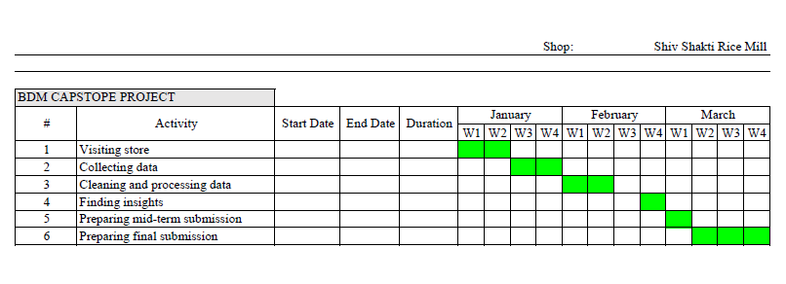

# Expected Outcome

* Will help in increasing the profit and increase the customers as well as.
* Assist the store manager in managing the store inventory effectively and efficiently through the best possible solution for inventory management.
* This project will help in these aspects and will provide great insights about products and customer experience.

After applying the new techniques and planning, this project will certainly increase the profit and lower the risk of wastage of products.

**Submitted by-**

Digpal Singh

Roll Number: 21F3001362