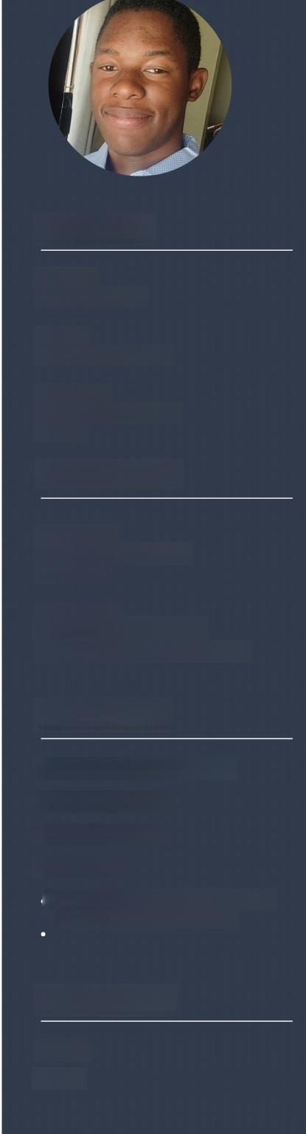
Contact

Phone
+263788291615

Email
digreatbrianagmail.com

Address
9154,Paradise,Highfield,
Harare
Education

2023-2024
Software Engineering
ALX Africa

2024-2028
Information Technology
Chinhoyi University of Technology

Expertise

·Mobile/Desktop Applcations
·Web development
·Python Scripting

·Innovation
Programming Languages (Python,C, Bash,Javascript,HTML,CSS)

Language

English
Shona

Brian Musakwa
Fullstack Developerl Python expert
The writer is a full-stack developer with more than 5 years of experience in Python and a strong background in front-end and back-end development.I am proficient in various technologies, including HTML,CSS,JavaScript,Python,Bash,C,Django,SQL,RESTful APIs,jQuery,and AJAX.I am passionate about building high-quality web and mobile applications and have worked on various projects,from small-scale websites to large,complex applications.I am also skilled in collaborating with cross-functional teams,optimizing workflows,and improving productivity. Additionaly,Ialso possess excellent communication skills and problem-solving abilities.
Experience

Q 2022-2023

Project:Aluquote
I was busy tinkering away on a Python project during that time -a desktop app that crunched numbers for a construction company's windows and doors prices.It was slick! You could add,change,or delete data and get creative with input fields for customized pricing.It was a treasure trove of learning for me.In fact,while crafting this app,I even conjured up my very own encryption mechanism to keep it all hush-hush.If you're curious, check out the encryption module on my Github Repo at https://github.com/digreatbrian/encryptos.git.

2023

Project:XKivy
This Python-based project is relatively small in scope.Inspired by KivyMD,a Python module that facilitates the creation of beautiful mobile and desktop applications through the use of elegant widgets,I developed XKivy,a module featuring custom widgets and extended functionality for Kivy applications.While KivyMD simplifies the app creation process,I aspired to design and integrate custom widgets to further streamline development.Improvements to this project will undoubtedly come by expanding my skillset and exploring new development strategies.

2023-2024

Projects:Smiley and Pythonic
l have been working on two projects lately,both of which have encountered some obstacles,leading to delayed completion.The first project,Smiley,is a mobile application designed to facilitate image editing by allowing users to add quotes,create memes,and more.Currently,I am working on designing a file manager for the application that will allow easy exporting of images to the application space.This file manager will also enable other Kivy developers to select files more efficiently without interfering with the main application thread.On the other hand,I am working on Pythonic,a Django-based web application that aims to help new developers learn Python.

Reference Github

Julien Barbier
https://github.com/digreatbrian
Mentor at ALX Africa

