CYBLE
The Coordinator
Design Document
Backend / Distributed Systems — Take-Home Exercise
Distributed locking for concurrent worker access to a shared external resource: backend approaches evaluated, the failure mode the exercise is built around, and why correctness is enforced at the resource via fencing tokens rather than at the lock.
Implementation: Java (plain, no framework) • Backend: Redis (assumed)

Table of Contents

1. Problem Statement
A fleet of worker instances processes jobs from a shared queue. Some jobs touch a shared external entity — a billing ledger row, a document, an inventory record — where concurrent action by two workers causes real, visible corruption: double charges, lost writes, duplicated shipments.
The inherited design (verbatim, from the previous owner):
Inherited design note
"Before a worker touches the resource, it acquires a lock on the entity key with a TTL. If it gets the lock, it does the work, then releases. The TTL means we don't deadlock if a worker dies. We've been running this for months and it's basically fine."

The task: implement this coordination correctly, under the following operating conditions, which the inherited design does not account for:
- Workers are not reliable narrators of their own liveness — a GC pause, blocked syscall, or CPU steal can make a live worker look dead, then it resumes with no idea time passed.
- The network is not instantaneous or ordered — a request can arrive late, after the sender believes it has moved on.
- Clocks drift and step — the TTL expiry the coordination service observes and the expiry a worker assumes may not be the same instant.
- Job duration is bimodal — most jobs are fast, but the ones that matter run long enough to collide with any TTL you'd pick. No TTL value escapes both failure modes (too short loses legitimate long jobs; too long lets a dead worker hold an entity hostage).

2. Architecture Overview
The system has three participants: the worker fleet, a coordination service (assumed Redis-like — see Section 3 for why), and the protected resource itself. The key architectural decision is where the safety property actually lives: not in the lock, but in the resource's write path.
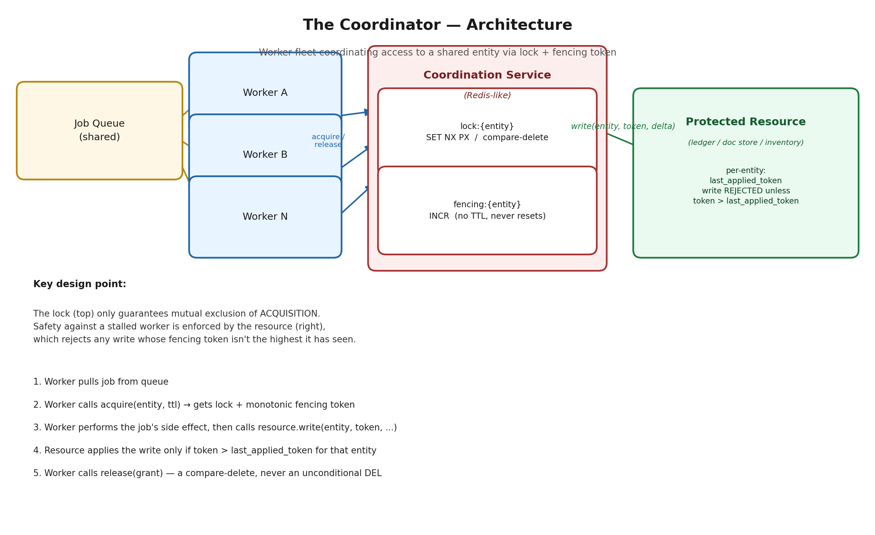
Figure 1 — Component architecture. The lock issues a monotonically increasing fencing token on every grant; the resource, not the lock, is the final authority on whether a write is accepted.

2.1 Flow
- A worker pulls a job from the shared queue.
- It calls acquire(entity, ttl) against the coordination service. On success it receives a LockGrant carrying an ownerId (for safe release) and a fencing token (a strictly monotonic integer for that entity).
- It performs the job's side effect, then calls resource.write(entity, token, ...).
- The resource applies the write only if token is strictly greater than the highest token it has previously applied for that entity; otherwise it rejects the write.
- The worker calls release(grant) — implemented as a compare-and-delete against its own ownerId, never an unconditional delete.
This flow is identical regardless of which backend implements the coordination service (Section 3) — the lock/fencing/resource logic depends only on three atomic primitives (SET-if-not-exists-with-TTL, compare-and-delete, and an ever-increasing counter), abstracted behind a single interface in the implementation.

3. Approaches Considered
Five points in the design space were evaluated, in increasing order of what they fix — and, critically, what none of them fix without an additional mechanism (Section 3.6).

3.1 Single-instance Redis (SET NX PX + TTL)
One Redis node. Acquire = SET lock:{key} owner NX PX ttl. Release = compare-and-delete on owner. This is the inherited design.
Solves: true mutual exclusion of acquisition, cheaply — one round trip to acquire, one to release.
Doesn't solve: single point of failure; no durability guarantee on an un-fsynced restart; and, even perfectly healthy, does nothing about a worker that stalls past the TTL and resumes with no idea time passed.

3.2 Redis with replication + Sentinel / Redis Cluster
A primary replicates asynchronously to replicas; Sentinel promotes a replica on primary failure. Cluster shards the same pattern across many primaries for throughput.
Solves: the single-point-of-failure problem from 3.1 — the service stays available across a node failure.
Doesn't solve — and actively reintroduces a hole: replication is asynchronous. A lock can be granted, acked to the client, and lost on failover before it replicates — a second worker then acquires cleanly, with zero TTL expiry or stall involved. This is Redis's own documented failure mode for Sentinel-based locking, not a hypothetical.

3.3 Redlock (multi-instance quorum on independent Redis nodes)
N (typically 5) independent Redis nodes, no replication between them. Acquire by SET NX PX on a majority within a bounded time; the lock is valid if quorum is reached and computed remaining validity time is still positive.
Solves: the 3.2 failover-loses-a-write problem — no single node's state is authoritative, so no single failover event can silently lose the lock.
Doesn't solve, and this is contested even for what it claims: Redlock's validity-time reasoning still assumes bounded clock drift and bounded pause duration between acquiring and using the lock — exactly the assumptions this exercise says don't hold. A GC pause after acquisition breaks Redlock's safety argument the same way it breaks 3.1. This is a public, unresolved disagreement between Martin Kleppmann's critique and Redis's own rebuttal — evidence the guarantee is weaker than it looks, not a settled matter in Redlock's favor.

3.4 Distributed coordination service — ZooKeeper / etcd
Consensus-based (Zab / Raft) — a cluster agrees on a single linearizable, durably replicated log. Locking is a pattern on top: ZooKeeper's ephemeral-sequential znodes (removed automatically when a client's session expires), or etcd's lease-based keys with required heartbeat keep-alives.
Solves: the 3.2 failover-consistency gap completely, not probabilistically — a write isn't committed until a majority durably persists it. Also gives a fencing sequence number for free (the znode's own sequence, or etcd's revision number).
Doesn't solve: session expiry is still a time-based liveness heuristic — a worker that stalls long enough to time out its session is indistinguishable from a dead one, and if it resumes believing it still holds the lock, the same problem as every approach above recurs. Also carries real operational cost: consensus round trips are slower than a single Redis command, and running a quorum ensemble is heavier than running Redis.

3.5 Fencing tokens — orthogonal to all of the above
Every successful acquisition returns a strictly monotonically increasing token for that entity (a separate never-expiring counter on Redis; free via sequence/revision numbers on ZooKeeper/etcd). The token travels with every write to the resource. The resource — not the lock — tracks the highest token it has ever accepted per entity and rejects anything lower.
This is the actual fix for the exercise's stated failure mode and it works identically underneath any backend in 3.1–3.4. See Section 5 for the walkthrough.
The one hard requirement it creates: the resource itself must be fencing-aware — able to compare and store a token per entity as part of the same atomic operation as the write. If the resource is a third-party system with no way to attach a token, fencing cannot be bolted on, and correctness falls back to whichever backend's raw liveness assumptions.

3.6 Comparison summary
Approach | Fixes SPOF? | Fixes failover-loses-write? | Fixes stalled-worker (needs fencing regardless)? | Ops cost | Latency
Single-instance Redis | No | N/A (no replicas) | No | Lowest | Lowest
Redis + Sentinel/Cluster | Yes | No — async replication gap | No | Low–Med | Low
Redlock (multi-instance quorum) | Yes | Yes (majority quorum) | No — same clock/pause assumptions | Medium | Medium
ZooKeeper / etcd | Yes | Yes (consensus-durable) | No — session expiry still time-based | High | Higher
Fencing tokens (orthogonal) | — | — | Yes, if resource enforces it | Low | Negligible

The pattern across every backend option: none of them, including ZooKeeper, remove the need for fencing. They differ in what they fix around it — availability, failover consistency, operational cost, latency — not in whether the dead-vs-paused ambiguity exists. That ambiguity is inherent to any system that infers liveness from elapsed time, not a bug in any particular backend.

4. Chosen Design
Backend assumption: single-instance Redis-like primitive (Section 3.1) for the submission's scope. Sentinel/Cluster failover and a ZooKeeper/etcd ensemble were deliberately not implemented — see Section 7 for the reasoning and what a production system should add.
Safety mechanism: fencing tokens (Section 3.5), enforced at the resource. This is backend-agnostic by construction in the implementation — DistributedLock and ProtectedResource depend only on a three-method CoordinationBackend interface (SET-NX-PX, compare-delete, INCR), so swapping the backend from the in-memory stand-in to real Redis, or to a ZooKeeper-based implementation, changes nothing about the lock or fencing logic.
If a production backend had to be named today: ZooKeeper or etcd, specifically because it closes the failover-consistency gap outright rather than probabilistically (Redlock), and its sequence/revision numbers give a fencing token for free. That is a separate, defensible choice from the one this exercise is centered on — solving the stalled-worker problem, which fencing solves the same way regardless.

5. Failure Mode Walkthrough
The test harness reproduces the exercise's exact failure mode with real threads and real wall-clock timing (not a mocked clock): Worker A acquires a lock on invoice-42 (TTL 150ms), then stalls for 400ms — simulating a GC pause — before doing its write. While it's stalled, the TTL expires and Worker B acquires the lock, writes, and releases. Worker A then resumes, unaware, and attempts its write using the token it obtained before it ever stalled.
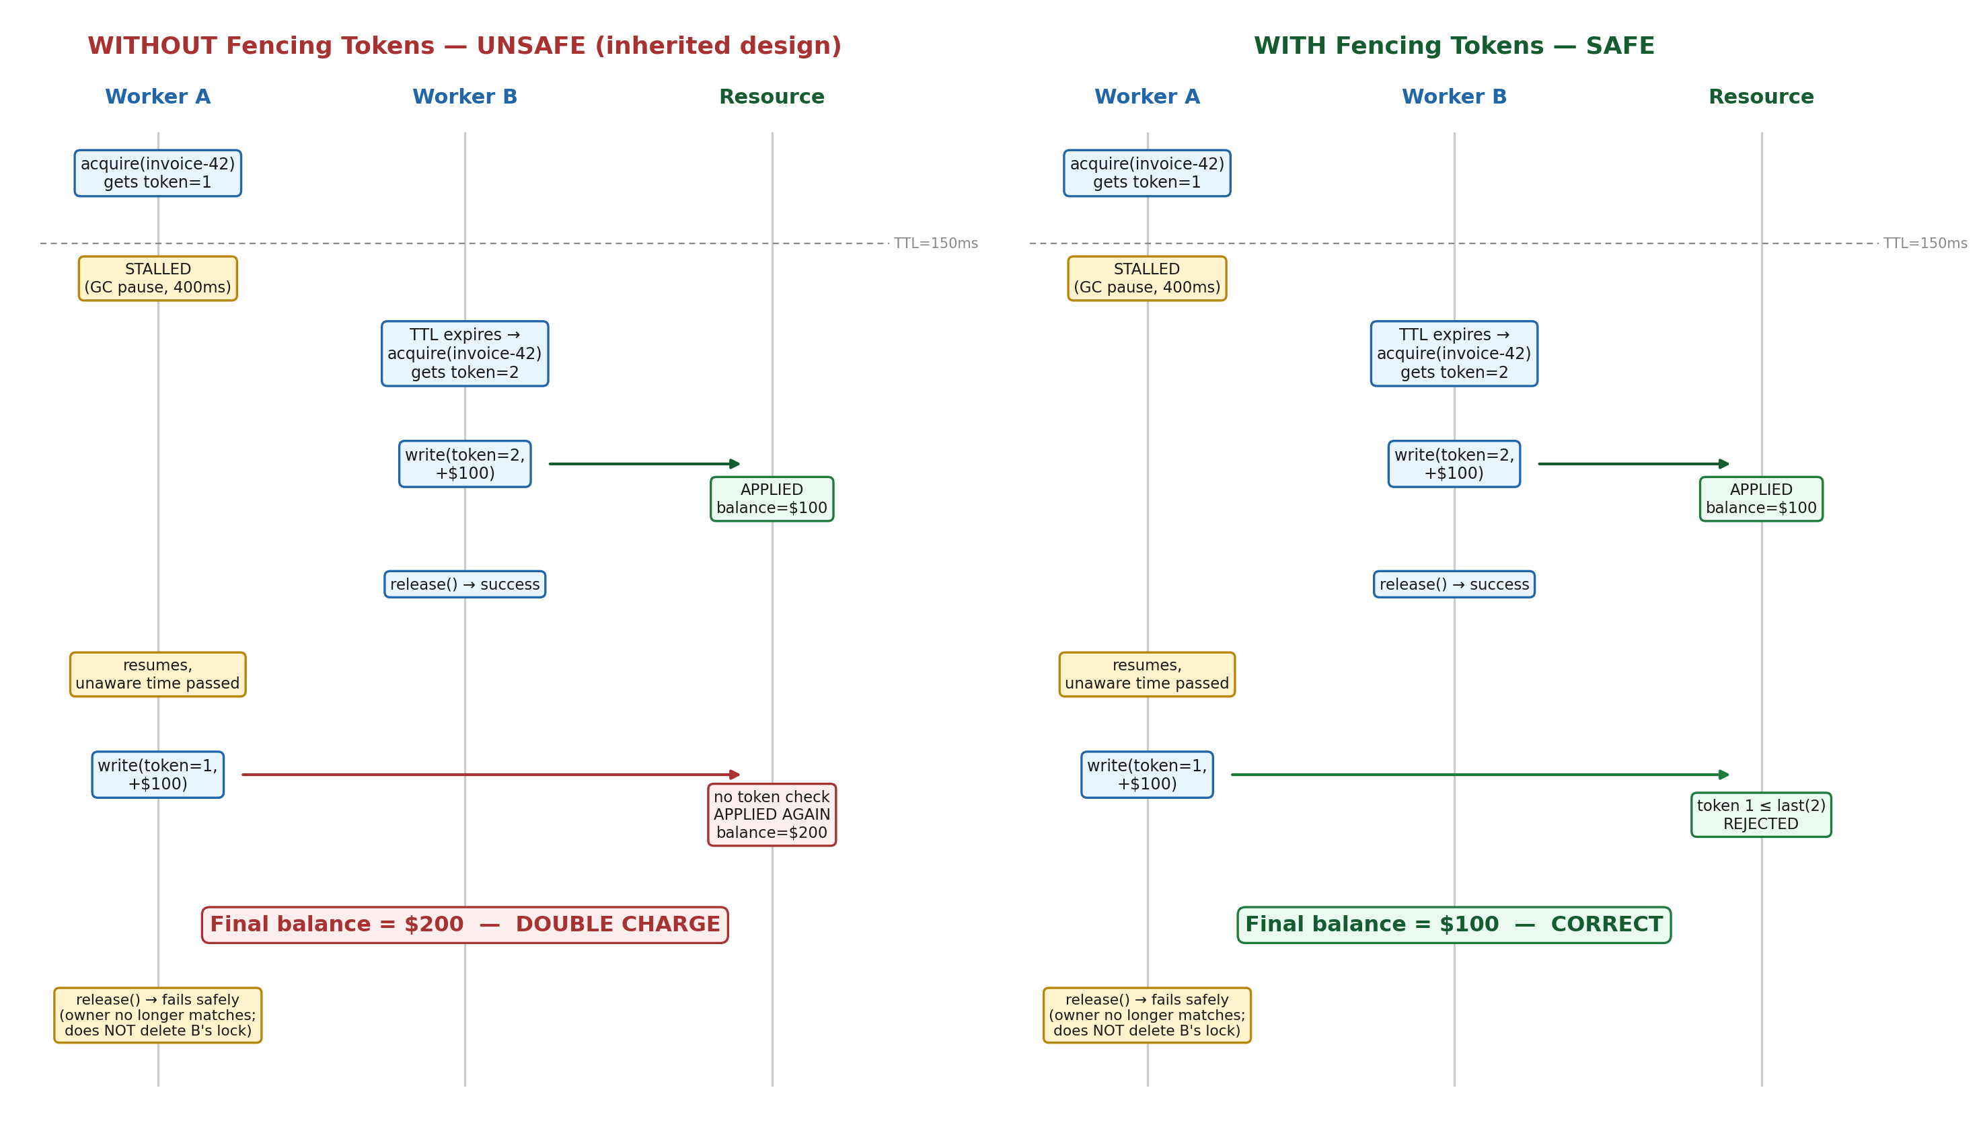
Figure 2 — Identical timing, run twice. Left: the inherited design (TTL lock, no fencing) produces a real double charge. Right: fencing at the resource catches the stale write.
Two things worth calling out in the right-hand (safe) timeline:
- The rejection happens at the resource, not the lock. By the time Worker A resumes, the lock service's job is already done — it correctly expired A's lock and granted B's, exactly per its own contract. The lock cannot know A is about to act on stale information; only the resource, by comparing tokens, can catch it.
- Worker A's own release() call also fails safely — compare-delete checks A's ownerId against what's currently stored, which is now B's. An unconditional DEL here would be a second, independent bug: it would let A delete a lock B is legitimately holding.

6. Required Design Note Sections

6.1 The Guarantee
What is guaranteed: at most one worker's write is ever applied to a given entity, provided the protected resource enforces fencing tokens. This is a guarantee about the write path, not about lock possession.
What the lock alone guarantees, and no more: at most one worker holds lock:{entity} at any instant the coordination service's clock is aware of — standard mutual exclusion of acquisition. This holds unconditionally; it does not depend on worker liveness, pause behavior, or clock skew, because it is enforced entirely inside the coordination service's own atomic operations.
What that does NOT guarantee: that the only worker acting on the resource at any moment is the one currently holding the lock. That stronger claim would additionally require worker pauses to never exceed the TTL and the coordination service's clock to stay in sync with each worker's — both explicitly ruled out by the operating conditions. The actual safety property (no double charge, no lost write) is therefore enforced one layer down, at the resource, and does not depend on either assumption.

6.2 The Failure You Can't Prevent at the Lock
The lock cannot prevent two workers from simultaneously believing they hold it. Worker A acquires, then stalls longer than the TTL; the coordination service — correctly, per its own contract — lets the TTL expire and hands the lock to Worker B, which does its work and releases. Worker A then wakes up with no signal any of this happened, because the TTL check only happens inside the coordination service, not inside A's paused thread. If A now acts on the resource, it acts without exclusivity, and the lock did nothing wrong — its job was already correctly completed by the time A resumes.
Where it's caught: at the resource, via the fencing token — A's token is lower than the one B already applied, so the resource rejects A's write. Section 5 demonstrates this directly: identical timing, and the only difference between a $200 double charge and a correct $100 charge is whether the resource enforces fencing.
A related, smaller failure in the same family: an unconditional DEL on release (instead of compare-and-delete) would let a stalled worker delete a lock a different, live worker currently and legitimately holds. Avoided here by having every grant carry a random ownerId that release must match.
What fencing does not catch: if the resource cannot attach or check a token — e.g. a third-party API that just takes "charge $100" with no idempotency mechanism — none of this helps, and the system is fully back to depending on the backend's raw liveness assumptions, or needs an idempotency key plus downstream reconciliation instead.

6.3 The TTL Decision
There is no TTL value that is simultaneously safe against a dead worker and generous enough for the slowest legitimate job, because "dead" and "merely slow" are indistinguishable from the outside — stated directly in the operating conditions, with no way around it. TTL was therefore treated as an availability/liveness knob, not a safety knob, with safety moved entirely onto fencing. That reframes the question from "what TTL is correct" (no such value exists) to "what TTL gives good throughput without making dead-worker recovery too slow" — a much easier tradeoff:
- Too short relative to the job: legitimate long jobs lose the lock mid-flight; a second worker starts redundant work; fencing means the slower worker's write is discarded — wasted work, not corruption.
- Too long: a genuinely dead worker holds an entity hostage for that long — a real availability cost (delayed invoice, stuck shipment), but not a correctness cost.
Recommendation: TTL ≈ 3–5× the p99 duration of jobs touching that entity type, measured per job class rather than globally (a billing-ledger job and a document-store job have different tails). For the minority of genuinely long jobs, add lock renewal (a heartbeat extending the TTL while the worker verifiably makes progress) rather than picking one static TTL that has to cover both the common fast case and the rare slow case — not implemented in this submission; see Section 7.

6.4 What You'd Do With More Time / In Production
- No lock renewal / heartbeating — a long job either finishes inside one static TTL or loses its lock. Add a background heartbeat thread per held lock (compare-and-set on ownerId, same safety property as release) so TTL can be set tight without punishing legitimate long jobs.
- No retry/backoff tuning — acquire() polls on a flat interval; under real contention this is thundering-herd-prone. Add exponential backoff with jitter, or a blocking wait if the backend supports it.
- No failover modeling for the coordination backend itself — Sentinel/Cluster promotion or a ZooKeeper/etcd ensemble were not implemented. Fencing at the resource likely degrades this to "occasionally reduced availability" rather than "occasionally unsafe" even across a backend failover, but that claim has been reasoned about, not tested.
- In-memory ProtectedResource, not a real datastore — a real ledger needs the fencing check and the write to be one atomic statement (e.g. UPDATE ... WHERE last_token < :token), not two separate calls the way a naive integration might do it.
- No idempotency key as a second line of defense — fencing prevents a stale write from applying, but does not guard against a worker retrying its own current write after a network blip. A production billing integration would want both.
- Simulation, not load test — the harness proves the specific failure mode and ordinary contention at small scale (20 workers × 50 ops); it has not been pushed to a scale that would surface, e.g., contention artifacts specific to the in-memory stand-in.

7. Implementation Summary
Plain Java, no framework. Two interchangeable backend implementations behind a single interface:
- CoordinationBackend — interface: setNxPx, compareDelete, incr, get.
- InMemoryCoordinationService — in-process stand-in; zero dependencies; used for the verified test results below.
- RedisCoordinationService — real Redis via Jedis: SET NX PX for acquire, a Lua EVAL for atomic compare-and-delete on release, plain INCR for the fencing counter.
- DistributedLock — acquire/release + fencing token issuance; depends only on CoordinationBackend.
- ProtectedResource — simulated ledger; enforces the fencing check on every write.
- Simulation / RedisSimulation — the same three test scenarios, runnable against either backend.

7.1 Test results (in-memory backend, compiled and run repeatedly)
Scenario | Fencing Enforced? | Expected | Result
1. Normal contention (20 workers × 50 ops) | Yes | Balance = 1000 | PASS — balance = 1000
2. Stalled worker (400ms stall, 150ms TTL) | No (inherited design) | Reproduces double charge | CONFIRMED — balance = $200
3. Stalled worker (identical timing) | Yes | Stale write rejected | PASS — balance = $100

Note on the Redis-backed path: RedisCoordinationService was written against the standard Jedis 5.x API and reviewed carefully, but could not be executed end-to-end in the environment this was built in (no network access, no local Redis instance). The logic is a direct, mechanical mapping of the same operations verified above onto real Redis commands — running it against a live Redis instance (via the included docker-compose.yml) is the recommended next step before treating it as fully verified.

7.2 Repository layout
src/coordinator/CoordinationBackend.java — the 3-method interface
src/coordinator/InMemoryCoordinationService.java — in-memory backend
src/coordinator/RedisCoordinationService.java — real Redis backend (Jedis)
src/coordinator/LockGrant.java — value object: ownerId + fencing token
src/coordinator/DistributedLock.java — acquire / release, backend-agnostic
src/coordinator/ProtectedResource.java — fencing enforcement lives here
src/coordinator/Simulation.java — 3 scenarios, in-memory backend
src/coordinator/RedisSimulation.java — same 3 scenarios, real Redis
pom.xml, docker-compose.yml — Maven + local Redis for the Redis path

7.3 How to run
Path A — no dependencies:
javac -d out src/coordinator/CoordinationBackend.java src/coordinator/InMemoryCoordinationService.java src/coordinator/LockGrant.java src/coordinator/DistributedLock.java src/coordinator/ProtectedResource.java src/coordinator/Simulation.java
java -cp out coordinator.Simulation
Path B — real Redis:
docker compose up -d && mvn compile exec:java

