**Deployment**

For deployment of the Spring Boot application. As soon as we push the code to Bitbucket or Github. We can use Code Build to trigger the build which uploads the artifacts to S3 bucket.

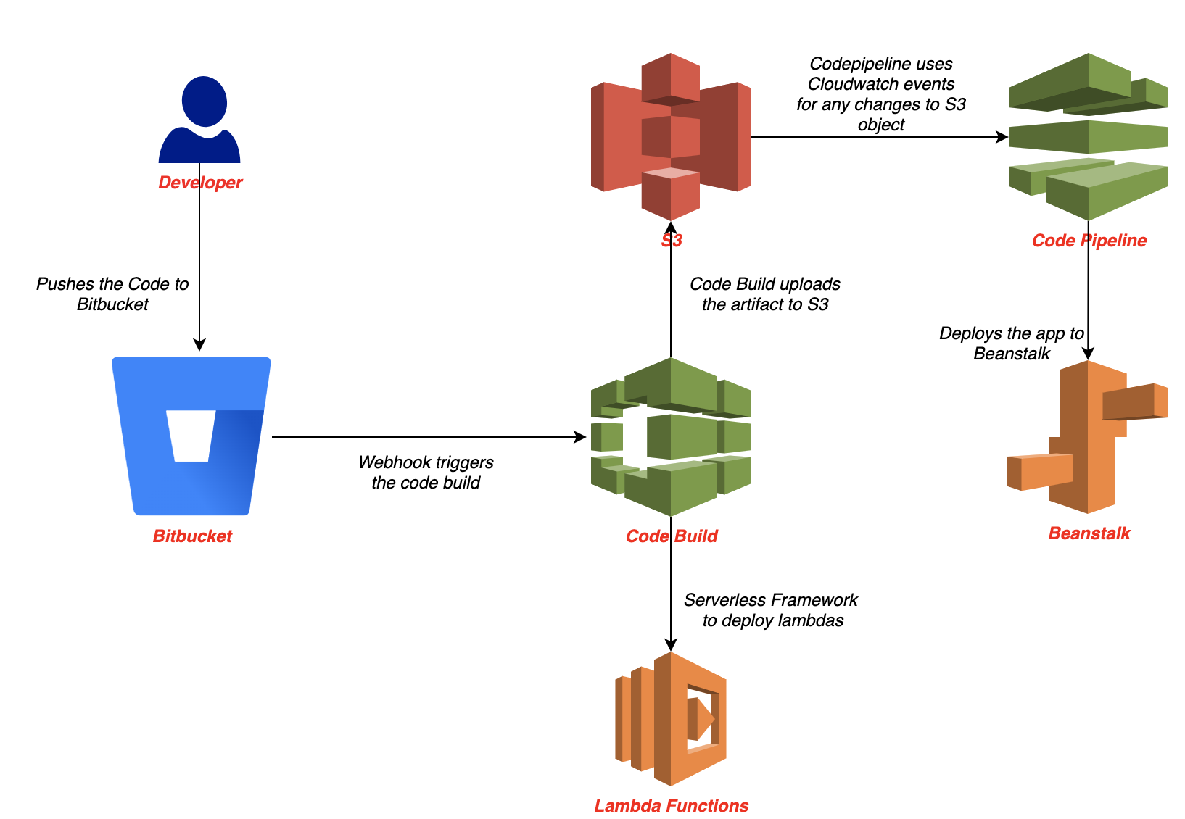

As shown in the screenshot.

The code pipeline will deploy the application in Elastic Beanstalk.

This is how the CodePipeline looks.

