LINQ

- Previously microsoft introduced SQL QL to interact with only SQL server database.
- Language Integrated Query.
- Ye kam ati h Objects, XML, Datasets, & SQL server se data access(nikalne/dalne) me.
- Ye c# me integrated rehti h isliye ise Integrated query kehte h or wha ise use krte h.
- LINQ includes : Standard query operators, Query Syntax, lambda expressions.
- Provides functions to query cached(get) data from various sources.
Benefits :-
- LINQ supports Sorting, Ordering, Grouping, Filtering.
- Debugging, compile-time checking.
- Single query language to work with multiple data sources.
- Easy Conversion of data from one data-type into another (ex: sql data into xml data)

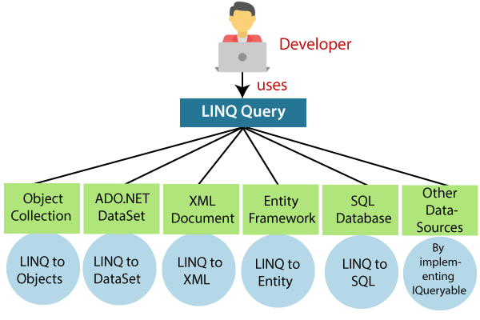
TYPES

LINQ to Objects
  - arrays
  - collections

LINQ to Database
  - Linq to entities
  - Linq to sql
  - Linq to ado.net

LINQ to XML
  - XML files

Why to use LINQ-SQL instead of ADO.NET ? beacuse ado.net too provide way to interact with sql.

Reasons to not use ado.net:

- In ado.net there is not compile time checking of query,
- Meaning the query will be in the string format and will be processed for exception, error, success only by the DB Engine.
- Also, it’s not a good practice to put the extra burden on the DB Engine.
- No Intelisense support, because c# does not know anything about the query, it is treated as string by c#.
- It’s not type safe.because you know nothing about the column data type u can send any type of data, that will only get checked at runtime at the db engine.
- No Debugging of query is possible, beacuse query is in the string format & is execute at DB engine.
- SQL queries are combination of object-oriented and Relational.

Reasons to use LINQ to SQL :

- LINQ queries are checked during compile time i.e. by c# compiler.
- LINQ queries are verified or executed by LINQ query engine, provided in .NET
- It’s type safe. i.e. all the data types of columns are already known by the c# compiler
that’s why you have to pass only appropriate values
- LINQ queries are executed by c# compiler so the compiler knows the error and displays it on compile time then we can easily debug.
- It’s 100% Object-Oriented code.

TO work with LINQ to SQL :

MAPPING IN LINQ to SQL

Relational Types Object Oriented Types

Table Class

Column Property

Row Object / Instance

Stored Procedure Method

This process is called ORM (Object Relational Mapping)
To perform ORM we have to use a tool called OR Designer.

