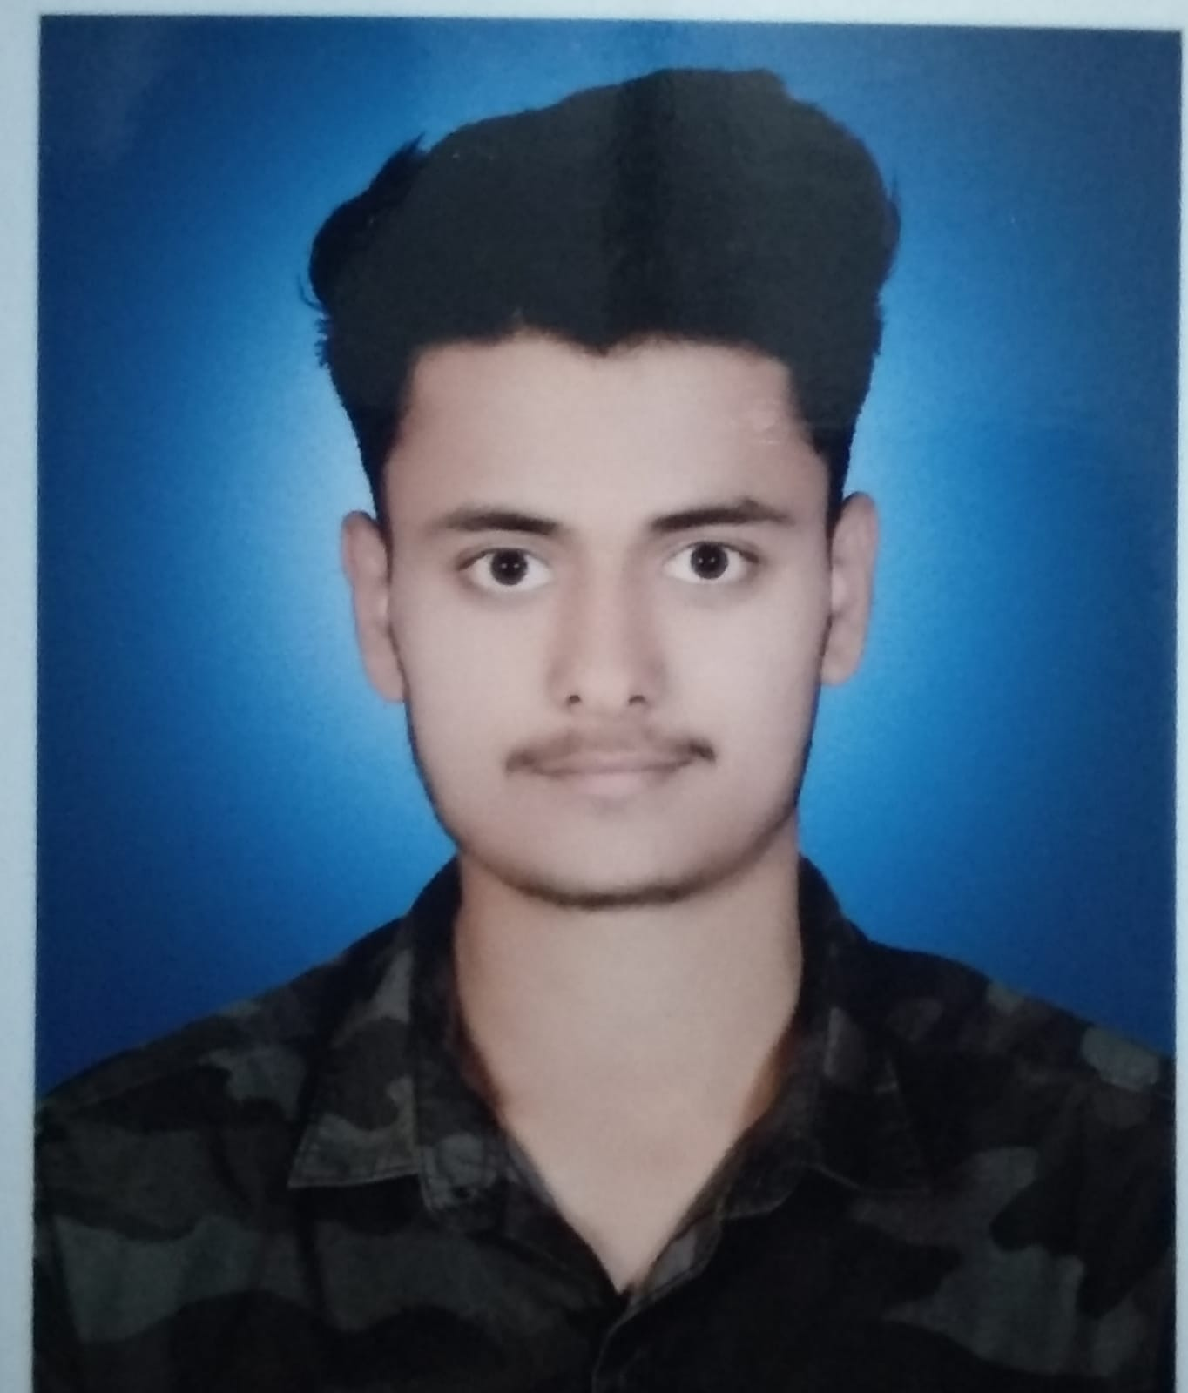

DIGVIJAY SINGH

# EDUCATION

**B.Tech in Computer Science and Engineering , GLA University, Mathura (76%)** 2023

# Intermediate, Universal Public School , Mughalsarai (62%) 2018

**High School, SRB Public School , Mughalsarai (95%)**  2016

**INTERNSHIP EXPERIENCE**

* **Have attended “Homeflic Wegrow web and android development” organized by Homeflic Wegrow Pvt. Ltd.**

# PROJECTS

* **An online book store website using HTML , CSS and JavaScript .**
* **A portfolio website of mine.**

# SKILLS

1. **Technical**
   * **Java**
   * **Structured Query Language (SQL)**
   * **HTML, CSS, JavaScript**
2. **Tools**
   * **Visual Studio Code editor , IntelliJ IDEA , MySQL**
3. **Skills**
   * **Front-End Development**
   * **Problem Solving**
   * **Data Structure and Algorithm**
   * **JAVA Object Oriented Programming (OOP)**

# Professional

* **A good team player**
* **Excellent in communication skill**
* **Leadership quality**

# EXTRA/CO-CURRICULAR ACTIVITIES

* + **Have attended online quizzes**
  + **Have participated in NSS GLAU event**
  + **Have been a part of GLA Handball team**

**DECLARATION**

**I hereby declare that all the above mentioned information is true and correct to the best of my knowledge.**

**Permanent Address :** Premapur Chakia Chandauli Uttar Pradesh, 232103

**Email :** [digvijay.singh_cs19@gla.ac.in](mailto:digvijay.singh_cs19@gla.ac.in%20)

**Linkedin :** <https://www.linkedin.com/in/digvijay-singh-35813a1b6/>

**Contact No. :**+91 9119704187