Bootstrap Basic And Advance

Q1) What are the advantages of Bootstrap?

Bootstrap is a css framework. It’s very easy to learn. It contains lots of styling which one can apply css properties by adding appropriate class. We can also create responsive design with bootstrap very easily.

Browser compatibility, Responsive features

Q2) What is a Bootstrap Container, and how does it work?

Containers are used give some padding to all sides.

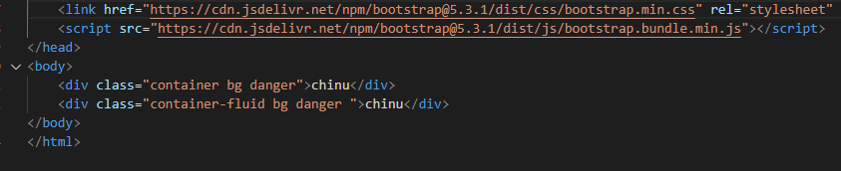



Q3) What are the default Bootstrap text settings?

Bootstrap 4 uses a default font-size of 16px, and its line-height is 1.5. The default font-family is "Helvetica Neue", Helvetica, Arial, sans-serif

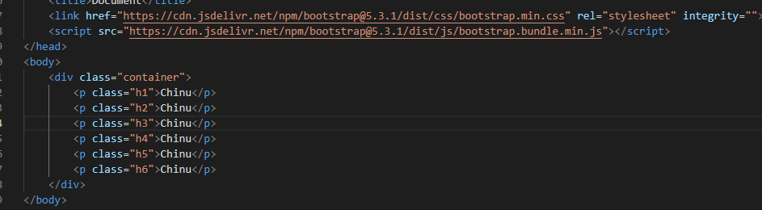



Q4) What do you know about the Bootstrap Grid System?

By using bootstrap’s grid system we can make responsive content. Bootstrap's grid system uses a series of containers, rows, and columns to layout and align content.

Bootstrap’s grid system allows up to 12 columns across the page.

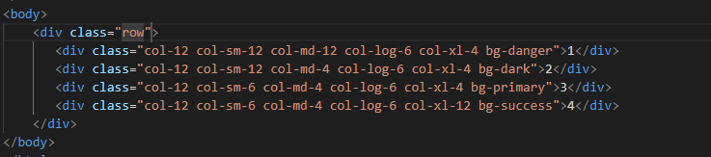



Q5) What is the difference between Bootstrap 4 and Bootstrap 5?

|  |  |  |
| --- | --- | --- |
| **Basis of** | **Bootstrap 4** | **Bootstrap 5** |
| *Grid system* | It has 5 tier | It has 6 tier |
| *Color* | It has limited colors | Extra colors added |
| *jQuery* | It has jQuery and all related plugins | jQuery is removed |
| *Internet Explore* | Supports both IE 10 and 11 | Doesn’t Support IE 10 and 11 |
| *Form Elements* | Form uses whatever default browser provide | Form can be customized and form controls can be added, they would not depend on browser |
| *Utility API* | We cannot modify utilities | Modify and also create our own utilities |
| *Gutter* | Use gutter with font size in px | Use .g* with font size in rem |
| *Vertical classes* | Columns can be positioned  relative | Columns cannot be positioned relative |
| *icon* | Doesn’t have its own SVG icons | its own SVG icons |
| *jumbotron* | It’s supported | Doesn’t support |
| *Card deck* | Card deck card used to create a set of card with equal width and height | Card deck class remove |
| *navbar* | We have inline-block property and we will get white dropdown | Inline-block property is removed and we will get black dropdown |
| *Static site generator* | Uses Jekyll software | Uses Hugo software |
| *Flexbox grid* | Easier to implement vertical designs, and the columns and row can be easily be implemented | Advanced grid system is made available. |
| *RTL (Right to Left) supports* | It does not enable RTL | It enables RTL |
| *Offcanvas* | It does not support off canvas | It supportoff canvas |

Q6) What is a Button Group, and what is the class for a basic Button Group?

Button groups is a class of name “btn-group” which is used to create a series of buttons in groups vertically or horizontally.

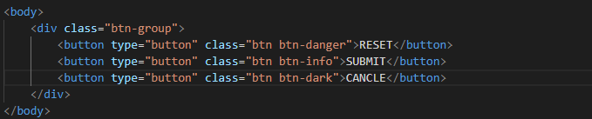

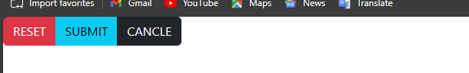

Q7) How can you use Bootstrap to make thumbnails?

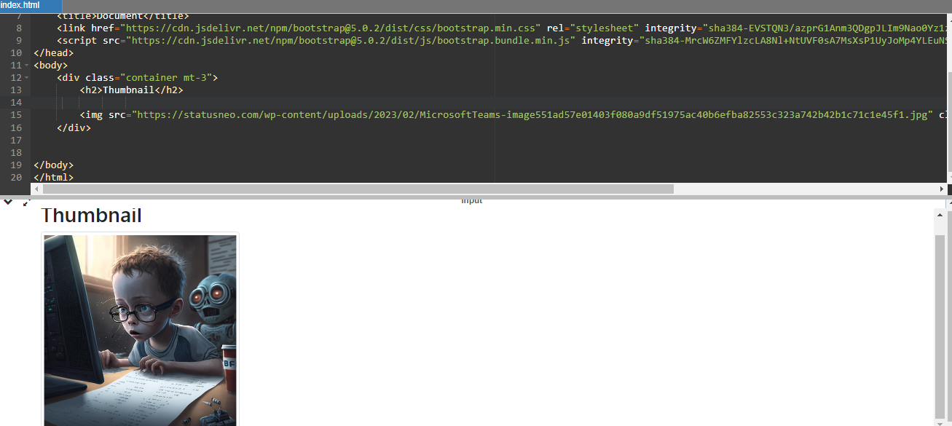

Q8) In Bootstrap 4, what is flexbox?

Quickly manage the layout, alignment, and sizing of grid columns, navigation, components, and more with a full suite of responsive flexbox utilities.

<body>

    <div class="container mt-5">

    <div class="d-flex flex-row">

        <div class="p-2 bg-danger">flex items 1</div>

        <div class="p-2 bg-primary">flex items 2</div>

        <div class="p-2 bg-info">flex items 3</div>

    </div>

    <body>

        <div class="d-flex flex-row-reverse">

            <div class="p-2 bg-warning">flex items 1</div>

            <div class="p-2 bg-dark">flex items 2</div>

            <div class="p-2 bg-success">flex items 3</div>

        </div>

    </div>

</body>



Q9) How can one create an alert in Bootstrap?

<body>

    <div class="container mt-5">

        <div class="alert alert-primary" role="alert">

            this is a primary alert-check it out!

        </div>

        <div class="alert alert-dark" role="alert">

            this is a secondary alert-check it out!

        </div>

        <div class="alert alert-danger" role="alert">

            this is a bg-success alert-check it out!

        </div>

    </div>

</body>

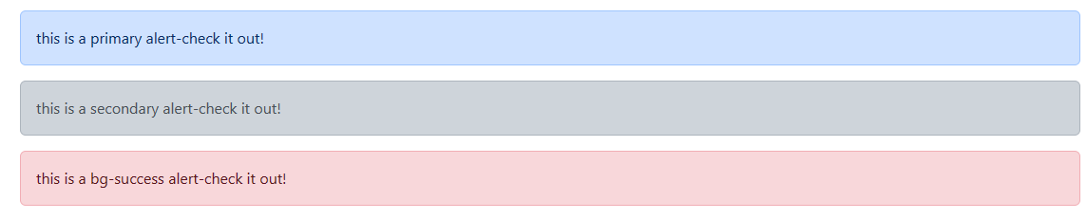

Q10) What is a bootstrap card and how would you create one?

Bootstrap’s cards provide a flexible and extensible content container with multiple variants and options.

