[1]

All in one Agriculture Website (Crop’s Diseases Detection and Crop & Fertilizer Recommendation Website for Farmers)

Digvijay Kailas Patil

***Abstract***— Crop diseases are a key danger for food security. The progress in field of computer vison and deep learning resulted better technique for many computer vison tasks. Using a public dataset of over 7000 images of infected and healthy leaves of various crops collected under controlled conditions, we trained a deep convolutional neural network to identify diseases corresponding to the crops. The trained model achieved an accuracy of over 75% on a held-out test set. The main objective of our web-application is to design a platform which will detect diseases on crop-leaves and which will farmers to take care of crops and take prevention to avoid such diseases

***Keywords*** *—*

*CNN, Deep Learning, computer vision, Machine Learning*

# **INTRODUCTION**

Since the dawn of time, humans were depending on edible plants to survive, our ancestors would travel for long distances searching for food, no surprise that the first human civilizations began after the invention of agriculture, without crops will be impossible for humanity to survive. Modern technologies have given human society the ability to produce enough food to meet the demand of more than 7 billion people. However, food security still threated by many factors including plant diseases, Plant diseases are major threats for smallholder farmers, whose depend on healthy crops to survive, and about 80% of the agricultural production in the developing world is generated by them. Identifying a disease correctly when it first appears is a crucial step for efficient disease management, traditional approaches to identify diseases is done by visiting local plant clinics .The early detection of diseases is important in agriculture for an efficient crop yield. The bacterial spot, late blight, Septoria leaf spot and yellow curved leaf diseases affect the crop quality of tomatoes. Automatic methods for classification of plant diseases also help taking action after detecting the symptoms of leaf diseases.

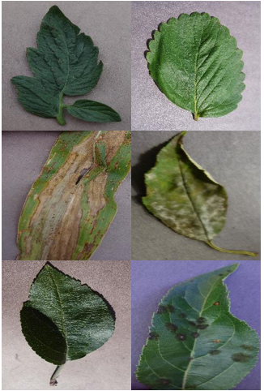

Images of healthy and diseased leaf

Analysis- Fungal infection represents up to of yield losses, making it necessary to apply effective and cost efficient fungicide treatments, whose efficacy depends on infestation type, situation and time. In these cases, a correct and early identification of the specific infection is mandatory to minimize yield losses and increase the efficacy and efficiency of the treatments The mixture of increasing worldwide smartphone dispersion and current advances in computer

Vision made conceivable by deep learning has cemented the way for smartphone-assisted disease identification. Using a public dataset of over 7000 images of infected and healthy leaves of various crops collected under controlled conditions, we trained a deep convolutional neural network to identify diseases corresponding to the crops. The trained model achieved an accuracy of over 75% on a held-out test set, demonstrating the feasibility of this approach. Overall, the approach of training deep learning models on increasingly large and publicly available image datasets presents a clear path toward smartphone-assisted crop disease diagnosis on a massive global scale.

A successful protection strategy should start with an early detection of the disease in order to choose the appropriate treatment at the right time to prevent it from spreading. Usually, this detection is achieved by experts having an academic knowledge reinforced by practical experience on symptoms and causes of diseases. Furthermore, these experts must monitor plants consistently to avoid disease spreading. This continuous monitoring represents a difficult and time-consuming task for humans, which makes the automation of the plant diseases detection and identification essential to protect plants Modern technologies have given human society the ability to produce enough food to meet the demand of more than 7 billion people. However, food security still threated by many factors including plant Diseases, Plant diseases are major threats for smallholder farmers, whose depend on healthy crops to survive, and about 80% of the agricultural production in the developing world is generated by them.

Identifying a disease correctly when it first appears is a crucial step for efficient disease management, traditional approaches to identify diseases is done by visiting local plant clinics.

# Literature Review

The problem we are working on is related to the agricultural domain and our solution will surely help farmers overcome this problems of detection of there diseases. Here we will working on advanced concepts like deep learning and computer vision. To get an idea of these vast subjects we took references of a book by Aaorn Courville titled "Deep Learning".

In every problem data is a very important component. So we searched for useful data and got it from sites like "kaggle","plant village" and many more sites on the internet.

We also referred many research papers from various sites such as "reserachgate","IEEE" and many more available on Google Scholar. We also referred some tutorial videos on YouTube.

Next part of our project is the front-end part for which we will be using HTML,CSS. So we got great tutorial for these programming languages on sites like "W3Schools","Tutorial point", "GFG" and many other sites.

# Methodology/Experimental

## Materials/Components/Flowchart/Block Diagram/Theory

## Synthesis/Algorithm/Design/Method

## 

1]The Artifical Convolutional Neural

Network:

In machine learning, a Convolutional Neural Network (CNN or ConvNet) is a class of deep, feed-forward artificial neural networks, most commonly applied to analyzing visual imagery. CNNs use a variation of multilayer perceptrons designed to require minimal preprocessing. This means that the network learns the filters that in traditional

algorithms were hand-engineered. This independence from prior knowledge and human effort in feature design is a major advantage. They have applications in image and video

recognition, recommender systems and natural language processing.

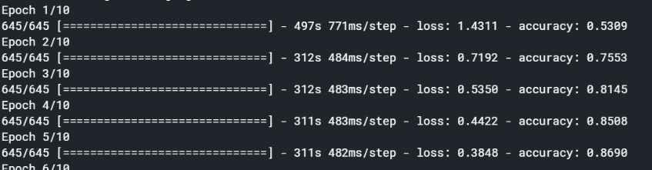

2] A CNN consists of an input and an output layer, as well as multiple hidden layers. The hidden layers of a CNN typically consist of convolutional layers, pooling layers, fully 12 connected layers and normalization layers [1-5]. Description of the process as a convolution in neural networks is by convention. Mathematically it is a cross correlation rather than a convolution. This only has significance for the indices in the matrix, and thus which weights are placed at which index

3] Convolutional and Pooling layers:-

Convolutional layers apply a convolution operation to the input, passing the result to the next layer. The convolution emulates the response of an individual neuron to visual stimuli. Each convolutional neuron processes data only for its receptive field. Although fully. Convolutional networks may include local or global pooling layers [8, 9, 10], which combine the outputs of neuron clusters at one layer into a single neuron in the next layer. For example, max pooling uses the maximum value from each of a cluster of neurons

at the prior layer. Another example is average pooling,

After creating, designing model/classifier then what?

How everyone can use this feature? Then web deployment comes into picture

Heroku is a cloud platform as a service supporting several programming languages.

We will be building our app using flask, html and will style it using css.

# Future Scope

There are many possibilities to extend this project , For example adding chat-bot feature that will act as customer care or decision support system for farmers, we can also integrate this hardware like raspberry pi, node mcu ,Possibilities are endless. If this technique is developed into a sophisticated interface in the form of an Android Application it may be great asset to the agricultural sector. In the future this methodology can be integrated with other yet to be developed methods for disease identification and classification. The use of other algorithms can be explored to enhance the efficiency of the system in future.

# Conclusion

The Feed Forward and Cascaded Feed Neural Network algorithms can be used to design an expert system for the farmers for early detection of Plant Diseases. Presently 13 Diseases as mentioned earlier can be detected by this process. The Feed Forward and Cascaded Feed algorithms can be expanded for detection of multiple diseases on a significantly large scale. By increasing the number of features and the number of inputs to the Neural Network the algorithms can be enhanced.

References

1. Hussain, Mahbub; Bird, Jordan J.; Faria, Diego R. (September 2018). Advances in Computational Intelligence Systems (1st ed.). Nottingham, UK.: Springer. ISBN 978-3-319-97982-
2. Akhtar, A., Khanum, A., Khan, S.A., Shaukat, A.: Automated plant disease analysis (APDA): performance comparison of machine learning techniques. In: 2013 11th International Conference on Frontiers of Information Technology, pp. 60–65. IEEE Computer Society, Islamabad (2013)
3. Grel, Tomasz "Region of interest pooling explained". deepsense.io. 5. Krizhevsky, Alex; Sutskever, Ilya; Hinton, Geoffrey E. (2017-05-24). "ImageNet classification with deep convolutional neural networks" .
4. Mr. Sanjay Mirchandani1, Mihir Pendse2, Prathamesh Rane3, Ashwini Vedula4 PLANT DISEASE DETECTION AND CLASSIFICATION USING IMAGE PROCESSING AND ARTIFICIAL NEURAL NETWORKS
5. Brahimi M., Arsenovic M., Laraba S., Sladojevic S., Boukhalfa K., Moussaoui A. (2018) Deep Learning for Plant Diseases: Detection and Saliency Map Visualisation. In: Zhou J., Chen F. (eds) Human and Machine Learning
6. Al Hiary, H., Bani Ahmad, S., Reyalat, M., Braik, M., ALRahamneh, Z.: Fast and accurate detection and classification of plant diseases. Int. J. Comput. Appl. 17(1), 31–38 (2011)

1.