Table of Contents

*1.1 Purpose 1*

*1.2 Project Idea 1*

*1.3 System Overview 1*

*1.4 System Specification 2*

*1.4.1 Web Ordering System – Detailed 2*

*1.4.2 Manu Management System Tool 8*

*1.5 DESIGN…………………………………………………………………………………………..……………………11*

|  |  |
| --- | --- |
| Document Version | Updated By |
| Version 1.0 |  |

## Purpose

The purpose of this document is to serve as a single reference document while developing the online food ordering web application. Right form UI mock ups to design and API related solutions would be drafted in this document

## Project Idea

Online food ordering system is a web designed primarily for use in food delivery industry. This system will allow customer directly order the food via visiting the website. User will also be able to pay the amount online. The system also allows to quickly and easily managing an online menu, which customers can browse, and use to place orders with just few clicks.

## System Overview

Following are the technical details for the proposed online food ordering system

* + 1. High Level Modules
       1. Web Ordering System

This module will have the customer UI interface that allows selecting the food item via a self-service navigation menu. User should be able to add the menu items in the cart, review the cart, pay the due amount and finally get the confirmation message.

* + - 1. Menu Management System

This module of the online system will be used by the admin user. User with admin privileges will be able to manage the online meus and will be able to do operations like adding a new menu item in the menu, deleting an existing item and updating an existing menu item.

* + - 1. Order Retrieval

This module will be used by the restaurant employees to track and to fulfill the orders placed by the customers. This will be going to be the future enhancement.

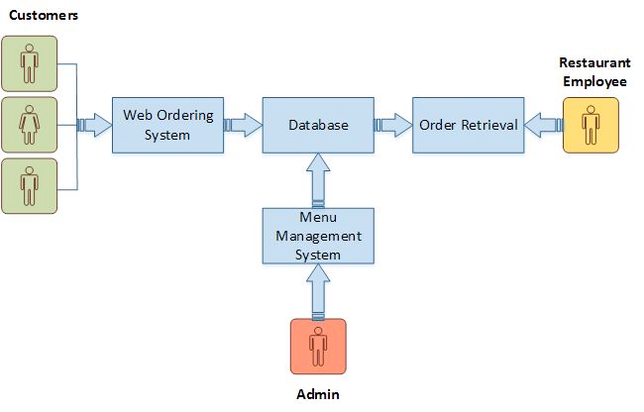

## System Specification

## Web Ordering System – Detailed

* + - 1. **Home page Navigation Panel**

Navigation panel will have set of link that will allow user to go access different functionalities

Reference Mock Up:

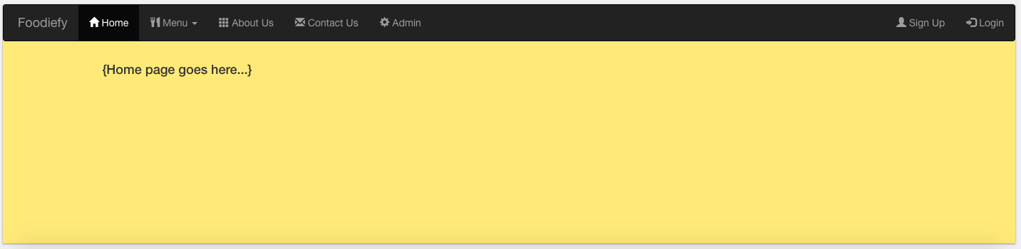

* + - 1. **Sign Up Module**

On click on Sign up user will be able to create the online profile which will be used for future logins

Reference Mock Up:

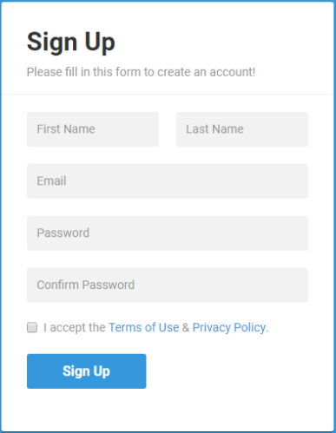

* + - 1. **Login**

Login screen will accept the user’s login credentials. On successful login users profile will be loaded.

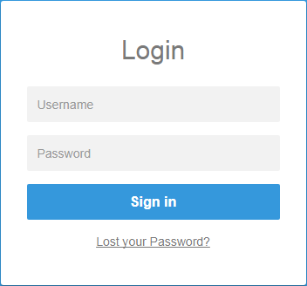

* + - 1. **Menu Selection**

User should be able to see the menu item offered via clicking on the category.

Reference Mock Up:

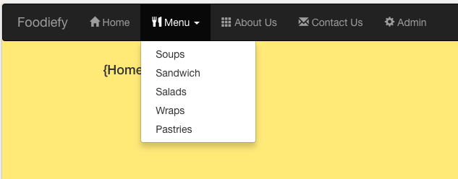

* + - 1. **Loading the Menu**

Once user clicks on the menu category let’s say Sandwich, the menu items associated to the category will be loaded on the home page. Once menu items are loaded for the selected category, user will be able to read the description and the price of the item.

Reference Mock Up:

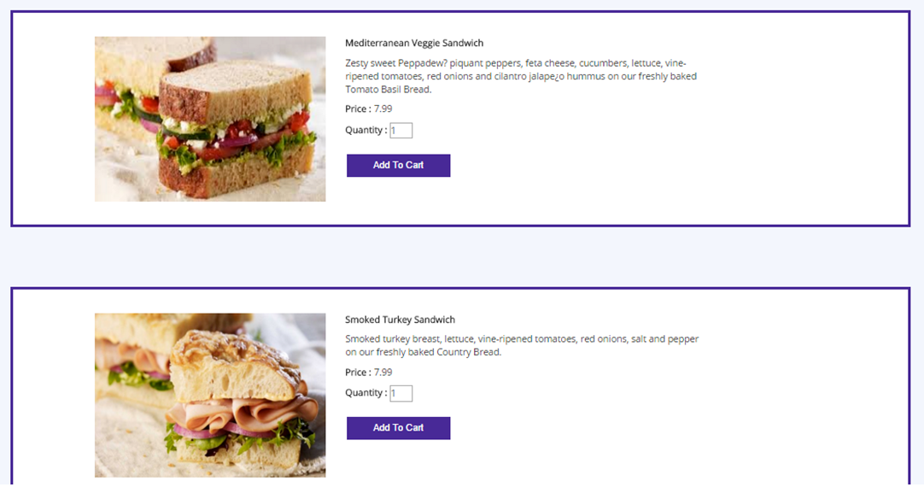

* + - 1. **Adding item to the cart**

All individual menu items will have the individual add to cart button. On clicking on it Item will be added to the cart and system should have a way to bring up the message saying item has been added to the cart.

Reference Mock up:



* + - 1. **Review/ Modify Cart**

Before proceeding to the checkout, user should be able to see the summary of their order, review the cart and should be able to modify if they wish, should be able to delete an item from the cart, change quantity, and a link to go for checkout.

Reference Mock up:

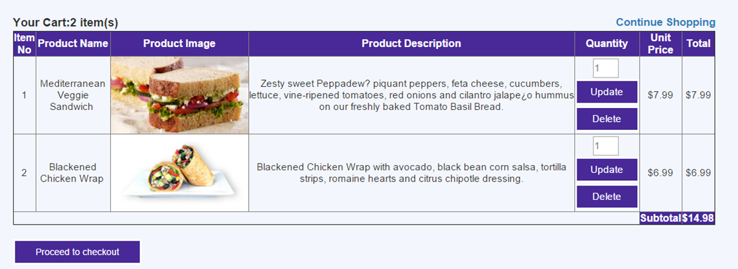

* + - 1. **Payment Section**

Once User done reviewing the cart and clicks on ‘Proceed to Checkout’ button, user should be navigated to payment section where user should be able to make a payment via a debit/credit card for the amount totaled in review page.

Reference Mock up:

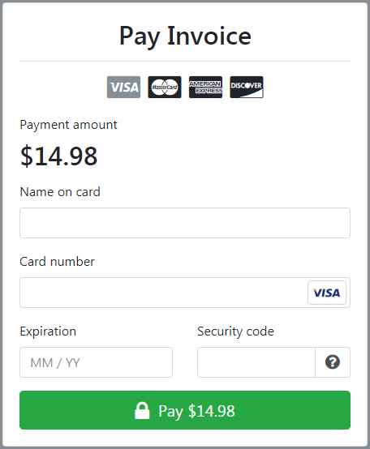

* + - 1. **Check Out**

Once user has provided the payment details, the final step will be checking out the order. User will have a checkout button which will authorize the payment and will submit the order placed.

Reference Mock Up:

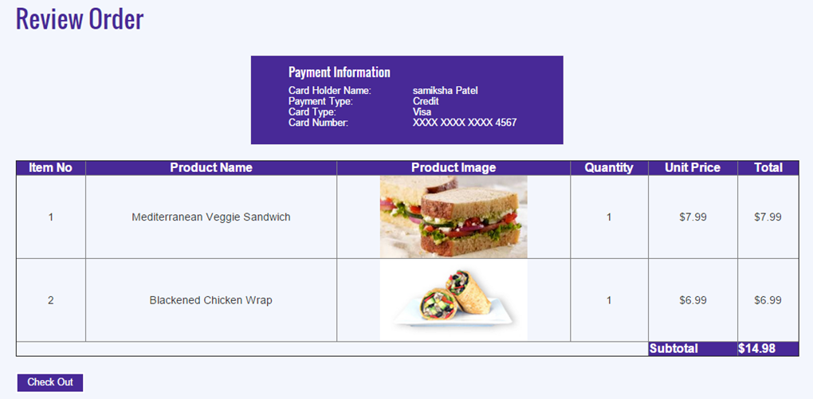

* + - 1. **Order Confirmation**

On successful payment system will process the order and user should receive a confirmation message

Reference Mock Up:



## Manu Management System Tool

This module of the online system will be used by the admin user. User with admin privileges will be able to manage the online meus and will be able to do operations like adding a new menu item in the menu, deleting an existing item and updating an existing menu item. Only the user with admin privileges should be able to have access to this functionality

* + - 1. **Add a New Menu Item**

This functionality will let user to add a new menu item.

Reference Mock up:

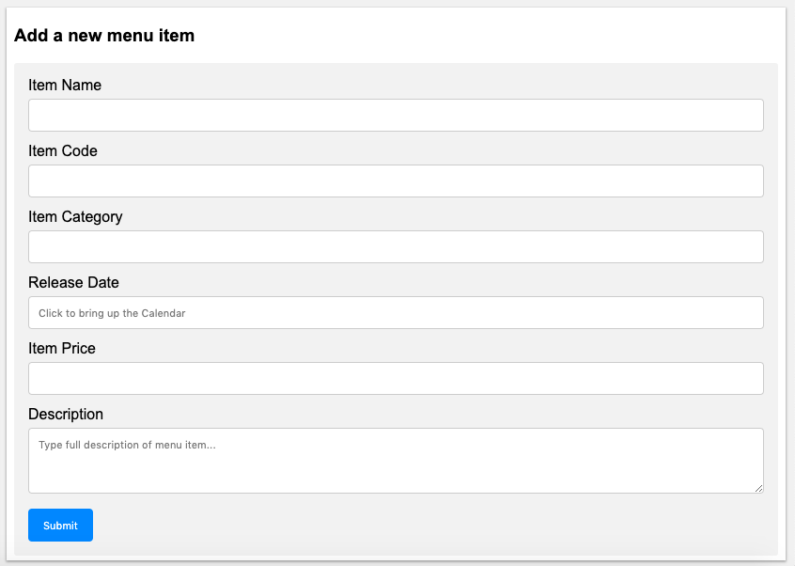

* + - 1. **Menu Dashboard**

User will have a table in the form of grid where user can see all the menu items listed and will be able to see the records in the tabular view. User should have an ability of searching, sorting, filtering and pagination on the menu items table. User will also have a way to delete or edit an existing item

Reference Mock up:

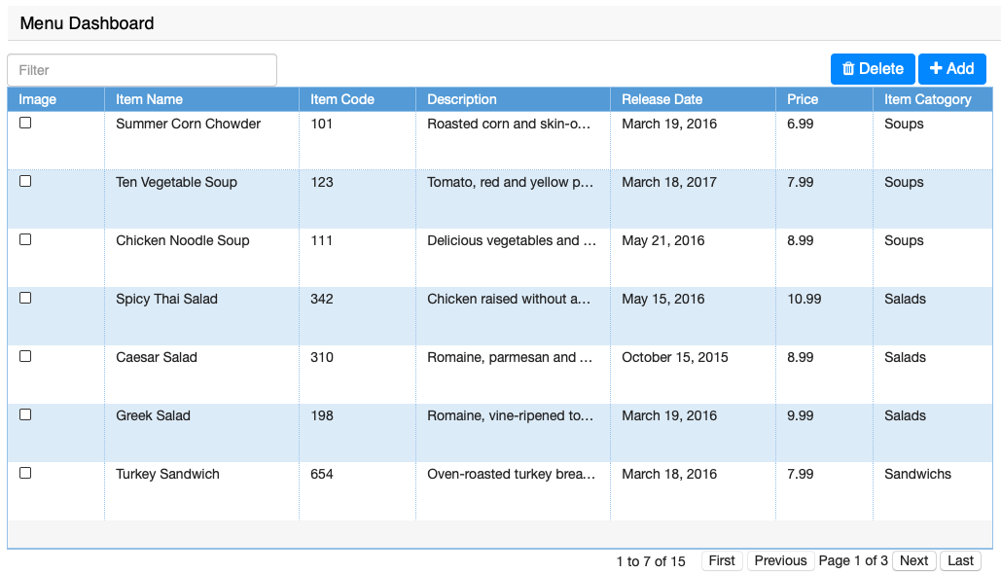

* + - 1. ***Edit an existing menu item***

User should be able to edit an existing menu item

Reference Mock up:

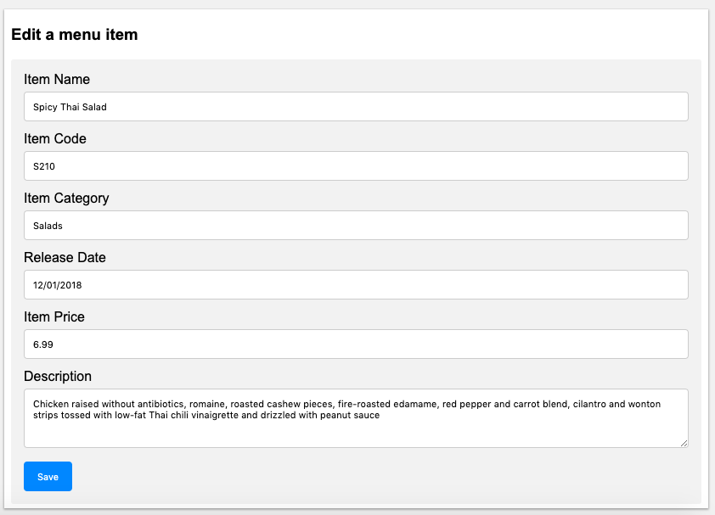

* 1. **Design**

{Design discussion goes here in this section}