**Air Quality Measurement**

Course name : Fundamental of Electronics and Digital System Lab

Course code : CSC 232

Section : B

Group No : 11

Group Name : Tesla

Date : 26/12/2021

Submitted to:

Course Instructor

**Prof. Dr.Hasibur Rashid Chayon**

Associate Professor & Coordinator

Dept. of Computer Science & Engineering

Prepared by:

|  |  |  |
| --- | --- | --- |
| **Name** | **Student ID** | **Program** |
| Rakibul Hasan Dihan | 20203038 | BCSE |
| Md. Redwan Hossain | 20203005 | BCSE |
| Sadia Jahan Fatema | 20203062 | BCSE |



**IUBAT—International University of Business Agriculture and Technology**

4 Embankment Drive Road, Sector 10, Uttara Model Town, Dhaka-1230

**Abstract**

Technology nowadays is getting smarter day by day because of the use of Internet of Things also known as IoT. Environment conservation is one of the most crucial and critical topics which desperately needs to be discussed and acted upon. Air Quality Index (AQI) is a scale of measuring the quality of air in the surrounding areas. The air quality detector leads us the knowledge of all harmful gases present in the air and the also informs about the concentration of such gases in PPM (Parts Per Million). This high concentration of particulate matter is smaller and thinner than a width of a human hair (70 microns). The gathered data from the Arduino is then sent to the software where it combines and stores the output in a graphical form for any future references. This type of project leads to public awareness among the common people and helps them realize the great importance for environment conservation.

**Table of Content**

**Chapter 1**

1. **Introduction …………………. 6**

**Chapter 2**

1. **Arduino UNO ………………… 7**
2. **LCD Screen …………………... 7**
3. **MQ-135 Sensor ………………..7**
4. **I2C Adaptor …………………… 8**
5. **Jump Wire …………………….. 10**
6. **Range of PPM in respect of Air Quality …… 11**
7. **Working Procedure of MQ 135 ……………. 11**

**Chapter 3**

1. **Design ………………………… 12**
2. **Circuit ………………………… 13**
3. **Hardware ………………………… 15**
4. **Software ………………………… 15**
5. **Codding………………………… 16**
6. **Experiment ………………………… 17**

**Chapter 4**

1. **Experiment & Result ………………………………. 19**

**Chapter 5**

1. **Conclusion …………………………………………... 23**

**List of Figures**

1. **Fig 2.2: MQ-135 Sensor**
2. **Fig 2.3: LCD Screen**
3. **Fig 2.5: Jumper wire**
4. **Fig: Circuit of Air Quality Measurement**

**List of Table**

1. **Air Quality range in PPM**
2. **Connection of components**

# **Chapter 1**

# **Introduction**

Nowadays pollution is world wide problem and air pollution is one of the biggest issues among them. Air is getting polluted in several ways. When unexpected sustain mix with normal element in the air that’s called air pollution. Pollution is kind of threat for human living. It creates many problems in environment even many natural digesters are causes for it. And increasing world temperature air pollution has great impact on it. There are some elements like carbon mono oxide, lead, nitrogen oxides, ground-level ozone etc. Air causes many diseases asthma, lung damage, nausea and fatigue.

So, to prevent or taking step about air pollution first we need to know quality on the air. We have to use a device to check the quality of the air.

So according to our project task we have make a small device which is an air quality detective device. An air quality detective device which is give information about the condition of air. This project aimed made for air quality monitors. And it is so small device that can be portable, it can be also used for measuring air pollution indoors, outdoors air.it has a sensor which is MQ-135 gas sensors that is detecting concentration of the harmful element of the air.

**Chapter 2**

**Theoretical background**

In this chapter we discuss about the theoretical background of each components, those are used in this project.

The components are used in this project those are :

1. Arduino UNO R3
2. MQ-135 Sensor
3. LCD screen
4. I2C Adaptor
5. Jump wire

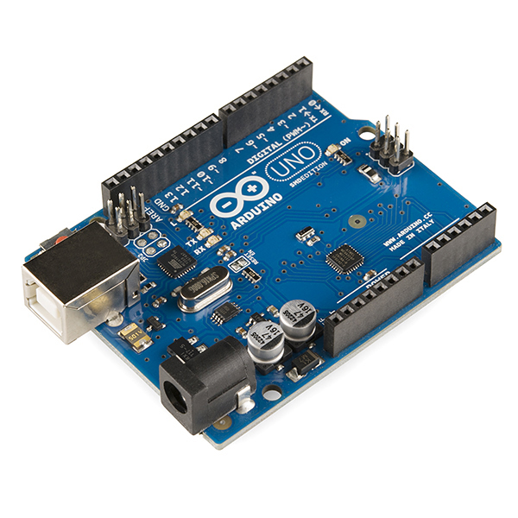**I. Arduino UNO :**  The Arduino UNO is an [open-source](https://en.wikipedia.org/wiki/Open-source) [microcontroller board](https://en.wikipedia.org/wiki/Microcontroller_board) based on the [Microchip](https://en.wikipedia.org/wiki/Microchip_Technology) [ATmega328P](https://en.wikipedia.org/wiki/ATmega328P) microcontroller and developed by [Arduino.cc](https://en.wikipedia.org/wiki/Arduino). The board is equipped with sets of digital and analog [input/output](https://en.wikipedia.org/wiki/Input/output) (I/O) pins that may be interfaced to various [expansion boards](https://en.wikipedia.org/wiki/Expansion_board) (shields) and other circuits. The board has 14 digital I/O pins (six capable of [PWM](https://en.wikipedia.org/wiki/Pulse-width_modulation) output), 6 analog I/O pins, and is programmable with the [Arduino IDE](https://en.wikipedia.org/wiki/Arduino#Software) (Integrated Development Environment), via a type B USB Cable. It can be powered by the

**Fig 2.1: Aurdino UNO R3**

USB cable or by an external [9-volt battery](https://en.wikipedia.org/wiki/9-volt_battery), though it accepts voltages between 7 and 20 volts.

**General pin functions of Arduino-**

* **LED:** There is a built-in LED driven by digital pin 13. When the pin is high value, the LED is on, when the pin is low, it is off.
* **VIN:** The input voltage to the Arduino board when it is using an external power source as opposed to 5 volts from the USB connection or other regulated power source. Voltage can be supplied through this pin, or, if supplying voltage via the power jack, access it through this pin.
* **5V:** This pin outputs a regulated 5V from the regulator on the board. The board can be supplied with power either from the DC power jack (7 - 20V), the USB connector (5V), or the VIN pin of the board (7-20V). Supplying voltage via the 5V or 3.3V pins bypasses the regulator, and can damage the board.
* **3V3:** A 3.3 volt supply generated by the on-board regulator. Maximum current draw is 50 mA.
* **GND:** Ground pins.
* **Reset**: Typically used to add a reset button to shields that block the one on the board.

**II. MQ-135 Sensor:** The MQ135 is one of the popular gas sensors from the MQ series of sensors that are commonly used in air quality control equipment. It operates from 2.5V to 5.0V and can provide both digital and analog output.

The **MQ-135 Gas sensor** can detect gases like Ammonia (NH3), sulfur (S), Benzene (C6H6), CO2, and other harmful gases and smoke. Similar to other MQ series gas sensor, this sensor also has a digital and analog output pin. When the level of these gases go beyond a threshold limit in the air the digital pin goes high. This threshold value can be set by using the on-board potentiometer. The analog output pin, outputs an analog voltage which can be used to approximate the level of these gases in the atmosphere.

The MQ135 air quality sensor module operates at 5V and consumes around 150mA. It requires some pre-heating before it could actually give accurate results.

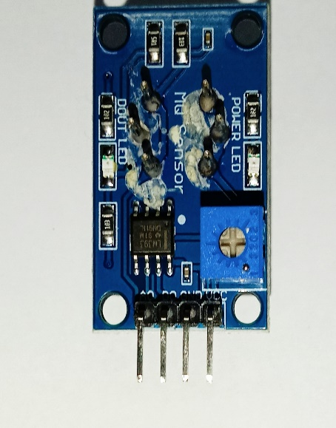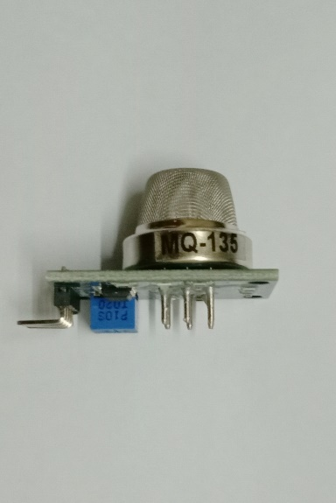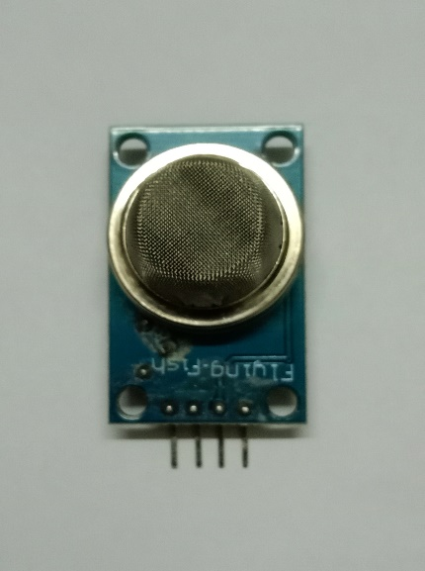   **Fig 2.2: MQ-135 Sensor**

**III. LCD Screen:** LCD (Liquid Crystal Display) screen is an electronic display module and find a wide range of applications. A 16x2 LCD display is very basic module and is very commonly used in various devices and circuits. These modules are preferred over seven segments and other multi segment LEDs. The reasons being: LCDs are economical; easily programmable; have no limitation of displaying special & even custom characters (unlike in seven segments), animations and so on.

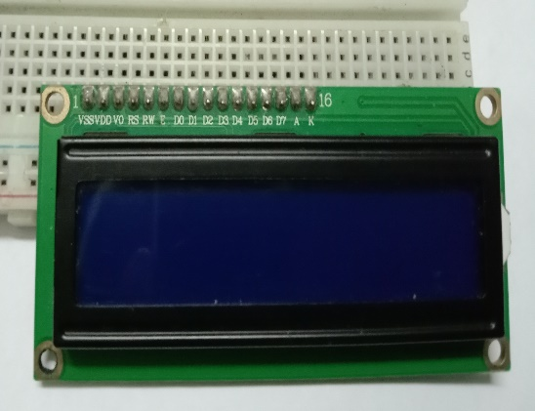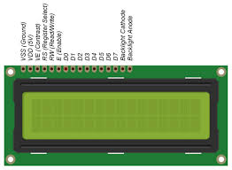A 16x2 LCD means it can display 16 characters per line and there are 2 such lines. In this LCD each character is displayed in 5x7 pixel matrix. This LCD has two registers, namely, Command and Data.

**Fig 2.3: LCD Screen**

**IV. I2C Adaptor:** It is also known as I2C Module. It has total of 20 male pins. 16 pins are faced to rear side and 4 pins faced towards front side. The 16 pins for connect to 16x2 LCD and the 2 pins out of 4 pins are SDA and SCL. SDA is the serial data pin and SCL is the clock pin. The rest 2 pins for power supply -Vcc and ground.There is a POT on the I2C Module. We can control the contrast of the LCD display by rotating this POT. And there is a jumber fixed on the module. When we remove the jumber, the backlight of the LCD display will go OFF.

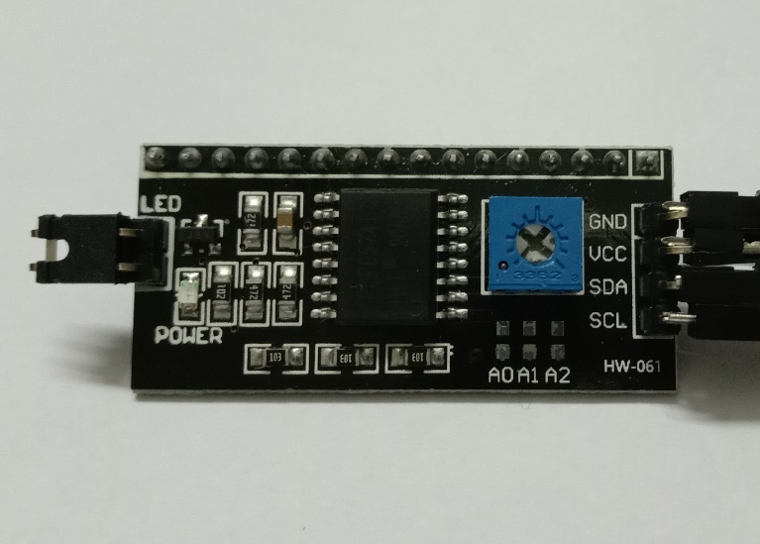 **Fig 2.4: I2C Module**

**V. Jump Wire:** A jump wire also known as jumper, jumper wire, jumper cable or cable ,is an [electrical wire](https://en.wikipedia.org/wiki/Electrical_wire), or group of them in a cable, with a connector or pin at each end or sometimes without them – simply "tinned", which is normally used to interconnect the components of a [breadboard](https://en.wikipedia.org/wiki/Breadboard) or other prototype or test circuit, internally or with other equipment or components, without soldering. We have used some jumper wire to connect the component with one another.

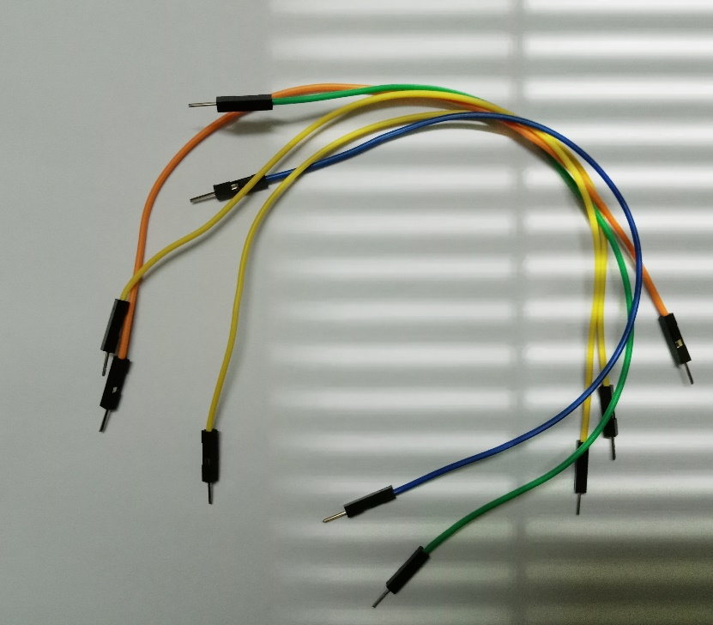 **Fig 2.5: Jumper wire**

**Air Quality Index:**

An Air Quality Index is used by government agencies to communicate to the public how polluted the air currently is or how polluted it is forecast to become.

**Range of PPM in respect of Air Quality:**

|  |  |
| --- | --- |
| **Air Quality** | **Range of PPM** |
| Good Air | 0 – 30 |
| Moderate Air | 31 – 150 |
| Harmful Air | 151 – 250 |
| Hazardous Air | 251 – more |

**Table: Air Quality range in PPM**

**Working Procedure of MQ 135:**

The MQ-135 gas sensor senses gases like ammonia nitrogen, oxygen, alcohols, aromatic compounds, sulfide, and smoke. The boost converter of the chip MQ-3 gas sensor is PT1301. The operating voltage of this gas sensor is from 2.5V to 5.0V. The MQ-3 gas sensor has a lower conductivity to clean the air as a gas sensing material. In the atmosphere, we can find polluting gases, but the conductivity of the gas sensor increases as the concentration of polluting gas increases. MQ-135 gas sensor can be implemented to detect the smoke, benzene, steam, and other harmful gases. It has the potential to detect different harmful gases.

The air quality sensor is also an MQ-135 sensor for detecting venomous gases that are present in the air in homes and offices. The gas sensor layer of the sensor unit is made up of tin dioxide (SnO2); it has lower conductivity compare to clean hair and due to air pollution the conductivity is increased. The air quality sensor detects ammonia, nitrogen oxide, smoke, CO2, and other harmful gases. The air quality sensor has a small potentiometer that permits the adjustment of the load resistance of the sensor circuit. The 5V power supply is used for air quality sensor.

**Chapter: 3**

**Project development**

**Design:**

The circuit has been designed in ISIS 7 Professional which is a simulator for electronics design.

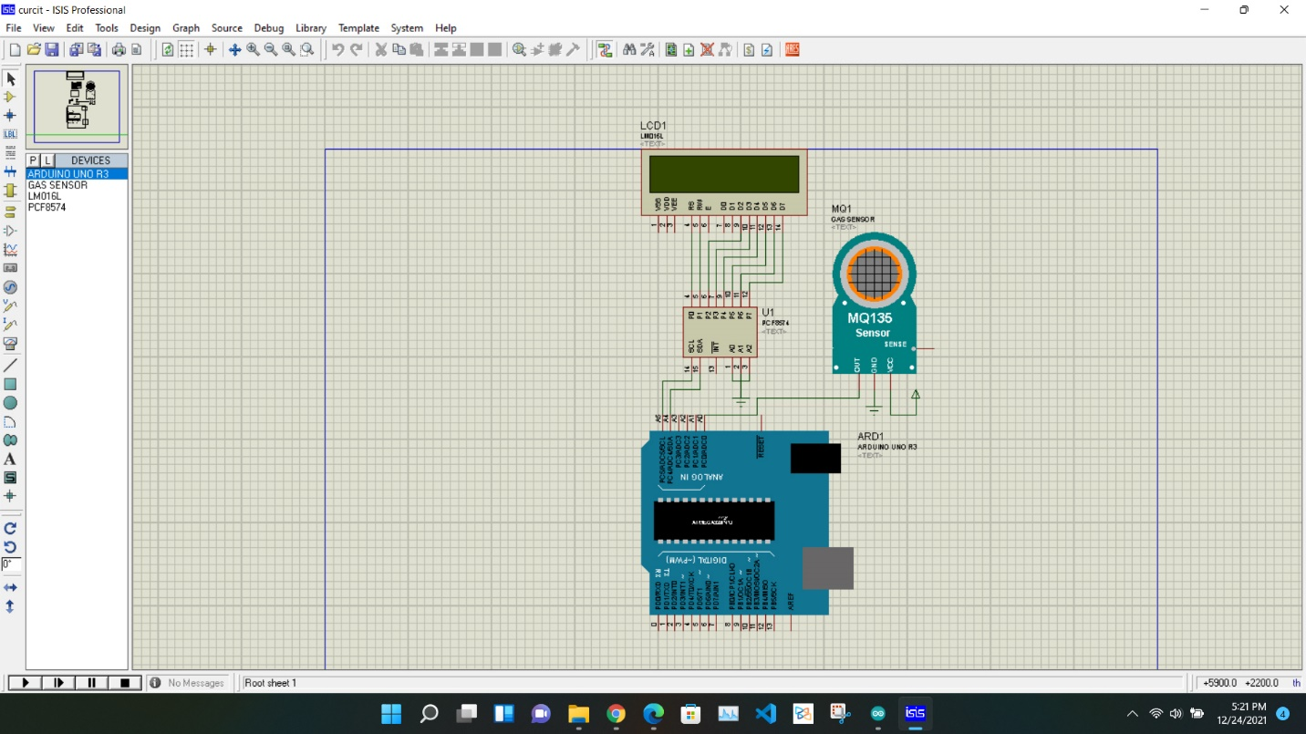

In the simulator ‘Arduino UNO R3’ is the microcontroller which is used to receive and to convert the signal reading from the sensor MQ-135. The microcontroller can execute the reading to the 16x2 LCD display. The LCD display has an additional module ‘I2C LCD Adapter Module’.

**Circuit:**

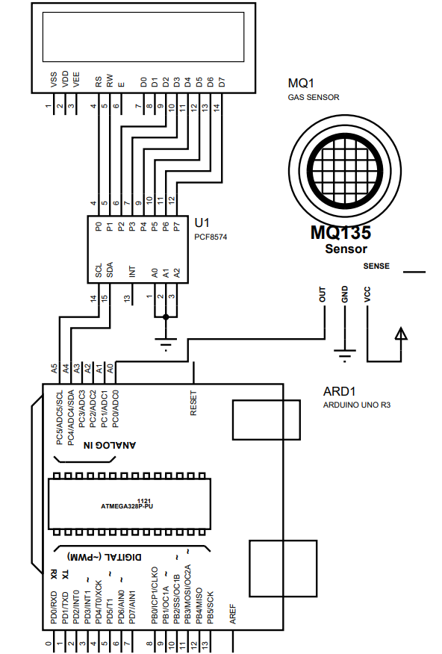

Fig: Circuit of Air Quality Measurement

**Connection**:

|  |  |  |
| --- | --- | --- |
| **Arduino UNO R3** | **MQ- 135** | **I2C LCD Adapter Module** |
| 5v | VCC | VCC |
| A0 | A0 |  |
| A4 |  | SDA |
| A5 |  | SCL |
| GND | GND | GND |

**Table: Connection of components**

The display LCD 16x2 has been connected to the I2C LCD Adapter Module to 1 – 16 pins.

**Implementation:**

1. **Hardware:**

At first 5v and GND of Arduino has been connected by Jumper Wire to the positive section and a negative section of the Breadboard. Then MQ-135 has been attached in the Breadboard. VCC and GND of MQ-135 has been connected to the 5v and GND section of the Breadboard. A0 or analog reading has been connected to the A0 of the Arduino UNO R3.

VCC and GND of I2C LCD Adapter Module has been connected to the 5v and GND section of the Breadboard. And there are 16 pins in the I2C LCD Adapter Module which has been parallelly connected to the 16x2 LCD display. SDA and SCL of I2C Adapter Module has been connected the A4 and A5 of Arduino UNO R3.

1. **Software:**

Arduino UNO R3 is a physical device which is a single-board microcontroller. It can run Arduino Programming Language. There is an open source software and integrated developed environment called Arduino IDE.



It can be used to compile and to upload the code to Arduino hardware.

1. **Codding:**

Arduino Programming Language is used of run instructions to the physical Arduino hardware. There is a USB type-B port in Arduino to connect with computer or any external device. Code can uploaded from Arduino software to the hardware by an USB cable. The following code has been used to implement the instruction.

// Air Quality Measurement

#include <Wire.h>

#include <LiquidCrystal_I2C.h>

LiquidCrystal_I2C lcd(0x27, 16, 2); // set the LCD address to 0x27 for a 16 chars and 2 line display

void setup()

{

lcd.init(); // initialize the lcd

// Print a message to the LCD.

lcd.backlight();

Serial.begin(9600);

}

void loop()

{

int sv = analogRead(A0);

sv = sv - 500 ;

Serial.print("AQI: ");

Serial.print(sv , DEC);

Serial.println(" PPM");

if ( sv <= 50 )

{

lcd.setCursor(0, 0) ;

lcd.print("Good Air");

lcd.setCursor(0, 1) ;

lcd.print("AQI : ");

lcd.print(sv , DEC);

lcd.print(" PPM");

delay (1000) ;

}

else if ( sv > 50 && sv < 150 )

{

lcd.setCursor(0, 0) ;

lcd.print("Moderate Air");

lcd.setCursor(0, 1) ;

lcd.print("AQI : ");

lcd.print(sv , DEC);

lcd.print(" PPM");

delay (1000) ;

}

else if ( sv >= 150 && sv < 250 )

{

lcd.setCursor(0, 0) ;

lcd.print("Unhealthy Air");

lcd.setCursor(0, 1) ;

lcd.print("AQI : ");

lcd.print(sv , DEC);

lcd.print(" PPM");

delay (1000) ;

}

else if ( sv > 250)

{

lcd.setCursor(0, 0) ;

lcd.print("Hazardous Air");

lcd.setCursor(0, 1) ;

lcd.print("AQI : ");

lcd.print(sv , DEC);

lcd.print(" PPM");

delay (1000) ;

}

}

In the code ‘sv’ is variable which is assigned to ‘analogRead(A0)’. The sensor MQ-135 returns value from its ‘A0’ to Arduino ‘A0’ pin. And here ‘sv’ receives the ‘A0’ value and executes its to the decimal value.

Here some conditions have been used to execute the result. When one certain condition is meet, it executes the particular statement.

**Experiment:**

It executes the analog reading from ‘A0’ pin. It needs to pre-heat to get accurate value. After pre-heating, the sensor value shows around 55 - 150 ppm for an environment. The range is normal in the environment and it is considered as ‘Moderate Air’. In a while, Carbon dioxide, Sulfur dioxide, Butene has been mixed in air to test the value. At that time, the sensor value increased to 155 ppm. Which indicates ‘Bad Air’.

**Chapter 4**

**Experiment & Result**

In a room temperature and indoor, the module has been pre-heated and some experiment has been done. The MQ- 135 module needs to be calibrated to get an accurate value. Calibrated can be done by turning the potentiometer clock-wise or anti clock-wise.

In normal air, the value 0 - 50 ppm. It indicates normal air or good air for the case. And the LCD display shows ‘Good Air’.

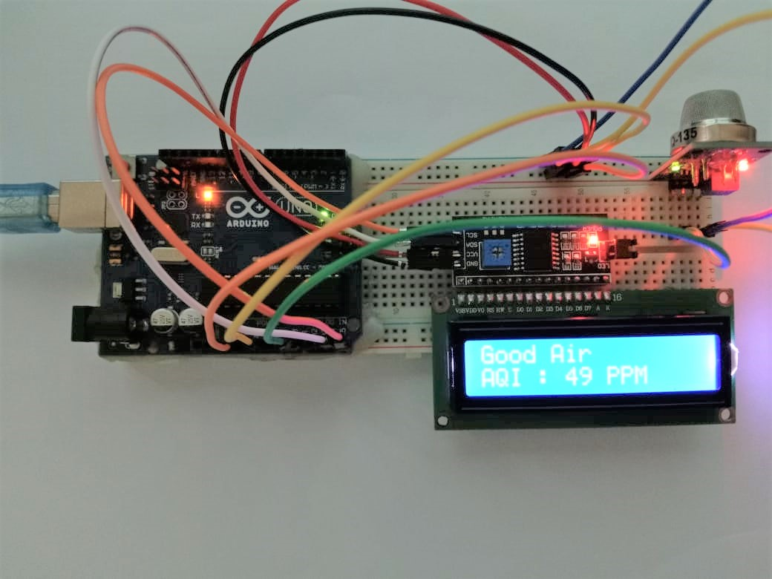

The range of ‘Good Air’ is 50 - 150 ppm. When the sensor returns any value within the range, it shows ‘Air Quality: Good’ to the 16x2 LCD display.

After a while, changing the room position and adding very little amount smoke and gas , the result shows 104 ppm.

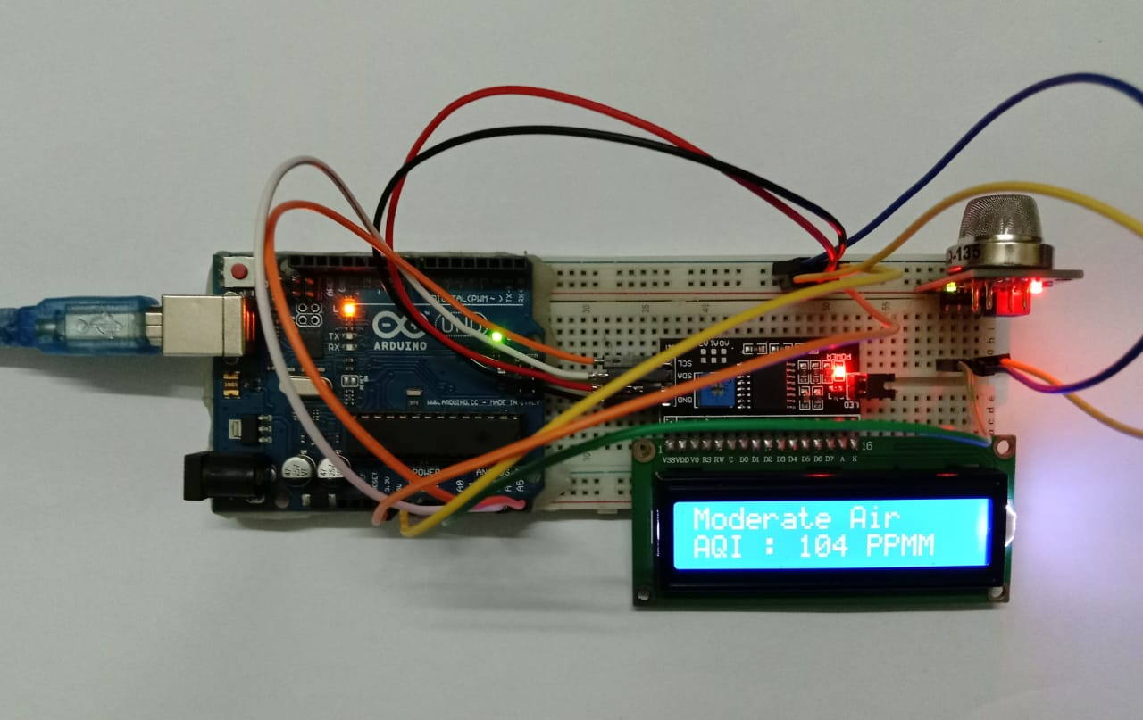

The range of ‘Moderate Air’ is 50 - 150 ppm. When the sensor returns any value within the range, it shows ‘Moderate Air’ to the 16x2 LCD display.

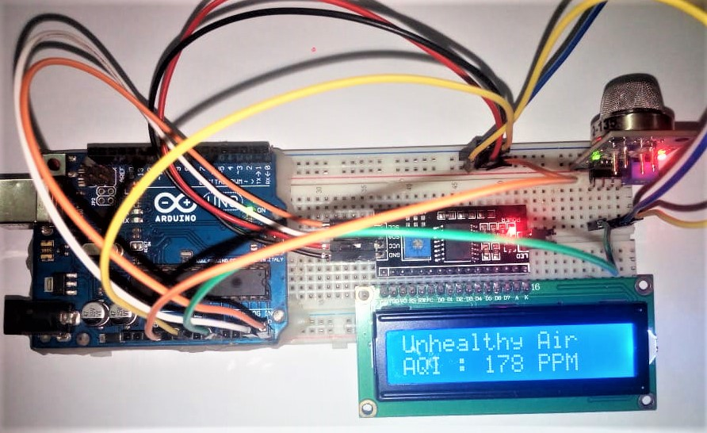

When the rage is greater than 150 ppm it returns the print as ‘Unhealthy Air’. The range of ‘Unhealthy Air’ is 150 - 250 ppm. When the sensor returns any value within the range, it shows ‘Unhealthy Air’ to the 16x2 LCD display.

In case of high concentration of several gas, the value increases extremely. At that time, it shows ‘Hazardous Air’. The range is 250 and more.

**Chapter 5**

**Conclusion**

Air quality monitoring systems are usually designed using different sensors for indoor and outdoor air quality monitoring. In this project we have used some electric components to develop our project including- Arduino UNO R3, I2C Module, an LCD screen, a MQ-135 gas sensor and some jumper wire. After connecting these components

WASP module is used which is costly. Instead of that different sensors can be used. The proposed system is developed for indoor air quality monitoring remotely. It is cost and energy efficient request and respond protocol is used along with combination of address and data centric protocols. Paper presents the summary of various techniques of air quality monitoring. These techniques are elaborately discussed in the paper. In the proposed system, one of the most preferred technique is cloud based air quality monitoring system. Using the same cloud data, website is hosted and data is displayed on the website.

As the Arduino is a microcontroller, the value can be changed in own way. So, the device can be used in medical sector, chemical manufacturing industries where air quality is important. There are some limitations of the device such as it requires pre-heat for about 20 hours or more to get most optimized value. But most of the is executes close to actual result of air quality.

**\*\*\***