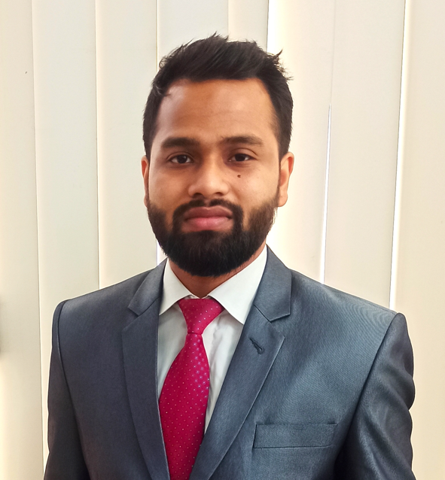

Contact

**Address:**

Uttara, Sector: 10, Road: 11 , 1230 Dhaka

**Phone:**

+880 1876463849

**Email:**

dihanrh@gmail.com

**LinkedIn:**

linkedin.com/in/rakibulhasandihan

**Website**:

dihanrh.wordpress.com

Languages

Bangla (Fluent)

English (Fluent)

Hobbies

* Design
* Public Speaking
* Illustration

Certifications

* **Champion (Campus) - Hult Prize 2021**

Summary

I am a **mentor** and **trainer** of C ++ & Object-Oriented Programing language at International University of Business Agriculture and Technology. I have been working as a “**Founder and Head of the Operation**” of a Clothing brand. I was the **champion** of the **Hult Prize** on-campus round 2021. I was the **team leader** of the regional final in 2021. In this journey, I have learned about leadership techniques & effective communication.

Skill Highlights

|  |  |
| --- | --- |
| * Project management * Strong decision maker * Graphics Designing | * Creative design * Innovative * Service-focused |

Programming Languages : C, C++, Python, Java,

Git Bash

IOT : Arduino UNO 3

Computer Hardware : IT Support, Computer

Network

Microsoft Office : MS Word, MS Excel,

MS Powerpoint

**Experience**

**Academic Mentor** ( March, 2022 – Present)

Mentor in Object Oriented Programming (C++) at IUBAT, Dhaka

**Trainer - Basic programming language** (Apr 2022 – Present)

IUBAT IT Society- Programming Wing (Programming Club). Basic programming language is a structured programming language course. My role is to tech about fundamental of programming in this course.

**Founder and Owner : Torso (Clothing Brand ) (2020 – Present )**

Torso is an uprising clothing brand. It works for men’s fashion design.

**Education**

**International University of Business Agriculture and Technology**

**B.Sc. in Computer Science & Engineering (Mar 2020 - Apr 2024)**

**7th semester (CGPA: 3.68 out of 4.00)**

**Feni Govt. College**

Higher Secondary School Certificate

Rakibul Hasan Dihan