**Question 5 : C program (code )**

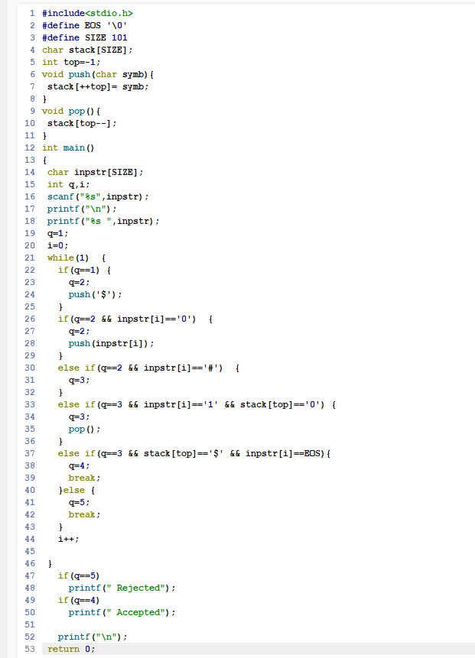

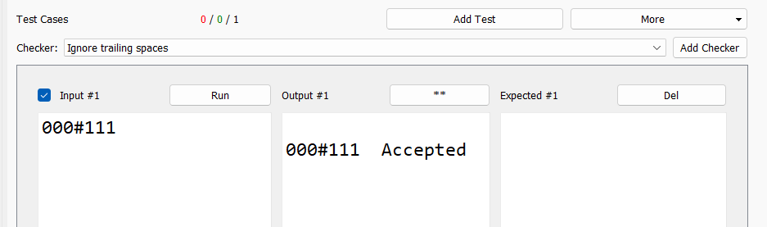

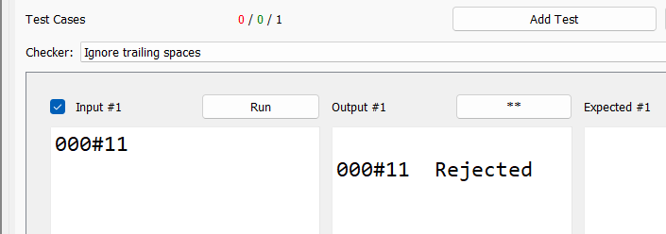

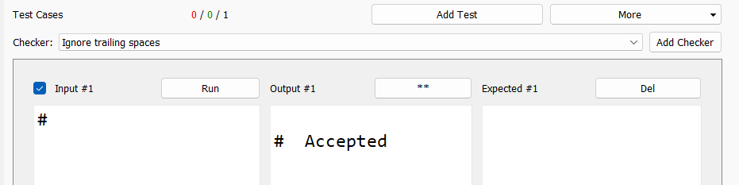

**Question 7:**

**Conclusion: We got a clear idea about PDA and the way it works.**