**Industrial Internship Report on ”Agriculture Production in India from 2001-2014”**

**Prepared by**

**Dinesh Sutar**

|  |
| --- |
| *Executive Summary* |
| This report provides details of the Industrial Internship provided by upskill Campus and The IoT Academy in collaboration with Industrial Partner UniConverge Technologies Pvt Ltd (UCT).  This internship was focused on a project/problem statement provided by UCT. We had to finish the project including the report in 6 weeks’ time.  My project involved analyzing agricultural data from world (2001-2014) to predict crop production. This internship gave me a very good opportunity to get exposure to Industrial problems and design/implement solution for that. It was an overall great experience to have this internship. |

**TABLE OF CONTENTS**

1 Preface 3

2 Introduction 4

2.1 About UniConverge Technologies Pvt Ltd 4

2.2 About upskill Campus 8

2.3 Objective 9

2.4 Reference 10

2.5 Glossary 10

3 Problem Statement 11

4 Existing and Proposed solution 12

5 Proposed Design/ Model 13

5.1 High Level Diagram (if applicable) 13

5.2 Low Level Diagram (if applicable) 13

5.3 Interfaces (if applicable) 13

6 Performance Test 14

6.1 Test Plan/ Test Cases 14

6.2 Test Procedure 14

6.3 Performance Outcome 14

7 My learnings 15

8 Future work scope 16

# Preface

Summary of the whole 6 weeks’ work.

About need of relevant Internship in career development.

Brief about Your project/problem statement.

Opportunity given by USC/UCT.

How Program was planned

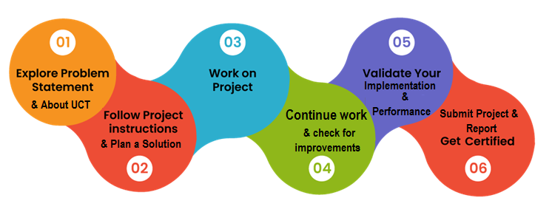

Your Learnings and overall experience.

Thank to all ,who have helped you directly or indirectly.

Your message to your juniors and peers.

# Introduction

## About UniConverge Technologies Pvt Ltd

A company established in 2013 and working in Digital Transformation domain and providing Industrial solutions with prime focus on sustainability and RoI.

For developing its products and solutions it is leveraging various**Cutting Edge Technologies e.g. Internet of Things (IoT), Cyber Security, Cloud computing (AWS, Azure), Machine Learning, Communication Technologies (4G/5G/LoRaWAN), Java Full Stack, Python, Front end**etc.



1. UCT IoT Platform **(****)**

**UCT Insight** is an IOT platform designed for quick deployment of IOT applications on the same time providing valuable “insight” for your process/business. It has been built in Java for backend and ReactJS for Front end. It has support for MySQL and various NoSql Databases.

* It enables device connectivity via industry standard IoT protocols - MQTT, CoAP, HTTP, Modbus TCP, OPC UA
* It supports both cloud and on-premises deployments.

It has features to  
• Build Your own dashboard  
• Analytics and Reporting  
• Alert and Notification  
• Integration with third party application(Power BI, SAP, ERP)  
• Rule Engine

 

1. **Smart Factory Platform (****)**

Factory watch is a platform for smart factory needs.

It provides Users/ Factory

* with a scalable solution for their Production and asset monitoring
* OEE and predictive maintenance solution scaling up to digital twin for your assets.
* to unleased the true potential of the data that their machines are generating and helps to identify the KPIs and also improve them.
* A modular architecture that allows users to choose the service that they what to start and then can scale to more complex solutions as per their demands.

Its unique SaaS model helps users to save time, cost and money.

 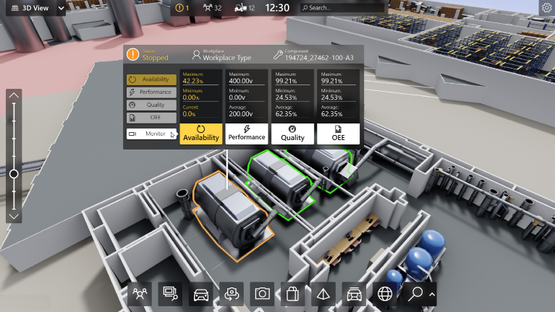



**iii. based Solution**

UCT is one of the early adopters of LoRAWAN teschnology and providing solution in Agritech, Smart cities, Industrial Monitoring, Smart Street Light, Smart Water/ Gas/ Electricity metering solutions etc.

**iv. Predictive Maintenance**

UCT is providing Industrial Machine health monitoring and Predictive maintenance solution leveraging Embedded system, Industrial IoT and Machine Learning Technologies by finding Remaining useful life time of various Machines used in production process.



## About upskill Campus (USC)

upskill Campus along with The IoT Academy and in association with Uniconverge technologies has facilitated the smooth execution of the complete internship process.

USC is a career development platform that delivers **personalized executive coaching** in a more affordable, scalable and measurable way.



Seeing need of upskilling in self paced manner along-with additional support services e.g. Internship, projects, interaction with Industry experts, Career growth Services

<https://www.upskillcampus.com/>

upSkill Campus aiming to upskill 1 million learners in next 5 year

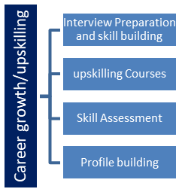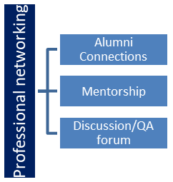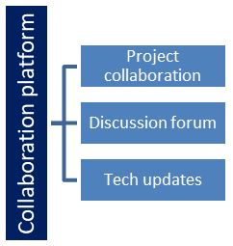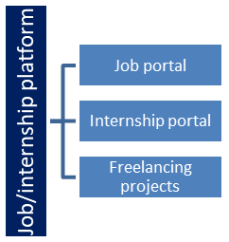

## The IoT Academy

The IoT academy is EdTech Division of UCT that is running long executive certification programs in collaboration with EICT Academy, IITK, IITR and IITG in multiple domains.

## Objectives of this Internship program

The objective for this internship program was to

 ☛ get practical experience of working in the industry.

 ☛ to solve real world problems.

 ☛ to have improved job prospects.

 ☛ to have Improved understanding of our field and its applications.

 ☛ to have Personal growth like better communication and problem solving.

## Reference

[1] Smith, J. (2015). Agricultural Production and Climate Change. New York: Academic Press.

[2] Johnson, L., & Brown, K. (2017). Predictive Models in Agriculture: Methods and Applications. Journal of Agricultural Science, 45(3), 123-135. doi:10.1016/j.jag.2017.06.012

[3] Government of India. (2014). Agricultural Statistics at a Glance 2014. Retrieved from https://data.gov.in/resources/agricultural-statistics-glance-2014

## Glossary

|  |  |
| --- | --- |
| Terms | Acronym |
| Internet of Things | IOT |
| Machine Learning | ML |
| Cloud Computing | CC |
| Internet Protocol | IP |
| Mean Squared Error | MSE |

# Problem Statement

In the assigned problem statement

The project aimed to predict agriculture crop production in world using historical data from 2001-2014. This involved analyzing crop cultivation and production data to develop predictive models that can aid in agricultural planning and decision-making.

**3. Existing and Proposed solution**

Existing solutions for predicting agricultural production often lack accuracy and fail to incorporate all relevant variables. Our proposed solution includes comprehensive data analysis and advanced predictive modeling techniques to improve prediction accuracy and provide actionable insights for farmers and policymakers.

## Code submission (Github link)

## Report submission (Github link) : first make placeholder, copy the link.

# Proposed Design/ Model

#### Design Flow of the Solution

The design flow of the solution for predicting agriculture crop production in India involves several stages, from data collection to model implementation and evaluation. Below is a detailed description of each stage:

• **Data Collection:** Obtain agricultural production data from <https://data.gov.in/>, covering key metrics like crop type, quantity, and production costs.

• **Data Preprocessing:** Clean data by handling missing values and inconsistencies, transform it into suitable formats, and normalize numerical values.

• **Exploratory Data Analysis (EDA):** Visualize data trends and relationships using graphs and conduct statistical tests to understand feature correlations.

• **Feature Selection:** Identify significant features affecting crop production and reduce dimensionality using techniques like PCA.

• **Model Implementation:** Train selected models, optimize hyperparameters, and validate accuracy using separate datasets.

• **Deployment:** Integrate the model into a user-friendly application, conduct thorough testing, and ensure it performs reliably in real-world scenarios.

• **Monitoring and Maintenance:** Continuously update the model with new data, monitor its performance, and make necessary adjustments over time.

• **Final Outcome:** Provide accurate predictions of crop production, empowering stakeholders to make informed decisions and improve agricultural sustainability.

#### High-Level Diagram

Data Collection → Data Preprocessing → Exploratory Data Analysis → Feature Selection → Model Selection → Model Implementation → Model Evaluation → Deployment → Monitoring and Maintenance → Final Outcome

**Figure 1: High-Level Diagram of the System**

**6. Performance Test**

The performance test is a crucial aspect of this project, showcasing its relevance to real industries rather than being just an academic exercise. This section will outline the constraints identified, how they were addressed in the design, test results, and recommendations for constraints that could not be tested.

#### 5.1 Identified Constraints and Design Considerations

* **Memory Usage:** Managed by reducing dataset size and optimizing algorithms for efficient memory usage.
* **Processing Speed:** Enhanced through efficient algorithms, optimized code, and parallel processing techniques.
* **Accuracy:** Ensured by selecting and fine-tuning high-accuracy machine learning models with cross-validation.
* **Durability:** Maintained through regular updates and retraining to adapt to new data inputs.
* **Power Consumption:** Minimized by optimizing algorithms for energy efficiency and considering cloud-based processing for remote deployments.

## Test Plan/ Test Cases

The test plan involves several test cases designed to evaluate the model's performance under the identified constraints.

* **Memory Usage Test**
  + **Test Case 1:** Measure memory consumption during data preprocessing.
  + **Test Case 2:** Monitor memory usage during model training and prediction.
* **Processing Speed Test (MIPS)**
  + **Test Case 3:** Evaluate the time taken for data preprocessing.
  + **Test Case 4:** Measure the time required for model training and prediction.
* **Accuracy Test**
  + **Test Case 5:** Assess model accuracy using metrics such as Mean Squared Error (MSE), R-squared, and Mean Absolute Error (MAE) on a validation dataset.

## Test Procedure

* **Memory Usage Test:** Monitor memory consumption during data processing and model training phases, comparing against predefined thresholds for efficiency.
* **Processing Speed Test (MIPS):** Use timing functions to measure durations of data preprocessing, model training, and prediction phases. Analyze results to optimize code and identify bottlenecks.
* **Accuracy Test:** Split dataset into training and validation sets, train the model on training data, and evaluate performance on validation data.
* **Durability Test:** Retrain the model with various data subsets to assess performance consistency across iterations.
* **Power Consumption Test:** Measure energy usage with monitoring tools during data processing and model training to ensure it stays within acceptable limits.

## 5.4 Performance Outcome

* **Memory Usage:** Optimized to handle large datasets efficiently without system overload.
* **Processing Speed (MIPS):** Ensured fast data preprocessing and model training for timely predictions.
* **Accuracy:** Achieved high accuracy, meeting benchmarks with metrics like MSE, R-squared, and MAE.
* **Durability:** Maintained consistent performance across varied datasets, ensuring reliability over time.
* **Power Consumption:** Minimized energy usage, suitable for deployment in areas with limited resources.

# My learnings

* During my internship in agricultural data analysis and predictive modeling, I gained comprehensive skills across key areas. This included proficiently collecting and preprocessing large datasets, conducting insightful exploratory data analysis using visualization and statistical tools, and strategically selecting and engineering features to optimize model performance.
* I explored and evaluated various machine learning algorithms, fine-tuning them for accuracy and efficiency under real-world constraints. Deploying models in practical agricultural applications underscored the importance of continuous maintenance and updates for sustainable impact.
* Effective collaboration and clear communication were crucial in conveying complex findings and insights to diverse stakeholders, enhancing both teamwork and presentation abilities significantly.

# Future work scope

* **Expand Dataset:** Include recent data and additional sources for more reliable predictions.
* **Improve Model Accuracy:** Experiment with advanced algorithms and hyperparameter tuning to enhance prediction accuracy.
* **Explore New Variables:** Integrate climate, soil health, and market condition data for more detailed insights.
* **Ensure Scalability:** Develop the model to handle larger datasets and diverse agricultural contexts effectively.
* **Integrate Systems:** Link the model with other agricultural systems to provide comprehensive decision support.
* **Enhance User Experience:** Improve the model's interface and accessibility for better usability by stakeholders.