**OBSERVATION OF EDA OF FIVE COIL**

>>**The statistical data of the five coil is given below:**

|  |  |  |  |  |  |  |  |  |
| --- | --- | --- | --- | --- | --- | --- | --- | --- |
|  | SEGEMTNR | LINE_SPEED | COIL_NO | RC1_TEMP | RC2_TEMP | RC3_TEMP | POTENTIOMETER  ENTRY | POTENTIOMETER  EXIT |
| **count** | 699.000000 | 699.000000 | 699.000000 | 699.000000 | 699.000000 | 699.000000 | 699.000000 | 699.000000 |
| **mean** | 55.227468 | 37.479247 | 23134.689557 | 69.139940 | 68.915393 | 72.707139 | 180.922862 | 178.467250 |
| **std** | 38.232377 | 12.778056 | 31609.986591 | 1.124241 | 0.949647 | 1.775610 | 40.859944 | 39.030875 |
| **min** | 0.000000 | 0.000000 | 10093.000000 | 66.654648 | 67.553146 | 70.115746 | 149.379425 | 148.177078 |
| **25%** | 23.000000 | 25.671306 | 10094.000000 | 68.685326 | 68.035732 | 71.078194 | 152.951401 | 153.125000 |
| **50%** | 51.000000 | 44.779892 | 10151.000000 | 69.219353 | 68.758980 | 72.439583 | 165.711807 | 160.503479 |
| **75%** | 82.000000 | 46.179886 | 10299.000000 | 69.584423 | 69.729618 | 74.377048 | 171.527786 | 172.569443 |
| **max** | 156.000000 | 50.519867 | 99995.000000 | 72.443176 | 70.879631 | 76.053635 | 271.988983 | 257.891754 |

>>**The unique values in the column are listed below:**

|  |  |
| --- | --- |
| I_SEGMENTNR | 157 |
| I_LINE_SPEED | 96 |
| I_COIL_NO | 5 |
| I_RC1_TEMPERATURE | 578 |
| I_RC2_TEMPERATURE | 671 |
| I_RC3_TEMPERATURE | 697 |
| I_LINEAR_POTENTIOMETER_ENTRY | 310 |
| I_LINEAR_POTENTIOMETER_EXIT | 152 |
| I_DT_TIME | 120 |

>> **No null values are found in the given data.**

**>>The graph plotted below is of linear potentiometer entry against the line speed for the Coil no 10093, 10094, 10151, 10299, 99995. The inferences are:**

--The Density of Line speed is more at values between 35 to 50 where the value linear potentiometer entry lies between 160 to 180 for all the five coils.

--A considerable density of coils lies in plotting area where the values above 260 for linear potentiometer entry and the values between 0 to 20 for line speed match.

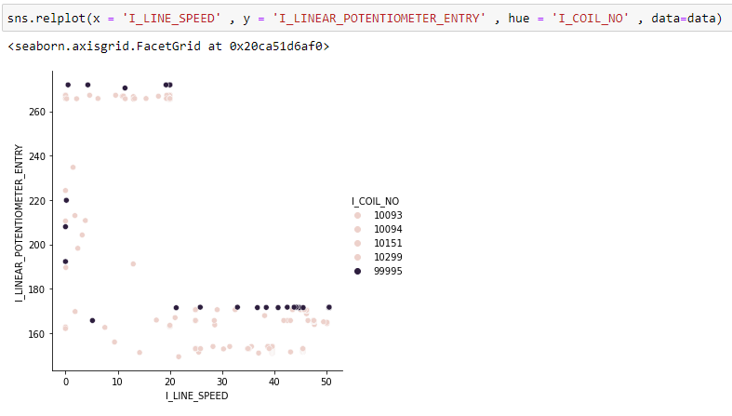

>>Maximum entrypoints have RC1 Temperature between values 68 to 70. Very less coil checkpoint have RC1 temperature between 71 to 73.

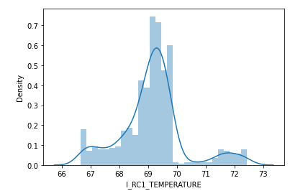

>> Maximum entrypoints have RC2 Temperature around 68. A considerable no. of checkpoints has RC2 Temperature lying between 68.5 to 70.5.

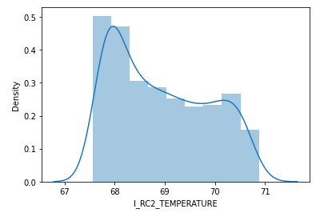

>> Maximum entrypoints have RC3 Temperature between 70 to 72. A considerable no. of checkpoints has RC3 Temperature lying between 74 to 76.

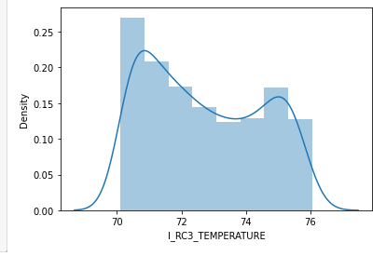

* The RC1 Temperature lies between 67 to 72.5
* The RC2 Temperature lies between 67.5 to 71.
* The RC3 Temperature lies between 70 to 76.

**>>From the below correlation matrix we infer:**

Value 1 in the below correlation matrix depicts the perfect +ve correlation among the Attributes

The Strong positive correlation is found between Linear_Potentiometer_Entry and Linear_Potentiometer_Exit.

The correlation between RC1 TEMPERATURE and RC2 TEMPERATURE is 0.27

(weak +ve correlation)

The correlation between RC1 TEMPERATURE and RC3 TEMPERATURE is 0.0033

(No correlation)

The correlation between RC2 TEMPERATURE and RC3 TEMPERATURE is -0.39

(Weak -ve correlation)

Correlation between Line_Speed and Linear_Potentiometer_Exit is -0.76 (Strong Negative Correlation)

Moderate -ve correlation exists between the attributes SEGMENTNR and LIBEAR_POTENTIOMETER_ENTRY.

