

**CAPSTONE PROJECT 1**

**Virtual Service-Staff System**

USER INTERFACE DESIGN DOCUMENT

**Version: 1.0**

**Mentor:** Tran Kim Sanh

**Harley Team**

**Team members:**

* Tran Duy Khuong
* Ho Thanh Hau
* Nguyen Ba Hoang
* Nguyen Xuan Anh
* Nguyen Anh Nguyen

**Da Nang, 09/14/2019**

**PROJECT INFORMATION**

|  |  |  |  |  |  |
| --- | --- | --- | --- | --- | --- |
| **Project Acronym** | VSSS | | | | |
| **Project Title** | Virtual Service Staff System | | | | |
| **Start Date** | 08/11/2019 | | **End Date** | 12/10/2019 | |
| **Lead Institution** | International School, Duy Tan University | | | | |
| **Role** | **Name** | **Email** | | | **Phone** |
| **Project Mentor** | Tran Kim Sanh | sanhtk@gmail.com | | | 0987409464 |
| **Team Member** | Nguyen Anh Nguyen | yaphets1603@gmail.com | | | 0935570445 |
| Tran Duy Khuong | khuongtrandtu@gmail.com | | | 0346761555 |
| Ho Thanh Hau | thanhhau1998.2015@gmail.com | | | 0938828842 |
| Nguyen Ba Hoang | nguyenbahoang2101@gmail.com | | |  |
| Nguyen Xuan, Anh | NguyenXuanAnh694@gmail.com | | | 0355666161 |

**DOCUMENT NAME**

|  |  |  |  |
| --- | --- | --- | --- |
| **Document Title** | Project Plan Document | | |
| **Reporting Period** | 12/17/2019 | | |
| **Author(s)** | All Team | | |
| **Role** | Team member | | |
| **Date** | 09/14/2019 | **Filename** | Harley_UI_Capstone1_Ver1.0 |

**Document Approvals:** The following signatures are required for approval of this document.

|  |  |  |  |
| --- | --- | --- | --- |
| **MENTOR** | Tran Kim Sang | Signature: |  |
| Date: |  |
| **TEAM LEADER** | Nguyen Anh Nguyen | Signature: |  |
| Date: |  |

**REVISION HISTORY**

|  |  |  |
| --- | --- | --- |
| **Version** | **Date** | **Description** |
| 1.0 | 09/14/2019 | Create UI Design Document |
|  |  |  |

Contents

**1.** **Introduction** 4

**1.1.** **Purpose** 4

**1.2.** **Scope** 4

**2.** **List of Interface** 4

**3.** **Describe User Interface** 5

**3.1.** **UI_01: Sign up** 5

**3.2.** **UI_02: Login** 7

**3.3.** **UI_03: User Management** 8

**3.4.** **UI_04 : Add New User** 9

**3.5.** **UI_05 : View Detail** 11

**3.6.** **UI_06 : Edit** 12

**3.7.** **UI_07 : Add New Beverage** 14

**3.8.** **UI_08 : Update Beverage** 16

**3.9.** **UI_09 : View Beverage** 18

**3.10.** **UI_ 10 : Delete** 19

1. **Introduction**
   1. **Purpose**

This document describes the interface design of virtual service staff system.

* 1. **Scope**
* Overview of the stage of the software.
* Create complete interface and describe them clearly.

1. **List of Interface**

|  |  |
| --- | --- |
| **UI ID** | **UI Name** |
| UI_01 | Sign Up |
| UI_02 | Login |
| UI_03 | User Management |
| UI_04 | Add New User |
| UI_05 | View Detail |
| UI_06 | Edit |
| UI_07 | Add New Beverage |
| UI_08 | Update Beverage |
| UI_09 | View Beverage |
| UI_10 | Delete |

1. **Describe User Interface**
   1. **UI_01: Sign up**

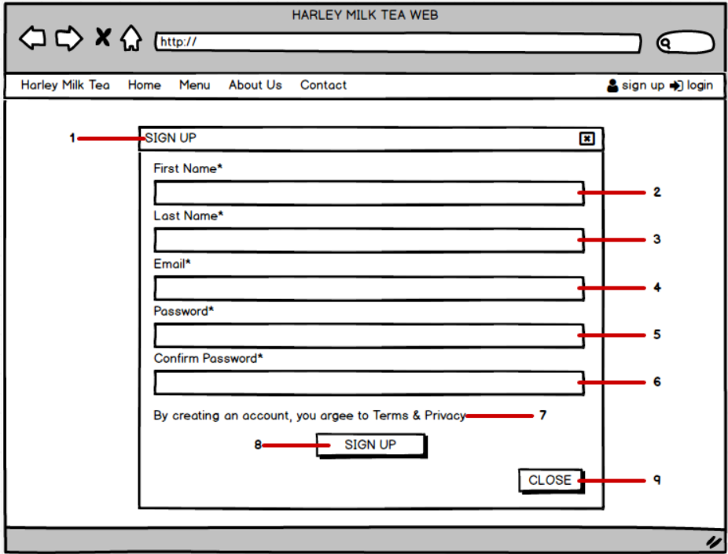

|  |  |  |  |  |  |
| --- | --- | --- | --- | --- | --- |
| **Main Display** | | Sign up | | | |
| **Description** | | Sign up new account | | | |
| **How to access** | | Click to “Sign up” | | | |
| **Interface Content** | | | | | |
| **Number** | **Category** | | **HTML tag** | **Description** | |
| 1 | “Sign up” header | | <h> | Display Sign up header | |
| 2 | “First Name” input | | <input> | Display the input first name textbox | |
| 3 | “Last Name” input | | <input> | Display the input last name text box | |
| 4 | “Email” input | | <input> | Display the input email textbox | |
| 5 | “Password” input | | <input> | Display the input password textbox | |
| 6 | “Confirm password” input | | <input> | Display the input confirm password textbox | |
| 7 | Confirmation text | | <p> | Display confirmation when registering an account | |
| 8 | “Sign up” button | | <button> | Click to sign up | |
| 9 | “Close” button | | <button> | Click to close | |
| **Action** | | | | | |
| **Action name** | | | **Success** | | **Failure** |
| Input into first name textbox | | | Input first name | | Required, max length 120 |
| Input into last name textbox | | | Input last name | | Required, max length 120 |
| Input into email textbox | | | Input email | | Email not correct |
| Input into password textbox | | | Input password | | Too short,  too long,  content special characters |
| Input into confirm password textbox | | | Input confirm password | | Required |
| Click into “Sign up” button | | | Sign up seccessful | | None |
| Click into “Close” button | | | Close this form | | None |

* 1. **UI_02: Login**

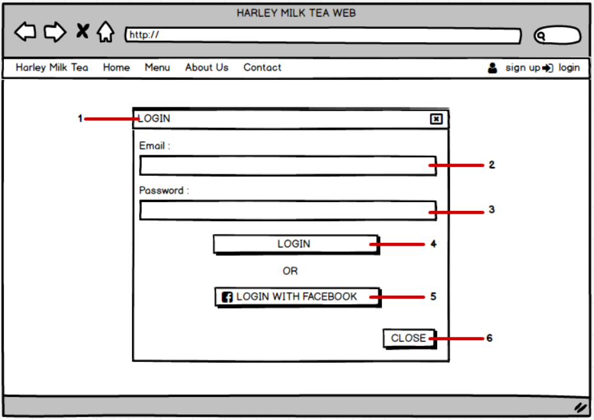

|  |  |  |  |  |  |
| --- | --- | --- | --- | --- | --- |
| **Main Display** | | Login | | | |
| **Description** | | Login | | | |
| **How to access** | | Click to “Login” | | | |
| **Interface Content** | | | | | |
| **Number** | **Category** | | **HTML tag** | **Description** | |
| 1 | “Login” header | | <h> | Display login header | |
| 2 | “Email” input | | <input> | Display the input email textbox | |
| 3 | “Passsword” input | | <input> | Display the input password textbox | |
| 4 | “Login” button | | <button> | Click to login | |
| 5 | “Login with Facebook” button | | <button> | Click to login with Facebook account | |
| 6 | “Close” button | | <button> | Click to close | |
| **Action** | | | | | |
| **Action name** | | | **Success** | | **Failure** |
| Input into email textbox | | | Input email | | Email not correct |
| Input into password textbox | | | Input password | | Too short,  too long,  content special characters |
| Input into login textbox | | | Login seccessful | | Email and password are not correct |
| Click into “Login with Facebook” button | | | Login Facebook account successful | | No account |
| Click into “Close” button | | | Close this form | | None |

* 1. **UI_03: User Management**

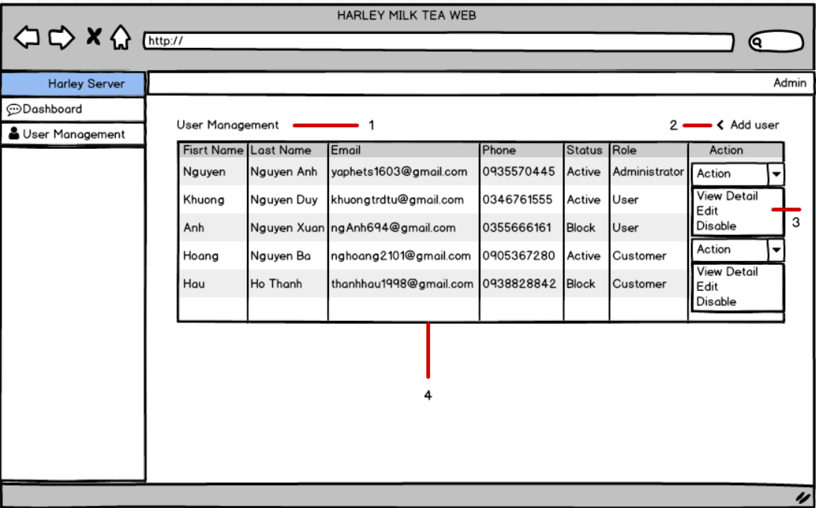

|  |  |  |  |  |  |
| --- | --- | --- | --- | --- | --- |
| **Main Display** | | User Management | | | |
| **Description** | | User Management | | | |
| **How to access** | | Click to “User Management” | | | |
| **Interface Content** | | | | | |
| **Number** | **Category** | | **HTML tag** | **Description** | |
| 1 | “User Management” header | | <h> | Display user management header | |
| 2 | “Add New User” button | | <button> | Click to add new user | |
| 3 | Action option | | <option> | Contain list of actions (view detail,edit,disable) | |
| 4 | Data table | | <table> | Display data of accounts | |
| **Action** | | | | | |
| **Action name** | | | **Success** | | **Failure** |
| Click into “Add New User ” option | | | Add new user | | None |
| Click into “Action” option | | | Show list of actions | | None |

* 1. **UI_04 : Add New User**

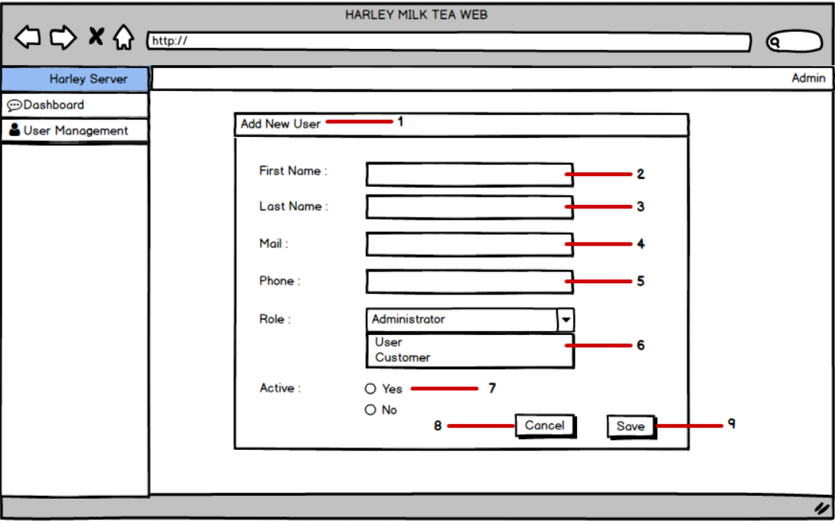

|  |  |  |  |  |  |
| --- | --- | --- | --- | --- | --- |
| **Main Display** | | Add new user | | | |
| **Description** | | Add new user | | | |
| **How to access** | | Click to “Add new user ” | | | |
| **Interface Content** | | | | | |
| **Number** | **Category** | | **HTML tag** | **Description** | |
| 1 | “Add new user ” header | | <h> | Display add new user header | |
| 2 | “First Name” input | | <input> | Display the input first name textbox | |
| 3 | “Last Name” input | | <input> | Display the input last name textbox | |
| 4 | “Email” input | | <input> | Display the input email textbox | |
| 5 | “Phone” input | | <input> | Display the input phone textbox | |
| 6 | “Role” option | | <option> | Contain list of role | |
| 7 | “Active ” radio button | | <button> | Display “Yes/No” radio button | |
| 8 | “Cancel” button | | <button> | Click to cancel | |
| 9 | “Save” button | | <button> | Click to save | |
| **Action** | | | | | |
| **Action name** | | | **Success** | | **Failure** |
| Input into first name textbox | | | Input first name | | Required, max length 120 |
| Input into last name textbox | | | Input last name | | Required, max length 120 |
| Input into email name textbox | | | Input email | | Email not correct |
| Input into phone textbox | | | Input phone | | Required |
| Click into “Role” option | | | Show list role | | Required |
| Click into “Active” radio button | | | Click into select “Yes/No” | | Required |
| Click into “Cancel” button | | | Cancel | | None |
| Click into “Save” button | | | Save | | None |

* 1. **UI_05 : View Detail**

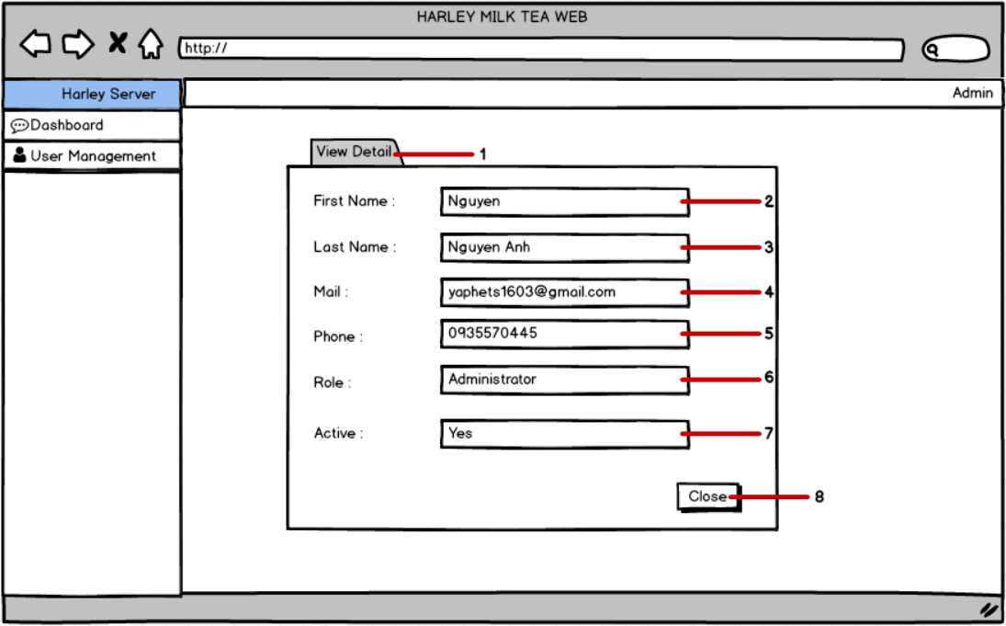

|  |  |  |  |  |  |
| --- | --- | --- | --- | --- | --- |
| **Main Display** | | View Detail | | | |
| **Description** | | View Detail | | | |
| **How to access** | | Click to “View Detail ” | | | |
| **Interface Content** | | | | | |
| **Number** | **Category** | | **HTML tag** | **Description** | |
| 1 | “View Detail ” header | | <h> | Display View Detail header | |
| 2 | “First Name” input | | <input> | Display the input first name textbox | |
| 3 | “Last Name” input | | <input> | Display the input last name textbox | |
| 4 | “Email” input | | <input> | Display the input email textbox | |
| 5 | “Phone” input | | <input> | Display the input phone textbox | |
| 6 | “Role” input | | < input > | Display the input role textbox | |
| 7 | “Active ” input | | < input > | Display “Yes/No” input | |
| 8 | “Close” button | | <button> | Click to close | |
| **Action** | | | | | |
| **Action name** | | | **Success** | | **Failure** |
| Input into first name textbox | | | Input first name | | Required, max length 120 |
| Input into last name textbox | | | Input last name | | Required, max length 120 |
| Input into email textbox | | | Input email | | Email not correct |
| Input into phone textbox | | | Input phone | | Required |
| Click into “Role” option | | | Show list role | | Required |
| Click into “Active” input | | | “Yes/No” | | Required |
| Click into “Close” button | | | Close this form | | None |

* 1. **UI_06 : Edit**

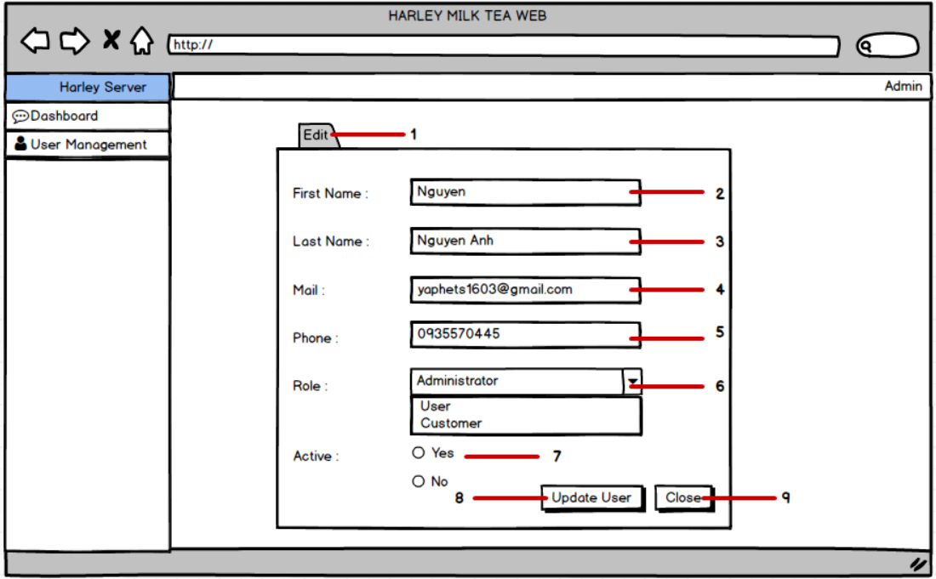

|  |  |  |  |  |  |
| --- | --- | --- | --- | --- | --- |
| **Main Display** | | Edit | | | |
| **Description** | | Edit | | | |
| **How to access** | | Click to “Edit” | | | |
| **Interface Content** | | | | | |
| **Number** | **Category** | | **HTML tag** | **Description** | |
| 1 | “Edit ” header | | <h> | Display edit header | |
| 2 | “First Name” input | | <input> | Display the input first name textbox | |
| 3 | “Last Name” input | | <input> | Display the input last name textbox | |
| 4 | “Email” input | | <input> | Display the input email texrtbox | |
| 5 | “Phone” input | | <input> | Display the input phone textbox | |
| 6 | “Role” option | | <option> | Contain list of role | |
| 7 | “Active ” radio button | | <button> | Display “Yes/No” radio button | |
| 8 | “Update User ”button | | <button> | Click to update user | |
| 9 | “Close” button | | <button> | Click to close | |
| **Action** | | | | | |
| **Action name** | | | **Success** | | **Failure** |
| Input into first name textbox | | | Input first name | | Required, max length 120 |
| Input into last name textbox | | | Input last name | | Required, max length 120 |
| Input into email textbox | | | Input email | | Email not correct |
| Input into phone textbox | | | Input phone | | Required |
| Click into “Role” option | | | Show list role | | Required |
| Click into “Active” radio button | | | Click into select “Yes/No” | | Required |
| Click into “Update User” button | | | Update user successful | | None |
| Click into “Close” button | | | Close this form | | None |

* 1. **UI_07 : Add New Beverage**

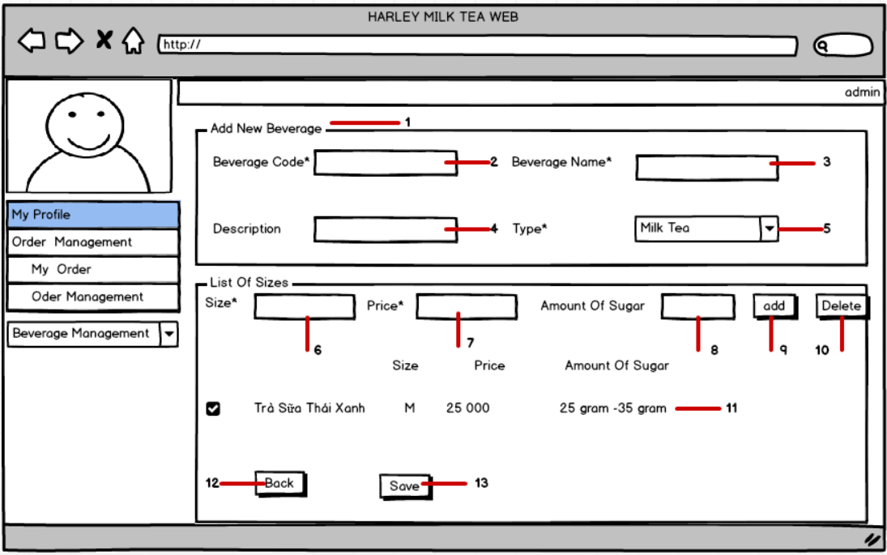

|  |  |  |  |  |  |
| --- | --- | --- | --- | --- | --- |
| **Main Display** | | Add new beverage | | | |
| **Description** | | Add new beverage | | | |
| **How to access** | | Click to “Add new beverage” | | | |
| **Interface Content** | | | | | |
| **Number** | **Category** | | **HTML tag** | **Description** | |
| 1 | “Add new beverage ” header | | <h> | Display add new beverage header | |
| 2 | “Beverage code*” input | | <input> | Display the input beverage code textbox | |
| 3 | “Beverage name*” input | | <input> | Display the input beverage name textbox | |
| 4 | “Description” input | | <input> | Display the input description textbox | |
| 5 | “Type*” option | | <option> | Contain list of type (milk tea, fruit tea, coffee,smoothie) | |
| 6 | “Size*” option | | <option> | Contain list of size (M,L) | |
| 7 | “Price*” input | | <input> | Display the input price textbox | |
| 8 | “Amount of sugar*” input | | <input> | Display the input amount of sugar textbox | |
| 9 | “Add” button | | <button> | Click to add | |
| 10 | “Delete” button | | <button> | Click to delete | |
| 11 | Beverage table | | <table> | Display data of beverage | |
| 12 | “Back” button | | <button> | Click to back | |
| 13 | “Save” button | | <button> | Click to save | |
| **Action** | | | | | |
| **Action name** | | | **Success** | | **Failure** |
| Input into beverage code textbox | | | Input beverage code | | Required |
| Input into beverage name textbox | | | Input beverage name | | Required |
| Input into description textbox | | | Input description | | Required |
| Click into “Type” option | | | Show list type | | Required |
| Click into “Size” option | | | Show list size | | Required |
| Click into price textbox | | | Input price | | Required |
| Click into amount of sugar textbox | | | Input amount of sugar | | Required |
| Click into “Add” button | | | Add | | None |
| Click into “Delete” button | | | Delete | | None |
| Click into “Back” button | | | Back | | None |
| Click into “Save” button | | | Save | | None |

* 1. **UI_08 : Update Beverage**

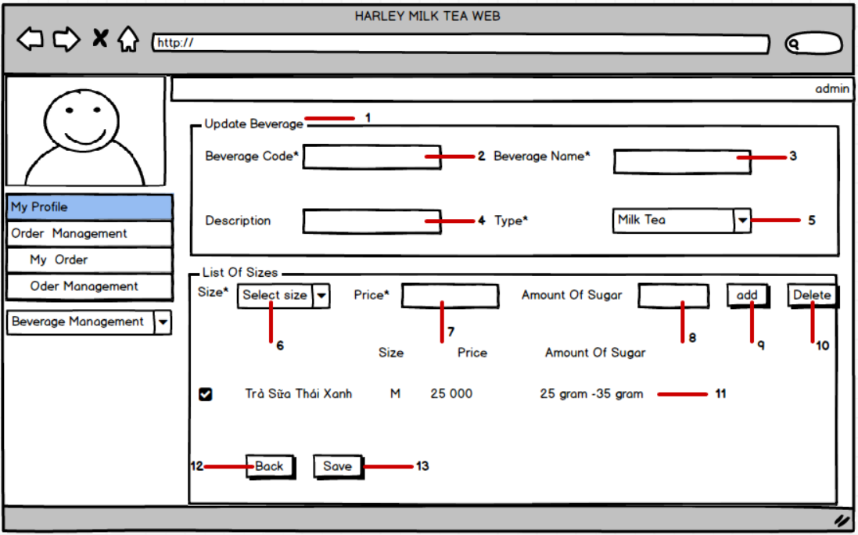

|  |  |  |  |  |  |
| --- | --- | --- | --- | --- | --- |
| **Main Display** | | Update beverage | | | |
| **Description** | | Update beverage | | | |
| **How to access** | | Click to “Update beverage” | | | |
| **Interface Content** | | | | | |
| **Number** | **Category** | | **HTML tag** | **Description** | |
| 1 | “Update beverage ” header | | <h> | Display update beverage header | |
| 2 | “Beverage code*” input | | <input> | Display the input beverage code textbox | |
| 3 | “Beverage name*” input | | <input> | Display the input beverage name textbox | |
| 4 | “Description” input | | <input> | Display the input description textbox | |
| 5 | “Type*” option | | <option> | Contain list of type (milk tea, fruit tea, coffee,smoothie) | |
| 6 | “Size*” option | | <option> | Contain list of size (M,L) | |
| 7 | “Price*” input | | <input> | Display the input price textbox | |
| 8 | “Amount of sugar*” input | | <input> | Display the input amount of sugar textbox | |
| 9 | “Add” button | | <button> | Click to add | |
| 10 | “Delete” button | | <button> | Click to delete | |
| 11 | Beverage table | | <table> | Display data of beverage | |
| 12 | “Back” button | | <button> | Click to back | |
| 13 | “Save” button | | <button> | Click to save | |
| **Action** | | | | | |
| **Action name** | | | **Success** | | **Failure** |
| Input into beverage code textbox | | | Input beverage code | | Required |
| Input into beverage name textbox | | | Input beverage name | | Required |
| Input into description textbox | | | Input description | | Required |
| Click into “Type” option | | | Show list type | | Required |
| Click into “Size” option | | | Show list size | | Required |
| Click into price textbox | | | Input price | | Required |
| Click into amount of sugar textbox | | | Input amount of sugar | | Required |
| Click into “Add” button | | | Add | | None |
| Click into “Delete” button | | | Delete | | None |
| Click into “Back” button | | | Back | | None |
| Click into “Save” button | | | Save | | None |

* 1. **UI_09 : View Beverage**

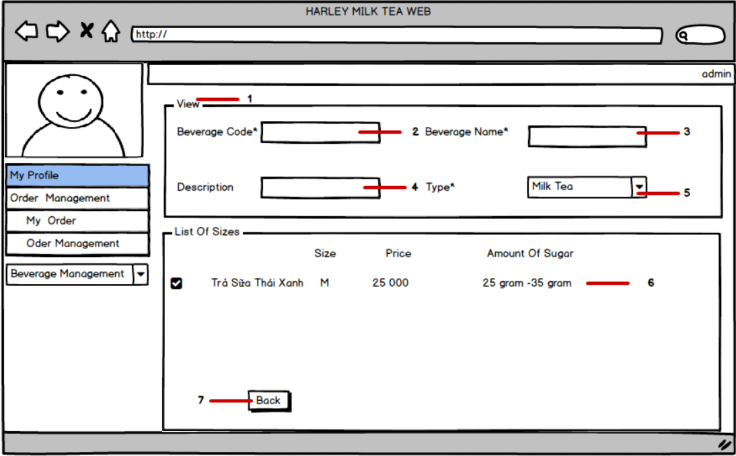

|  |  |  |  |  |  |
| --- | --- | --- | --- | --- | --- |
| **Main Display** | | View beverage | | | |
| **Description** | | View beverage | | | |
| **How to access** | | Click to “View beverage” | | | |
| **Interface Content** | | | | | |
| **Number** | **Category** | | **HTML tag** | **Description** | |
| 1 | “View beverage ” header | | <h> | Display view beverage header | |
| 2 | “Beverage code*” input | | <input> | Display the input beverage code textbox | |
| 3 | “Beverage name*” input | | <input> | Display the input beverage name textbox | |
| 4 | “Description” input | | <input> | Display the input description textbox | |
| 5 | “Type*” option | | <option> | Contain list of type (milk tea, fruit tea, coffee,smoothie) | |
| 6 | Beverage table | | <table> | Display data of beverage | |
| 7 | “Back” button | | <button> | Click to back | |
| **Action name** | | | **Success** | | **Failure** |
| Input into beverage code textbox | | | Input beverage code | | Required |
| Input into beverage name textbox | | | Input beverage name | | Required |
| Input into description textbox | | | Input description | | Required |
| Click into “Type” option | | | Show list type | | Required |
| Click into “Back” button | | | Back | | None |

* 1. **UI_ 10 : Delete**

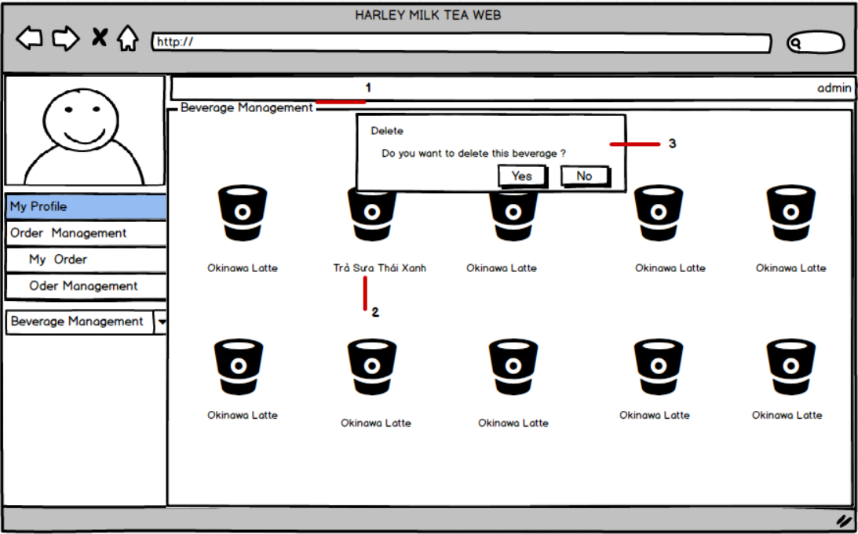

|  |  |  |  |  |  |
| --- | --- | --- | --- | --- | --- |
| **Main Display** | | Beverage management | | | |
| **Description** | | Beverage management | | | |
| **How to access** | | Click to “Beverage management” | | | |
| **Interface Content** | | | | | |
| **Number** | **Category** | | **HTML tag** | **Description** | |
| 1 | “Beverage management ” header | | <h> | Display beverage management header | |
| 2 | “Trà sữa thái xanh” text | | <p> | Display tra sua thai xanh when order | |
| 3 |  | |  |  | |
| **Action name** | | | **Success** | | **Failure** |
| Input into beverage code textbox | | | Input beverage code | | Required |
| Input into beverage name textbox | | | Input beverage name | | Required |
| Input into description textbox | | | Input description | | Required |
| Click into “Type” option | | | Show list type | | Required |
| Click into “Back” button | | | Back | | None |