VISVESVARAYA TECHNOLOGICAL UNIVERSITY
BELAGAVI


Leetcode Problem Solving Report

Submitted in the partial fulfillment for the requirements of the degree of

BACHELOR OF ENGINEERING
IN
ARTIFICIAL INTELLIGENCE AND MACHINE LEARNNG

Submitted By

STUDENT NAME:DIYA SHETTY
USN :1BY24AI042

Under the guidance of

GUIDE
NAME:PROF.SHRUTHI



DEPARTMENT OF ARTIFICIAL INTELLIGENCE AND MACHINE LEARNING
BMS INSTITUTE OF TECHNOLOGY & MANAGEMENT
YELAHANKA, BENGALURU - 560064.
2025-2026

Evaluation Sheet

Sl.  No. | Problem Type | Problem Name | Marks (Code) | Marks  (Test  Cases) | Marks (Output) | Total
1 | Easy | Valid  Parentheses
2 | Easy | Implement Stack using
3 | Easy | Queues  Implement  Queue Using
4 | Easy | Stacks  Number of  Students
5 | Easy | Unable to Eat  Reverse Linked  List
6 | Easy | Middle of the Linked List
7 | Easy | Maximum  Depth of
8 | Easy | Binary Tree  Invert Binary  Tree
9 | Easy | Find if Path Exists in
10 | Easy | Graph  Number of  Islands
11 | Medium | Min Stack
12 | Medium | Evaluate  Reverse Polish
13 | Medium | Notation Design  Circular
14 | Medium | Dequeue Kth Kth Largest  Element in a
15 | Medium | Stream  Remove Nth  Node from End
of List

Evaluation Sheet

Sl.  No. | Problem Type | Problem Name | Marks (Code) | Marks  (Test  Cases) | Marks (Output) | Total
16 | Medium | Add Two Numbers
17 | Medium | (Binary Tree Linked  Level Order
18 | Medium | Validate Binary
19 | Medium | Course Schedule
20 | Medium | Network  Delay Time
21 | Hard | Basic  Calculator II
22 | Hard | Longest Valid Parentheses
23 | Hard | Sliding  Window Max
24 | Hard | The Tower of Hanoi
25 | Hard | Merge k  Sorted Lists
26 | Hard | Copy List with Random
27 | Hard | Serialize and Desrializeary
28 | Hard | Binary Tree  Maximum
29 | Hard | Floyd–  Warshall
30 | Hard | Word Ladder
Total

Easy problems:

Problem 1

a)Problem statement:
Given a string containing only the characters '(' , ')' , '{' , '}' , '[' , ']', determine if the input string is valid.
A string is considered valid if:
- Every opening bracket has a matching closing bracket.
- Brackets close in the correct order.
- Types of brackets must match.
b)Code Implementation:

#include <stdio.h>
#include <string.h>
#include <stdbool.h>

bool isValid(char *s) {
char stack[10000];
int top = -1;

for (int i = 0; s[i] != '\0'; i++) {
char c = s[i];

if (c == '(' || c == '{' || c == '[') {
stack[++top] = c;
} else {
if (top == -1) return false;

char t = stack[top--];

if ((c == ')' && t != '(') ||
(c == '}' && t != '{') ||
(c == ']' && t != '['))
return false;
}
}
return top == -1;
}
c)Test Cases Considered:

Test Case Input Expected Output Reason
- "()" Valid Basic correct pair
- "()[]{}" Valid Multiple bracket types
- "(]" Invalid Mismatched brackets
- "([{}])" Valid Properly nested
- "(((" Invalid Missing closing brackets
- "]" Invalid Closing without opening

d. Output Screenshots / Console Output:
Input :S=”([)]”
Output: false

e)Explanation:

When an opening bracket appears → push it onto the stack.
- When a closing bracket appears:
  - If stack is empty → invalid o Pop the top element and check if it matches the correct opening bracket.
- If any mismatch occurs → invalid.
- After processing the whole string:
  - If stack is empty → valid string o If stack still has remaining brackets → invalid
This ensures correct ordering, matching, and nesting of brackets.

Problem 2

a)Problem statement:

Implement a last-in-first-out (LIFO) stack using only two queues. The implemented stack should support all the functions of a normal stack (push, top, pop, and empty).
Implement the MyStack class:
- void push(int x) Pushes element x to the top of the stack.
- int pop() Removes the element on the top of the stack and returns it.
- int top() Returns the element on the top of the stack.
- boolean empty() Returns true if the stack is empty, false otherwise.

b)Code Implementation:
#include <stdbool.h>

typedef struct {
int q[1000];
int front, rear;
} MyStack;

void myStackInit(MyStack* obj) {
obj->front = 0;
obj->rear = -1;
}

void myStackPush(MyStack* obj, int x) {
obj->q[++obj->rear] = x;

int size = obj->rear - obj->front + 1;
while (size > 1) {
obj->q[++obj->rear] = obj->q[obj->front++];
size--;
}
}

int myStackPop(MyStack* obj) {
return obj->q[obj->front++];
}

int myStackTop(MyStack* obj) {
return obj->q[obj->front];
}

bool myStackEmpty(MyStack* obj) {
return obj->front > obj->rear;
}

c)Test Cases Considered:

["MyStack","push","push","top","pop","empty"]

[[],[1],[2],[],[],[]]

d)Output Screenshots / Console Output:

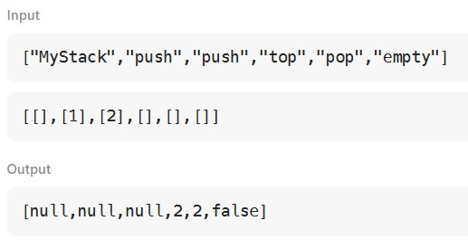
e)Explanation:

The idea is to use one queue and rotate the elements after each push:
- When pushing a new element x,
→ Insert into queue
→ Rotate the queue to bring x to the front
- Thus the newest element is always at the front, acting like a stack top. This makes:
- push() = O(n)
- pop() = O(1)
- top() = O(1)
- empty() = O(1)

Problem 3

a)Problem statement:

Implement a first in first out (FIFO) queue using only two stacks. The implemented queue should support all the functions of a normal queue (push, peek, pop, and empty).
Implement the MyQueue class:
- void push(int x) Pushes element x to the back of the queue.
- int pop() Removes the element from the front of the queue and returns it.
- int peek() Returns the element at the front of the queue.
- boolean empty() Returns true if the queue is empty, false otherwise.

b)Code Implementation:

#include <stdbool.h>

typedef struct {
int s1[1000], s2[1000];
int top1, top2;
} MyQueue;

void myQueueInit(MyQueue* obj) {
obj->top1 = -1;
obj->top2 = -1;
}

void myQueuePush(MyQueue* obj, int x) {
obj->s1[++obj->top1] = x;
}

int myQueuePop(MyQueue* obj) {
if (obj->top2 == -1) {
while (obj->top1 != -1)
obj->s2[++obj->top2] = obj->s1[obj->top1--];
}
return obj->s2[obj->top2--];
}

int myQueuePeek(MyQueue* obj) {
if (obj->top2 == -1) {
while (obj->top1 != -1)
obj->s2[++obj->top2] = obj->s1[obj->top1--];
}
return obj->s2[obj->top2];
}

bool myQueueEmpty(MyQueue* obj) {
return obj->top1 == -1 && obj->top2 == -1;
}
c)Test Cases Considered:

["MyQueue","push","push","peek","pop","empty"]

[[],[1],[2],[],[],[]]

d)Output Screenshots / Console Output:
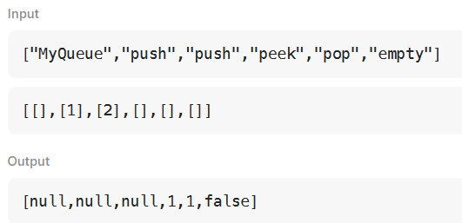

e)Explanation:

A queue works like:
✔ First In → First Out (FIFO) Example: people standing in a line. But a stack works like: ✔ Last In → First Out (LIFO)
Example: plates stacked on each other.
We must use two stacks to behave like a queue.

Problem 4

a)Problem statement:

The school cafeteria offers circular and square sandwiches at lunch break, referred to by numbers 0 and 1 respectively. All students stand in a queue. Each student either prefers square or circular sandwiches.
The number of sandwiches in the cafeteria is equal to the number of students. The sandwiches are placed in a stack. At each step:
- If the student at the front of the queue prefers the sandwich on the top of the stack, they will take it and leave the queue.
- Otherwise, they will leave it and go to the queue's end.
This continues until none of the queue students want to take the top sandwich and are thus unable to eat.

b)Code Implementation:
int countStudents(int* students, int studentsSize,
int* sandwiches, int sandwichesSize) {

int cnt[2] = {0, 0};

for (int i = 0; i < studentsSize; i++)
cnt[students[i]]++;

for (int i = 0; i < sandwichesSize; i++) {
if (cnt[sandwiches[i]] > 0)
cnt[sandwiches[i]]--;
else
return cnt[0] + cnt[1];
}
return 0;
}

- Test Cases Considered:

students = [1,1,0,0]
sandwiches = [0,1,0,1]

- Output Screenshots / Console Output:
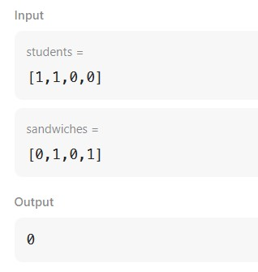

- Explanation:

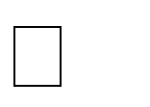



  - Count how many want 0 and how many want 1
  - Give sandwiches in order
  - If a sandwich appears that nobody wants → stop
  - Return how many students are left

Problem 5

- Problem Statement:

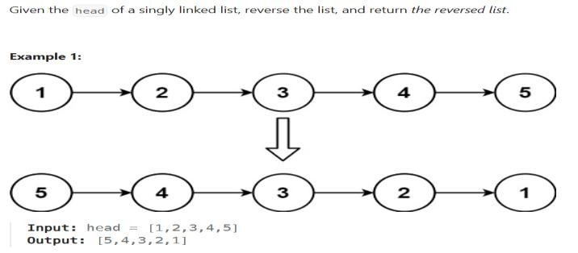

- Code Implementation:

class Solution { public:
ListNode* reverseList(ListNode* head) {
ListNode* prev = nullptr;
ListNode* curr = head;

while (curr != nullptr) {
ListNode* nextNode = curr->next; // store next curr->next = prev; // reverse pointer prev = curr; // move prev forward
curr = nextNode; // move curr forward
}

return prev; // new head
}
};

- Test Cases Considered:
head = [1,2,3,4,5]

- Output Screenshots / Console Output:

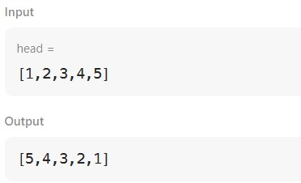

e) Explanation:

We reverse the pointers one by one:
- prev starts as NULL
- curr starts at the head For each node:
- Save the next node
- Point the current node backwards
- Move prev forward
- Move curr forward When curr becomes NULL,
prev will be the new head of the reversed list.

Problem 6

Given the head of a singly linked list, return the middle node of the linked list. If there are two middle nodes, return the second middle node.

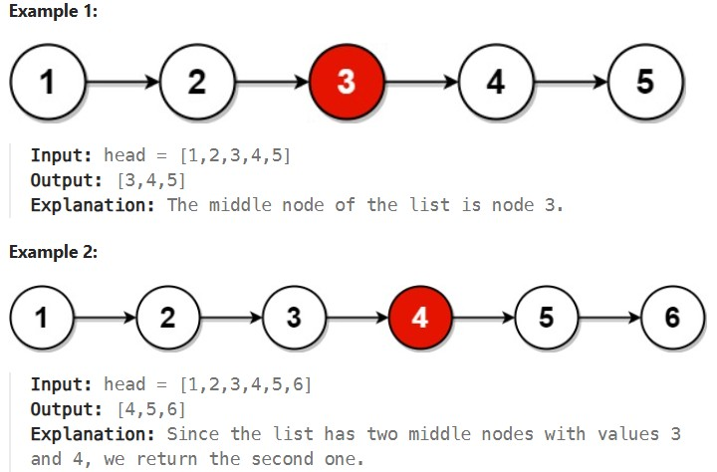

b. Code Implementation:

struct ListNode* middleNode(struct ListNode* head) {
struct ListNode *slow = head, *fast = head;

while (fast != NULL && fast->next != NULL) {
slow = slow->next;
fast = fast->next->next;
}
return slow;
}
c. Test Cases Considered:

head = [1,2,3,4,5]

d.Output Screenshots / Console Output:

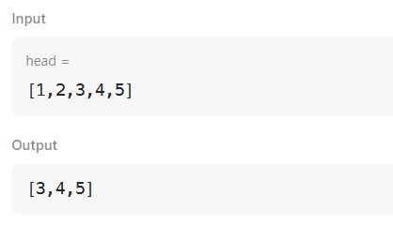

e. Explanation:

We use two pointers:
- ✔ slow pointer → moves 1 step at a time
- ✔ fast pointer → moves 2 steps at a time As fast moves faster:
- When fast reaches the end of the list
- slow will be standing in the middle
•

Problem 7

a.Problem Statement:

Given the root of a binary tree, return its maximum depth.
A binary tree's maximum depth is the number of nodes along the longest path from the root node down to the farthest leaf node.
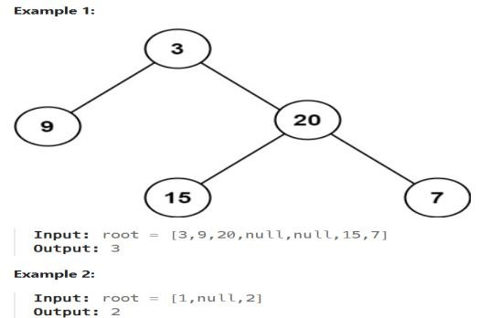
- Code Implementation:

class Solution { public:
int maxDepth(TreeNode* root) { if (root == nullptr)
return 0;

int leftDepth = maxDepth(root->left);
int rightDepth = maxDepth(root->right);

return 1 + max(leftDepth, rightDepth);
}
};

- Test Cases Considered:

root =

- Output Screenshots / Console Output:

- Explanation:

The depth of a binary tree means:
  - Length of the longest path
  - From the root node
  - Down to the deepest leaf node

Problem 8

a.Problem Statement:

Given the root of a binary tree, invert the tree, and return its root.

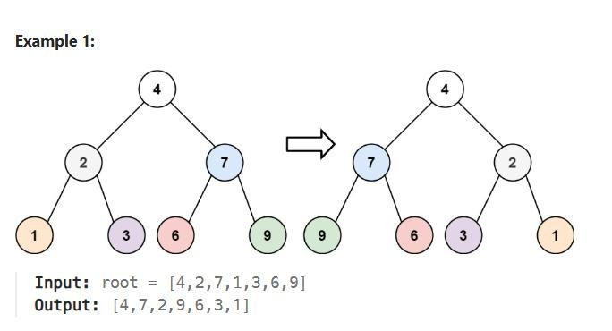

b. Code Implementation:
struct TreeNode* invertTree(struct TreeNode* root) {
if (root == NULL) return NULL;

struct TreeNode* temp = root->left;
root->left = root->right;
root->right = temp;

invertTree(root->left);
invertTree(root->right);

return root;
}
c. Test Cases Considered:
case 1: case 2:
root =[4,2,7,1,3,6,9] root =[2,1,3]
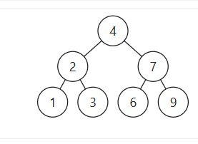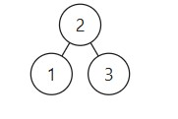

d.Output Screenshots / Console Output:

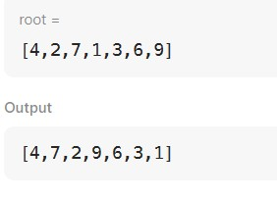
e.Explanation:

Invert Binary Tree = Swap left and right children at every node

Problem 9

a.Problem Statement:
There is a bi-directional graph with n vertices, where each vertex is labeled from 0 to n - 1 (inclusive). The edges in the graph are represented as a 2D integer array edges, where each edges[i] = [u_{i}, v_{i}] denotes a bi-directional edge between vertex u_{i} and vertex v_{i}. Every vertex pair is connected by at most one edge, and no vertex has an edge to itself. You want to determine if there is a valid path that exists from vertex source to vertex destination.
Given edges and the integers n, source, and destination, return true if there is a valid path from source to destination, or false otherwise.
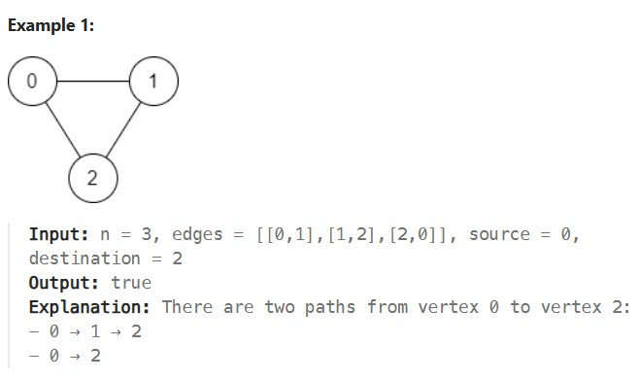

b. Code Implementation:

#include <stdbool.h>

bool dfs(int node, int dest, int** adj, bool* visited, int* size) {
if (node == dest) return true;
visited[node] = true;

for (int i = 0; i < size[node]; i++) {
int n = adj[node][i];
if (!visited[n] && dfs(n, dest, adj, visited, size))
return true;
}
return false;
}
c. Test Cases Considered:
case 1 n =
3
edges =
[[0,1],[1,2],[2,0]]
source =
0
destination =
2

d.Output Screenshots / Console Output:

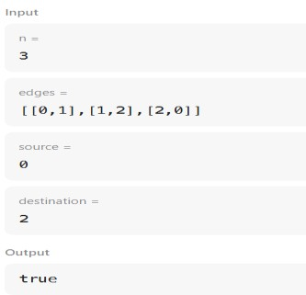
e. Explanation:

This code checks whether there is a path from the source node to the destination node in an undirected graph. First, it converts the given edges into an adjacency list to store which nodes are connected. Then it uses Depth First Search (DFS) starting from the source node. A visited array is used to avoid visiting the same node again and getting stuck in a loop. If during DFS the destination node is reached, the function returns true; if all possible paths are explored and the destination is not found, it returns false.

Problem 10

a.Problem Statement:
Given an m x n 2D binary grid grid which represents a map of '1's (land) and '0's (water), return the number of islands.An island is surrounded by water and is formed by connecting adjacent lands horizontally or vertically. You may assume all four edges of the grid are all surrounded by water.

Example 1:
Input: grid = [
["1","1","1","1","0"],
["1","1","0","1","0"],
["1","1","0","0","0"],
["0","0","0","0","0"]
]
Output: 1

b. Code Implementation:
#include<stdio.h>
#include<string.h>
void dfs(char** grid, int i, int j, int m, int n) {
if (i < 0 || j < 0 || i >= m || j >= n || grid[i][j] == '0')
return;

grid[i][j] = '0';

dfs(grid, i+1, j, m, n);
dfs(grid, i-1, j, m, n);
dfs(grid, i, j+1, m, n);
dfs(grid, i, j-1, m, n);
}

int numIslands(char** grid, int gridSize, int* gridColSize) {
int count = 0;

for (int i = 0; i < gridSize; i++) {
for (int j = 0; j < gridColSize[0]; j++) {
if (grid[i][j] == '1') {
count++;
dfs(grid, i, j, gridSize, gridColSize[0]);
}
}
}
return count;
}c. Test Cases Considered:
grid =
[["1","1","1","1","0"],["1","1","0","1","0"],["1","1","0","0","0"],["0","0","0","0","0"]]

d.Output Screenshots / Console Output:

Input grid =
[["1","1","1","1","0"],["1","1","0","1","0"],["1","1","0","0","0"],["0","0","0","0","0"]]
Output
1
Expected
1

e. Explanation:

This program counts the number of islands in a given 2D grid by using Depth First Search (DFS). It scans the grid cell by cell, and whenever it finds a land cell ('1'), it considers it the start of a new island and increases the island count. From that cell, DFS is called to visit all horizontally and vertically connected land cells, marking them as water ('0') so they are not counted again. This process ensures that each island is counted only once. After the entire grid is traversed, the final count represents the total number of islands present in the grid

Medium problems:

Problem 1

- Problem Statement:
Design a stack that supports push, pop, top, and retrieving the minimum element in constant time. Implement the MinStack class:
  - MinStack() initializes the stack object.
  - void push(int val) pushes the element val onto the stack.
  - void pop() removes the element on the top of the stack.
  - int top() gets the top element of the stack.
  - int getMin() retrieves the minimum element in the stack.
You must implement a solution with O(1) time complexity for each function.

Example 1:
Input
["MinStack","push","push","push","getMin","pop","top","getMin"]
[[],[-2],[0],[-3],[],[],[],[]]

Output
[null,null,null,null,-3,null,0,-2]

- Code Implementation:

#include <limits.h>

typedef struct {
int val;
int min;
} Pair;

typedef struct {
Pair stack[10000];
int top;
} MinStack;

void minStackInit(MinStack* obj) {
obj->top = -1;
}

void minStackPush(MinStack* obj, int val) {
obj->top++;
obj->stack[obj->top].val = val;

if (obj->top == 0)
obj->stack[obj->top].min = val;
else {
int prevMin = obj->stack[obj->top - 1].min;
obj->stack[obj->top].min = (val < prevMin) ? val : prevMin;
}
}

void minStackPop(MinStack* obj) {
obj->top--;
}

int minStackTop(MinStack* obj) {
return obj->stack[obj->]()c. Test Cases Considered:

case
["MinStack","push","push","push","getMin","pop","top","getMin"]
[[],[-2],[0],[-3],[],[],[],[]]

d.Output Screenshots / Console Output:
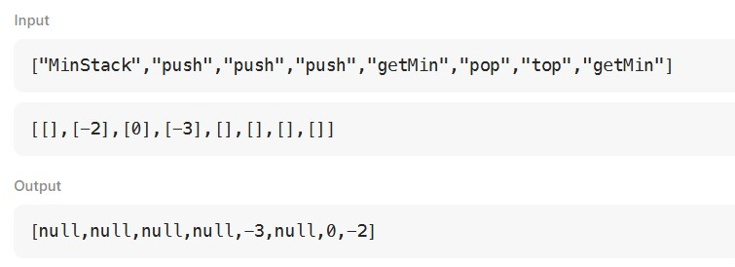
e. Explanation:

The MinStack program supports normal stack operations along with finding the minimum element in constant time. It works by storing each element as a pair: the actual value and the minimum value in the stack at that moment. When a new value is pushed, it updates the minimum by comparing it with the previous minimum. When an element is popped, the stored minimum is automatically updated. This way, push, pop, top, and getMin all work in O(1) time.

Problem 2

- Problem Statement:
You are given an array of strings tokens that represents an arithmetic expression in a Reverse Polish Notation. Evaluate the expression. Return an integer that represents the value of the expression. Note that: The valid operators are '+', '-', '*', and '/'. Each operand may be an integer or another expression. The division between two integers always truncates toward zero. There will not be any division by zero. The input represents a valid arithmetic expression in a reverse polish notation. The answer and all the intermediate calculations can be represented in a 32-bit integer. Example 1: Input: tokens = ["2","1","+","3","*"] Output: 9 Explanation: ((2 + 1) * 3) = 9

- Code Implementation:
#include <stdlib.h>
#include <string.h>

int evalRPN(char** tokens, int tokensSize) {
int stack[1000];
int top = -1;

for (int i = 0; i < tokensSize; i++) {
char* t = tokens[i];

if (strcmp(t, "+") == 0 ||
strcmp(t, "-") == 0 ||
strcmp(t, "*") == 0 ||
strcmp(t, "/") == 0) {

int b = stack[top--];
int a = stack[top--];

if (strcmp(t, "+") == 0) stack[++top] = a + b;
else if (strcmp(t, "-") == 0) stack[++top] = a - b;
else if (strcmp(t, "*") == 0) stack[++top] = a * b;
else stack[++top] = a / b;
} else {
stack[++top] = atoi(t);
}
}
return stack[top];
}

- Test Cases Considered:
tokens =
["2","1","+","3","*"]

- Output Screenshots / Console Output:
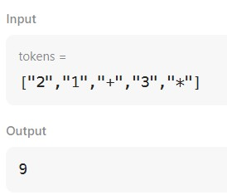
- Explanation:

This program evaluates an arithmetic expression written in Reverse Polish Notation (RPN) using a stack. It scans the tokens one by one from left to right. If the token is a number, it is pushed onto the stack. If the token is an operator (+, -, *, /), the top two numbers are popped from the stack, the operation is performed in the correct order, and the result is pushed back onto the stack. Division automatically truncates toward zero as required. After all tokens are processed, the single value left on the stack is the final result of the expression.

Problem 3

a.Problem Statement:
Design your implementation of the circular double-ended queue (deque). Implement the MyCircularDeque class: MyCircularDeque(int k) Initializes the deque with a maximum size of k. boolean insertFront() Adds an item at the front of Deque. Returns true if the operation is successful, or false otherwise. boolean insertLast() Adds an item at the rear of Deque. Returns true if the operation is successful, or false otherwise. boolean deleteFront() Deletes an item from the front of Deque. Returns true if the operation is successful, or false otherwise. boolean deleteLast() Deletes an item from the rear of Deque. Returns true if the operation is successful, or false otherwise. int getFront() Returns the front item from the Deque. Returns -1 if the deque is empty. int getRear() Returns the last item from Deque. Returns -1 if the deque is empty. boolean isEmpty() Returns true if the deque is empty, or false otherwise. boolean isFull() Returns true if the deque is full, or false otherwise.
Example 1: Input ["MyCircularDeque", "insertLast", "insertLast", "insertFront",
"insertFront", "getRear", "isFull", "deleteLast", "insertFront", "getFront"] [[3], [1], [2], [3],
[4], [], [], [], [4], []] Output [null, true, true, true, false, 2, true, true, true, 4]

- Code Implementation:
#include <stdbool.h>

typedef struct {
- int* arr;
int front, rear, size, capacity;
- } MyCircularDeque;

- MyCircularDeque* myCircularDequeCreate(int k) {
- MyCircularDeque* obj = (MyCircularDeque*)malloc(sizeof(MyCircularDeque));
- obj->arr = (int*)malloc(sizeof(int) * k);
- obj->capacity = k;
- obj->front = 0;
- obj->rear = -1;
- obj->size = 0;
- return obj;
- }

- bool insertFront(MyCircularDeque* obj, int value) {
- if (obj->size == obj->capacity) return false;
- obj->front = (obj->front - 1 + obj->capacity) % obj->capacity;
- obj->arr[obj->front] = value;
- if (obj->size == 0) obj->rear = obj->front;
- obj->size++;
- return true;
}

- bool insertLast(MyCircularDeque* obj, int value) {
- if (obj->size == obj->capacity) return false;
- obj->rear = (obj->rear + 1) % obj->capacity;
- obj->arr[obj->rear] = value;
- obj->size++;
- return true;
- }

- bool deleteFront(MyCircularDeque* obj) {
- if (obj->size == 0) return false;
- obj->front = (obj->front + 1) % obj->capacity;
- obj->size--;
- return true;
- }

- bool deleteLast(MyCircularDeque* obj) {
- if (obj->size == 0) return false;
- obj->rear = (obj->rear - 1 + obj->capacity) % obj->capacity;
- obj->size--;
- return true;
- }

- int getFront(MyCircularDeque* obj) {
- return obj->size == 0 ? -1 : obj->arr[obj->front];
}

int getRear(MyCircularDeque* obj) {
return obj->size == 0 ? -1 : obj->arr[obj->rear];
}

Test Cases Considered:
case
["MyCircularDeque","insertLast","insertLast","insertFront","insertFront","getRear","isFull" ,"deleteLast","insertFront","getFront"]
[[3],[1],[2],[3],[4],[],[],[],[4],[]]

- Output Screenshots / Console Output:
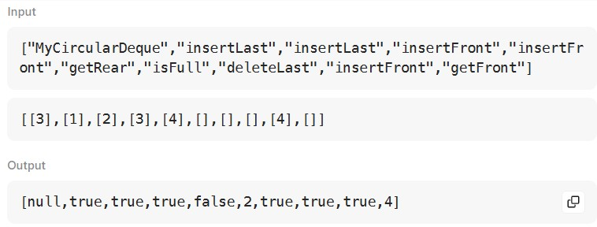
- Explanation:

MyCircularDeque myCircularDeque = new MyCircularDeque(3);
myCircularDeque.insertLast(1); // return True myCircularDeque.insertLast(2); // return True myCircularDeque.insertFront(3); // return True myCircularDeque.insertFront(4); // return False, the queue is full.
myCircularDeque.getRear(); // return 2 myCircularDeque.isFull(); // return True myCircularDeque.deleteLast(); // return True myCircularDeque.insertFront(4); // return True myCircularDeque.getFront(); // return 4

Problem 4

a.Problem Statement:
You are part of a university admissions office and need to keep track of the kth highest test score from applicants in real-time. This helps to determine cut-off marks for interviews and admissions dynamically as new applicants submit their scores. You are tasked to implement a class which, for a given integer k, maintains a stream of test scores and continuously returns the kth highest test score after a new score has been submitted. More specifically, we are looking for the kth highest score in the sorted list of all scores. Implement the KthLargest class: KthLargest(int k, int[] nums) Initializes the object with the integer k and the stream of test scores nums. int add(int val) Adds a new test score val to the stream and returns the element representing the kth largest element in the pool of test scores so far.
b. Code Implementation:
typedef struct {
int heap[10000];
int size;
int k;
} KthLargest;

void heapifyUp(KthLargest* obj, int i) {
while (i > 0 && obj->heap[(i - 1) / 2] > obj->heap[i]) {
int t = obj->heap[i];
obj->heap[i] = obj->heap[(i - 1) / 2];
obj->heap[(i - 1) / 2] = t;
i = (i - 1) / 2;
}
}

void heapifyDown(KthLargest* obj, int i) {
int smallest = i;
int l = 2 * i + 1, r = 2 * i + 2;

if (l < obj->size && obj->heap[l] < obj->heap[smallest]) smallest = l;
if (r < obj->size && obj->heap[r] < obj->heap[smallest]) smallest = r;

if (smallest != i) {
int t = obj->heap[i];
obj->heap[i] = obj->heap[smallest];
obj->heap[smallest] = t;
heapifyDown(obj, smallest);
}
}

int add(KthLargest* obj, int val) {
obj->heap[obj->size++] = val;
heapifyUp(obj, obj->size - 1);

if (obj->size > obj->k) {
obj->heap[0] = obj->heap[--obj->size];
heapifyDown(obj, 0);
}
return obj->heap[0];
}
- Test Cases Considered:

["KthLargest","add","add","add","add","add"]

[[3,[4,5,8,2]],[3],[5],[10],[9],[4]]

- Output Screenshots / Console Output:
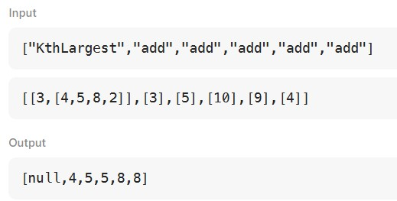
- Explanation:

This program keeps track of the kth highest test score from a stream of scores using a minheap. The heap always stores only the k largest scores seen so far. Whenever a new score is added, it is pushed into the heap, and if the heap size becomes greater than k, the smallest score is removed. This way, the smallest element in the heap represents the kth largest score overall. Since only heap operations are used, the solution efficiently updates and returns the kth largest score in O(log k) time.

Problem 5

- Problem Statement:
Given the head of a linked list, remove the n^{th} node from the end of the list and return its head.

Example 1:
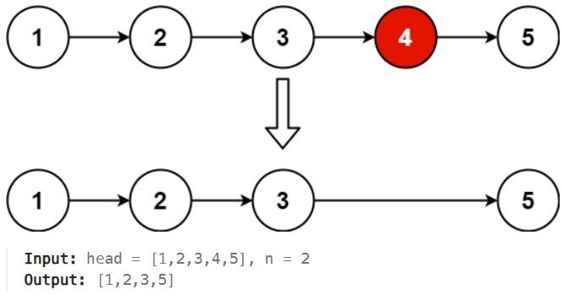

- Code Implementation:
#include <stdio.h>
#include <stdlib.h>

/**
* Definition for singly-linked list.
*/
struct ListNode {
int val;
struct ListNode *next;
};

struct ListNode* removeNthFromEnd(struct ListNode* head, int n) {
// Create a dummy node to handle cases where the head needs to be removed
struct ListNode dummy;
dummy.next = head;
struct ListNode *fast = &dummy;
struct ListNode *slow = &dummy;

// 1. Move fast pointer n steps ahead
for (int i = 0; i < n; i++) {
fast = fast->next;
}

// 2. Move both until fast reaches the last node
while (fast->next != NULL) {
fast = fast->next;
slow = slow->next;
}

// 3. Skip the nth node from the end
struct ListNode* nodeToDelete = slow->next;
slow->next = slow->next->next;

// Optional: free the memory of the deleted node
// free(nodeToDelete);

return dummy.next;
}
c. Test Cases Considered:
head = [1,2,3,4,5]
n =2

- Output Screenshots / Console Output:

Input head =
[1,2,3,4,5] n = 2
Output
[1,2,3,5]

- Explanation:
This approach uses two pointers. The fast pointer is moved n steps ahead, then both fast and slow pointers move together until fast reaches the end. At that point, slow is just before the node to be removed, so we skip that node by adjusting the link. This removes the nth node from the end in one pass.

Problem 6

- Problem Statement:
You are given two non-empty linked lists representing two non-negative integers. The digits are stored in reverse order, and each of their nodes contains a single digit. Add the two numbers and return the sum as a linked list.
You may assume the two numbers do not contain any leading zero, except the number 0 itself.
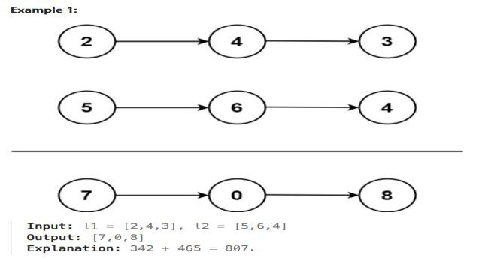

- Code Implementation:
struct ListNode* addTwoNumbers(struct ListNode* l1, struct ListNode* l2) {
struct ListNode dummy;
dummy.next = NULL;
struct ListNode* curr = &dummy;
int carry = 0;

while (l1 || l2 || carry) {
int sum = carry;
if (l1) { sum += l1->val; l1 = l1->next; }
if (l2) { sum += l2->val; l2 = l2->next; }

carry = sum / 10;
curr->next = (struct ListNode*)malloc(sizeof(struct ListNode));
curr = curr->next;
curr->val = sum % 10;
curr->next = NULL;
}
return dummy.next;
}

- Test Cases Considered:
l1 =
[2,4,3] l2 = [5,6,4]

- Output Screenshots / Console Output: Input l1 =
[2,4,3] l2 =
[5,6,4]
Output
[7,0,8]

- Explanation:
The number of nodes in each linked list is in the range [1, 100].
0<= Node.val <= 9
It is guaranteed that the list represents a number that does not have leading zeros.

Problem 7

a. Problem Statement:
Given the root of a binary tree, return the level order traversal of its nodes' values. (i.e., from left to right, level by level).
- Code Implementation:
#include <stdio.h>
#include <stdlib.h>

/**
* Definition for a binary tree node.
*/
struct TreeNode {
int val;
struct TreeNode *left;
struct TreeNode *right;
};

/**
* Return an array of arrays of size *returnSize.
* The sizes of the arrays are returned as *returnColumnSizes array.
*/
int** levelOrder(struct TreeNode* root, int* returnSize, int** returnColumnSizes) {
*returnSize = 0;
if (root == NULL) return NULL;

// Initial allocation for the result array
int** result = malloc(sizeof(int*) * 2000);
*returnColumnSizes = malloc(sizeof(int) * 2000);

// Queue for BFS: store TreeNode pointers
struct TreeNode** queue = malloc(sizeof(struct TreeNode*) * 2000);
int head = 0, tail = 0;

// Enqueue root
queue[tail++] = root;

while (head < tail) {
int levelSize = tail - head; // Number of nodes at the current level
(*returnColumnSizes)[*returnSize] = levelSize;
result[*returnSize] = malloc(sizeof(int) * levelSize);

for (int i = 0; i < levelSize; i++) {
struct TreeNode* node = queue[head++];
result[*returnSize][i] = node->val;

// Enqueue children for the next level
if (node->left) queue[tail++] = node->left;
if (node->right) queue[tail++] = node->right;
}
(*returnSize)++;
}

free(queue);
return result;
}
- Test Cases Considered:
root =
[3,9,20,null,null,15,7]
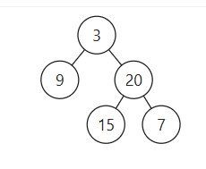

- Output Screenshots / Console Output:
Input root =
[3,9,20,null,null,15,7]
Output
[[3],[9,20],[15,7]]
Expected
[[3],[9,20],[15,7]]

Problem 8

a. Problem Statement:
Given the root of a binary tree, determine if it is a valid binary search tree (BST).
A valid BST is defined as follows:
- The left subtree of a node contains only nodes with keys strictly less than the node's key.
- The right subtree of a node contains only nodes with keys strictly greater than the node's key.
- Both the left and right subtrees must also be binary search trees.
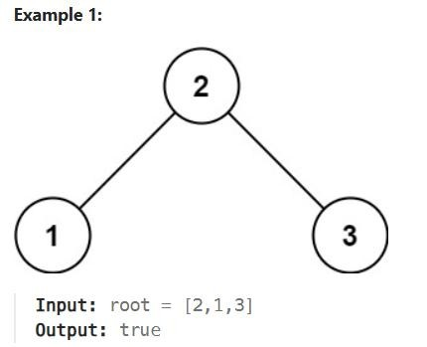

b. Code Implementation:
class Solution { public:
bool isValidBST(TreeNode* root) { return validate(root, LONG_MIN, LONG_MAX);
}

bool validate(TreeNode* node, long minVal, long maxVal) {
if (node == nullptr)
return true;

if (node->val <= minVal || node->val >= maxVal) return false;

return validate(node->left, minVal, node->val) && validate(node->right, node->val, maxVal);
}
};

c. Test Cases Considered:
root =
[2,1,3]

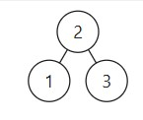
d.Output Screenshots / Console Output:
Input root = [2,1,3] Output
true

e. Explanation:
A binary tree is a valid BST if every node’s value lies within a valid range. We start with the range (−∞, +∞) for the root. For each node, its value must be greater than the minimum and less than the maximum allowed.

Problem 9

- Problem Statement:
There are a total of numCourses courses you have to take, labeled from 0 to numCourses - 1. You are given an array prerequisites where prerequisites[i] = [a_{i}, b_{i}] indicates that you must take course b_{i} first if you want to take course a_{i}.
• For example, the pair [0, 1], indicates that to take course 0 you have to first take course 1.
Return true if you can finish all courses. Otherwise, return false.

Example 1:
Input: numCourses = 2, prerequisites = [[1,0]]
Output: true
Explanation: There are a total of 2 courses to take.
To take course 1 you should have finished course 0. So it is possible.

- Code Implementation:
#include <stdbool.h>
#include <stdlib.h>

bool canFinish(int numCourses, int** prerequisites, int prerequisitesSize, int* prerequisitesColSize) {
if (numCourses <= 0) return true;

// 1. Initialize In-degree array and Adjacency List
int* inDegree = (int*)calloc(numCourses, sizeof(int));

// Using a simple adjacency list representation
// For large graphs, a linked-list based adj list is better.
// Here we use a 2D array approach for clarity in C.
int** adj = (int**)malloc(numCourses * sizeof(int*));
int* adjSize = (int*)calloc(numCourses, sizeof(int));
for (int i = 0; i < numCourses; i++) {
adj[i] = (int*)malloc(prerequisitesSize * sizeof(int));
}

// 2. Build the graph
for (int i = 0; i < prerequisitesSize; i++) {
int course = prerequisites[i][0];
int prereq = prerequisites[i][1];
adj[prereq][adjSize[prereq]++] = course;
inDegree[course]++;
}

// 3. Initialize Queue with nodes having 0 in-degree
int* queue = (int*)malloc(numCourses * sizeof(int));
int head = 0, tail = 0;
for (int i = 0; i < numCourses; i++) {
if (inDegree[i] == 0) {
queue[tail++] = i;
}
}

// 4. Process the queue
int count = 0;
while (head < tail) {
int current = queue[head++];
count++;

for (int i = 0; i < adjSize[current]; i++) {
int neighbor = adj[current][i];
inDegree[neighbor]--;
if (inDegree[neighbor] == 0) {
queue[tail++] = neighbor;
}
}
}

// Cleanup
for (int i = 0; i < numCourses; i++) free(adj[i]);
free(adj);
free(adjSize);
free(inDegree);
free(queue);

// 5. If count equals numCourses, no cycle exists
return count == numCourses;
}
c. Test Cases Considered:
numCourses =
2
prerequisites =
[[1,0]]

d.Output Screenshots / Console Output: Input numCourses =
2
prerequisites =
[[1,0]] Output
true

e. Explanation:
To check if all courses can be finished, we treat each course as a node and each prerequisite as a directed edge. The idea is to see whether these dependencies form a cycle. If a cycle exists, it means some courses depend on each other, so they cannot be completed. We count how many prerequisites (indegree) each course has and start with courses that have no prerequisites.

Problem 10

a.Problem Statement:
You are given a network of n nodes, labeled from 1 to n. You are also given times, a list of travel times as directed edges times[i] = (u_{i}, v_{i}, w_{i}), where u_{i} is the source node, v_{i} is the target node, and w_{i} is the time it takes for a signal to travel from source to target.We will send a signal from a given node k. Return the minimum time it takes for all the n nodes to receive the signal. If it is impossible for all the n nodes to receive the signal, return -1.

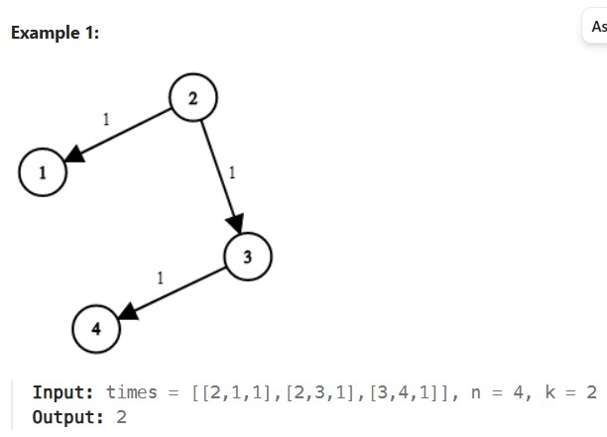
- Code Implementation:
#include <stdio.h>
#include <stdlib.h>
#include <limits.h>

#define INF INT_MAX

int networkDelayTime(int** times, int timesSize, int* timesColSize, int n, int k) {
// 1. Initialize distances array
int* dist = (int*)malloc(sizeof(int) * (n + 1));
int* visited = (int*)calloc(n + 1, sizeof(int));
for (int i = 1; i <= n; i++) dist[i] = INF;

dist[k] = 0;

// 2. Dijkstra's Algorithm (using a simple search for min since k is usually small)
for (int count = 0; count < n; count++) {
int u = -1;
int min_dist = INF;

// Find the unvisited node with the smallest distance
for (int i = 1; i <= n; i++) {
if (!visited[i] && dist[i] < min_dist) {
min_dist = dist[i];
u = i;
}
}

if (u == -1) break; // No more reachable nodes
visited[u] = 1;

// Relax edges
for (int i = 0; i < timesSize; i++) {
if (times[i][0] == u) {
int v = times[i][1];
int w = times[i][2];
if (dist[u] != INF && dist[u] + w < dist[v]) {
dist[v] = dist[u] + w;
}
}
}
}

// 3. Find the maximum travel time
int maxTime = 0;
for (int i = 1; i <= n; i++) {
if (dist[i] == INF) {
free(dist);
free(visited);
return -1;
}
if (dist[i] > maxTime) maxTime = dist[i];
}

free(dist);
free(visited);
return maxTime;
}
c. Test Cases Considered:
times =
[[2,1,1],[2,3,1],[3,4,1]]
n = 4 k = 2

d.Output Screenshots / Console Output: Input times =
[[2,1,1],[2,3,1],[3,4,1]]
n = 4 k = 2
Output
2

e. Explanation:
This problem is solved by finding the shortest time for a signal to reach every node starting from node k. We model the network as a directed graph, where nodes are computers and edges represent travel times.

Hard Questions

Problem 1

a.Problem Statement:

Given a string s representing a valid expression, implement a basic calculator to evaluate it, and return the result of the evaluation.
Note: You are not allowed to use any built-in function which evaluates strings as mathematical expressions, such as eval().

Example 1:
Input: s = "1 + 1"
Output: 2

b. Code Implementation:
#include <string.h>

- int longestValidParentheses(char* s) {
- int stack[10000];
- int top = -1, maxLen = 0;
- stack[++top] = -1;

- for (int i = 0; s[i]; i++) {
if (s[i] == '(')
- stack[++top] = i;
- else {
- top--;
- if (top == -1)
stack[++top] = i;
else {
int len = i - stack[top];
if (len > maxLen) maxLen = len;
}
}
}
return maxLen;
}Test Cases Considered:
s= "1 + 1"

- Output Screenshots / Console Output: Input s = "1 + 1"
Output
2

- Explanation:

The basic calculator problem is solved by scanning the given expression from left to right and evaluating it step by step using a stack. We maintain a variable result to store the current calculated value, a variable num to build the current number from digits, and a variable sign to indicate whether the number should be added or subtracted. When we encounter digits, we form the number by combining them.

Problem 2

a.Problem Statement:
Given a string containing just the characters '(' and ')', return the length of the longest valid (well-formed) parentheses substring.

Example 1:
Input: s = "(()"
Output: 2
Explanation: The longest valid parentheses substring is "()".

- Code Implementation:
#include <string.h>

int longestValidParentheses(char* s) {
int stack[10000];
int top = -1, maxLen = 0;
stack[++top] = -1;

for (int i = 0; s[i]; i++) {
if (s[i] == '(')
stack[++top] = i;
else {
top--;
if (top == -1)
stack[++top] = i;
else {
int len = i - stack[top];
if (len > maxLen) maxLen = len;
}
}
}
return maxLen;
}
- Test Cases Considered:
s="(()"

- Output Screenshots / Console Output: Input s = "(()"
Output
2

- Explanation:

To find the longest valid parentheses substring, we use a stack to store indices of brackets. We first push -1 into the stack to act as a base for length calculation. When we encounter an opening bracket '(', we push its index onto the stack.

Problem 3

a.Problem Statement:
You are given an array of integers nums, there is a sliding window of size k which is moving from the very left of the array to the very right. You can only see the k numbers in the window. Each time the sliding window moves right by one position.
Return the max sliding window.

Example 1:
Input: nums = [1,3,-1,-3,5,3,6,7], k = 3 Output: [3,3,5,5,6,7] Explanation:
Window position Max
--------------- ----- [1 3 -1] -3 5 3 6 7 3
1 [3 -1 -3] 5 3 6 7 3
1 3 [-1 -3 5] 3 6 7 5
1 3 -1 [-3 5 3] 6 7 5
1 3 -1 -3 [5 3 6] 7 6
1 3 -1 -3 5 [3 6 7] 7

- Code Implementation:
#include <stdio.h>
#include <stdlib.h>

/**
* Note: The returned array must be malloced, assume caller calls free().
*/
int* maxSlidingWindow(int* nums, int numsSize, int k, int* returnSize) {
if (numsSize == 0 || k == 0) {
*returnSize = 0;
return NULL;
}

int* result = (int*)malloc(sizeof(int) * (numsSize - k + 1));
*returnSize = numsSize - k + 1;

// Deque will store indices of elements
int* deque = (int*)malloc(sizeof(int) * numsSize);
int head = 0; // Front of deque
int tail = 0; // Back of deque

for (int i = 0; i < numsSize; i++) {
// 1. Remove indices that are out of the current window range
if (head < tail && deque[head] <= i - k) {
head++;
}

// 2. Remove elements from the back that are smaller than current element
// They will never be the maximum because current element is larger and newer
while (head < tail && nums[deque[tail - 1]] <= nums[i]) {
tail--;
}

// 3. Add current element's index to the back
deque[tail++] = i;

// 4. If window has reached size k, the front of deque is our max
if (i >= k - 1) {
result[i - k + 1] = nums[deque[head]];
}
}

free(deque);
return result;
}
- }Test Cases Considered:
nums =
[1,3,-1,-3,5,3,6,7] k = 3

- Output Screenshots / Console Output: Input
nums =
[1,3,-1,-3,5,3,6,7] k = 3
Output
[3,3,5,5,6,7]

- Explanation:

To find the maximum in each sliding window efficiently, we use a deque (double-ended queue) that stores indices of elements in decreasing order of their values. As we move the window from left to right, we first remove indices from the front of the deque that are outside the current window.

Problem 4

a.Problem Statement:

The n-queens puzzle is the problem of placing n queens on an n x n chessboard such that no two queens attack each other.
Given an integer n, return all distinct solutions to the n-queens puzzle. You may return the answer in any order.
Each solution contains a distinct board configuration of the n-queens' placement, where 'Q' and '.' both indicate a queen and an empty space, respectively.

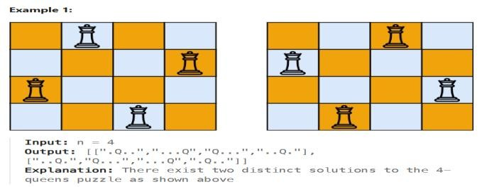

b. Code Implementation:
#include <stdio.h>
#include <stdlib.h>
#include <string.h>
#include <stdbool.h.>

- /**
- * Return an array of arrays of size *returnSize.
- * The sizes of the arrays are returned as *returnColumnSizes array.
- */

- void backtrack(int n, int row, int* cols, int* diag1, int* diag2, char** board,
- char**** results, int* returnSize, int** returnColumnSizes) {
- if (row == n) {
- // Found a solution: Copy the current board state
- (*returnSize)++;
- *results = realloc(*results, sizeof(char**) * (*returnSize));
- *returnColumnSizes = realloc(*returnColumnSizes, sizeof(int) * (*returnSize));

- char** solution = malloc(sizeof(char*) * n);
- for (int i = 0; i < n; i++) {
- solution[i] = malloc(sizeof(char) * (n + 1));
- strcpy(solution[i], board[i]);
- }

- (*results)[*returnSize - 1] = solution;
- (*returnColumnSizes)[*returnSize - 1] = n;
- return;
- }

- for (int col = 0; col < n; col++) {
- // Check columns and diagonals (diag1: row-col, diag2: row+col)
- // We add (n-1) to d1 to keep indices positive
- int d1 = row - col + (n - 1);
- int d2 = row + col;

- if (!cols[col] && !diag1[d1] && !diag2[d2]) {
- // Place Queen
- board[row][col] = 'Q';
- cols[col] = diag1[d1] = diag2[d2] = 1;

- backtrack(n, row + 1, cols, diag1, diag2, board, results, returnSize, returnColumnSizes);

- // Backtrack (Remove Queen)
- board[row][col] = '.';
- cols[col] = diag1[d1] = diag2[d2] = 0;
- }
- }
- }

- char*** solveNQueens(int n, int* returnSize, int** returnColumnSizes) {
- *returnSize = 0;
- *returnColumnSizes = NULL;
- char*** results = NULL;

- // Initialize temporary board
- char** board = malloc(sizeof(char*) * n);
- for (int i = 0; i < n; i++) {
- board[i] = malloc(sizeof(char) * (n + 1));
- for (int j = 0; j < n; j++) board[i][j] = '.';
- board[i][n] = '\0';
- }

- // Helper arrays to check constraints in O(1)
- int* cols = calloc(n, sizeof(int));
- int* diag1 = calloc(2 * n - 1, sizeof(int));
- int* diag2 = calloc(2 * n - 1, sizeof(int));

- backtrack(n, 0, cols, diag1, diag2, board, &results, returnSize, returnColumnSizes);

- // Cleanup local board and helpers
- for (int i = 0; i < n; i++) free(board[i]);
- free(board);
- free(cols);
- free(diag1);
- free(diag2);

- return results;
- }Test Cases Considered:
n=4

- Output Screenshots / Console Output: Input n = 4
Output
[[".Q..","...Q","Q...","..Q."],["..Q.","Q...","...Q",".Q.."]]

- Explanation:

The N-Queens problem is solved using backtracking. We place one queen in each row, starting from the first row. For every row, we try placing the queen in all columns and check whether it is safe. A position is considered safe if no other queen is present in the same column, the upper-left diagonal, or the upper-right diagonal.

Problem 5

a.Problem Statement:

You are given an array of k linked-lists lists, each linked-list is sorted in ascending order. Merge all the linked-lists into one sorted linked-list and return it.

Example 1:
Input: lists = [[1,4,5],[1,3,4],[2,6]]
Output: [1,1,2,3,4,4,5,6]
Explanation: The linked-lists are:
[
1->4->5,
1->3->4,
2->6
]
merging them into one sorted linked list:
1->1->2->3->4->4->5->6

- Code Implementation:
#include <stdio.h>
#include <stdlib.h>

// Definition for singly-linked list node
struct ListNode {
int val;
struct ListNode *next;
};

// Heap node to keep track of which list the value came from
struct HeapNode {
struct ListNode* node;
};

// Swap function for heapify
void swap(struct HeapNode* a, struct HeapNode* b) {
struct HeapNode temp = *a;
*a = *b;
*b = temp;
}

// Standard min-heapify function
void minHeapify(struct HeapNode* heap, int size, int i) {
int smallest = i;
int left = 2 * i + 1;
int right = 2 * i + 2;

if (left < size && heap[left].node->val < heap[smallest].node->val)
smallest = left;
if (right < size && heap[right].node->val < heap[smallest].node->val)
smallest = right;

if (smallest != i) {
swap(&heap[i], &heap[smallest]);
minHeapify(heap, size, smallest);
}
}

struct ListNode* mergeKLists(struct ListNode** lists, int listsSize) {
if (listsSize == 0) return NULL;

struct HeapNode* heap = (struct HeapNode*)malloc(sizeof(struct HeapNode) * listsSize);
int heapSize = 0;

// 1. Build initial heap with the head of each list
for (int i = 0; i < listsSize; i++) {
if (lists[i] != NULL) {
heap[heapSize++].node = lists[i];
}
}

// Initial build-heap process
for (int i = (heapSize - 2) / 2; i >= 0; i--) {
minHeapify(heap, heapSize, i);
}

struct ListNode dummy; // Dummy head to simplify result list construction
struct ListNode* tail = &dummy;
dummy.next = NULL;

// 2. Extract min and push next node from the same list
while (heapSize > 0) {
// Get the smallest node
struct ListNode* smallestNode = heap[0].node;
tail->next = smallestNode;
tail = tail->next;

if (smallestNode->next != NULL) {
// Replace root with next node from the same list
heap[0].node = smallestNode->next;
} else {
// If list is exhausted, replace root with last heap element
heap[0] = heap[heapSize - 1];
heapSize--;
}
// Maintain heap property
minHeapify(heap, heapSize, 0);
}

free(heap);
return dummy.next;
}

Test Cases Considered: lists=[[1,4,5],[1,3,4],[2,6]]

- Output Screenshots / Console Output: Input lists =
[[1,4,5],[1,3,4],[2,6]]
Output
[1,1,2,3,4,4,5,6]

- Explanation:

To merge multiple sorted linked lists into one sorted list, we use a min-heap (priority queue). First, we insert the head node of each linked list into the heap.

Problem 6
a.Problem Statement:

A linked list of length n is given such that each node contains an additional random pointer, which could point to any node in the list, or null.
Construct a deep copy of the list. The deep copy should consist of exactly n brand new nodes, where each new node has its value set to the value of its corresponding original node. Both the next and random pointer of the new nodes should point to new nodes in the copied list such that the pointers in the original list and copied list represent the same list state. None of the pointers in the new list should point to nodes in the original list.
For example, if there are two nodes X and Y in the original list, where X.random --> Y, then for the corresponding two nodes x and y in the copied list, x.random --> y.
Return the head of the copied linked list.
The linked list is represented in the input/output as a list of n nodes. Each node is represented as a pair of [val, random_index] where:
- val: an integer representing Node.val
- random_index: the index of the node (range from 0 to n-1) that the random pointer points to, or null if it does not point to any node.
Your code will only be given the head of the original linked list.

Example 1:
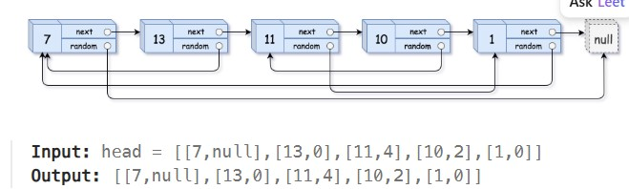

b. Code Implementation: #include #include <stdio.h>
#include <stdlib.h>

/* Definition for a Node */
struct Node {
int val;
struct Node* next;
struct Node* random;
};

/* Function to copy the linked list */
struct Node* copyRandomList(struct Node* head) {
if (head == NULL)
return NULL;

struct Node* curr = head;

/* STEP 1: Insert copied nodes after original nodes */
while (curr != NULL) {
struct Node* copy = (struct Node*)malloc(sizeof(struct Node));
copy->val = curr->val;
copy->next = curr->next;
copy->random = NULL;
curr->next = copy;
curr = copy->next;
}

/* STEP 2: Assign random pointers to copied nodes */
curr = head;
while (curr != NULL) {
if (curr->random != NULL)
curr->next->random = curr->random->next;
curr = curr->next->next;
}

/* STEP 3: Separate original and copied lists */
curr = head;
struct Node* copyHead = head->next;

while (curr != NULL) {
struct Node* copy = curr->next;
curr->next = copy->next;
if (copy->next != NULL)
copy->next = copy->next->next;
curr = curr->next;
}

return copyHead;
}

/* -------- OPTIONAL TESTING -------- */
int main() {
/* Create list: 1 -> 2 -> 3 */
struct Node* n1 = (struct Node*)malloc(sizeof(struct Node));
struct Node* n2 = (struct Node*)malloc(sizeof(struct Node));
struct Node* n3 = (struct Node*)malloc(sizeof(struct Node));

n1->val = 1; n2->val = 2; n3->val = 3;
n1->next = n2; n2->next = n3; n3->next = NULL;

n1->random = n3;
n2->random = n1;
n3->random = n2;

struct Node* copied = copyRandomList(n1);

printf("Original Head: %d\n", n1->val);
printf("Copied Head: %d\n", copied->val);

return 0;
}Test Cases Considered:
head=[[7,null],[13,0],[11,4],[10,2],[1,0]]

- Output Screenshots / Console Output: Input head =
[[7,null],[13,0],[11,4],[10,2],[1,0]]
Output
[[7,null],[13,0],[11,4],[10,2],[1,0]]

- Explanation:

To create a deep copy of the linked list with random pointers, we use a hash map to keep track of original nodes and their corresponding copied nodes.

Problem 7
a.Problem Statement:
Serialization is the process of converting a data structure or object into a sequence of bits so that it can be stored in a file or memory buffer, or transmitted across a network connection link to be reconstructed later in the same or another computer environment.
Design an algorithm to serialize and deserialize a binary tree. There is no restriction on how your serialization/deserialization algorithm should work. You just need to ensure that a binary tree can be serialized to a string and this string can be deserialized to the original tree structure.
Clarification: The input/output format is the same as how LeetCode serializes a binary tree. You do not necessarily need to follow this format, so please be creative and come up with different approaches yourself.
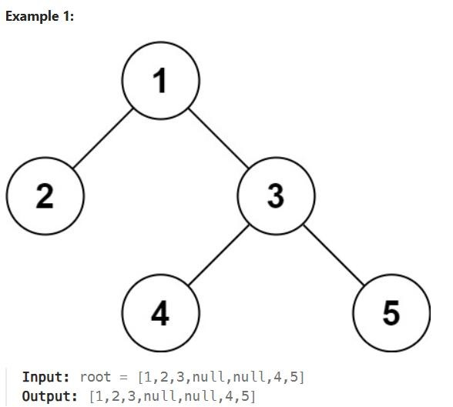

- Code Implementation:
#include <stdio.h>
#include <stdlib.h>
#include <string.h>

/* Definition for a binary tree node */
struct TreeNode {
int val;
struct TreeNode *left;
struct TreeNode *right;
};

/* ---------- SERIALIZATION ---------- */

void serializeHelper(struct TreeNode* root, char* buffer) {
char temp[20];

if (root == NULL) {
strcat(buffer, "#,");
return;
}

sprintf(temp, "%d,", root->val);
strcat(buffer, temp);

serializeHelper(root->left, buffer);
serializeHelper(root->right, buffer);
}

char* serialize(struct TreeNode* root) {
char* buffer = (char*)malloc(10000 * sizeof(char));
buffer[0] = '\0';
serializeHelper(root, buffer);
return buffer;
}

/* ---------- DESERIALIZATION ---------- */

struct TreeNode* deserializeHelper(char** data) {
if (**data == '#') {
*data += 2; // skip "#,"
return NULL;
}

int num = 0, sign = 1;

if (**data == '-') {
sign = -1;
(*data)++;
}

while (**data >= '0' && **data <= '9') {
num = num * 10 + (**data - '0');
(*data)++;
}
num *= sign;
(*data)++; // skip ','

struct TreeNode* node = (struct TreeNode*)malloc(sizeof(struct TreeNode));
node->val = num;
node->left = deserializeHelper(data);
node->right = deserializeHelper(data);

return node;
}

struct TreeNode* deserialize(char* data) {
return deserializeHelper(&data);
}

/* ---------- OPTIONAL TEST (MAIN) ---------- */
/* You can remove main() when submitting to LeetCode */

int main() {
/* Create sample tree
1
/ \
2 3
/ \
4 5
*/

struct TreeNode* root = (struct TreeNode*)malloc(sizeof(struct TreeNode));
root->val = 1;

root->left = (struct TreeNode*)malloc(sizeof(struct TreeNode));
root->left->val = 2;
root->left->left = NULL;
root->left->right = NULL;

root->right = (struct TreeNode*)malloc(sizeof(struct TreeNode));
root->right->val = 3;

root->right->left = (struct TreeNode*)malloc(sizeof(struct TreeNode));
root->right->left->val = 4;
root->right->left->left = NULL;
root->right->left->right = NULL;

root->right->right = (struct TreeNode*)malloc(sizeof(struct TreeNode));
root->right->right->val = 5;
root->right->right->left = NULL;
root->right->right->right = NULL;

char* data = serialize(root);
printf("Serialized Tree: %s\n", data);

struct TreeNode* newRoot = deserialize(data);
printf("Deserialization successful.\n");

return 0;
}
- Test Cases Considered:
Root=[1,2,3,null,null,4,5]
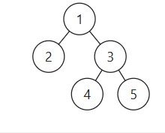
- Output Screenshots / Console Output: Input root =
[1,2,3,null,null,4,5]
Output
[1,2,3,null,null,4,5]

- Explanation:

Serialization converts the binary tree into a string so that it can be stored or transmitted, while deserialization rebuilds the original tree from that string. In this solution, we use preorder traversal (root → left → right) to serialize the tree.

Problem 8
a.Problem Statement:
A path in a binary tree is a sequence of nodes where each pair of adjacent nodes in the sequence has an edge connecting them. A node can only appear in the sequence at most once. Note that the path does not need to pass through the root.
The path sum of a path is the sum of the node's values in the path.
Given the root of a binary tree, return the maximum path sum of any non-empty path.

Example 1:
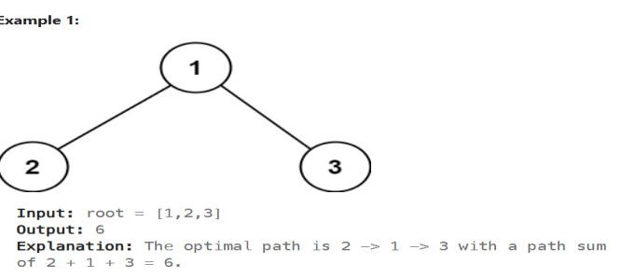

- Code Implementation:
#include <limits.h>

/* Definition for a binary tree node */
struct TreeNode {
int val;
struct TreeNode *left;
struct TreeNode *right;
};

int maxSum;

/* DFS helper function */
int dfs(struct TreeNode* root) {
if (root == NULL)
return 0;

/* Get max path sum from left and right */
int left = dfs(root->left);
int right = dfs(root->right);

/* Ignore negative paths */
if (left < 0) left = 0;
if (right < 0) right = 0;

/* Path through current node */
int currentPath = root->val + left + right;

/* Update global maximum */
if (currentPath > maxSum)
maxSum = currentPath;

/* Return max path including current node */
return root->val + (left > right ? left : right);
}

/* Main function */
int maxPathSum(struct TreeNode* root) {
maxSum = INT_MIN;
dfs(root);
return maxSum;
}
- Test Cases Considered:
Root= [1,2,3]
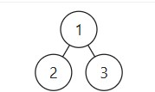
- Output Screenshots / Console Output: Input root = [1,2,3]
Output
6
- Explanation:

To find the maximum path sum in a binary tree, we use recursion and consider each node as a possible highest point of a path. For every node, we calculate the maximum sum we can get from its left and right subtrees, but we ignore any negative values because they would reduce the total sum.

Problem 9
a.Problem Statement:
Given a reference of a node in a connected undirected graph.
Return a deep copy (clone) of the graph.
Each node in the graph contains a value (int) and a list (List[Node]) of its neighbors.
class Node {
public int val; public List<Node> neighbors;
}

Test case format:
For simplicity, each node's value is the same as the node's index (1-indexed). For example, the first node with val == 1, the second node with val == 2, and so on. The graph is represented in the test case using an adjacency list.
An adjacency list is a collection of unordered lists used to represent a finite graph. Each list describes the set of neighbors of a node in the graph.
The given node will always be the first node with val = 1. You must return the copy of the given node as a reference to the cloned graph.
Example 1:

b. Code Implementation:
#include <stdlib.h>

/* Definition for a Node */
struct Node {
int val;
int numNeighbors;
struct Node** neighbors;
};

/* Map to store original node -> cloned node */
struct Node* visited[101];

/* Create a new node */
struct Node* createNode(int val) {
struct Node* node = (struct Node*)malloc(sizeof(struct Node));
node->val = val;
node->numNeighbors = 0;
node->neighbors = NULL;
return node;
}

/* DFS clone function */
struct Node* dfs(struct Node* node) {
if (node == NULL)
return NULL;

/* If already cloned, return it */
if (visited[node->val] != NULL)
return visited[node->val];

/* Clone the current node */
struct Node* clone = createNode(node->val);
visited[node->val] = clone;

clone->numNeighbors = node->numNeighbors;
clone->neighbors = (struct Node**)malloc(
sizeof(struct Node*) * node->numNeighbors);

/* Clone neighbors */
for (int i = 0; i < node->numNeighbors; i++) {
clone->neighbors[i] = dfs(node->neighbors[i]);
}
return clone;
}

/* Main function */
struct Node* cloneGraph(struct Node* s) {
for (int i = 0; i < 101; i++)
visited[i] = NULL;

return dfs(s);
}
- Test Cases Considered: edges= [[2,4],[1,3],[2,4],[1,3]]

- Output Screenshots / Console Output: Input edges =
[[2,4],[1,3],[2,4],[1,3]]
Output
[[2,4],[1,3],[2,4],[1,3]] e. Explanation:

To clone the given graph, we use Depth First Search (DFS) along with a hash map. The hash map stores the mapping between each original node and its cloned node, which helps avoid creating duplicate copies and prevents infinite loops caused by cycles in the graph.

Problem 10

a.Problem Statement:
A transformation sequence from word beginWord to word endWord using a dictionary wordList is a sequence of words beginWord -> s₁ -> s₂ -> ... -> s_{k} such that:
- Every adjacent pair of words differs by a single letter.
- Every s_{i} for 1 <= i <= k is in wordList. Note that beginWord does not need to be in wordList.
- s_{k} == endWord
Given two words, beginWord and endWord, and a dictionary wordList, return the number of words in the shortest transformation sequence from beginWord to endWord, or 0 if no such sequence exists

- Code Implementation:
#include <stdio.h>
#include <string.h>
#include <stdbool.h>

#define MAX 5000
#define WORD_LEN 20

/* Check if two words differ by exactly one character */
bool differByOne(char* a, char* b) {
int diff = 0;
for (int i = 0; a[i]; i++) {
if (a[i] != b[i])
diff++;
if (diff > 1)
return false;
}
return diff == 1;
}

/* Word Ladder Function */
int ladderLength(char* beginWord, char* endWord, char** wordList, int wordListSize) {
bool visited[MAX] = {false};
char queue[MAX][WORD_LEN];
int level[MAX];
int front = 0, rear = 0;

/* Check if endWord exists */
bool found = false;
for (int i = 0; i < wordListSize; i++) {
if (strcmp(wordList[i], endWord) == 0) {
found = true;
break;
}
}
if (!found)
return 0;

/* Initialize BFS */
strcpy(queue[rear], beginWord);
level[rear] = 1;
rear++;

while (front < rear) {
char current[WORD_LEN];
strcpy(current, queue[front]);
int currLevel = level[front];
front++;

if (strcmp(current, endWord) == 0)
return currLevel;

for (int i = 0; i < wordListSize; i++) {
if (!visited[i] && differByOne(current, wordList[i])) {
visited[i] = true;
strcpy(queue[rear], wordList[i]);
level[rear] = currLevel + 1;
rear++;
}
}
}
return 0;
}
/* Word Ladder*
- Output Screenshots / Console Output: Input beginWord =
"hit"
endWord = "cog" wordList =
["hot","dot","dog","lot","log","cog"]
Output
5
Expected
5
- Explanation:

To find the shortest transformation sequence, we use Breadth First Search (BFS) because BFS always finds the shortest path first. We start from the beginWord and try changing one letter at a time to form new words.

