**MONGODB**

**The insert() Method**

To insert data into MongoDB collection, you need to use MongoDB's **insert()** or **save()** method.

Syntax

The basic syntax of **insert()** command is as follows −

### >db. COLLECTION_NAME.insert(document).

### Eg:

### 

## The Update () Method

The update() method updates the values in the existing document.

### Syntax

The basic syntax of **update ()** method is as follows −

### >db. COLLECTION_NAME.update(SELECTION_CRITERIA, UPDATED_DATA)

### Eg:

### 

**The remove () Method**

MongoDB's **remove ()** method is used to remove a document from the collection. remove() method accepts two parameters. One is deletion criteria and second is justOne flag.

* **deletion criteria** − (Optional) deletion criteria according to documents will be removed.
* **justOne** − (Optional) if set to true or 1, then remove only one document.

### Syntax

Basic syntax of **remove ()** method is as follows –

### >db. COLLECTION_NAME.remove(DELLETION_CRITTERIA)

### Eg:

### 

## Insert multiple documents with Bulk

### It can be used to perform multiple write operations in bulk.

## Initialize a bulk operation builder

First initialize a bulk operation builder for the collection.

* var bulk = db. COLLECTION_NAME.initializeUnorderedBulkOp();

**Eg:**

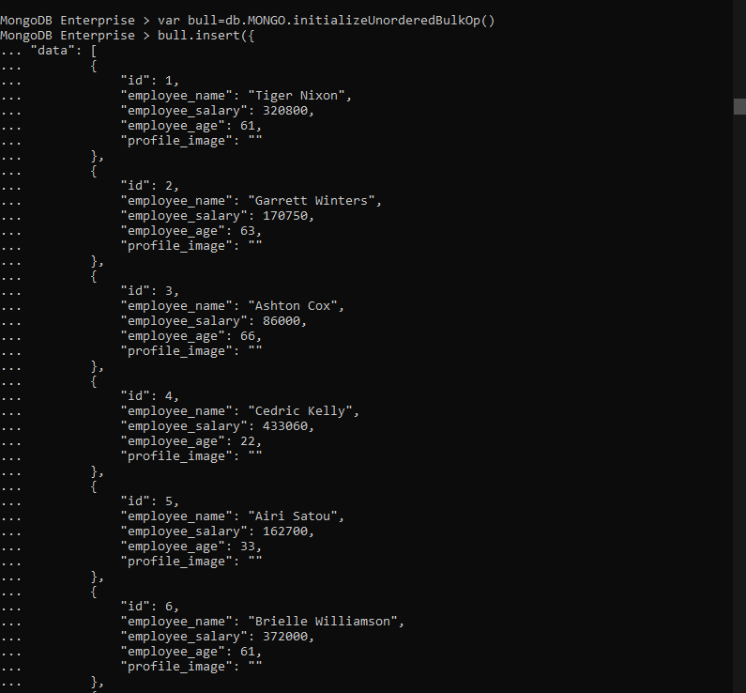

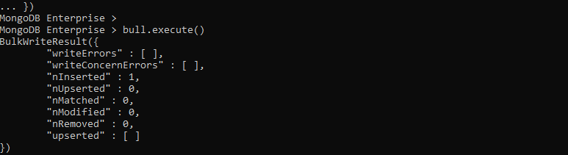

**The Find () Method**

MongoDB's find () method, when you execute find () method, then it displays all fields of a document. To limit this, you need to set a list of fields with value 1 or 0. 1 is used to show the field while 0 is used to hide the fields.

Syntax

The basic syntax of find () method with projection is as follows −

**>db. COLLECTION_NAME.find({}, {KEY:1})**

**Eg:**

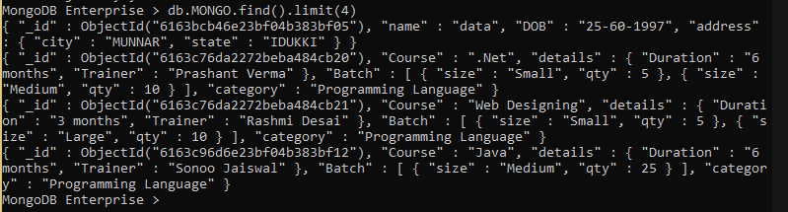

## The sort () Method

To sort documents in MongoDB, you need to use **sort ()** method. The method accepts a document containing a list of fields along with their sorting order. To specify sorting order 1 and -1 are used. 1 is used for ascending order while -1 is used for descending order.

### Syntax

The basic syntax of **sort ()** method is as follows −

### >db. COLLECTION_NAME.find(). sort ({KEY:1})

### Eg:

### 

**The aggregate () Method**

For the aggregation in MongoDB, you should use aggregate () method.

Syntax

Basic syntax of aggregate () method is as follows −

**>db. COLLECTION_NAME.aggregate(AGGREGATE_OPERATION)**

### ****$match****

### **The $match stage can use an index to filter documents if it occurs at the beginning of a pipeline.**

### ****$sort****

### **The $sort stage can use an index as long as it is not preceded by a $project, $unwind, or $group stage.**

### ****$group****

### **The $group stage can sometimes use an index to find the first document in each group if all of the following criteria are met:**

### **The $group stage is preceded by a $sort stage that sorts the field to group by,**

### **There is an index on the grouped field which matches the sort order and**

### **The only accumulator used in the $group stage is $first.**

### ****Eg for $match:****

### 

**Eg for $group:**

