**SBA6**

Maven Project Structure in Eclipse

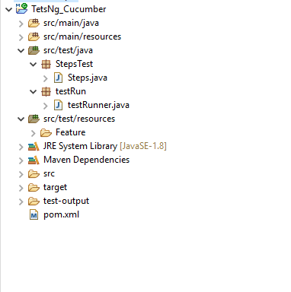

Steps.java

package StepsTest;

import org.openqa.selenium.By;

import org.openqa.selenium.WebDriver;

import org.openqa.selenium.chrome.ChromeDriver;

import org.testng.Assert;

import io.cucumber.java.After;

import io.cucumber.java.Before;

import io.cucumber.java.en.Then;

import io.cucumber.java.en.When;

public class Steps {

public WebDriver driver;

public String url = "https://demo.guru99.com/test/newtours/register.php";

public String path = "C:\\\\Users\\\\ustjavasdetb426\\\\Downloads\\\\chromedriver_win32\\\\chromedriver.exe";

@Before

public void i() {

System.setProperty("webdriver.chrome.driver", path);

driver = new ChromeDriver();

}

@When("^I open Register Page$")

public void i_open_register_page() {

driver.get(url);

}

@Then("Checking registeration without\"password confirmation\"")

public void Checking_registeration_without_password_confirmation() {

driver.navigate().to(url);

// System.out.println("f7 fun"+driver.getCurrentUrl());

driver.findElement(By.id("email")).sendKeys("abcd@gmail.com");

driver.findElement(By.name("password")).sendKeys("abcd123");

driver.findElement(By.name("submit")).click();

String e = driver.findElement(By.xpath(

"/html/body/div[2]/table/tbody/tr/td[2]/table/tbody/tr[4]/td/table/tbody/tr/td[2]/table/tbody/tr[5]/td/form/table/tbody/tr[15]/td[2]/span"))

.getText();

String a = "PAssword and con.password does not match";

Assert.assertEquals(a, e);

}

@Then("^Submit button should exists$")

public void Submit_button_should_exists() {

String a = "Note: Your user name is abcd@gmail.com.";

driver.findElement(By.name("email")).sendKeys("abcd@gmail.com");

driver.findElement(By.name("password")).sendKeys("abcd123");

driver.findElement(By.name("confirmPassword")).sendKeys("abcd123");

driver.findElement(By.name("submit")).click();

String e = driver.findElement(By.xpath(

"/html/body/div[2]/table/tbody/tr/td[2]/table/tbody/tr[4]/td/table/tbody/tr/td[2]/table/tbody/tr[3]/td/p[3]/font/b"))

.getText();

Assert.assertEquals(a, e);

}

@When("^I open Login Page$")

public void i_open_login_page() {

driver.get("http://demo.guru99.com/test/newtours/login.php");

}

@Then("^Login with wrong password$")

public void Login_with_wrong_password() {

String a = "Enter your userName and password correct";

driver.findElement(By.name("userName")).sendKeys("abcd@gmail.com");

driver.findElement(By.name("password")).sendKeys("ab");

driver.findElement(By.name("submit")).click();

String e = driver.findElement(By.xpath(

"/html/body/div[2]/table/tbody/tr/td[2]/table/tbody/tr[4]/td/table/tbody/tr/td[2]/table/tbody/tr[5]/td/form/table/tbody/tr[2]/td[2]/span"))

.getText();

Assert.assertEquals(a, e);

}

@Then("^Login button exists$")

public void Login_button_exists() {

String a = "Login Successfully";

driver.findElement(By.name("userName")).sendKeys("abcd@gmail.com");

driver.findElement(By.name("password")).sendKeys("abcd123");

driver.findElement(By.name("submit")).click();

String e = driver.findElement(By.xpath(

"/html/body/div[2]/table/tbody/tr/td[2]/table/tbody/tr[4]/td/table/tbody/tr/td[2]/table/tbody/tr[1]/td/h3"))

.getText();

Assert.assertEquals(a, e);

}

@After

public void ma()

{

driver.close();

}

}

testRunner.java

package testRun;

import io.cucumber.testng.AbstractTestNGCucumberTests;

import io.cucumber.testng.CucumberOptions;

@CucumberOptions(features = "src/test/resources/Feature",glue={"StepsTest"},monochrome=true)

public class testRunner extends AbstractTestNGCucumberTests{

}

Porm.xml

<project xmlns="http://maven.apache.org/POM/4.0.0"

xmlns:xsi="http://www.w3.org/2001/XMLSchema-instance"

xsi:schemaLocation="http://maven.apache.org/POM/4.0.0 https://maven.apache.org/xsd/maven-4.0.0.xsd">

<modelVersion>4.0.0</modelVersion>

<groupId>Jenkins_Cucumber</groupId>

<artifactId>Jenkins_Cucumber</artifactId>

<version>0.0.1-SNAPSHOT</version>

<dependencies>

<dependency>

<groupId>io.cucumber</groupId>

<artifactId>cucumber-java</artifactId>

<version>5.7.0</version>

</dependency>

<dependency>

<groupId>io.cucumber</groupId>

<artifactId>cucumber-testng</artifactId>

<version>5.7.0</version>

</dependency>

<dependency>

<groupId>org.testng</groupId>

<artifactId>testng</artifactId>

<version>7.4.0</version>

<scope>test</scope>

</dependency>

<dependency>

<groupId>org.seleniumhq.selenium</groupId>

<artifactId>selenium-java</artifactId>

<version>3.7.0</version>

</dependency>

</dependencies>

<build>

<plugins>

<plugin>

<artifactId>maven-compiler-plugin</artifactId>

<version>3.3</version>

<configuration>

<source>1.8</source>

<target>1.8</target>

</configuration>

</plugin>

<plugin>

<groupId>org.apache.maven.plugins</groupId>

<artifactId>maven-surefire-plugin</artifactId>

<version>2.19.1</version>

<configuration>

<includes>

<exclude>

**/*testRunner.java

</exclude>

</includes>

</configuration>

</plugin>

</plugins>

</build>

</project>

**JENKINS**

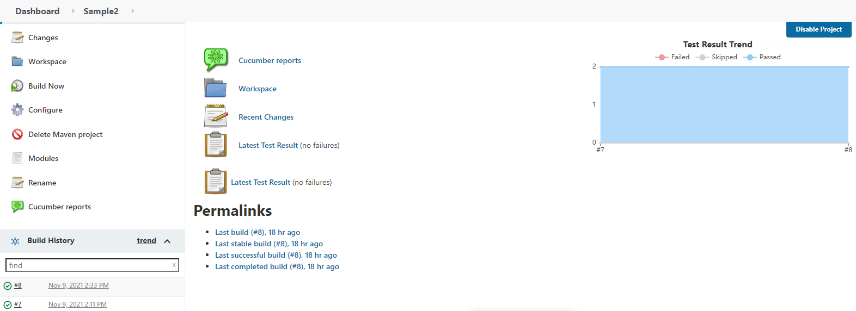

**CONSOLE OUTPUT IN JENKINS**

Started by user admin

Running as SYSTEM

Building in workspace C:\Users\ustjavasdetb426\eclipse-workspace\TetsNg_Cucumber

Parsing POMs

Established TCP socket on 52743

[TetsNg_Cucumber] $ "C:\Program Files\OpenJDK\openjdk-8u302-b08/bin/java" -cp "C:\ProgramData\Jenkins\.jenkins\plugins\maven-plugin\WEB-INF\lib\maven35-agent-1.13.jar;C:\Program Files\apache-maven-3.8.3\boot\plexus-classworlds-2.6.0.jar;C:\Program Files\apache-maven-3.8.3/conf/logging" jenkins.maven3.agent.Maven35Main "C:\Program Files\apache-maven-3.8.3" C:\ProgramData\Jenkins\war\WEB-INF\lib\remoting-4.10.1.jar C:\ProgramData\Jenkins\.jenkins\plugins\maven-plugin\WEB-INF\lib\maven35-interceptor-1.13.jar C:\ProgramData\Jenkins\.jenkins\plugins\maven-plugin\WEB-INF\lib\maven3-interceptor-commons-1.13.jar 52743

<===[JENKINS REMOTING CAPACITY]===>channel started

Executing Maven: -B -f C:\Users\ustjavasdetb426\eclipse-workspace\TetsNg_Cucumber\pom.xml clean install

[INFO] Scanning for projects...

[INFO]

[INFO] ------------------< TestNg_Cucumber:TestNg_Cucumber >-------------------

[INFO] Building TestNg_Cucumber 0.0.1-SNAPSHOT

[INFO] --------------------------------[ jar ]---------------------------------

[INFO]

[INFO] --- maven-clean-plugin:2.5:clean (default-clean) @ TestNg_Cucumber ---

[INFO] Deleting C:\Users\ustjavasdetb426\eclipse-workspace\TetsNg_Cucumber\target

[INFO]

[INFO] --- maven-resources-plugin:2.6:resources (default-resources) @ TestNg_Cucumber ---

[WARNING] Using platform encoding (Cp1252 actually) to copy filtered resources, i.e. build is platform dependent!

[INFO] Copying 0 resource

[INFO]

[INFO] --- maven-compiler-plugin:3.3:compile (default-compile) @ TestNg_Cucumber ---

[INFO] Nothing to compile - all classes are up to date

[INFO]

[INFO] --- maven-resources-plugin:2.6:testResources (default-testResources) @ TestNg_Cucumber ---

[WARNING] Using platform encoding (Cp1252 actually) to copy filtered resources, i.e. build is platform dependent!

[INFO] Copying 1 resource

[INFO]

[INFO] --- maven-compiler-plugin:3.3:testCompile (default-testCompile) @ TestNg_Cucumber ---

[INFO] Changes detected - recompiling the module!

[WARNING] File encoding has not been set, using platform encoding Cp1252, i.e. build is platform dependent!

[INFO] Compiling 2 source files to C:\Users\ustjavasdetb426\eclipse-workspace\TetsNg_Cucumber\target\test-classes

[INFO]

[INFO] --- maven-surefire-plugin:2.19.1:test (default-test) @ TestNg_Cucumber ---

-------------------------------------------------------

T E S T S

-------------------------------------------------------

Running testRun.testRunner

Nov 09, 2021 2:33:16 PM io.cucumber.testng.TestNGCucumberRunner <init>

WARNING: By default Cucumber is running in --non-strict mode.

This default will change to --strict and --non-strict will be removed.

You can use --strict or @CucumberOptions(strict = true) to suppress this warning

Starting ChromeDriver 95.0.4638.54 (d31a821ec901f68d0d34ccdbaea45b4c86ce543e-refs/branch-heads/4638@{#871}) on port 2824

Only local connections are allowed.

Please see https://chromedriver.chromium.org/security-considerations for suggestions on keeping ChromeDriver safe.

ChromeDriver was started successfully.

Nov 09, 2021 2:33:20 PM org.openqa.selenium.remote.ProtocolHandshake createSession

INFO: Detected dialect: W3C

Starting ChromeDriver 95.0.4638.54 (d31a821ec901f68d0d34ccdbaea45b4c86ce543e-refs/branch-heads/4638@{#871}) on port 20194

Only local connections are allowed.

Please see https://chromedriver.chromium.org/security-considerations for suggestions on keeping ChromeDriver safe.

ChromeDriver was started successfully.

Nov 09, 2021 2:33:28 PM org.openqa.selenium.remote.ProtocolHandshake createSession

INFO: Detected dialect: W3C

2 Scenarios (2 passed)

6 Steps (6 passed)

0m16.803s

Tests run: 2, Failures: 0, Errors: 0, Skipped: 0, Time elapsed: 18.362 sec - in testRun.testRunner

Results :

Tests run: 2, Failures: 0, Errors: 0, Skipped: 0

[JENKINS] Recording test results

[INFO]

[INFO] --- maven-jar-plugin:2.4:jar (default-jar) @ TestNg_Cucumber ---

[INFO] Building jar: C:\Users\ustjavasdetb426\eclipse-workspace\TetsNg_Cucumber\target\TestNg_Cucumber-0.0.1-SNAPSHOT.jar

[INFO]

[INFO] --- maven-install-plugin:2.4:install (default-install) @ TestNg_Cucumber ---

[INFO] Installing C:\Users\ustjavasdetb426\eclipse-workspace\TetsNg_Cucumber\target\TestNg_Cucumber-0.0.1-SNAPSHOT.jar to C:\Windows\system32\config\systemprofile\.m2\repository\TestNg_Cucumber\TestNg_Cucumber\0.0.1-SNAPSHOT\TestNg_Cucumber-0.0.1-SNAPSHOT.jar

[INFO] Installing C:\Users\ustjavasdetb426\eclipse-workspace\TetsNg_Cucumber\pom.xml to C:\Windows\system32\config\systemprofile\.m2\repository\TestNg_Cucumber\TestNg_Cucumber\0.0.1-SNAPSHOT\TestNg_Cucumber-0.0.1-SNAPSHOT.pom

[INFO] ------------------------------------------------------------------------

[INFO] BUILD SUCCESS

[INFO] ------------------------------------------------------------------------

[INFO] Total time: 25.676 s

[INFO] Finished at: 2021-11-09T14:33:36+05:30

[INFO] ------------------------------------------------------------------------

Waiting for Jenkins to finish collecting data

[JENKINS] Archiving C:\Users\ustjavasdetb426\eclipse-workspace\TetsNg_Cucumber\pom.xml to TestNg_Cucumber/TestNg_Cucumber/0.0.1-SNAPSHOT/TestNg_Cucumber-0.0.1-SNAPSHOT.pom

[JENKINS] Archiving C:\Users\ustjavasdetb426\eclipse-workspace\TetsNg_Cucumber\target\TestNg_Cucumber-0.0.1-SNAPSHOT.jar to TestNg_Cucumber/TestNg_Cucumber/0.0.1-SNAPSHOT/TestNg_Cucumber-0.0.1-SNAPSHOT.jar

channel stopped

[CucumberReport] Using Cucumber Reports version 5.6.1

[CucumberReport] JSON report directory is ""

[CucumberReport] Copied 4 properties files from workspace "C:\Users\ustjavasdetb426\eclipse-workspace\TetsNg_Cucumber" to reports directory "C:\ProgramData\Jenkins\.jenkins\jobs\Sample2\builds\8\cucumber-html-reports\.cache"

[CucumberReport] Copied 0 files from workspace "C:\Users\ustjavasdetb426\eclipse-workspace\TetsNg_Cucumber" to reports directory "C:\ProgramData\Jenkins\.jenkins\jobs\Sample2\builds\8\cucumber-html-reports\.cache"

[CucumberReport] Processing 0 json files:

[CucumberReport] Missing report result - report was not successfully completed

[CucumberReport] Build status is left unchanged

Finished: SUCCESS