# **SBA9**

## **SPRINGBOOT APPLICATION IN AWS**

1. Create AWS account
   1. Go to the aws web page (I.E.: <https://aws.amazon.com/premiumsupport/knowledge-center/create-and-activate-aws-account/>) AND

* ADD BASIC DETAILS AND
* ADD CARD inFo
* pay the fee for the acc.
* AFTER ACC. CREATTON GO to the Home page oF AWS

1. CREATE A STORAGE SAPCE
   1. SELECT S3 (ALL SERVICES -> STOrage -> S3)

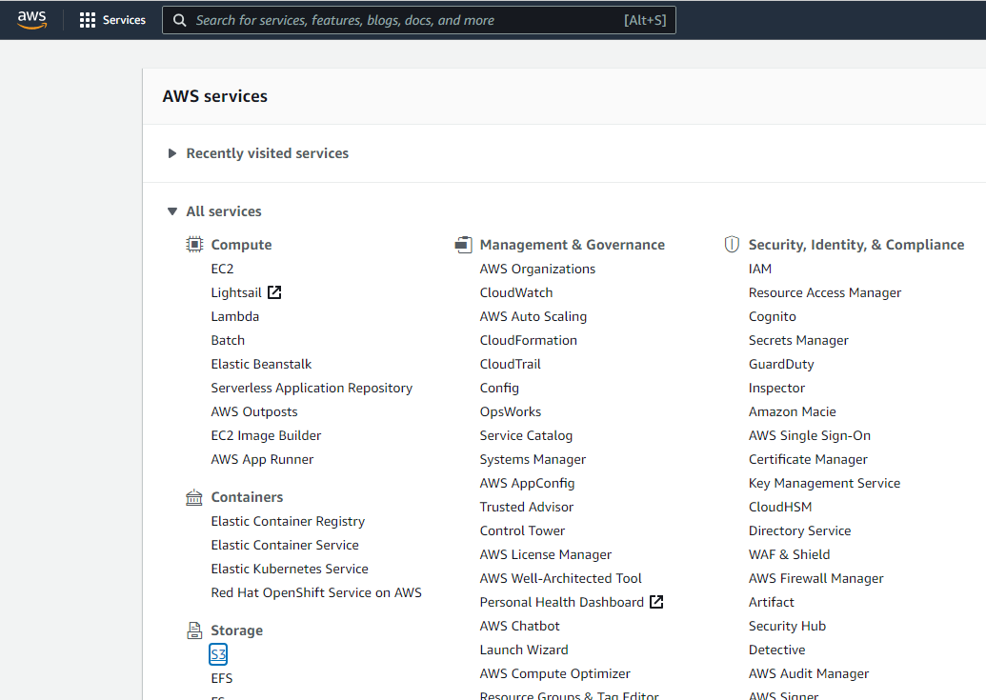

* 1. create a bucket

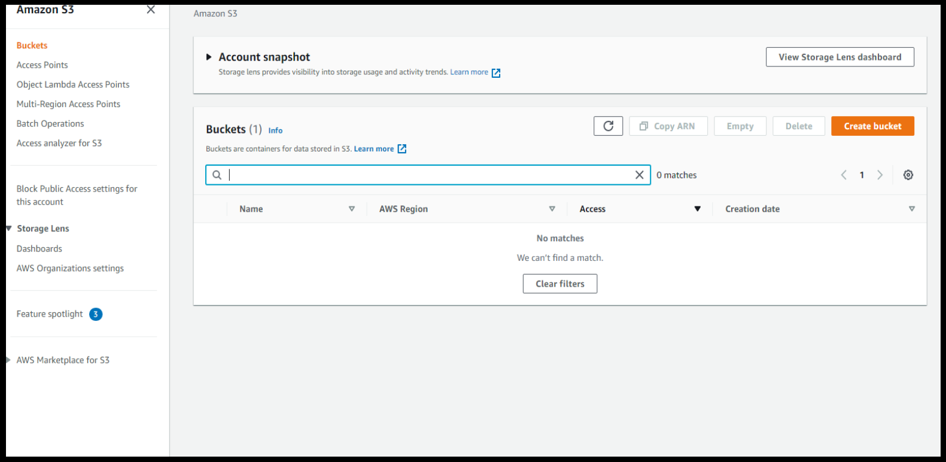

* 1. aDD GENERAL INFO THEN UNTICK TICK the BLOCk all public access (☑ 🡺 ☐)

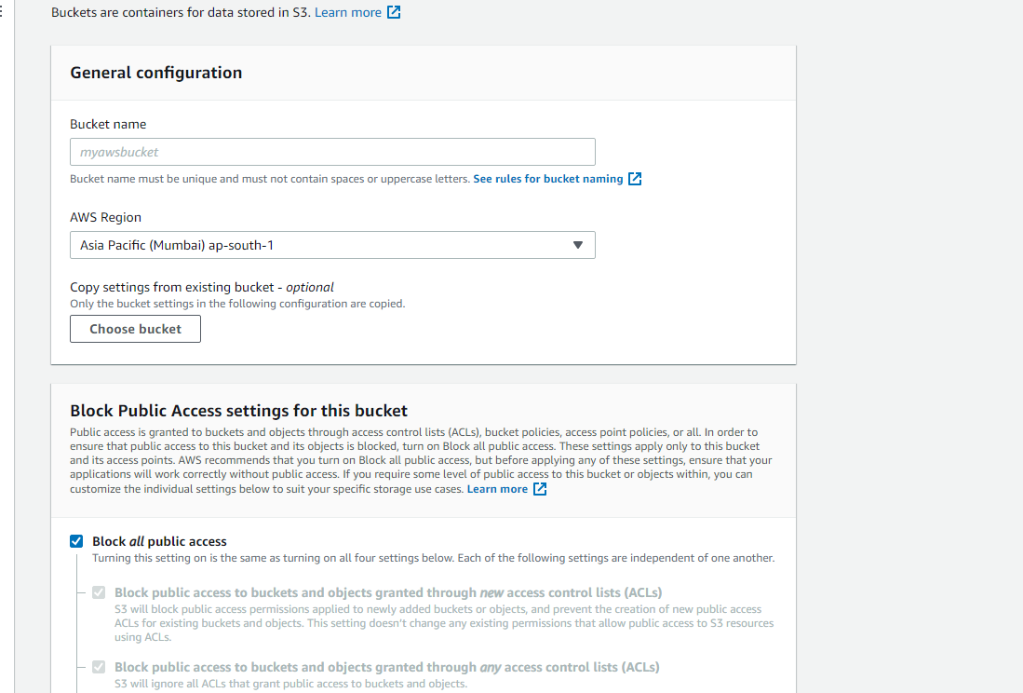

* 1. then TICK ☑ “TURNING off block all public access …….”.

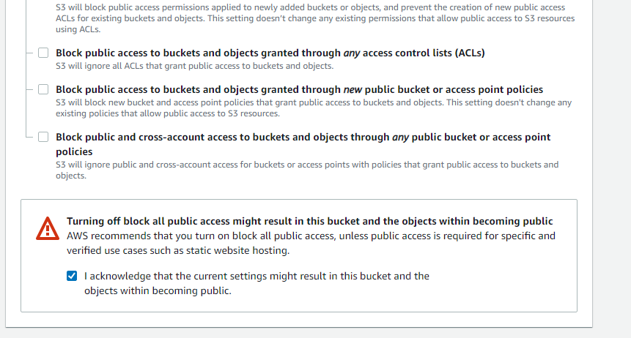

* 1. finally click create bucket button

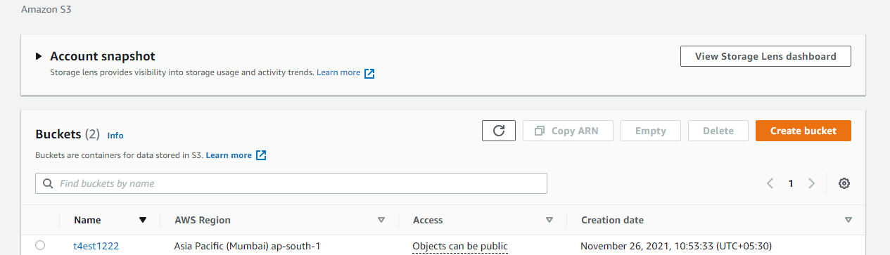

1. WE NEED to create war or jar file for our java sprintboot project
   1. go to your java project in eclipse then

* one way to make jar or war file
  + right click on the project u will see an export option

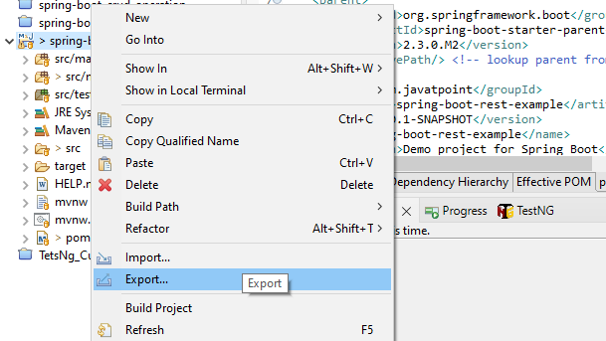

* + click on the export it will show many types of file format if you want to export the file in jar format choose JAVA 🡪 jar OTHERWISE, CHOOSE war in web 🡪war.
* another way to make jar or war is that in your project there is a pom file,

open it in eclipse.

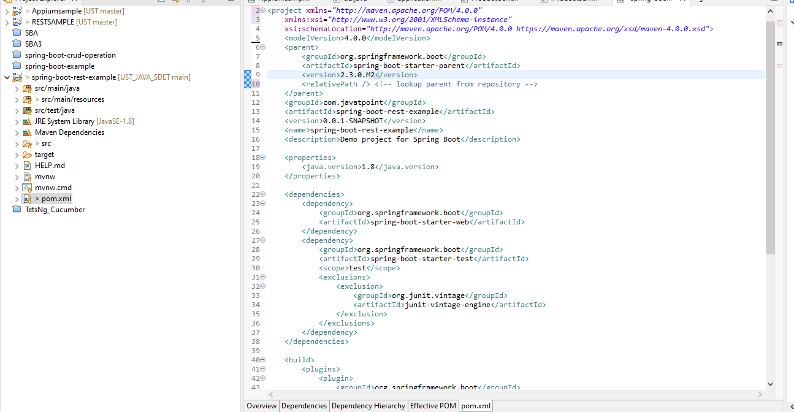

* IN here
  + ADD A tag I.E, <packaging>
  + inside this tag add which type of file format we want, put it there.
  + i.e, if we wanted a war file then

<packaging>war</packaging>

or need a jar then

<packaging>jar</packaging>

LIKE this,

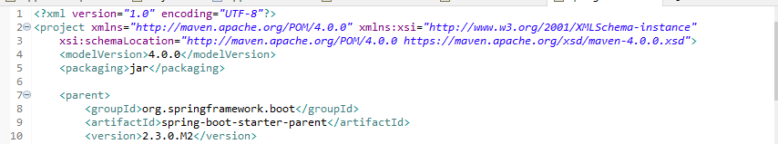

* after that right click on this springboot prjct.
  + run as 🡪 maven build

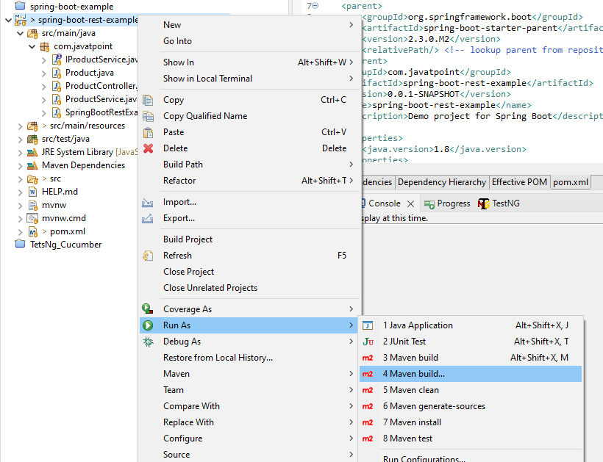

* AFter that, inside in the configuration set goal as 🡪
  + - * clean package

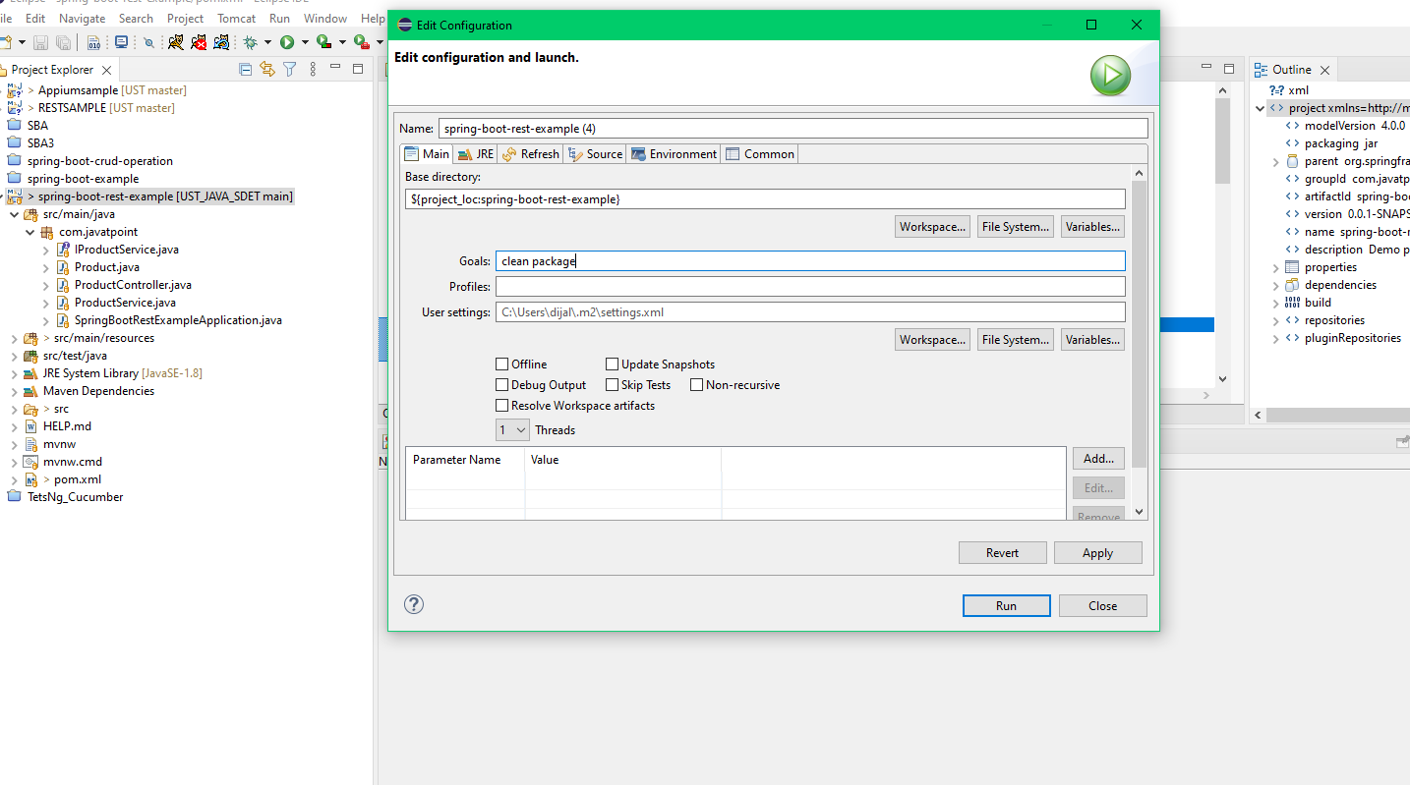

* run it, after it build SUCCESFULL, THEN refresh the project and u will see a folder in the project TARGET.

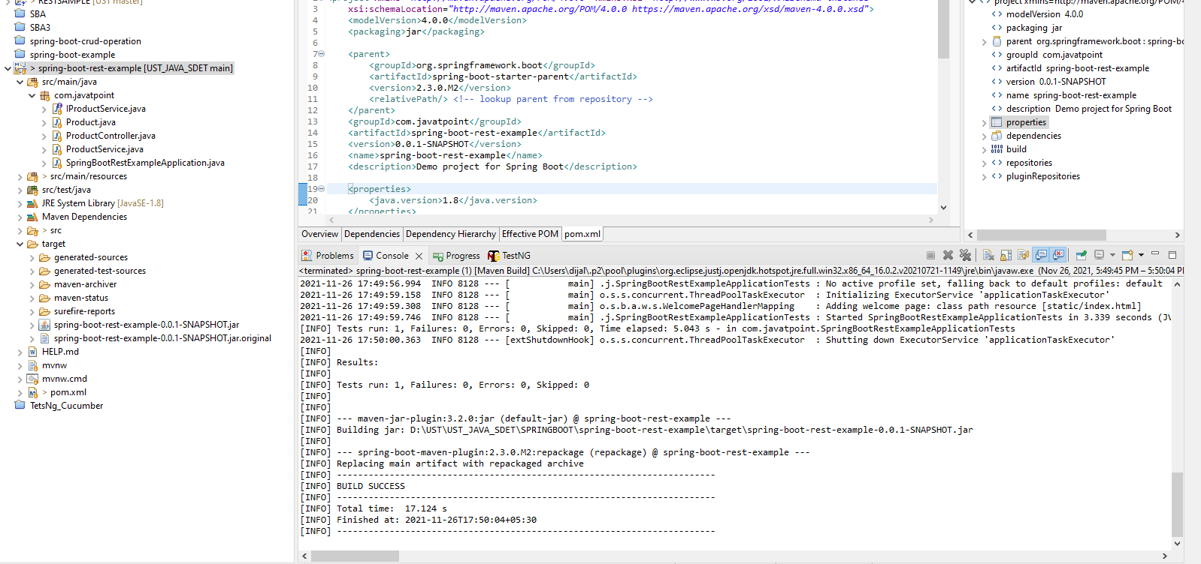

* inside this target folder u will see a jar file.

1. next step go to the aws 🡪 s3 🡪 open the bucket that u created.
   1. in that bucket u will see upload files BUTTON.

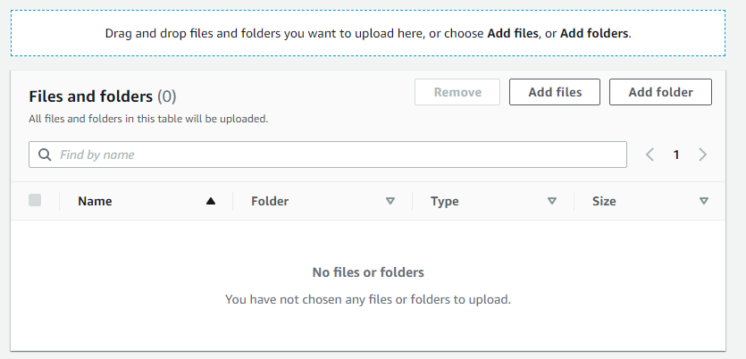

* 1. click on that upload files and choose the file (JAR or WAR) from that springboot project location after that upload it.

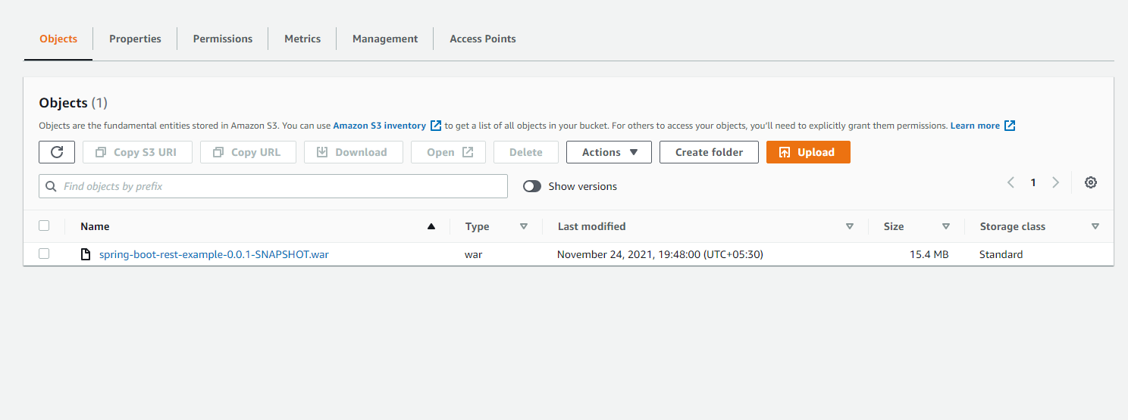

1. create a ec2 instance
   1. goto home page of aws or click on the services.
   2. click on the compute 🡪 EC2
   3. click launch instance select a mACHine (in here i select “Ubuntu Server 20.0.4 “)

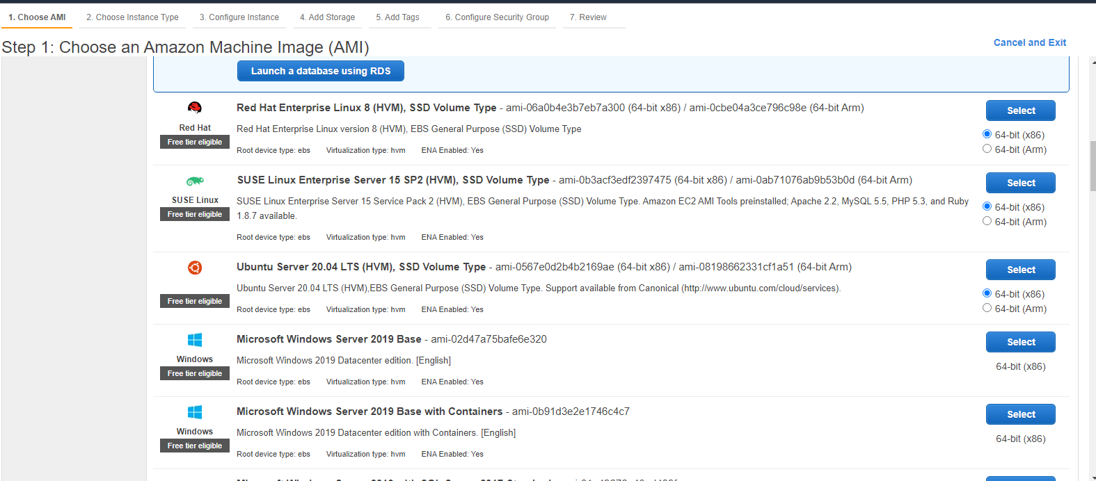

* 1. select free tier type and goto next.

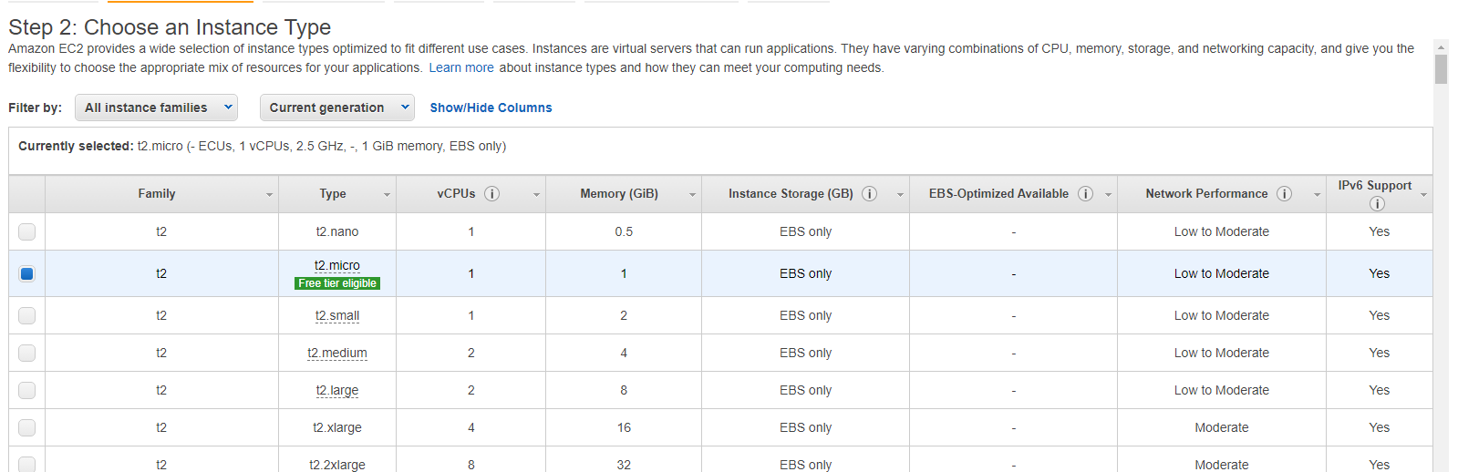

* 1. goto 6th step and change the type of protocol and source like that in the below image.then goto the 7th step click on launch.

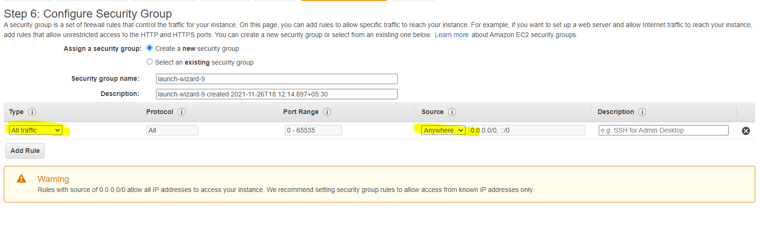

* 1. after LAUNCH IT will show a window for select security key-PAIR, IF you don’t have it click on the drop down and select create a new key-pair.then save it into your desired location.and click on launch instance.

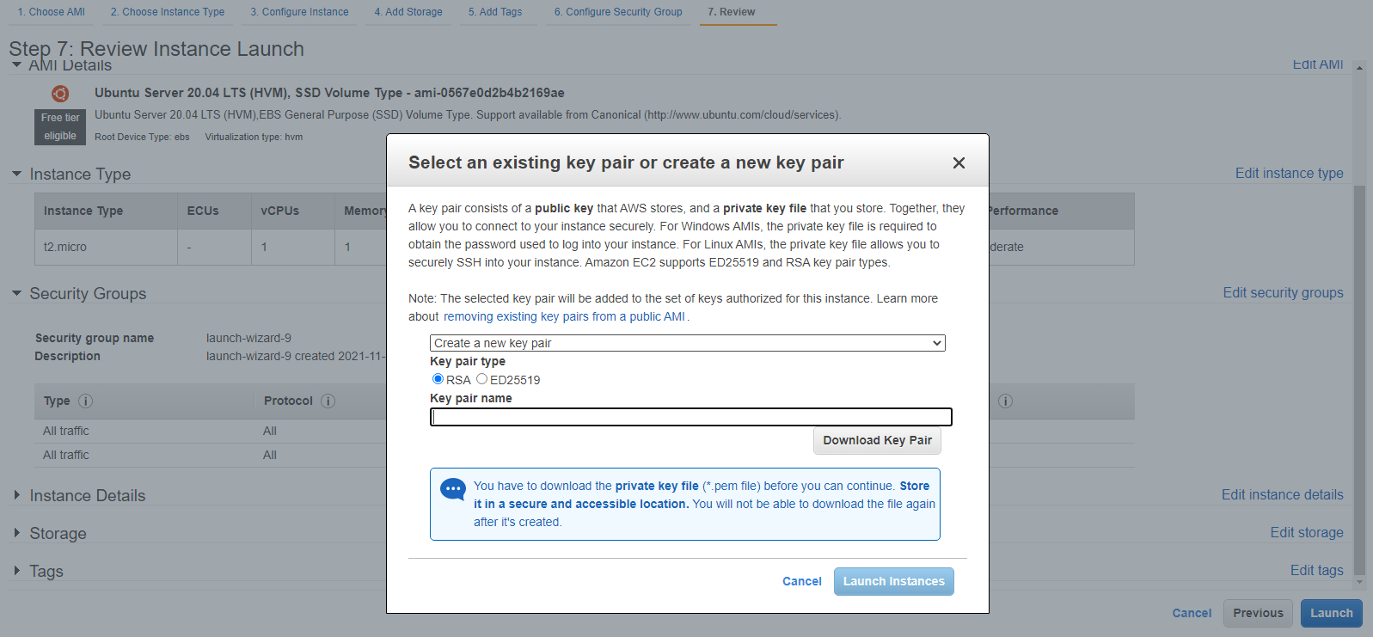

* 1. click on the instance (as you can see the status of your instance is now RUNNING)

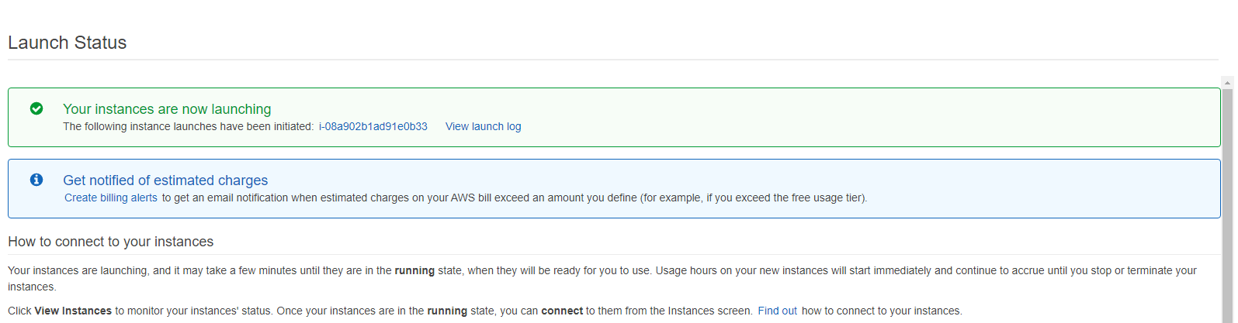

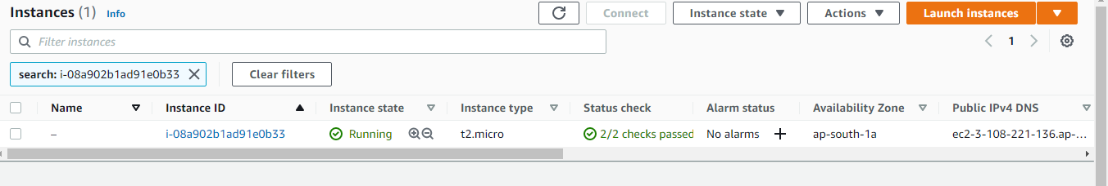

* 1. download putty for connectiing to the server or use your own cmd for connecting the serevr.
* if you use putty then 🡪download it from this link and check how to use it.(<https://www.chiark.greenend.org.uk/~sgtatham/putty/latest.html>)
* if you use cmd
  + goto the security file location that you downloaded from the aws.
  + right click on THE (. PEM) file and goto the properties and select advanced.

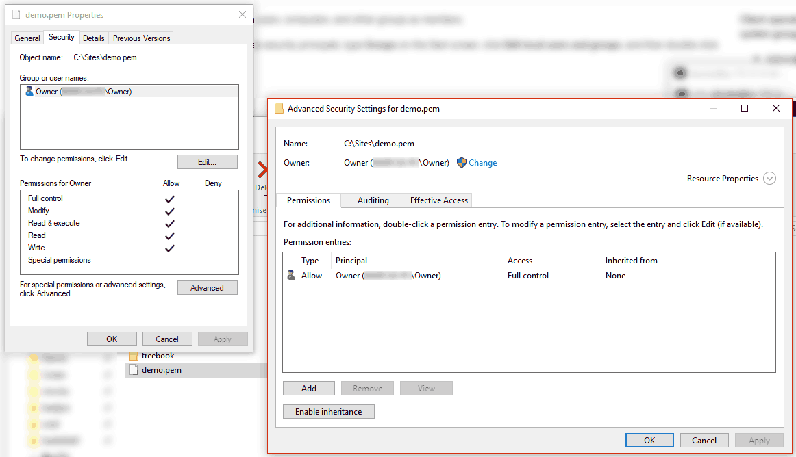

* then disable inheritance > 'Convert inherited permissions into explicit permission on this object'> remove all users and click on the add > select principal

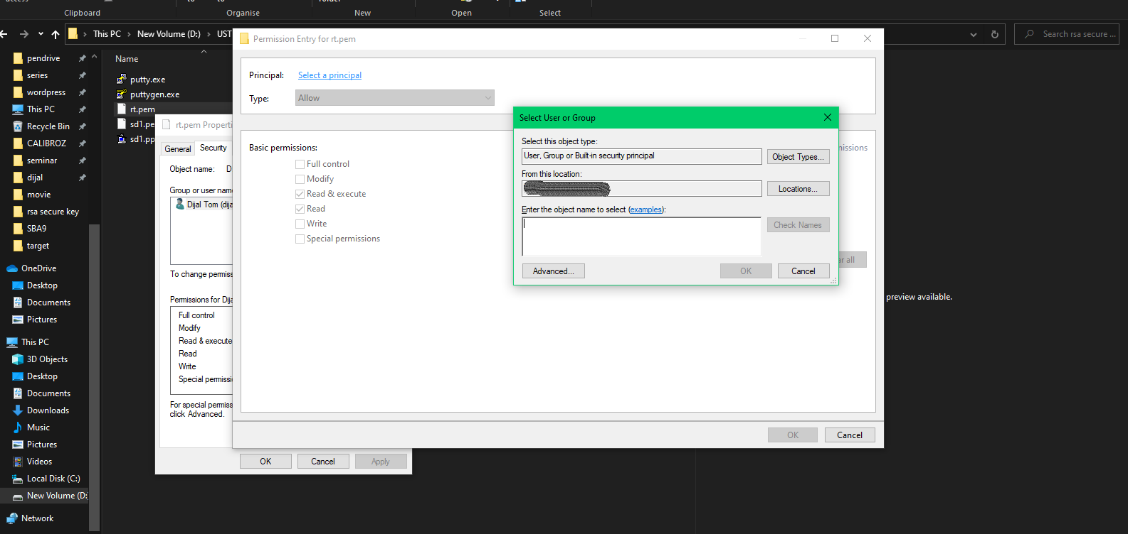

* + enter the current username and > check names > ok>   
    Click on "allow | everyone | Full Control" >ok > ok > ok (ok until all windows are closed).

1. connecting to the server
   1. copy the ssh command from
      1. goto the current ec2 instance that you created and right click on the instance🡪 SELECT CONNECT

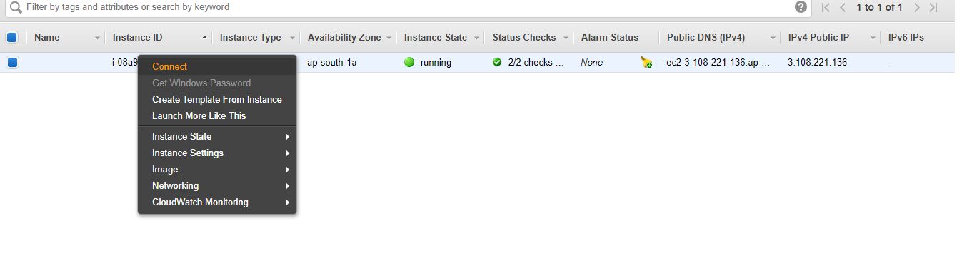

* + 1. then copy the ssh command

**Eg:**

**ssh -i "rt.pem"** [**ubuntu@ec2-3-108-221-136.ap-south-1.compute.amazonaws.com**](mailto:ubuntu@ec2-3-108-221-136.ap-south-1.compute.amazonaws.com)

* 1. then goto your key file (.pem) saved location and open the cmd in there.
     1. paste the ssh command there and it will pop up a message and type yes then it will look like in the below image.

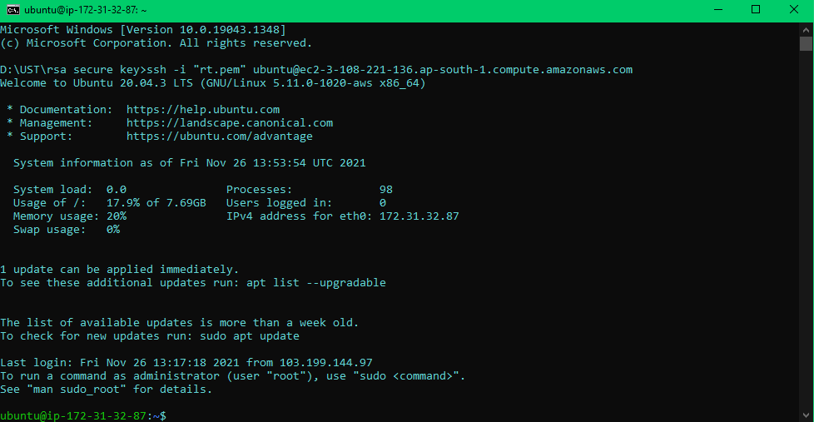

1. type the following command
   * 1. sudo apt update
     2. sudo apt-get install default-jre -y
   1. check the java version
      1. java -version

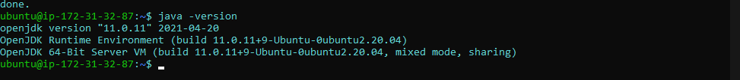

* 1. copy the object url from s3
     1. open your aws 🡪 goto your bucket 🡪 and click on that bucket 🡪 click on that (war or jar) file 🡪 copy the object url

eg: https://yourbucketname.s3.ap-south-1.amazonaws.com/spring-boot.war

* + 1. goto that cmd after the java version command type
       - wget <https://yourbucketname.s3.ap-south-1.amazonaws.com/spring-boot.war>
       - ls
    2. copy the file name from the cmd then type
       - java -jar filename
  1. after it will start the spring-boot appliaction
     1. THEN GOTO aws and goto the current ec2 instance that you created and right click on the instance🡪 SELECT CONNECT->copy the public dns

1. open any web-browser

such AS, (CHROME, EDGE....etc)

1. paste the url and add the port NUMBER (THAT u gave in spring-boot APPLICATION) in the url

eg.

